OTHER
XXRHC
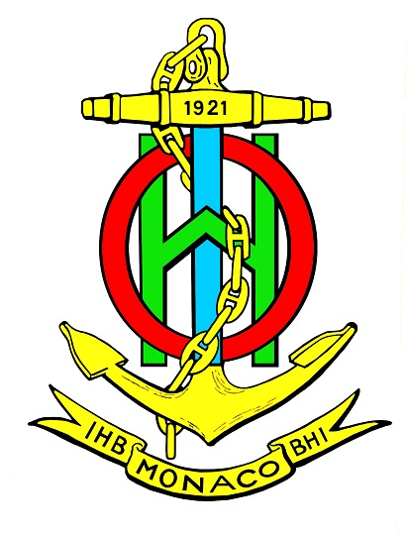

CERTIFICATE
This is to certify that
has participated in the
jointly organized by
the International Hydrographic Organization (IHO)

Name
Director
International/Regional Organization

Name
Chair
[_______] Regional Hydrographic Commission
Name
Director
International Hydrographic Organization

