INTERNATIONAL HYDROGRAPHIC  ORGANIZATION | INTERGOVERNMENTAL OCEANOGRAPHIC  COMMISSION (of UNESCO)

UNDERSEA FEATURE NAME PROPOSAL
(See IHO-IOC Publication B-6 and NOTE overleaf)

Note: The boxes will expand as you fill the form.
Name Proposed: | Tsukamoto Guyot | Ocean or Sea: | N/A

Geometry that best defines the feature (Yes/No) :
Point | Line | Polygon | Multiple points | Multiple lines* | Multiple polygons* | Combination of geometries*
 |  | Yes
* Geometry should be clearly distinguished when providing the coordinates below.
 | Lat. (e.g. 63°32.6’N) | Long. (e.g. 046°21.3’W)
Coordinates: | 20°15.97’N  20°16.74’N  20°10.10’N  19°59.68’N  19°53.71’N  20°01.84’N  20°15.97’N | 151°32.05’E  151°47.40’E  151°52.94’E  151°51.72’E  151°37.39’E  151°26.12’E  151°32.05’E

Feature Description: | Maximum Depth: | 5,795 m | Steepness : | N/A
Feature Description: | Minimum Depth : | 1,259 m | Shape : | Almost conical
Feature Description: | Total Relief : | 4,536 m | Dimension/Size : | 45 km × 40 km

Associated Features: | Hemler Guyot

Chart/Map References: | Shown Named on Map/Chart: | 6724
Chart/Map References: | Shown Unnamed on Map/Chart:
Chart/Map References: | Within Area of Map/Chart:

Reason for Choice of Name (if a person, state how associated with the feature to be named): | Named after an ex-Chief Hydrographer of Japan the late Mr. Yushiro Tsukamoto. See attached personal history for more details.

Discovery Facts: | Discovery Date: | Jan. 2002
Discovery Facts: | Discoverer (Individual, Ship): | Japanese survey vessel "Takuyo"

Supporting Survey Data, including Track Controls: | Date of Survey: | Jan. and Feb. - Mar. 2002
Supporting Survey Data, including Track Controls: | Survey Ship: | Japanese survey vessel "Shoyo" and "Takuyo"
Supporting Survey Data, including Track Controls: | Sounding Equipement: | Multibeam echo sounder  Seabeam 2112
Supporting Survey Data, including Track Controls: | Type of Navigation: | GPS without Selective Availability
Supporting Survey Data, including Track Controls: | Estimated Horizontal Accuracy, in nautical miles (M): | 0.014 nm (26 m)
Supporting Survey Data, including Track Controls: | Survey Track Spacing: | 9 nm
Supporting Survey Data, including Track Controls: | Supporting material can be submitted as Annex in analog or digital form.

Proposer(s): | Name(s): | JCUFN
Proposer(s): | Date: | August 20, 2018
Proposer(s): | E-mail: | ico@jodc.go.jp
Proposer(s): | Organization and Address: | Hydrographic and Oceanographic Department, Japan Coast Guard Kasumigaseki 3-1-1, Chiyoda-ku, Tokyo 100-8932, Japan
Proposer(s): | Concurrer (name, e-mail, organization and address):

Remarks: | The position of the summit is located in (20°02.24’N, 151°38.82’E).

NOTE: This form should be forwarded, when completed:

a) If the undersea feature is located inside the external limit of the territorial sea:
- to your "National Authority for Approval of Undersea Feature Names" (see Publication B-6) or, if this does not exist or is not known, either to the IHO or to the IOC (see addresses below);

b) If at least 50 % of the undersea feature is located outside the external limits of the territorial sea:
- to the IHO or to the IOC, at the following addresses :

International Hydrographic Organization (IHO)  4b, Quai Antoine 1er  B.P. 445  MC 98011 MONACO CEDEX  Principality of MONACO  Fax: +377 93 10 81 40  E-mail: info@iho.int  Web: www.iho.int | Intergovernmental Oceanographic Commission (IOC)  UNESCO  Place de Fontenoy  75700 PARIS  France  Fax: +33 1 45 68 58 12  E-mail: info@unesco.org  Web: http://ioc-unesco.org/

Personal history of late Mr. Yushiro Tsukamoto

Given name: Yushiro
Family name: Tsukamoto

May 17, 1901 Born in Fukuoka, Japan
December 22, 1965 Diseased

Education
1926 B.S., Department of Astronomy, Imperial University of Tokyo
1926-1927 Attended to the Graduate School of Science, Imperial University of Tokyo

Professional carrier:
1927 Joined the Hydrographic Department of Japan
1945 Director of the Astronomical Division, Hydrographic Department of Japan
1959-1963 Chief Hydrographer of Japan

Remarks:
He was an astro-geophysicst who made a significant contribution to Japan’s hydrography in the field of astronomy and calendar. With his colleagues, Drs. Toshio Akiyoshi and Keishin Suzuki, when astronomical almanacs could not be imported into Japan during the World War II, he was in charge of developing astronomical navigation table, resulting in Japan’s own astronomical navigation table (Japanese ephemeris) in 1943. In 1944, he further completed the “Alt-Azimuth Ephemeris”.

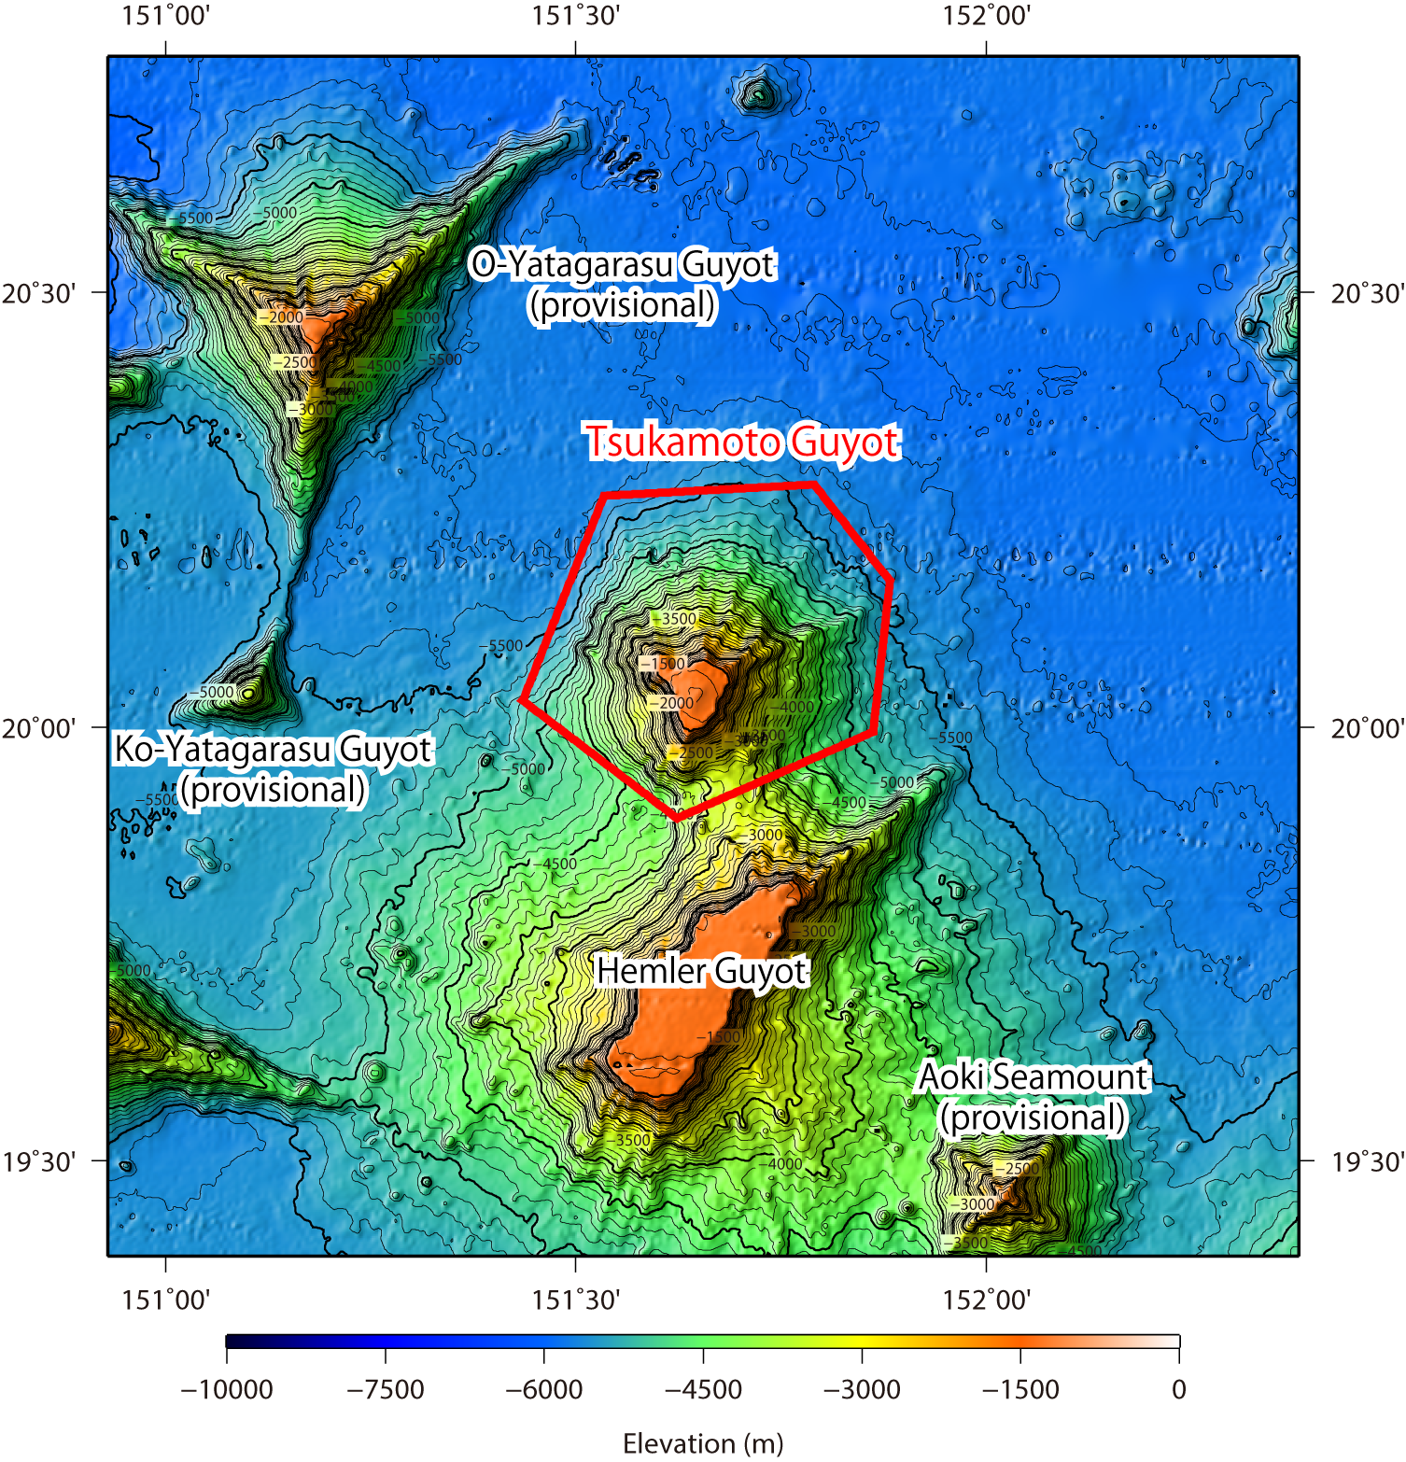

Fig. 1. Bathymetric map of the Tsukamoto Guyot. Contours are in 100 m.

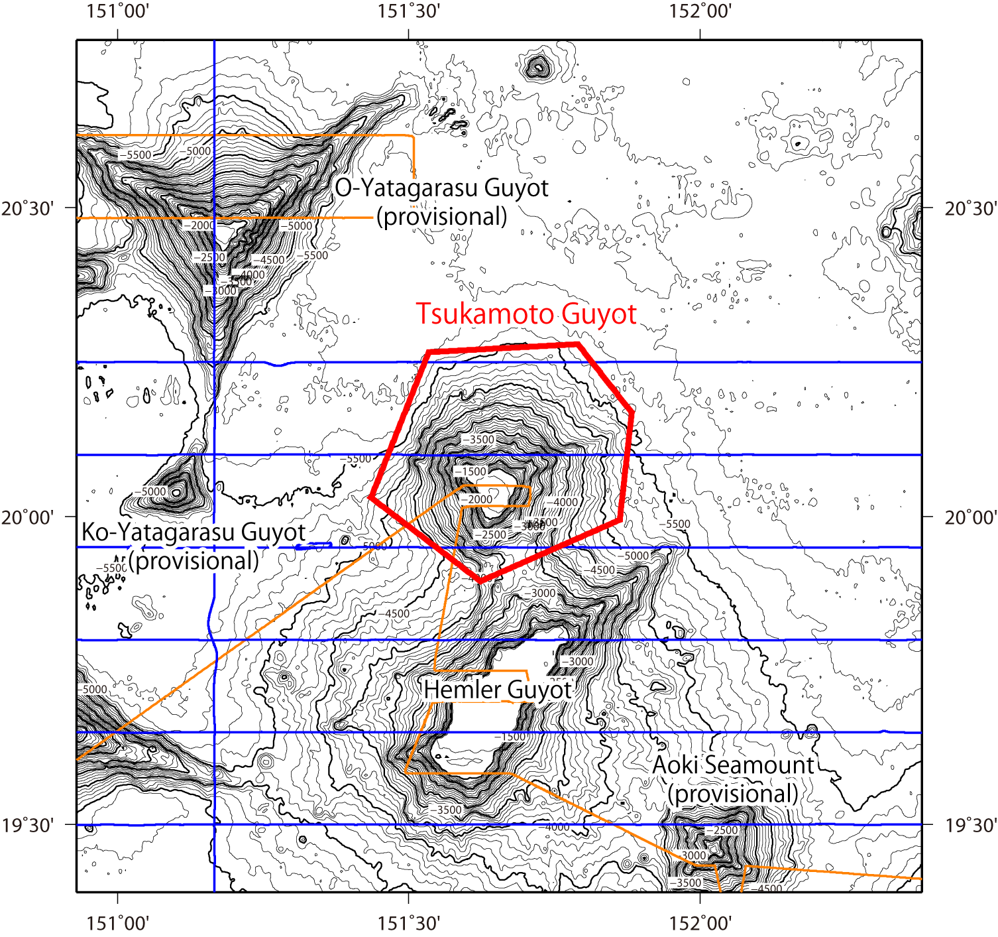

Fig. 2. Bathymetric map of the Tsukamoto Guyot, shown with track lines. Contours are in 100 m.

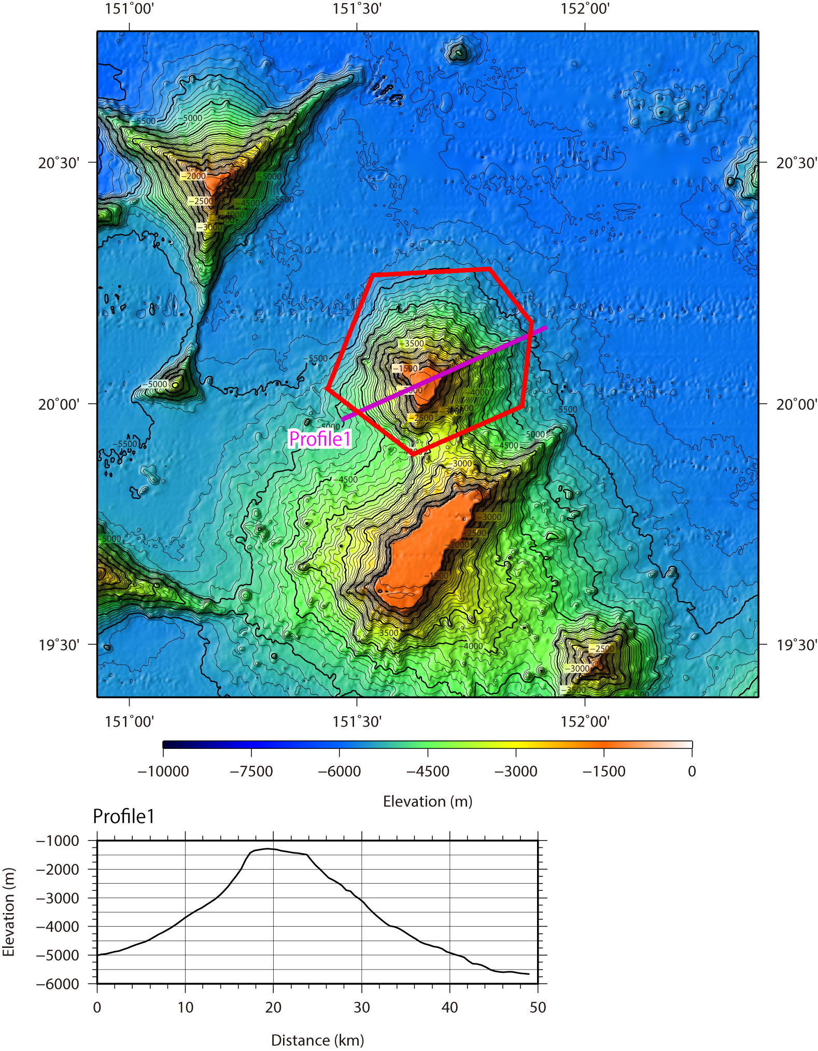

Fig. 3. Bathymetric profile across the Tsukamoto Guyot.

