INTERNATIONAL HYDROGRAPHIC  ORGANIZATION | INTERGOVERNMENTAL OCEANOGRAPHIC  COMMISSION (of UNESCO)

UNDERSEA FEATURE NAME PROPOSAL
(See NOTE overleaf)

Note: The boxes will expand as you fill the form.
Name Proposed: | Berdebed Basin | Ocean or Sea: | Philippine Sea

Geometry that best defines the feature (Yes/No) :
Point | Line | Polygon | Multiple points | Multiple lines* | Multiple polygons* | Combination of geometries*
 |  | Yes
* Geometry should be clearly distinguished when providing the coordinates below.
 | Lat. (degrees, north) | Long. (degrees, east)
Coordinates: | 13° 57' 28.413" N  13° 57' 48.971" N  13° 57' 31.839" N  13° 56' 26.737" N  13° 55' 59.326" N  13° 55' 07.929" N  13° 52' 57.725" N  13° 49' 45.846" N  13° 48' 16.759" N  13° 46' 20.260" N  13° 46' 37.392" N  13° 47' 25.362" N  13° 48' 51.023" N  13° 50' 20.110" N  13° 51' 42.344" N  13° 53' 28.563" N  13° 54' 23.386" N  13° 55' 25.061" N  13° 56' 09.605" N | 134° 43' 50.201" E  134° 44' 41.597" E  134° 45' 15.862" E  134° 45' 36.420" E  134° 46' 07.258" E  134° 46' 00.405" E  134° 45' 43.273" E  134° 45' 26.141" E  134° 44' 48.450" E  134° 43' 33.069" E  134° 42' 45.099" E  134° 42' 34.820" E  134° 42' 14.261" E  134° 42' 00.555" E  134° 42' 10.835" E  134° 42' 38.246" E  134° 42' 41.673" E  134° 42' 27.967" E  134° 42' 48.525" E

Feature Description: | Maximum Depth : | 5465 m | Steepness : | N/A
 | Minimum Depth : | 4800 m | Shape : | Oval Shaped
 | Total Relief : | 665 m | Dimension/Size : | 21 km x 6 km

Associated Features: | This feature is within the Kobayashi Basin and Ridge Province

Chart/Map References: | Shown Named on Map/Chart: | None
 | Shown Unnamed on Map/Chart: | None
 | Within Area of Map/Chart: | None

Reason for Choice of Name (if a person, state how associated with the feature to be named): | Berdebed is the Palauan name for juvenile Bumphead Parrot Fish, which is found on reefs throughout Palau.

Discovery Facts: | Discovery Date: | Dec. 2006
 | Discoverer (Individual, Ship): | S/V Shoyo (HODJ)

Supporting Survey Data, including Track Controls: | Date of Survey: | Dec. 2006
 | Survey Ship: | S/V Shoyo (HODJ))
 | Sounding Equipment: | Multibeam echo sounder  Seabeam 2112
 | Type of Navigation: | GPS without Selective Availability
 | Estimated Horizontal Accuracy (nm): | 0.014 nm (26 m)
 | Survey Track Spacing: | 6 nm
 | Supporting material can be submitted as Annex in analog or digital form.

Proposer(s): | Name(s): | David K. Idip, Jr. and Takamatsu Emesiochel
 | Date: | August 17, 2018
 | E-mail: | davididip@gmail.com
 | Organization and Address: | Territory and Boundary Task Force, Office of the President, Republic of Palau
 | Concurrer (name, e-mail, organization and address):

Remarks: | We used GMT and GeoMapApp software to visualize the bathymetric data. QGIS and ArcMap were the preferred GIS software.

NOTE : This form should be forwarded, when completed :

a) If the undersea feature is located inside the external limit of the territorial sea :-
to your "National Authority for Approval of Undersea Feature Names" (see page 2-9) or, if this does not exist or is not known, either to the IHB or to the IOC (see addresses below);

b) If at least 50 % of the undersea feature is located outside the external limits of the territorial sea :-
to the IHB or to the IOC, at the following addresses :

International Hydrographic Bureau (IHB)  4, Quai Antoine 1er  B.P. 445  MC 98011 MONACO CEDEX  Principality of MONACO  Fax: +377 93 10 81 40  E-mail: info@ihb.mc | Intergovernmental Oceanographic Commission (IOC)  UNESCO  Place de Fontenoy  75700 PARIS  France  Fax: +33 1 45 68 58 12  E-mail: info@unesco.org

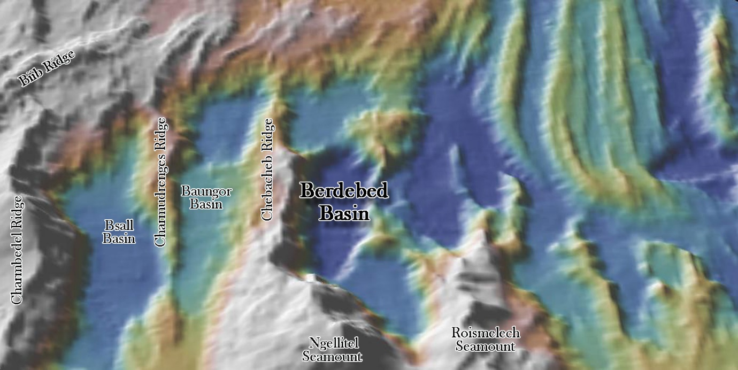

Fig. 1. Bathymetric 3D image of Berdebed Basin and its vicinity.

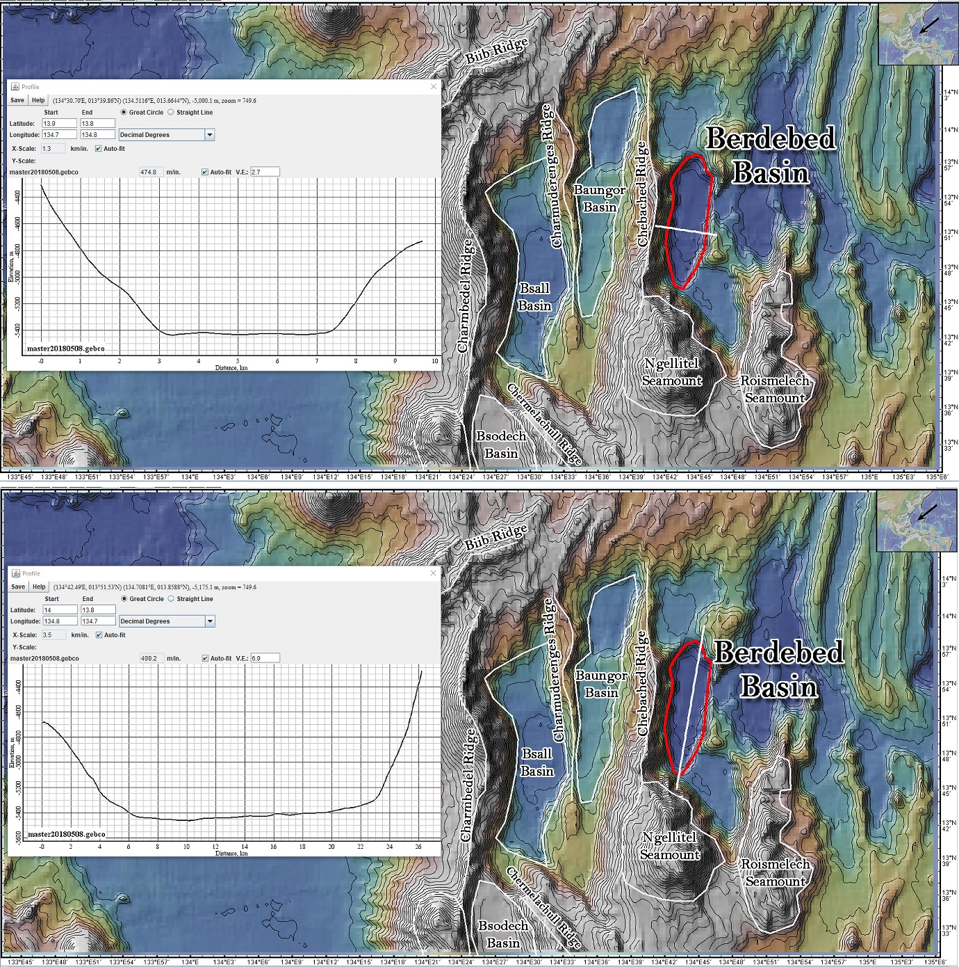

Fig. 2. Bathymetric profile across Berdebed Basin. The polygon that defines the basin is also shown. Contours in 100 m intervals.

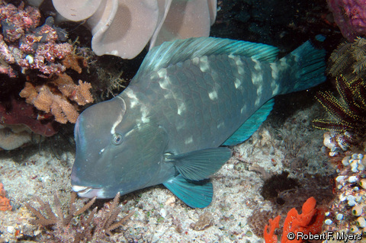

Fig. 3. Picture of a juvenile Bumphead Parrot Fish (Berdebed)

