INTERNATIONAL HYDROGRAPHIC  ORGANIZATION | INTERGOVERNMENTAL OCEANOGRAPHIC  COMMISSION (of UNESCO)

UNDERSEA FEATURE NAME PROPOSAL
(See IHO-IOC Publication B-6 and NOTE overleaf)

Note: The boxes will expand as you fill the form.
Name Proposed: | Ko-Unoashi Seamount | Ocean or Sea: | N/A

Geometry that best defines the feature (Yes/No) :
Point | Line | Polygon | Multiple points | Multiple lines* | Multiple polygons* | Combination of geometries*
 |  | Yes
* Geometry should be clearly distinguished when providing the coordinates below.
 | Lat. (e.g. 63°32.6’N) | Long. (e.g. 046°21.3’W)
Coordinates: | 23°49.25’N  23°47.54’N  23°42.82’N  23°39.75’N  23°41.82’N  23°46.68’N  23°49.25’N | 156°16.46’E  156°21.14’E  156°21.78’E  156°17.39’E  156°13.72’E  156°13.00’E  156°16.46’E

Feature Description: | Maximum Depth: | 5,672 m | Steepness : | N/A
Feature Description: | Minimum Depth : | 3,241 m | Shape : | Conical, limpet-like
Feature Description: | Total Relief : | 2,431 m | Dimension/Size : | 15 km × 15 km

Associated Features: | O-Unoashi Seamount

Chart/Map References: | Shown Named on Map/Chart: | 6724
Chart/Map References: | Shown Unnamed on Map/Chart:
Chart/Map References: | Within Area of Map/Chart:

Reason for Choice of Name (if a person, state how associated with the feature to be named): | Following the rule II-A-7 of B-6 (page 2-3), JCUFN gave a descriptive name to this feature. “Unoashi” is the Japanese for a broad-ribbed limpet, a mollusk. The shape of this feature resembles the shape of a broad-ribbed limpet.  “Ko” means “small” or “minor” in Japanese, therefore “Ko-Unoashi” means a “small broad-ribbed limpet”.  See more at  https://en.wikipedia.org/wiki/Limpet  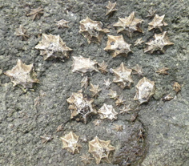  Image from http://www.godac.jamstec.go.jp/bismal/j/JAMSTEC_SampleDB/view/9019102

Discovery Facts: | Discovery Date: | Apr. 1999
Discovery Facts: | Discoverer (Individual, Ship): | Japanese survey vessel "Takuyo"

Supporting Survey Data, including Track Controls: | Date of Survey: | Apr. - May 1999  Jul. - Aug. 2007
Supporting Survey Data, including Track Controls: | Survey Ship: | Japanese survey vessel "Takuyo"
Supporting Survey Data, including Track Controls: | Sounding Equipement: | Multibeam echo sounder  Seabeam 2112 (2007)  Seabeam 210B (1999)
Supporting Survey Data, including Track Controls: | Type of Navigation: | GPS without Selective Availability (2007)  GPS with Selective Availability (1999)
Supporting Survey Data, including Track Controls: | Estimated Horizontal Accuracy, in nautical miles (M): | 0.014 nm (26 m) (2007)  0.054 nm (100 m) (1999)
Supporting Survey Data, including Track Controls: | Survey Track Spacing: | 5 nm
Supporting Survey Data, including Track Controls: | Supporting material can be submitted as Annex in analog or digital form.

Proposer(s): | Name(s): | JCUFN
Proposer(s): | Date: | August 20, 2018
Proposer(s): | E-mail: | ico@jodc.go.jp
Proposer(s): | Organization and Address: | Hydrographic and Oceanographic Department, Japan Coast Guard Kasumigaseki 3-1-1, Chiyoda-ku, Tokyo 100-8932, Japan
Proposer(s): | Concurrer (name, e-mail, organization and address):

Remarks: | The position of the summit is located in (23°44.56’N, 156°17.40’E).

NOTE: This form should be forwarded, when completed:

a) If the undersea feature is located inside the external limit of the territorial sea:
- to your "National Authority for Approval of Undersea Feature Names" (see Publication B-6) or, if this does not exist or is not known, either to the IHO or to the IOC (see addresses below);

b) If at least 50 % of the undersea feature is located outside the external limits of the territorial sea:
- to the IHO or to the IOC, at the following addresses :

International Hydrographic Organization (IHO)  4b, Quai Antoine 1er  B.P. 445  MC 98011 MONACO CEDEX  Principality of MONACO  Fax: +377 93 10 81 40  E-mail: info@iho.int  Web: www.iho.int | Intergovernmental Oceanographic Commission (IOC)  UNESCO  Place de Fontenoy  75700 PARIS  France  Fax: +33 1 45 68 58 12  E-mail: info@unesco.org  Web: http://ioc-unesco.org/

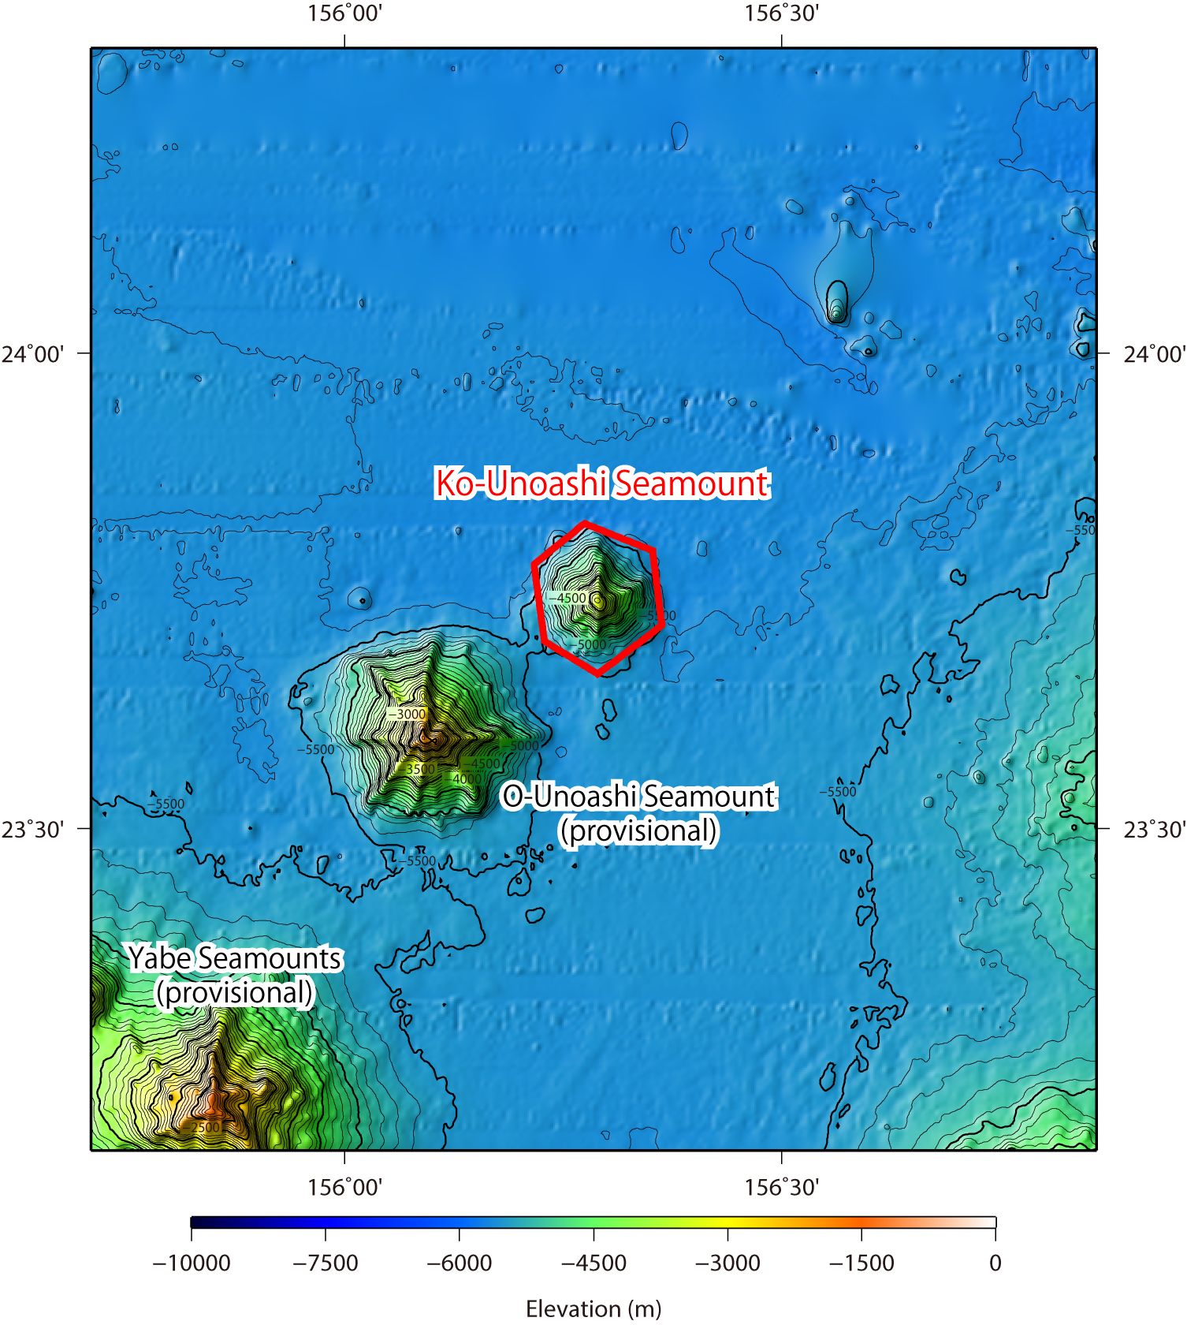

Fig. 1. Bathymetric map of the Ko-Unoashi Seamount. Contours are in 100 m.

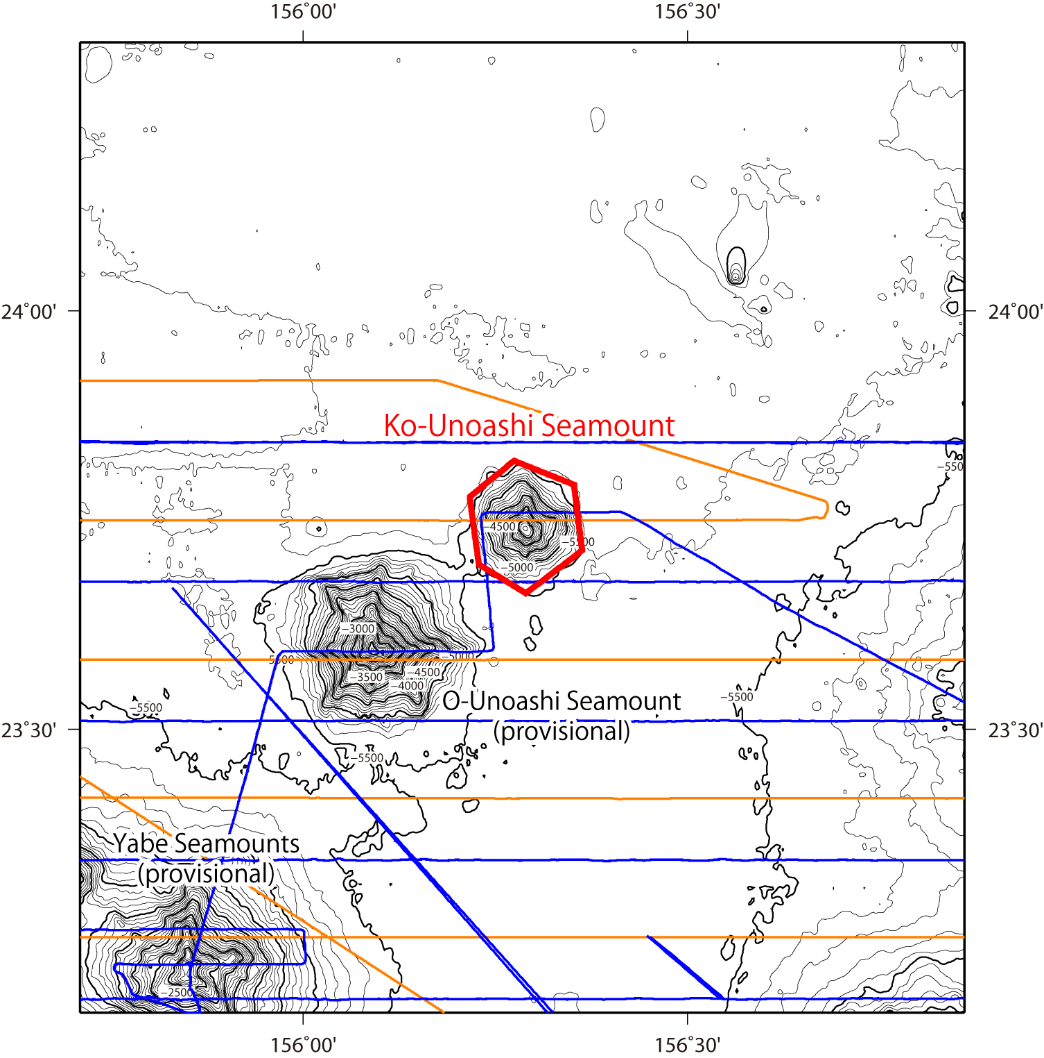

Fig. 2. Bathymetric map of the Ko-Unoashi Seamount, shown with track lines. Contours are in 100 m.

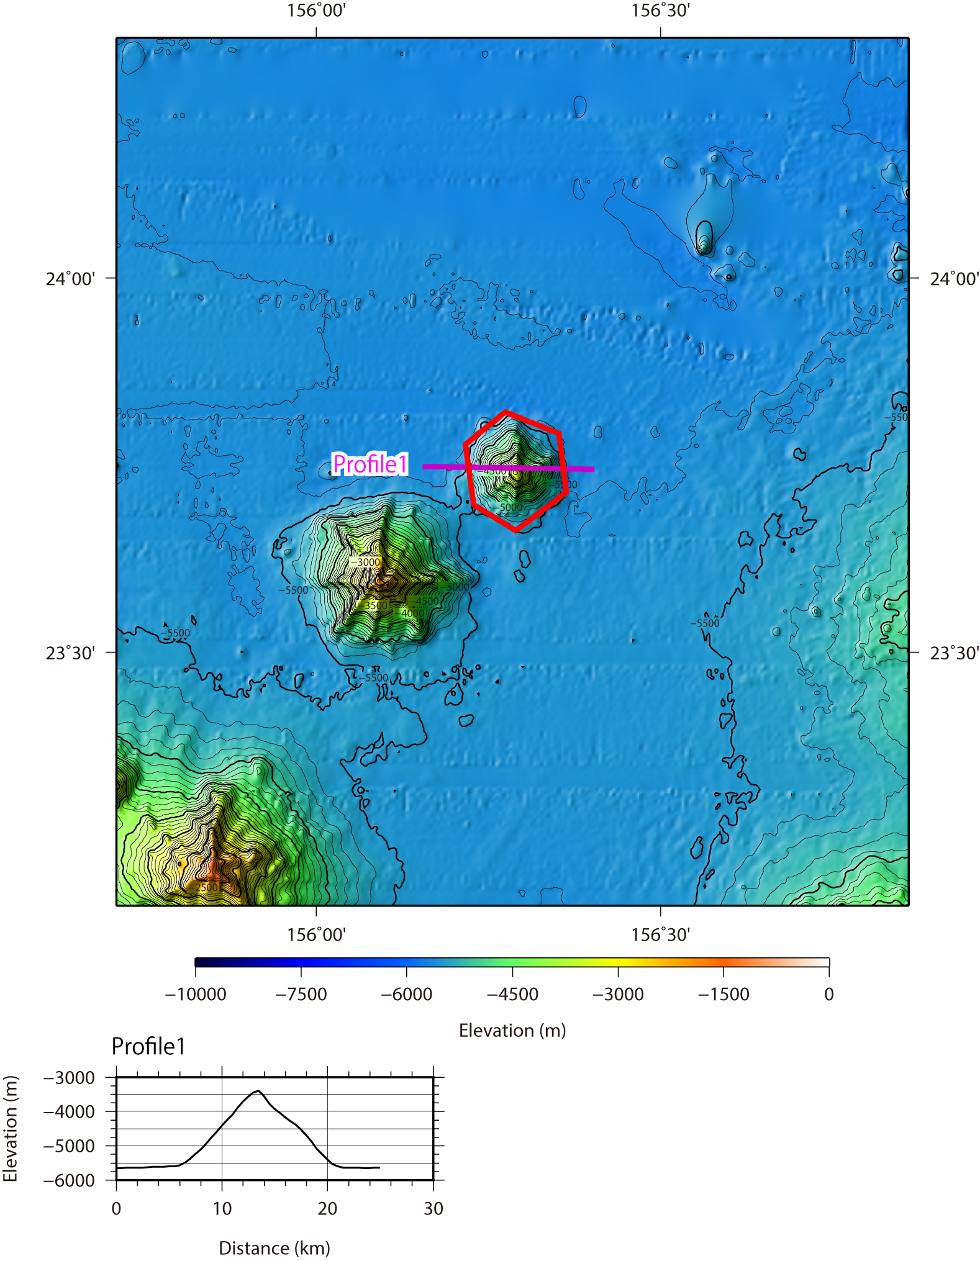

Fig. 3. Bathymetric profile across the Ko-Unoashi Seamount.

