INTERNATIONAL HYDROGRAPHIC  ORGANIZATION | INTERGOVERNMENTAL OCEANOGRAPHIC  COMMISSION (of UNESCO)

UNDERSEA FEATURE NAME PROPOSAL
(See IHO-IOC Publication B-6 and NOTE overleaf)

Note: The boxes will expand as you fill the form.
Name Proposed: | Fukuro-unagi Spur | Ocean or Sea: | N/A

Geometry that best defines the feature (Yes/No) :
Point | Line | Polygon | Multiple points | Multiple lines* | Multiple polygons* | Combination of geometries*
 |  | Yes
* Geometry should be clearly distinguished when providing the coordinates below.
 | Lat. (e.g. 63°32.6’N) | Long. (e.g. 046°21.3’W)
Coordinates: | 23°17.93’N  23°22.76’N  23°26.36’N  23°26.97’N  23°30.89’N  23°32.02’N  23°35.42’N  23°33.64’N  23°30.09’N  23°27.34’N  23°23.63’N  23°16.03’N  23°13.92’N  23°10.69’N  23°06.48’N  23°12.38’N  23°17.93’N | 153°23.47’E  153°31.23’E  153°32.49’E  153°38.09’E  153°44.46’E  153°48.84’E  153°51.99’E  153°59.34’E  154°00.04’E  153°58.82’E  153°50.59’E  153°48.84’E  153°42.89’E  153°34.83’E  153°29.05’E  153°22.58’E  153°23.47’E

Feature Description: | Maximum Depth: | 5,706 m | Steepness : | N/A
Feature Description: | Minimum Depth : | 1,178 m | Shape : | Elongated
Feature Description: | Total Relief : | 4,528 m | Dimension/Size : | 65 km × 50 km

Associated Features: | Takuyo-Daigo Seamount

Chart/Map References: | Shown Named on Map/Chart: | 6724
Chart/Map References: | Shown Unnamed on Map/Chart:
Chart/Map References: | Within Area of Map/Chart:

Reason for Choice of Name (if a person, state how associated with the feature to be named): | Following the rule II-A-7 of B-6 (page 2-3), JCUFN gave a descriptive name to this feature. “Fukuro-unagi” is the Japanese for a pelican eel. The shape of this feature, together with the main body Takuyo-Daigo Seamount resembles the shape of a pelican eel.  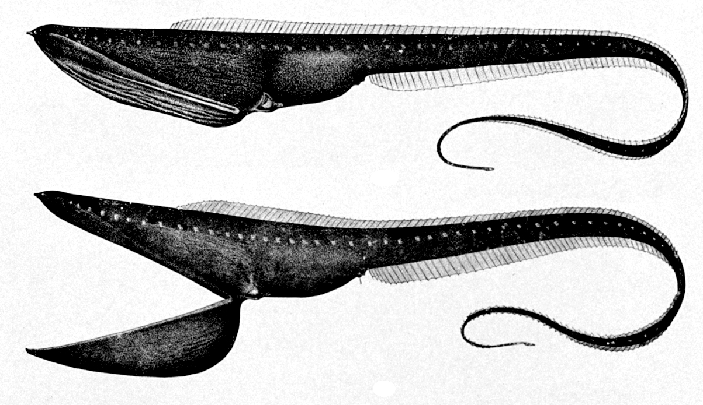  Image from Wikipedia

Discovery Facts: | Discovery Date: | Aug. 1999
Discovery Facts: | Discoverer (Individual, Ship): | Japanese survey vessel "Shoyo"

Supporting Survey Data, including Track Controls: | Date of Survey: | Aug. - Sep. 1999  Jan. 2000  Nov. 2003  Jul. - Aug. 2007
Supporting Survey Data, including Track Controls: | Survey Ship: | Japanese survey vessel "Shoyo" and "Takuyo"
Supporting Survey Data, including Track Controls: | Sounding Equipement: | Multibeam echo sounder  Seabeam 2112
Supporting Survey Data, including Track Controls: | Type of Navigation: | GPS without Selective Availability (2003 and 2007)  GPS with Selective Availability (1999 and 2000)
Supporting Survey Data, including Track Controls: | Estimated Horizontal Accuracy, in nautical miles (M): | 0.014 nm (26 m) (2003 and 2007)  0.054 nm (100 m) (1999 and 2000)
Supporting Survey Data, including Track Controls: | Survey Track Spacing: | 5 nm
Supporting Survey Data, including Track Controls: | Supporting material can be submitted as Annex in analog or digital form.

Proposer(s): | Name(s): | JCUFN
Proposer(s): | Date: | August 20, 2018
Proposer(s): | E-mail: | ico@jodc.go.jp
Proposer(s): | Organization and Address: | Hydrographic and Oceanographic Department, Japan Coast Guard Kasumigaseki 3-1-1, Chiyoda-ku, Tokyo 100-8932, Japan
Proposer(s): | Concurrer (name, e-mail, organization and address):

Remarks: | The position of the summit is located in (23°14.56’N, 153°31.14’E).

NOTE: This form should be forwarded, when completed:

a) If the undersea feature is located inside the external limit of the territorial sea:
- to your "National Authority for Approval of Undersea Feature Names" (see Publication B-6) or, if this does not exist or is not known, either to the IHO or to the IOC (see addresses below);

b) If at least 50 % of the undersea feature is located outside the external limits of the territorial sea:
- to the IHO or to the IOC, at the following addresses :

International Hydrographic Organization (IHO)  4b, Quai Antoine 1er  B.P. 445  MC 98011 MONACO CEDEX  Principality of MONACO  Fax: +377 93 10 81 40  E-mail: info@iho.int  Web: www.iho.int | Intergovernmental Oceanographic Commission (IOC)  UNESCO  Place de Fontenoy  75700 PARIS  France  Fax: +33 1 45 68 58 12  E-mail: info@unesco.org  Web: http://ioc-unesco.org/

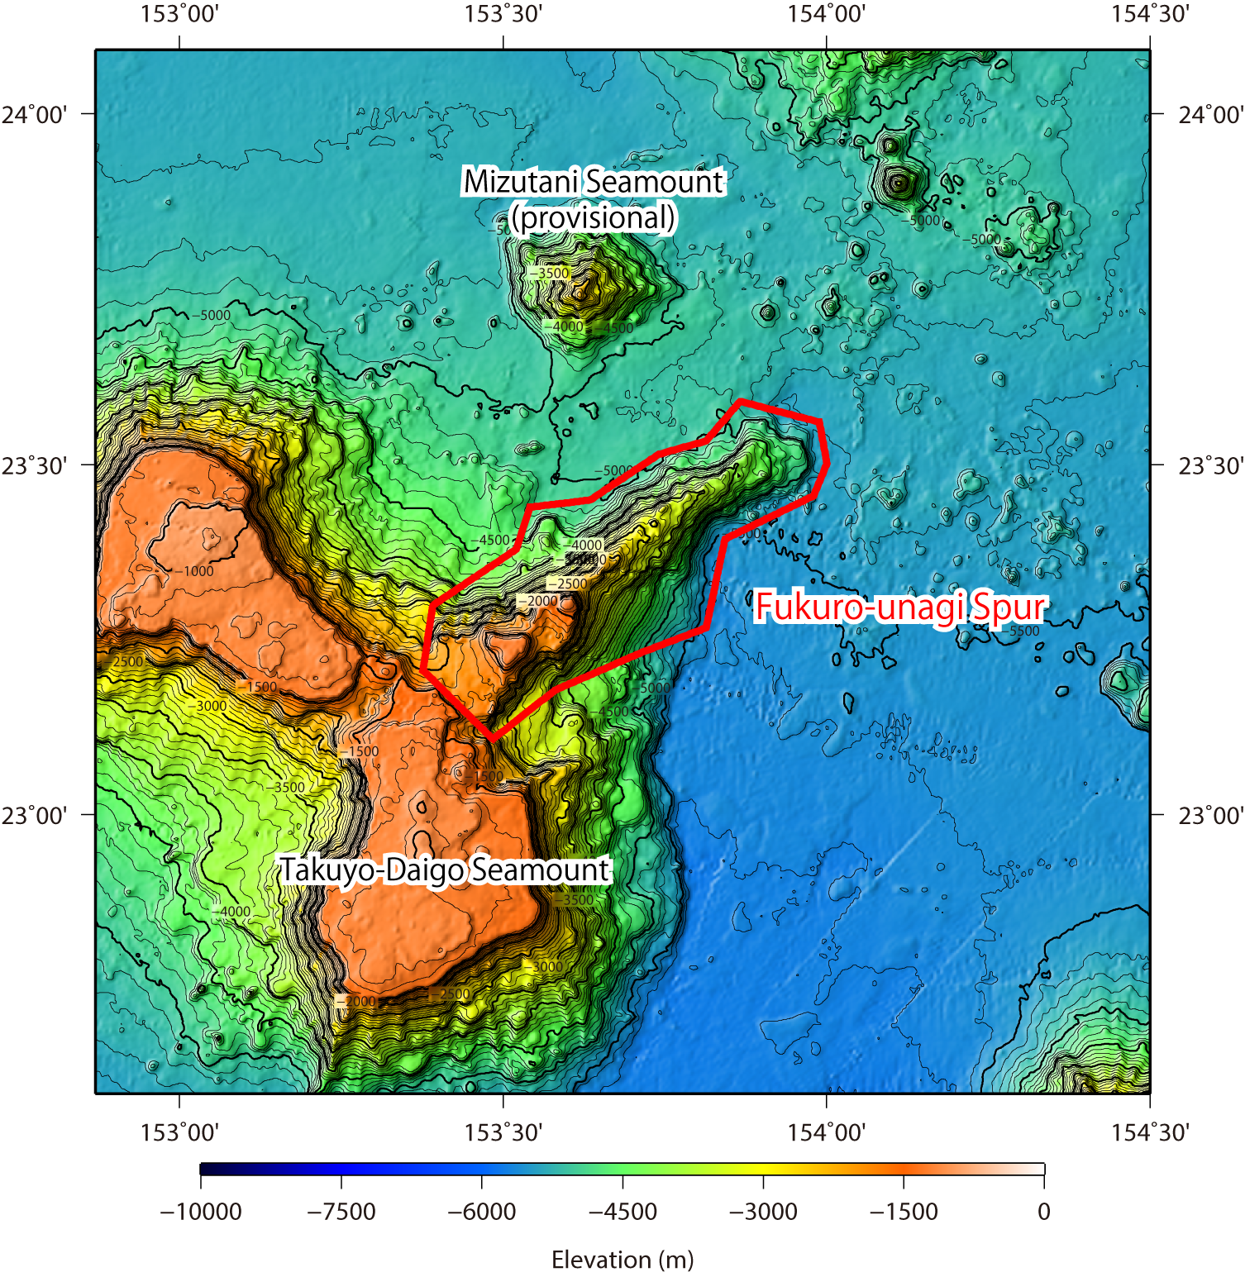

Fig. 1. Bathymetric map of the Fukuro-unagi Spur. Contours are in 100 m.

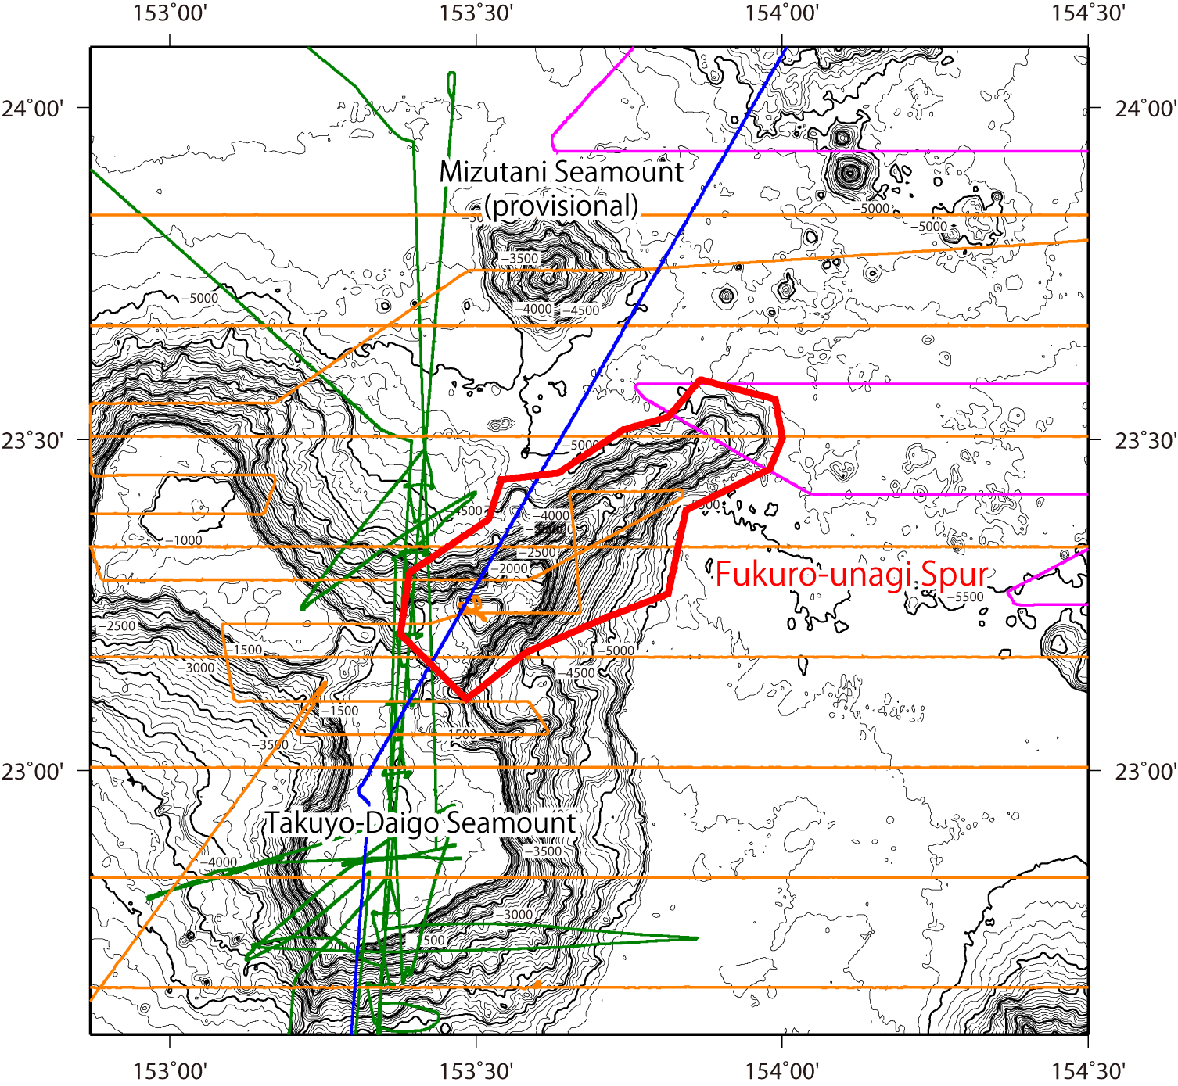

Fig. 2. Bathymetric map of the Fukuro-unagi Spur, shown with track lines. Contours are in 100 m.

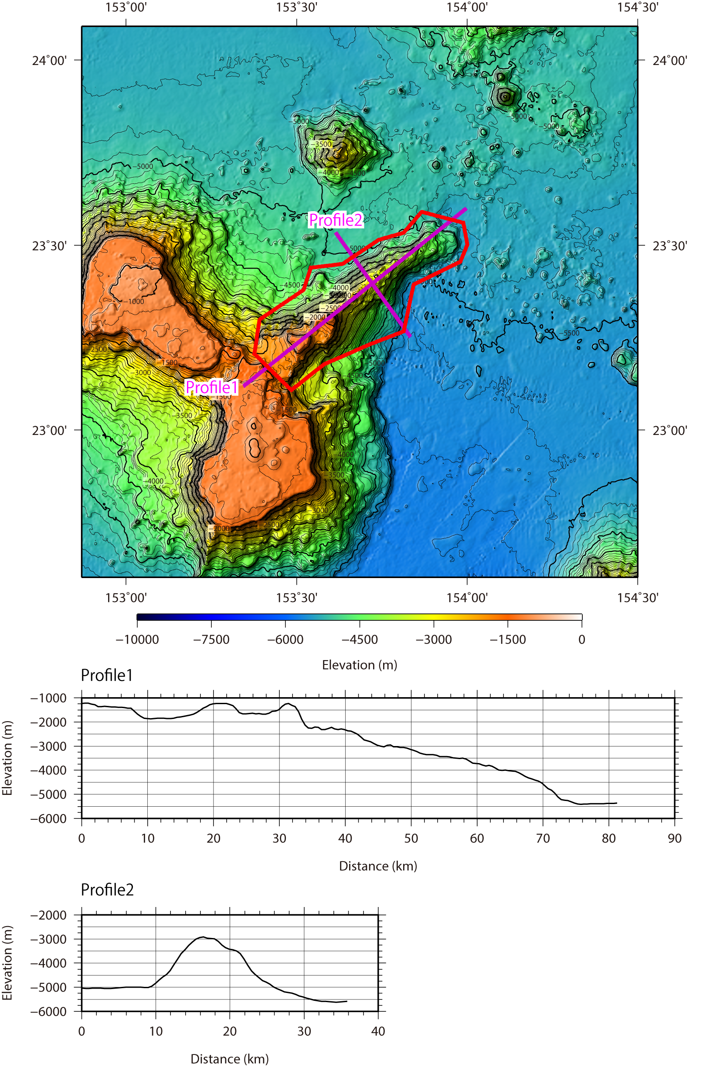

Fig. 3. Bathymetric profile across the Fukuro-unagi Spur.

