Roadmap for the S-100 Implementation Decade (2020 – 2030),

Annex 1

Collaboration with IMO and other liaising organizations

Version 2.0 Dated: July, 2022

A. Collaborative ecosystem to develop and apply S-100 based products

The S-100 framework and the related Product Specifications are not developed and maintained in isolation. Numerous international organizations collaborate actively with the technical bodies of IHO to develop and apply S-100 based products to their respective regulations and services. S-100 itself was approved as base line data model for IMO´s e-nav programme.

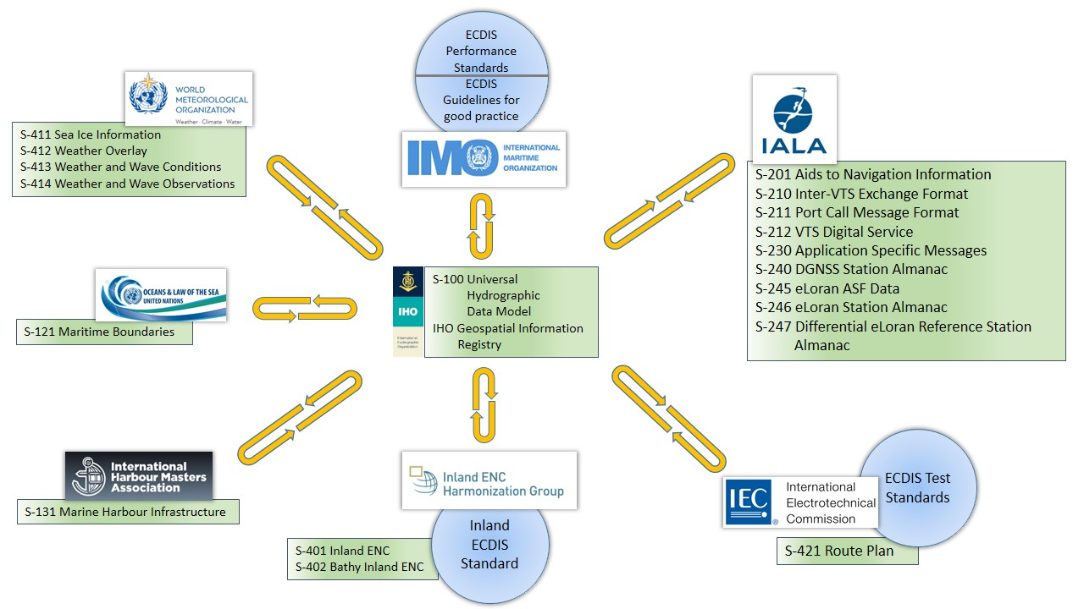
B. Timeline for the incorporation of S-100 into IMO and IEC instruments

This timeline is based on the outcome of IMO NCSR9 deliberations and resulting actions on IHO and IEC side as of July 2022. Later adaptations in view of the progression of the work of the affected international bodies cannot be ruled out. This prediction takes also into account the timelines given in Annex 2 (S-100 Timeline for the development of the prioritized IHO Product Specifications).

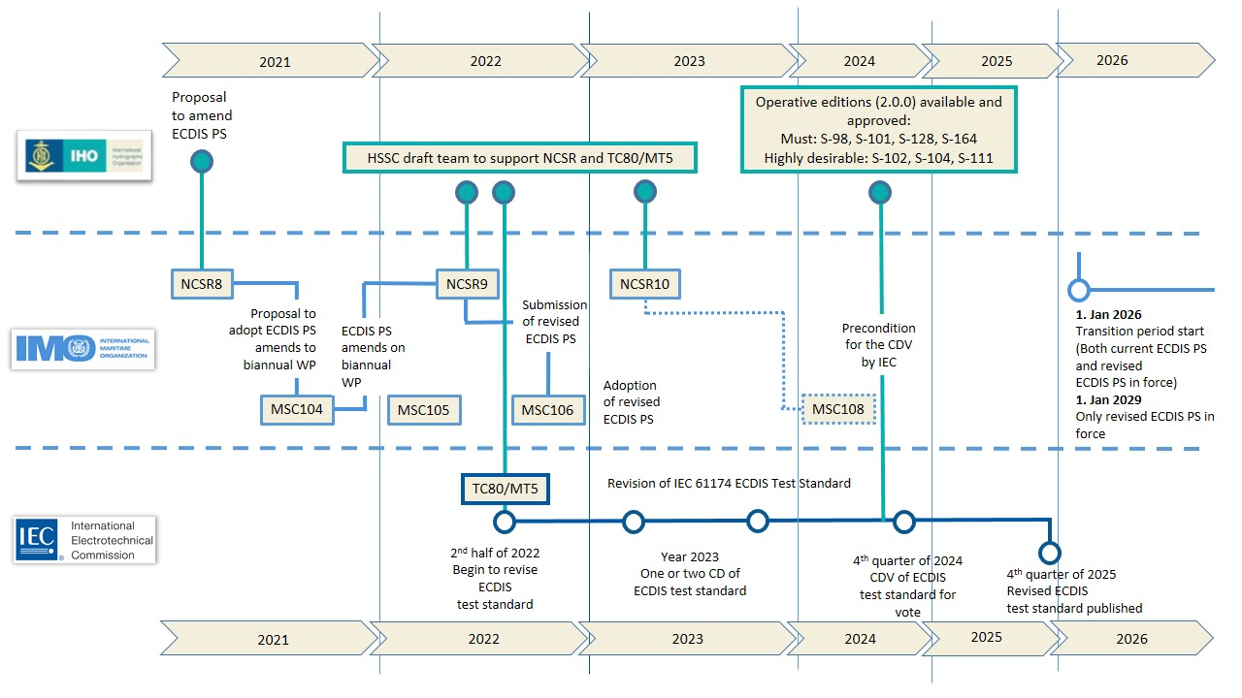

C. Dual Fuel Concept for S-100 ECDIS
Left blank intentionally (Document in preparation).Proposed Annex 4

It is acknowledged that the timeline above relies also on the development of S-100 ECDIS and the acceptance of the Dual Fuel Concept for S-100 ECDIS to be presented at the 3rd Session of the Assembly (April 2023) after endorsement at the 6th meeting of the Council (October 2022).

