Roadmap for the S-100 Implementation Decade (2020 – 2030), Annex 2
S-100 Timelines
Version 2.0 Dated: 12 July, 2022

S-100 Implementation Priorities
For the first edition of S-98, which will handle interoperability between different layers in the future S-100 ECDIS, priority will be given to layers used in route monitoring mode. In the next step layers used in route planning mode will be included. In order to achieve usage of S-100 products in future S-100 ECDIS it is critical to also develop the supporting framework in accordance with the S-100 timeline and even in some cases to speed up this development. The critical S-100 framework consist of the IHO Geospatial Information (GI) Registry, the S-100 Universal Hydrographic Data Model, the Interoperability Specification (S-98), the Catalogue of Nautical Products (S-128) and the Test Data Set for S-100 and ECDIS Type Approval (S-164). It should be noted that priorities given to the products used in route monitoring mode and the critical S-100 framework does not prevent route planning products to be developed in parallel to the once in the first step. In addition to the route monitoring products, also S-122, S-127 and S-131 should be operational 2026.
Table A – IHO list of S-100 products with special focus
First step – Route monitoring mode
S-101 | Electronic Navigational Chart (ENC)
S-102 | Bathymetric Surface
S-104 | Water Level Information for Surface Navigation
S-111 | Surface Currents
S-124 | Navigational Warnings
S-129 | Under Keel Clearance Management
Critical Framework
 | IHO Geospatial Information Registry
S-98 | Interoperability Specification
S-100 | Universal Hydrographic Data Model
S-128 | Catalogue of Nautical Products
S-164 | Test Data Set for S-100 and ECDIS Type Approval
Second step – Route planning mode
S-122 | Marine Protected Areas
S-123 | Marine Radio Services
S-125 | Marine Aids to Navigational (AtoN)
S-126 | Marine Physical Environment
S-127 | Marine Traffic Management
S-131 | Marine Harbour Infrastructure
Figure 1 The S-100 Implementation Priorities. The first step is product specifications for Route Monitoring which must be mode supported by the Critical S-100 Framework. Product specifications for Route Planning will be developed as the second step.

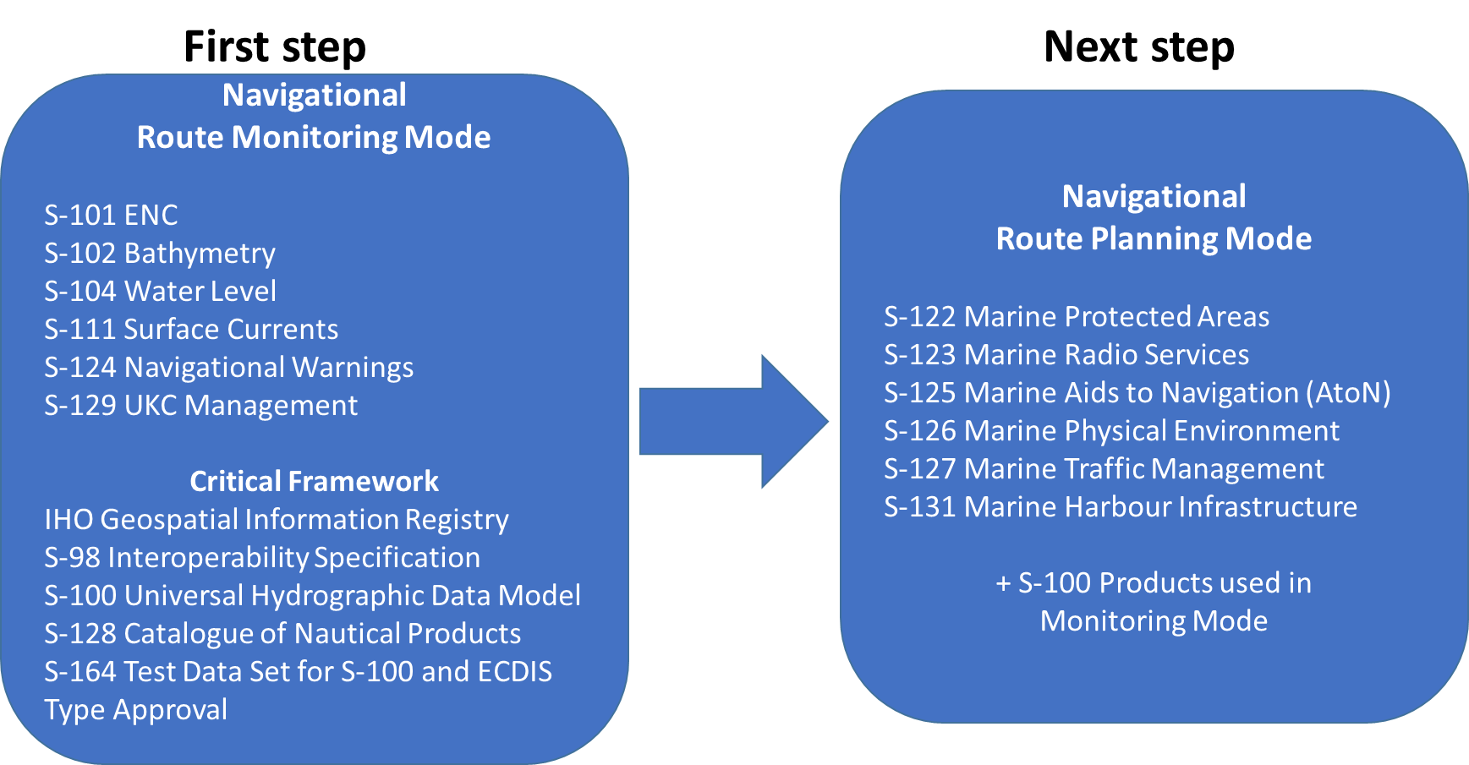
Figure 2 The IHO Navigational Package to be handled by the Interoperability Specification S-98. Additional layers may be added in the future.

S-100 Timeline for the prioritized IHO Product Specifications
The S-100 timeline is maintained by the IHO Secretariat as a version controlled Gantt Diagram and is updated and reported annually to the IHO Council.
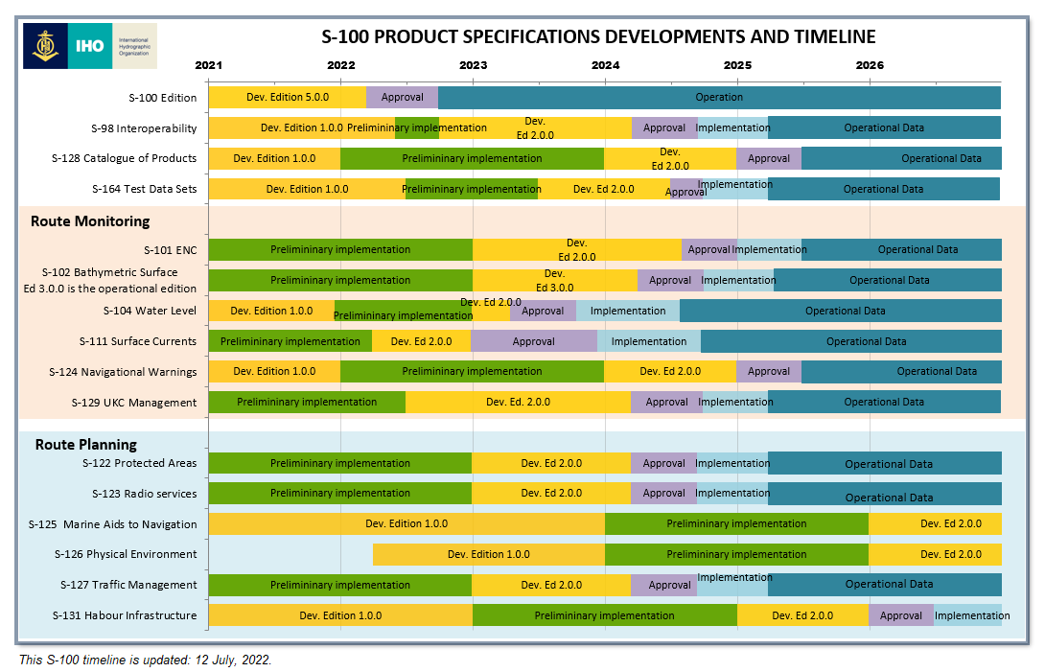
Figure 3 This S-100 timeline is updated: 12 July, 2022.

Synoptic Diagram on Options for HOs for Parallel Production of S-101 and S-57 ENCs
It is concluded that the preferred option for HOs would be to produce their ENCs from a database driven production system since it is expected that production systems software companies will include support for parallel ENC production (S-57 and S-101) when using a database driven system. However, HSSC has prepared a synoptic diagram to show other possible options for HOs in regards to parallel production.
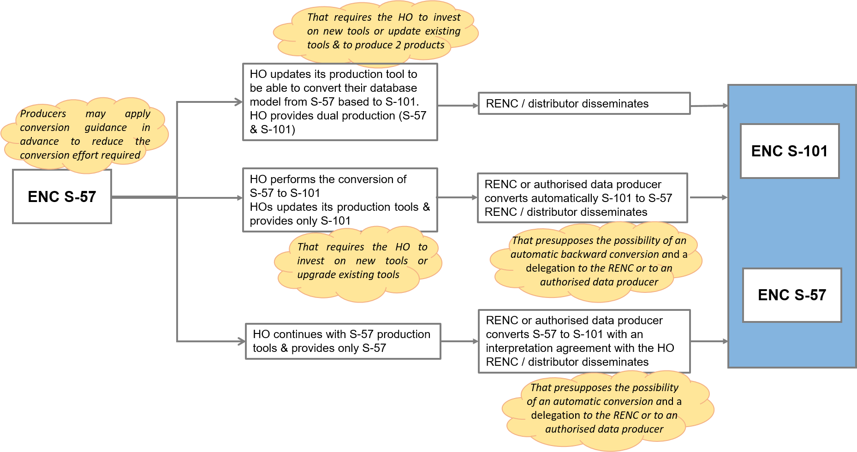
Figure 4 Potential options for HOs for future production of S-101 ENCs in conjunction with S-57 maintenance/production

