Roadmap for the S-100 Implementation Decade (2020 – 2030), Annex 2
S-100 Timelines
Version 3.0 Dated: 19 October 2023

S-100 Implementation Priorities
For the first edition of S-98, which will handle interoperability between different layers in the future S-100 ECDIS, priority will be given to layers used in Phase 1/ Route monitoring mode. In Phase 2 layers used in route planning mode will be included. In order to achieve usage of S-100 products in future S-100 ECDIS it is critical to also develop the supporting framework in accordance with the S-100 timeline and even in some cases to speed up this development. The critical S-100 framework consist of the IHO Geospatial Information (GI) Registry, the S-100 Universal Hydrographic Data Model, the Interoperability Specification (S-98), the Catalogue of Nautical Products (S-128) and the Test Data Set for S-100 and ECDIS Type Approval (S-164). It should be noted that priorities given to the products used in route monitoring mode and the critical S-100 framework does not prevent route planning products to be developed in parallel to the once in the first step. In addition to the route monitoring products, also S-122, S-127 and S-131 should be operational 2026.
Table A – IHO list of S-100 products with special focus
Phase 1 / Route monitoring
S-101 | Electronic Navigational Chart (ENC)
S-102 | Bathymetric Surface
S-104 | Water Level Information for Surface Navigation
S-111 | Surface Currents
S-124 | Navigational Warnings
S-129 | Under Keel Clearance Management
Critical Framework
 | IHO Geospatial Information Registry
S-98 | Interoperability Specification
S-100 | Universal Hydrographic Data Model
S-128 | Catalogue of Nautical Products
S-164 | Test Data Set for S-100 and ECDIS Type Approval
Phase 2 / Route planning
S-122 | Marine Protected Areas
S-123 | Marine Radio Services
S-125 | Marine Aids to Navigational (AtoN)
S-126 | Marine Physical Environment
S-127 | Marine Traffic Management
S-131 | Marine Harbour Infrastructure
S-411 (WMO) | Ice Information
S-412 (WMO) | Weather and Wave Hazards
Figure 1 The S-100 Implementation Priorities. Phase 1 is product specifications for Route Monitoring which must be supported by the Critical S-100 Framework. Product specifications for Route Planning will be developed as the phase 2.

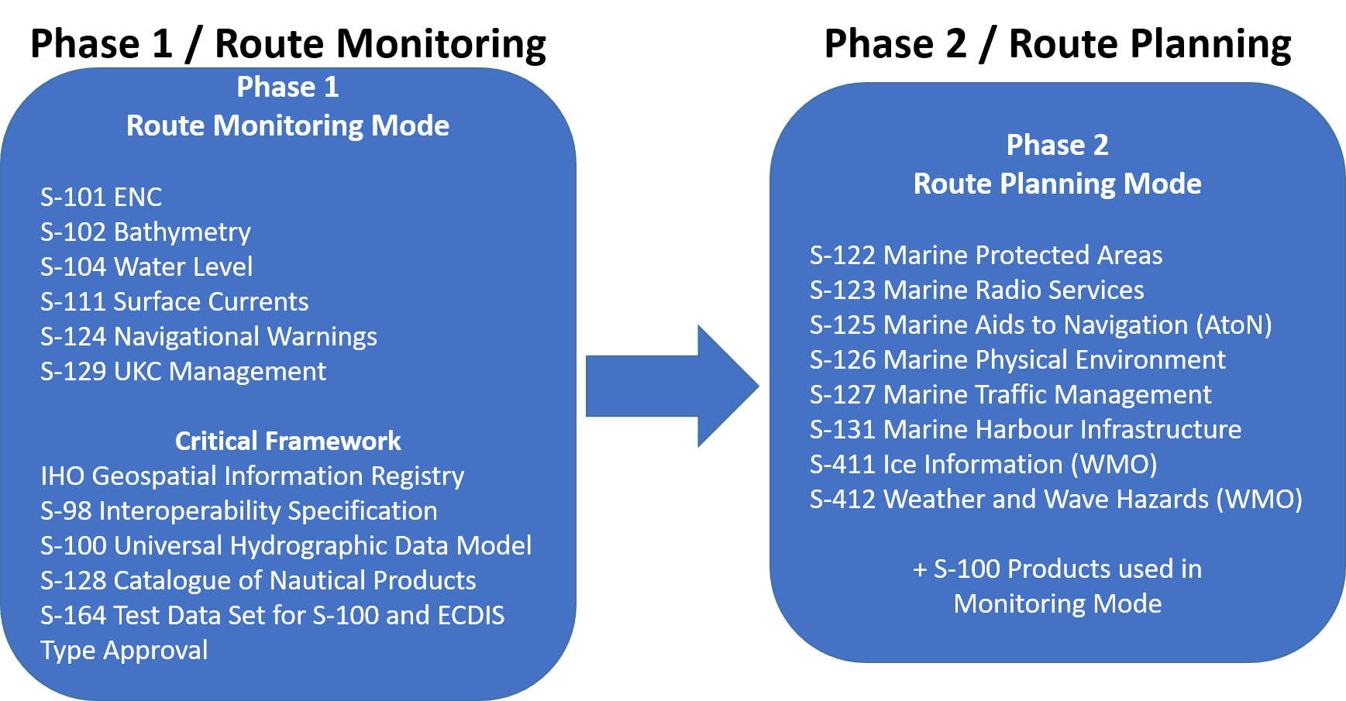
Figure 2 The IHO Navigational Package, for S-100 ECDIS, to be handled by the Interoperability Specification S-98. Additional layers and Phases may be added in the future.

S-100 Timeline for the prioritized IHO Product Specifications
The S-100 timeline is maintained by the IHO Secretariat as a version controlled Gantt Diagram and is updated and reported annually to the IHO Council.
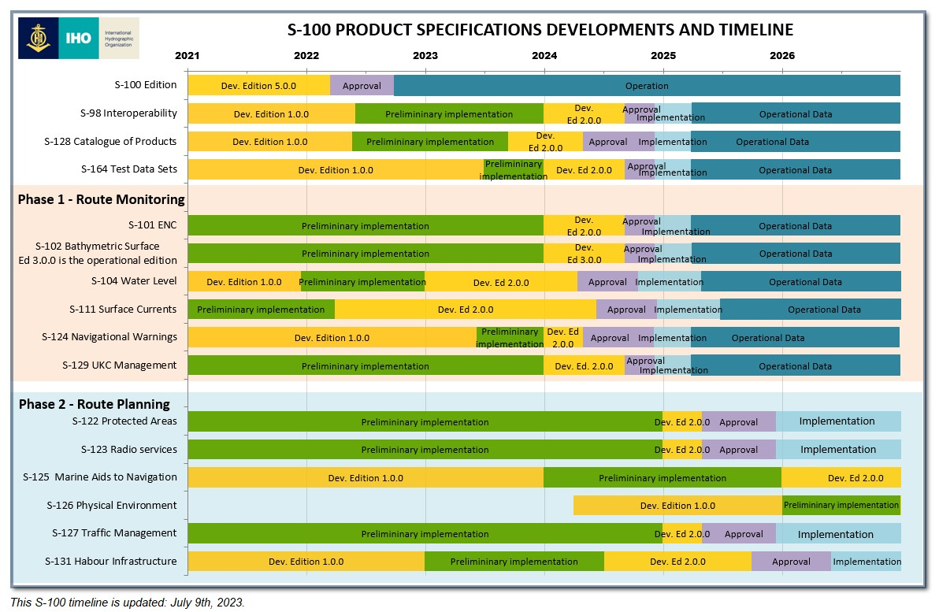
Figure 3 This S-100 timeline is updated: 9 July, 2023.

Synoptic Diagram on Options for HOs for Parallel Production of S-101 and S-57 ENCs
It is concluded that the preferred option for HOs would be to produce their ENCs from a database driven production system since it is expected that production systems software companies will include support for parallel ENC production (S-57 and S-101) when using a database driven system. However, HSSC has prepared a synoptic diagram to show other possible options for HOs in regards to parallel production.
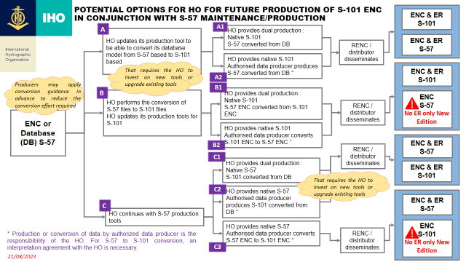
Figure 4 Potential options for HOs for future production of S-101 ENCs in conjunction with S-57 maintenance/production (Doc. C7-04.4B Rev2 refers)

