*Annex A to the Report of the IHO HSSC to the Council 8 –   
Draft Revision of Annex 2 to the   
Roadmap for the S-100 Implementation Decade (2020-2030)*

**Roadmap for the S-100 Implementation Decade (2020 – 2030), Annex 2**

**S-100 Timelines**

**Version 4.0 Dated: 8 July, 2024**

## S-100 Implementation Priorities

For the first edition of S-98, Phase 1 / Route Monitoring Mode will be prioritized, addressing interoperability between different layers in the future S-100 ECDIS. Phase 2 / Route Planning will be included in a following edition of S-98. In order to achieve usage of S-100 products in future S-100 ECDIS it is critical to develop the supporting framework in accordance with the S-100 timeline and to speed up development in some cases. The critical S-100 framework consist of the IHO Geospatial Information (GI) Registry, the S-100 Universal Hydrographic Data Model, the Interoperability Specification (S-98), the Catalogue of Nautical Products (S-128) and the Test Data Set for S-100 and ECDIS Type Approval (S-164).

It should be noted that priorities given to the products used in route monitoring mode and the critical S-100 framework do not prevent the development of route planning products in parallel with the ones in the Phase 1. Phase 1 product specifications should be operational late 2024, with the exception of S-98 and S-164 which will be operational mid-2025. In addition to Phase 1 specifications, the Phase 2 specifications S-122, S-123, S-127 and S-131 should be operational in late 2025.

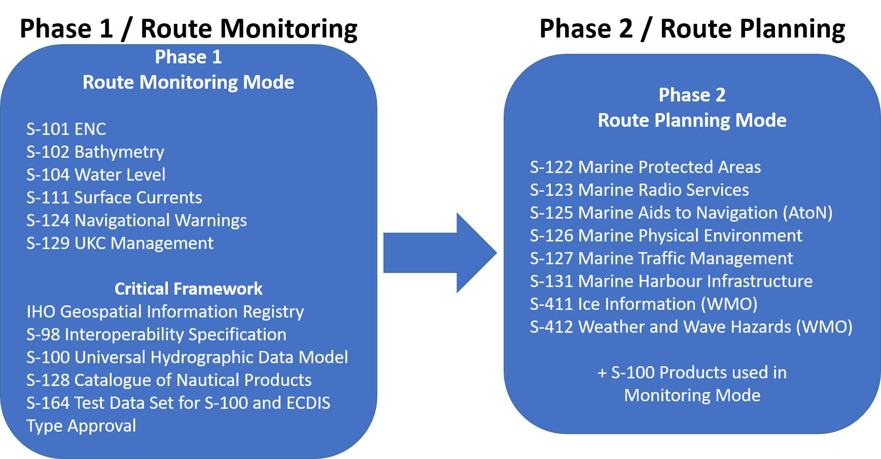

Figure 1 ; The IHO Navigational Package, for S-100 ECDIS, to be handled by the Interoperability Specification S-98. Additional layers and Phases may be added in the future. Updated October 2023.

|  |  |
| --- | --- |
| Table A – IHO list of S-100 products with special focus | |
| Phase 1 / Route monitoring | |
| **S-101** | Electronic Navigational Chart (ENC) |
| **S-102** | Bathymetric Surface |
| **S-104** | Water Level Information for Surface Navigation |
| **S-111** | Surface Currents |
| **S-124** | Navigational Warnings |
| **S-129** | Under Keel Clearance Management |
| Critical Framework | |
|  | IHO Geospatial Information Registry |
| **S-98** | Interoperability Specification |
| **S-100** | Universal Hydrographic Data Model |
| **S-128** | Catalogue of Nautical Products |
| **S-164** | Test Data Set for S-100 and ECDIS Type Approval |
| Phase 2 / Route planning | |
| **S-122** | Marine Protected Areas |
| **S-123** | Marine Radio Services |
| **S-125** | Marine Aids to Navigational (AtoN) |
| **S-126** | Marine Physical Environment |
| **S-127** | Marine Traffic Management |
| **S-131** | Marine Harbour Infrastructure |
| **S-411 (WMO)** | Ice Information |
| **S-412 (WMO)** | Weather and Wave Hazards |

Figure 2 ; The S-100 Implementation Priorities. Phase 1 is product specifications for Route Monitoring which must be supported by the Critical S-100 Framework. Product specifications for Route Planning will be developed as the phase 2. Updated October 2023.

## ENDS Tree Diagram

In the IMO Resolution MSC.530(106) Performance Standards for ECDIS the term for *Electronic Navigational Data Service* (ENDS) is defined as *“…a special-purpose database compiled from nautical chart and nautical publication data, standardized as to content, structure and format, issued for use with ECDIS by or on the authority of a government, authorized hydrographic office or other relevant government institution, and conforming to IHO standards; and, which is designed to meet the requirement of marine navigation and the nautical charts and nautical publications carriage requirements in SOLAS regulations V/19 and V/27. The navigational base layer of ENDS is the electronic navigational chart (ENC).*” To illustrate the ENDS definition and the relationship between S-100 products, the IMO Maritime Services, as defined in the IMO E-Navigation Strategy, and the SOLAS Regulations the ENDS Tree Diagram, has been developed. The diagram is intended to be a useful tool to help hydrographic offices communicate the importance of their S-100 implementation and in instances like IMO audits, once regulatory enforcement takes the availability of new S-100 data services and products into account.

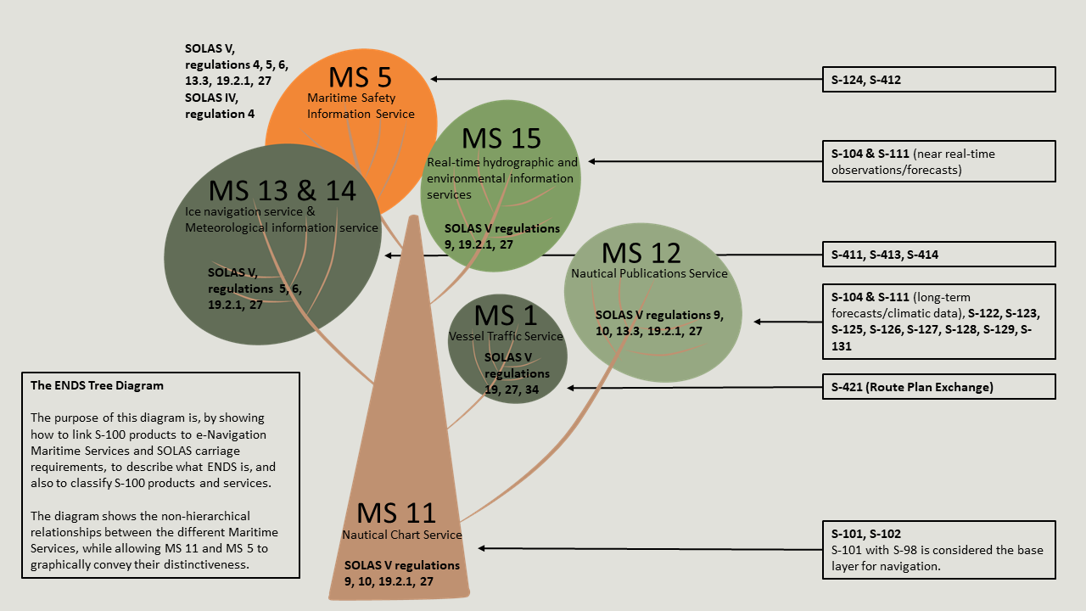

Figure 4 ; The ENDS Tree diagram illustrating the relationship between S-100 products, the IMO Maritime Services and the SOLAS Regulations. The ultimate goal is that these S-100 products, listed in the ENDS Tree Diagram, will support these Maritime Services and subsequently the mentioned SOLAS regulations. Updated 27 June 2024.

## S-100 Timeline for the prioritized IHO Product Specifications

The S-100 timeline is maintained by the IHO Secretariat as a version-controlled Gantt Diagram and is updated and reported annually to the IHO Council.

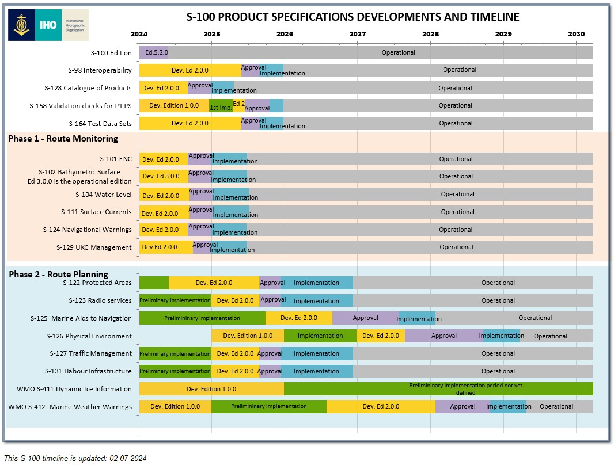

Figure 5 ; This S-100 timeline is updated: 2 July, 2024.

## Synoptic Diagram on Options for HOs for Parallel Production of S-101 and S-57 ENCs

It is concluded that the preferred option for HOs would be to produce their ENCs from a database driven production system since it is expected that production systems software companies will include support for parallel ENC production (S-57 and S-101) when using a database driven system. However, HSSC has prepared a synoptic diagram to show other possible options for HOs supporting parallel production.

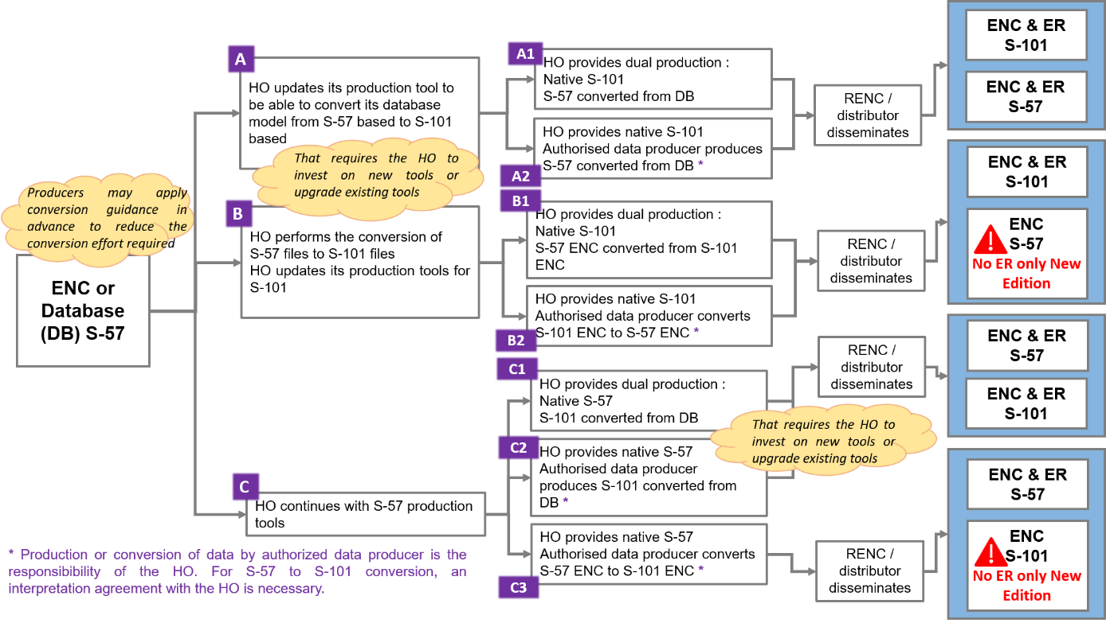

Figure 6 ; Potential options for HOs for future production of S-101 ENCs in conjunction with S-57 maintenance/production. Updated October 2023.