5th MEETING OF THE IHO COUNCIL
IHO C-5
Monaco, hybrid in-person/VTC, 19 – 21 October 2021

SUMMARY REPORT
(Version 1.0, 27 October 2021)

Note: while the 5th meeting of the IHO Council was conducted according to the timetable, this summary report is in line with the sections of the agenda.
Annex A: List of Registered Participants
Annex B: Agenda
Annex C: List of Decisions and Actions
- OPENING
  - Secretary-General Opening remarks
Docs: C5-01A List of Documents
C5-01B List of Participants
C5-01.4A Membership Contact List

The Secretary-General welcomed participants to the fifth session of the Council, which was taking place this year in a hybrid virtual/in-person format due to the global pandemic. The session had reached a quorum with 30 Council Member States registered and present. He confirmed that no Red Book, containing prior comments on Proposals to Council, was presented on this occasion, as no comments had been received.
  - Adoption of the Agenda and Timetable
Docs: C5-01.2A Rev1 Agenda
C5-01.2B Timetable

The Chair presented the proposed agenda and timetable, with minor changes from the version distributed in advance.
Decision C5/01: The Council adopted the agenda and the timetable as proposed and agreed to consider the information paper on the S-100 Test Bed Project provided by KHOA (Republic of Korea), and NOAA (United States of America) (Doc. C5-07.6A INF refers) at the end of session 2 time permitting.
  - Chair’s Opening remarks
Docs: C5-01.3A

The Chair of the Council, Dr Geneviève Béchard, welcomed members and noted that the current session of the Council would make an important contribution to preparations for the third session of the IHO Assembly. Among the items to be discussed were the proposals from HSSC, IRCC and the Secretariat for delivery of the Strategic Performance Indicators (SPIs) assigned to each of those bodies for the implementation of the IHO Strategic Plan, as well as the Roadmap for the S-100 Implementation Decade (2020-2030) for the development of digital products and services. Following bilateral talks between the Chair and Council Members, the Chair informed the Council that Member States stressed the need for IHO to support basic Capacity Building while also supporting the migration to S-100. The role of the RENCs had been a subject of discussion, and RENC representatives had therefore been invited by the Chair to attend the session as observers.
Decision C5/02: Council Members welcomed the opening addresses by Dr Geneviève Béchard, Council Chair and the Secretary-General and agreed on the participation of RENCs representatives as Observers.

1.4 Administrative Arrangements
Docs: C5-01.4A Membership Contact List & Useful References – Marked-up Basic Docs
(IHO Convention, General Regulations, Assembly ROP, Council ROP

The IHO Secretariat invited all members to check the Council membership list and confirm their individual details, and explained the process and timelines of the Council Summary Report, the work of the précis-writers and four rapporteurs kindly appointed by Canada, Peru, the United Kingdom and the United States of America.
Decision C5/03: IHO Member States having a seat at the Council to provide the IHO Secretariat with their updates to the IHO Council List of Contacts.

2. ITEMS REQUESTED BY THE 2nd IHO ASSEMBLY
  - Update on the Joint IHO-Singapore Innovation and Technology Laboratory – Proposals from the Council to the Governing Board (Decision A2/08) (To be discussed under agenda item 4.5).
  - Report on the Application of ISO 9001 Principles (To be discussed through the reports of HSSC and IRCC under agenda items 4.1 and 4.2 and 6.1). Decision A2/12
Decision C5/40: The Council endorsed the HSSC proposal that ISO 9001 principles will be experimented on the development of the Product Specification for ENCs S-101 ed. 2.0.0 (deadline: C-6)
The IRCC Chair also agreed to undertake to select a theme out of the IRCC subordinate bodies work programmes to which the ISO 9001 principles would be applied.
Action C5/08: The Council invited the IRCC to identify a theme on which ISO 9001 Principles should be applied and to propose it to Council for endorsement. (deadline: IRCC-14/C-6)
  - Update on the best way forward for the definition of hydrographic interest. (Decision A2/14)
The Chair recalled that C-4 had invited parties interested in the development of a definition of hydrographic interest to submit a joint proposal to review existing documents, resolve discrepancies, and submit a consolidated single proposal on the definition of hydrographic interest. A discussion of the item had not been planned for C-5. However, she was pleased to report that Argentina, Brazil, India and Uruguay had begun collaborations and that work on the item was underway.
India commended the Council Chair on her work to initiate collaboration between the interested parties. He said that discussions were ongoing among the interested parties, who were attempting to identify a consensus approach to the definition of hydrographic interest. Referring to the discussion of IHO's strategic performance indicators, he suggested that the Organization's interests might be summed up as i) capacity to undertake surveys, which every country should have ii) making the ENCs and products available for the benefit of larger society and iii) capacity building and international interaction. It was unclear how the question of tonnage fitted with or reflected those SPIs. He therefore called for a measure of introspection by the Council as to how the definition of hydrographic interest might better reflect IHO's strategic goals.

Decision C5/04: The Council thanked Council Chair for the update on the ongoing work by the interested parties Argentina, Brazil, India and Uruguay and invited them to submit a consolidated report on possible ways forward, including impact assessment on IHO Basic Documents.
(deadline: C-6 / -3 months)
  - Status report on the appropriateness and applicability of the new Strategic Performance Indicators (To be discussed under agenda item 6.1, taking into account recommendations from Secretary-General for Programme 1 in agenda item 6.1, from HSSC and IRCC Chairs for Programmes 2 and 3 in agenda items 4.1 and 4.2).
  - Proposed version 1.x of the Roadmap for the S-100 Implementation Decade (To be discussed under agenda item 4.4 following proposals from HSSC and IRCC under agenda items 4.1 and 4.2).Decisions A2/20
  - Update on the Dual-Fuel Concept (transition from S-57 to S-101 ENCs) (To be discussed under agenda item 4.1). Decision A2/33
  - Cumulative List of A-2 Decisions affecting the Council (Decisions A2/02, A2/04², A2/06², A2/08, A2/11², A2/12, A2/14, A2/20, A2/30, A2/31, A2/33).
Doc: C5-02.7A

- ITEMS REQUESTED BY THE IHO COUNCIL
  - Review of the status of Decisions and Actions from C-4
Doc: C5-03.1A

The IHO Secretariat reported that most decisions and actions from C-4 had been implemented or would be discussed under the relevant item. Pending decisions and actions not covered were:
Decision and Action C5/05: The Council to monitor the progress of the task given to HSSC and IRCC to review the IHO Resolutions with regard to PRO 2.3 when the operational implementation of the S-100 concept becomes mature enough. HSSC and IRCC to make proposals on the IHO Resolutions with regard to PRO 2.3 for endorsement by Council when appropriate. (deadline: C-6 as appropriate in preparation of A-3)
The Chair of HSSC and IHO Secretariat confirmed that this action was ongoing.
Decision C5/06: The Council invited the IRCC to instruct the CBSC to develop a system of performance indicators to measure, under the conduct of the CBSC and in accordance with the Revised Strategic Plan, the effectiveness and efficiency of CB activities. This system should be oriented to actual outcomes of CB support, not on quantity, or instances of CB activity.
(deadline: C-6)
The Chair of IRCC and IHO Secretariat confirmed that this action was ongoing as well.

4. ITEMS REQUESTED BY SUBSIDIARY ORGANS
4.1 Report and proposals from HSSC (Including update on the dual-fuel concept (transition from S-57 to S-101 electronic navigation charts (ENCs)).
- Annex A: Strategic Performance Indicators allocated to HSSC and proposed metrics.
- Annex B: Proposed Annex 2 (version 1.0, 7 July 2021) to the Roadmap for the S-100 Implementation Decade (2020-2030).
Doc: C5-04.1A Rev1

The Chair of HSSC reported on the work of the Committee for the current cycle of the Council, which had continued despite the constraints imposed by the pandemic.
Decision C5/09: The Council noted the report and commended the HSSC, its Working Groups and supporting organizations for the excellent achievements made in 2020-2021 despite the obstacles raised by the pandemic.
The priorities recommended by HSSC for implementation of the Roadmap for the S-100 Implementation Decade (2020 –2030) were, firstly, product specifications supporting the route monitoring mode planned to be covered by the S-98 Data Product Interoperability Specifications (S-98, ed. 1.0.0) and, secondly, product specifications supporting the navigational route planning mode to be covered in future S-98 editions. The S-100 WG is developing an ECDIS test data set for S-100, identified as S-164. The timeline for the prioritised product specification would be maintained by the IHO Secretariat in the form of a version-controlled Gantt chart and would be reported on annually to the IHO Council.
HSSC had identified three options for parallel production of S-57 and S-101 ENCs:
- hydrographic offices (HOs) would convert their own database models from S-57 to S-101 and produce both products from their own databases;
- HOs would update their production tools and produce only S-101-based products, with RENCs likely to offer S-101 to S-57 conversion services; or
- HOs would continue to generate S-57 data only, with the RENCs converting that to S-101 data.
The third option was considered less favourable but might provide a short-term solution for Member States with lower capacity and comparably small numbers of ENCs under service. More work was needed to develop more detailed guidance on future parallel production of S-57 and S-101.
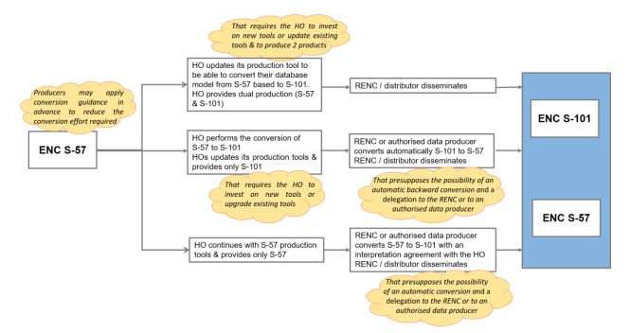
Figure 1 Potential options for HOs for future production of S-101 ENCs in conjunction with S-57 maintenance/production

It was reported that the draft governance document on the ‘dual fuel’ concept would be considered by HSSC-14 and subsequently submitted to C-6.
Decision and Action C5/10: The Council noted the actions in progress within HSSC for the development of a governance document in support of the dual fuel concept and associated actions. HSSC to report on the outcome at the next meeting. (deadline: C-6)
To develop a guidance document on the dual fuel concept, the S-100 WG, under HSSC, was conducting a series of workshops that included discussions on the subject as well as on on the future continuation of the system-ENC (SENC) delivery. The ENC Standards Maintenance Working Group (ENCWG) was also working on a guidance document for HOs on how ENC features could be enhanced to support automated conversion to S-101. The work was expected to partly be done in collaboration with the IHO-Singapore Innovation and Technology Laboratory (IHO Lab).
The revision of the International Maritime Organization (IMO) ECDIS Guidance for Good Practice and ECDIS Performance Standards was due to be considered by the IMO Sub-Committee on Navigation, Communications and Search and Rescue (NCSR-9) in June 2022. Consideration of a proposal by European Union Member States of IMO to revise the ECDIS Performance Standards to include S-104 route plans had been postponed to the 105th session of the IMO Maritime Safety Committee. HSSC 13 agreed upon a drafting group, with the confirmed participation of CIRM, IEC and Intertanko, to be able to submit drafted documents to NCSR 9.

Decision C5/11: The Council noted the work in progress by HSSC Chair Group, CIRM, IEC, Intertanko, for the revision of the IMO MSC.1/Circ.1503/Rev1 – ECDIS Guidance for Good Practice and Resolution MSC.232(82) - ECDIS Performance Standard. (deadline: HSSC-14/NCSR-9 (June 2022) then C-6)
A project team under the Nautical Cartography Working Group (NCWG) had been established to develop a baseline symbology library to support automated production of paper charts from S-101 data.
Decision and Action C5/12: The Council to continue the monitoring of the implementation by HSSC of the recommendations on the Future of the Paper Nautical Chart as appropriate. The Council noted the development of a Baseline Symbology Project Team to support automated production of paper charts from S-101 data and the priority given to RHCs ICCWGs to focus on ENC schemes. (deadline: HSSC-14/C-6)
The new Hydrographic Surveys Working Group (HSWG) had met for the first time in late June 2021. Two new Project Teams had been created, the first to develop a new S-130 polygonal demarcations of global sea areas product specification, and the second to address Maritime Autonomous Surface Ship (MASS) requirements in navigation data and services.
In the subsequent discussion, France noted that the first option for parallel production of S-57 and S-101 data was likely to be beyond the capacity of many HOs, while the third option might mean that no native S-101 data were produced by certain HOs, if the conversion from S-57 to S-101 was left exclusively to the RENCs. France therefore favoured the second option, with S-101 becoming the default reference standard.
New Zealand likewise favoured the second option, and also supported the work on establishing the standards for automated production of paper nautical charts from S-100 data. New Zealand noted that S-101 is still evolving, that some small HOs would be challenged to implement S-100 technology anyway, and that the roll-out to S-101 needed to be quicker than the S-57 roll-out, in order to gain substantial coverage.
USA emphasised the need to develop a standard set of symbology for use in automated ENC-based paper chart production systems. The new NCWG Baseline Symbology Project Team should establish simplified symbols and rules for paper chart production that were accessible and applicable to both S-57 and S-101. The US noted many Member States are already transforming their paper chart production environments to take advantage of automated processes. Highlighting greater collaboration among the efforts underway around the world will result in a standard set of symbol and portrayal rules, endorsed by the NCWG and approved by the HSSC within the next year or two. Many HOs would make use of them as soon as they became available.
Australia drew attention to the high level of resources Member States would require in order to maintain the ‘dual fuel’ system. Conversion tools should be developed promptly, and S-57 should be taken out of use as soon as practicable. Australia favoured the first option.
Russian Federation likewise favoured the first option, that all production should be a national responsibility.
Netherlands and France noted that, in the third option, Member States would still bear the legal responsibility for the ENC content they provided, with the RENCs exercising a purely contractual function that would need verification and monitoring.
PRIMAR drew attention to its working group on conversion from S-57 to S-101 and vice-versa, which expected to reach conclusions on its role in the area of S-101 conversion in the next year.
The Secretary-General said that the added value of the S-100 series of standards was derived not merely from the S-101 ENCs themselves, but the real opportunity is through the developments of the many other associated S-100 products, such as those on water level information or surface currents. Services that would enable the end-user to benefit from those products should be established at the regional level; building critical mass within regions will encourage data suppliers, Original Equipment Manufacturers (OEMs) and users to integrate these fields.
Decision C5/13: The Council to monitor the progress of the task given to HSSC to prepare (done) now maintain the synoptic summary report on the various options offered to HOs for future production of S-101 ENCs in conjunction with S-57 maintenance/production. (deadline: C-6)

Decision and Action C5/14: Considering the timelines between HSSC-14 and IRCC-14 meetings in 2022 and the countdown for submission of reports and proposals to C-6, the Council invited HSSC and IRCC Chairs to prepare their 2022 meeting minutes with the view that they will be used/submitted directly as reports and proposals to be considered at C-6. (deadline: July 2022)

4.2 Report and proposals from IRCC
Doc: C5-04.2A
The IRCC Chair presented his report on the Committee’s activities. Noting that participation in IRCC-13 had been good, he said a suitable mix of virtual, hybrid and in-person meetings would need to be found in future. The Regional Hydrographic Committee (RHC) Chairs were asked to focus their oral reports on work on the Strategic Plan and gap analysis, important findings, and proposals to IRCC. Along these themes, issues raised by Regional Hydrographic Committee (RHC) chairs related to the need for guidance on the determination of Strategic Performance Indicator (SPI) values at the regional level and implementation of S-100, communication issues between Member States enhanced due to the pandemic, low productivity of virtual teleconferences, the difficulty of recruiting new Member States, implementation of Marine Spatial Data Infrastructure (MSDI) initiatives, postponement of capacity building projects and the importance of online training. More issues and details can be found in the written report.

Decision and Action C5/15: The Council noted the report and commended the IRCC, the RHCs, and IRCC Sub-Committees for their achievements as well as the outcome of the IRCC October Workshop on the Strategic Plan.
The Council, acknowledging the need for further recommendations on the realization of the Strategic Plan in RHCs by Member States, invited the IRCC to provide these recommendations to the RHCs as a matter of priority. (deadline: By April 2022/IRCC-14/C-6).
The Council recognized the need for further IRCC workshops to support the realization of the IHO Strategic Plan.
The Chair of the Hydrographic Commission on Antarctica (HCA) reported one issue: consideration of the extended role of regional charting coordinators for implementation of the S-100 Roadmap. The Chair also reported that there was a discussion on the application of IHO Resolution 2/1997 to HCA statutes.
Graphs provided by the World-Wide Navigation Warning Service (WWNWS) sub-committee showed trends in the promulgation of Marine Safety Information (MSI). The first showed the percentage of National Coordinators providing MSI in the different NAVAREAs providing MSI in 2020, information that can be used to measure the efficiency of the MSI capacity building course, and to determine where to focus future capacity building training. The second graph showed an increasing trend in the promulgation of navigational warnings – 14% in the last 5 years. A train-the-trainer course was to be offered to address the lack of qualified trainers.
The Empowering Women in Hydrography project was launched with a kick-off meeting via virtual teleconference held on 28 September 2021. Funded by Canada until 2024 and with intensive support from the IHO Secretariat, the goals of the project include to give more exposure to women to the field of hydrography and to increase gender diversity in the field. Lines of action include outreach, contact and learning, including internships, at-sea experiences and train-on-the-job activities. A specific webpage (https://iho.int/en/basic-cbsc-ewh) has been set up under the Capacity Building Sub-Committee (CBSC) for this project. The Project Team has been established for the IHO e-Learning Center, along with terms of reference and rules of procedure. Operational tests with IHO Member States were expected to begin in 2022. However, the success of the e-learning initiative was dependent on contributions of online learning material from Member States and partners.
Decision C5/16: The Council to monitor the progress made by IRCC to establish an IHO e-Learning Center based on A-2 PRO 3.3 and the related recommendations of IRCC/CSBC. (deadline: C-6)
Decision C5/17: The Council to monitor the progress made by IRCC on the CBSC work item of Empowering Women in Hydrography (EWH). (deadline: C-6)
The World-wide Electronic Navigational chart Database (WEND) Working Group (WG) focused on WEND-100 principles. IRCC had endorsed the recommendations made on amendment of the Roadmap for the S-100 Implementation Decade (Annex A) and requested Council's approval. Council was therefore requested to take note of the adoption of the WEND-100 principles (IHO C 37/2021).
As part of the IRCC, two surveys - one on the production of High Density Electronic Navigational Charts (HD ENCs) and one on S-100 Operational Analysis - had been disseminated to Member States in CL 26/2021 and CL 27/2021 respectively.
The concept of MSDI V2.0 was presented, with the Arctic SDI Governance model proposed as a role model for MSDI cooperation in RHC. MSDIWG was closely cooperating with the United Nations Committee of Experts on Global Geospatial Information Management (UN-GGIM)-WG on Marine Geospatial Information and also with the Open GIS Consortium (OGC) (see CL 41/2021).
The IHO-EU Network working group was contributing to the programmes of the European Union, focusing on EMODnet Portals, especially EMODnet Bathymetry. Maritime Spatial Planning was another area of interest. European Directive 2019/2024 on open data and the reuse of public sector information, whereby high level datasets were considered as open data, had a possible impact for Hydrographic Offices (HOs) if it applied to ENC data.
The poor quality of initial submissions to the FIG/IHO/ICA International Board on Standards of Competence for Hydrographic Surveyors and Nautical Cartographers (IBSC), reflecting difficulties in interpreting the new standards, were creating a heavy workload of intersessional revisions.
The views of HOs regarding crowd-sourced bathymetry (CSB) were heterogeneous; it should be emphasized that the focus was to collect data in poorly surveyed or un-surveyed areas. IHO B-12 was updated. IHO Member States and stakeholders were invited to contribute and encouraged to provide bathymetric data. The General Bathymetric Chart of the Oceans (GEBCO) GC reported an increase in data coverage from 6% to almost 21% of the sea floor: the main challenges were in getting governments, institutions and private industry to share bathymetric data, and in the question of how to map the remaining 80% of the planet's unmapped ocean seafloor. Seabed mapping should be promoted and contributions to Seabed 2030 encouraged. A presentation by Shell on "enabling contributions" had highlighted a need to simplify countries' complex permission processes that hampered the donation of data. Collaboration between HOs and the Natural Resource Regulator should be improved, and permitting requirements for systematic data acquisition in transits through EEZ simplified.
The first IRCC Workshop on the IHO Strategic Plan and Strategic performance indicators was held on 7 October 2021, as a virtual teleconference with more than 70 participants, in order to facilitate the exchange of information and discussion to improve coordination in IRCC; more such workshops are planned. An excellent gap analysis on the regions ability to report on the strategic performance indicators of the IHO Strategic Plan was reported by the South West Pacific Hydrographic Commission (SWPHC) and could serve as an example for other RHCs.
In the discussion, Norway, speaking as Chair of the Capacity Building Subcommittee, acknowledged the generous contributions of the Republic of Korea, Japan and Canada, but expressed a general concern about the lack of non-earmarked project funding. It was suggested that the Empowering Women in Hydrography project would be complemented by further awareness-raising efforts, such as reporting on gender equality within the HO. The RHCs should ask their subordinate bodies to develop online learning content to support the e-Learning Center. It was noted that, despite the momentum provided by Seabed 2030 and the United Nations Decade of Ocean Science, most of the reported increase in coverage had come from existing data being made available, and so the time horizon for a fully mapped planet remained several generations away. Leadership brought with it not only the responsibility to represent one's country but also to challenge and improve national regulations for improving GEBCO, in turn improving climate modelling and monitoring of marine biodiversity.
The Republic of Korea said that the country would strive to develop the e-learning courses needed so that the IHO e-Learning Center could be operational from 2022 and would consider the possibility of allocating more non-earmarked funds.
India mentioned the need to quantify the benefits of training, such as to employability, and ensure that time and finances spent on training were counted. The increase in MSI messages could be taken as a positive indication in relation to NAVEREA VIII. However, the low number of users of Iridium SafetyCast undermined the cost-effectiveness of its use; consideration should be given to measures to support its uptake, like for example offering the service free initially so that users could understand the benefit.
IHO Director Sinapi commended the outstanding teamwork achieved by the IRCC and its subordinated bodies in the difficult context of the pandemic. The educational programme sponsored by the IHO with generous donor support including from the Republic of Korea, the Nippon Foundation, UKHO and USA was a shining example of innovative responses to that challenge.
Portugal noted the conclusion of the Eastern Atlantic Hydrographic Commission that the capacity building approach needed improvement: on-line training alone was not sufficient to achieve the goal of giving less developed countries real hydrographic capacity - on-job training was also needed. The CB Strategy should be aligned with bilateral cooperation actions, led by nations with greater hydrographic capacity.
Colombia noted that thanks to a national vaccination program, they can organize the MSDI workshop between the three Latin American commissions in December this year in person.
Colombia also noted the solution of granting a six-month extension for completion of the practical components of training that could not be completed in online training for Cat A and Cat B.
IHO Assistant Director Guillam also highlighted the work of the GEBCO Sub-committee on undersea feature names for the provision of associated bathymetric data to the IHO DCDB and Seabed2030.
  - Left blank intentionally
  - Proposed version 1.x of the Roadmap for the S-100 Implementation Decade
Doc: C5-04.4A
Members viewed a video produced by the Korea Hydrographic and Oceanographic Agency (KHOA) in celebration of one hundred years of international cooperation in hydrography for World Hydrography Day 2021. The HSSC Chair then presented the HSSC's proposed amendments to the Roadmap for the S-100 Implementation Decade (2020-2030). These comprised, firstly an amendment expanding the IHO list of S-100 products with a special focus on S-100 products in Table A, and grouping them into first step of route monitoring mode (S-101, S-102, S-104, S-111, S-124, S-128, S-129) and the second step of route planning mode (S-122, S123, S-125, S126, S-127 and S-131). Secondly, a proposed amendment to paragraph 2 to clarify the progress with S-101. Thirdly, HSSC proposed to include as an Annex 2 to the roadmap, a Gantt chart showing S-100 product specifications developments and timeline, and a synoptic diagram showing the three options for parallel production of S-57 and S-101 databases.
In the discussion, USA noted that, as a technical and consultative organization, IHO should strive for innovative data environment but also allow flexibility to enable SOLAS signatory nations to meet the requirements of Chapter V, Regulation 9 – which establishes the responsibility of a nation to arrange for the provision of hydrographic services – in a variety of ways. This was illustrated by the Council's discussions of the multiple options for moving forward in relation to one standard, S-101. Given the differences between nations with large hydrographic offices and smaller coastal nations as signatory states, the need for multiple national solutions for the provisioning of hydrographic data, products and services is something that must be accepted. He encouraged the Council to recognize that there would not be a one-size-fits-all solution: Council could use its role, via RHCs, to encourage work programmes to be managed with awareness of the need for flexibility and innovation.
Decision C5/23: The Council noted the statement made by the US calling for the IHO to accept some flexibility in the implementation of IHO standards (production, distribution and WEND-100 services in particular) as SOLAS Chap. V, Reg. 9 allows.

Responding to one member's question as to the reason for the timeline for S-102 having been pushed back by a year in the Gantt chart, the HSSC Chair explained that the delayed timeline for S-102 was explained by the limitations of the virtual teleconference format, as more in-depth discussions were needed of how S-102 would be used in practice in navigational environments. The Secretary-General observed that WEND-100 faced a similar challenge, in that detailed discussions were needed to resolve how WEND-100 worked in combination with SOLAS requirements. IHO had proved to be pragmatic in its support of developing countries in assisting them to comply with their SOLAS arrangements. It could be expected that in future, regional solutions would need to play a larger role.

Decision C5/18: The Council agreed to the proposed amended list of S-100 products with special focus (e.g. route monitoring, planning) as cited in Table A of Annex A of the HSSC report.
Decision C5/19: The Council agreed to the proposed amendment to the S-100 Implementation Roadmap to clarify the progress with S-101 as contained in Annex B of the HSSC report.
Decision C5/20: The Council approved the proposed Annex 2 to the Roadmap for the s-100 Implementation Decade (2020-2030) as described in Annex B of the HSSC report (S-1xx Products, Product Specifications Development Timeline and synoptic diagram from S-57 o S-101).
Decision C5/21: The Council endorsed the amendment to the S-100 Implementation Roadmap as proposed by the WENDWG and contained in Annex A of the IRCC report.
Decision C5/22: IHO Secretariat to upload version 2.0 of the Roadmap including approved amendments. (deadline: 31 January 2022)
Decision C5/24: The Council/HSSC/IRCC Chairs/SecGen supported by subject matter experts and Member States as appropriate to maintain the S-100 Implementation Roadmap as an incremental version-controlled document (including narrative and timelines) on an annual basis.
Decision C5/25: SG, Council Chair, HSSC, IRCC Chairs to maintain the three annexes related to the IHO WP 1, 2 and 3 to S-100 Implementation Roadmap.
Decision C5/26: The Assembly having noted the update on interrelations and tasks, Secretary-General to continue to liaise with IMO and other relevant stakeholders and organizations involved in the development of other S-100 based products.

  - Update on the Joint IHO-Singapore Innovation and Technology Laboratory – Proposals from the Council to the Governing Board.
Doc: C5-4.5A
Singapore, summarizing the activities of the Joint IHO-Singapore Innovation and Technology Laboratory, reported on two meetings of the Governing Board, on 28 April and 8 September 2021. A two-step procedure for the submission of project proposals had been established, whereby stage one involved providing enough funding, and stage two involved a more detailed proposal once a beneficiary had been identified. He outlined the project to develop the S-57 to S-101 conversion guidance document; comments regarding test bedding, and innovations such as the Korean eye-track trial had been noted. The Marine Harbour Infrastructure Database Project had drawn interest from ports in Norway as well as Singapore and Maritime connectivity task force. The Maritime Connectivity Platform looked at not only authentication but also at the question of centralized or decentralized data. The website for IHO-Singapore Lab had been launched, with the help of the Secretariat. He proposed that the IHO website might usefully serve as a registry of projects to provide clarity on who was doing what. Two pilot projects had been agreed. The involvement of industry stakeholders should be encouraged.
In response, the USA noted the particular importance of projects concerning the interoperability of S-57 and S-100.
Decision C5/27: The Council noted the update report on the Joint IHO-Singapore Innovation & Technology Laboratory including simplified procedures for submission of project proposals.
Decision C5/28: The Council endorsed the HSSC project proposals: a. Testing automated conversion of S-57 to S-101 in support of the dual-fuel concept; and b. Prototyping a S-131 database (and interface) for marine harbour information.
Action C5/29: The Council tasked HSSC to encourage ENCWG and NIPWG to manage their project applications respectively through the Lab.

- IHO ANNUAL WORK PROGRAMME AND BUDGET
  - Review of the Current Financial Status of the IHO
Docs: C5-5.1A

The Secretary-General reviewed the current financial status of the Organization. 80.19% of Member State contributions due in 2021 had been received, which was lower than both the previous year (84.6%) and the average over the past 5 years (84.09%); it was unclear whether that figure has been impacted by COVID-19. Two Member States had not yet paid their 2019 contributions; five Member States had not yet paid their 2020 contributions. Three Member States had paid their contributions in advance for 2022. He welcomed Kenya as a new IHO Member State; and the Democratic Republic of Congo, which had paid its arrears and been reinstated as an IHO Member State after a long suspension back in 1983.
The Secretary-General detailed expenditure from the Special Projects Fund totalling €46100. Sponsored projects had included the development of Product Specification S-131 (Marine Harbour Infrastructure); development of the S-100 ECDIS Concept Document; and UML Updates for S-100 Edition 5.0.0. Expenditure on Capacity Building projects totalling €337100 had included IHO Capacity Building funds to cover a technical visit of Côte d’Ivoire; Project Officer’s expenses funded by the Nippon Foundation; and Project Officer’s expenses and a Category A education programme funded by the Republic of Korea. A fiscally conservative approach to the budget had historically resulted in a small end-of-year surplus, often allocated into the Special Projects Fund and/or Capacity Building Fund. However, the surplus for 2021 was estimated to be €465000, which was unusually high due to the impact of COVID-19 on personnel costs and operational costs, which included travel. Expenditure on personnel costs, (€207000) operating costs (€25000) and capital expenditure (€8000) had all been below budget. Proposals on how that surplus should be used would be discussed by the Finance Committee and brought to the Council for approval in the first half of 2022.

Decision C5/30: The Council noted the information provided on the current financial status.

Action C5/31: The Council invited the Secretary-General to provide recommendations to the Council Members by Finance Circular Letter on the allocation of the anticipated surplus for 2021, with priority for additional funds going to capacity building. (deadline: April 2022).

  - Proposed IHO Work Programme for 2022
Doc: C5-5.2A

The Secretary-General, introducing the item, noted that the proposed IHO Annual Work Programme 2022 was based on the second year of the three-year Work Programme (2021-2023) that had been approved by A-2. The proposal covered all three Work Programme elements – Corporate Affairs (Work Programme 1), Hydrographic Services and Standards (Work Programme 2) and Interregional Coordination and Support (Work Programme 3) – and took into account all activities that had taken place under the respective work programme items since the previous Council C-4.
He invited the Council to approve the proposed Work Programme for 2022, and take note of the specific challenges for 2022, which related to the preparation of the Preparation of Work Plan for 2023 and the Work Plan for 2024-2026 to be submitted to C-6 before A-3 (Task 1.4.2) and preparation for A-3 (Task 1.6.1). Preparations for the Assembly would need to begin a year in advance. The Council was also asked to take note of the proposed theme for World Hydrography Day 2022: "How hydrography can contribute to the United Nations Ocean Decade".
Decision C5/32: The Council agreed to and approved the IHO Work Programme for 2022, as presented by the Secretary-General, including the preparation of A-3 and IHO Work Programme 2024-2026.
Action C5/33: IHO Secretariat to issue an IHO CL making the IHO Work Programme 2022 available to the IHO Member States as approved by the Council.
Members indicated support for the Work Programme and endorsed the proposed theme for World Hydrography Day 2022. One member suggested replacing the word "can" with the word "will". The Secretary General said that such amendments to the wording of the theme may be suggested in Member States’ responses to the IHO Circular Letter that will be issued in October.
Decision and Action C5/34: The Council noted the proposed theme for the 2022 World Hydrography Day by the Secretary-General “How hydrography can contribute to the United Nations Ocean Decade” IHO Secretariat to circulate the theme for 2022 to the IHO Member States by IHO CL. (deadline: End of October 2021).
  - Proposed IHO Budget for 2022
Doc: C5-5.3 A

The Secretary-General, introducing the item, noted that the proposed budget estimates for 2022 were based on the second year of the approved three-year IHO Work Programme 2021-2023. The estimates included a forecast increase in planned income from national tonnage figures of €148.900 from 37 additional shares. It was proposed that the additional planned income be allocated to: i) a proposal to compensate for the historic low interest rates of the Retirement Fund by €150000, planned for 2022; ii) a proposal to increase the allocation for retirement schemes by €53000 in order to supplement the capital needed for a new scheme to pay the pensions to future retirees; iii) a proposal to increase the provision for bad debts by €30000 to cover potential arrears of Member States that may occur due to the ongoing pandemic situation; and iv) a proposal to increase the Capacity Building Fund from €85000 to €100000 and the Special Projects Fund from €30000 to €80000.
Decision C5/35: The Council approved the budget estimates provided by the Secretary-General.

In the ensuing discussions, The Netherlands asked whether the proposals for spending the additional income forecast for 2022 could not be covered using the underspent budget from the current year. Portugal asked why a larger increase to the Capacity Building Fund was not proposed, given that much of the savings had resulted from capacity building activities that could not be conducted due to the pandemic. Chile enquired as to the rationale for the significant differential between the 18% increase to the Capacity Building Fund versus a 266% increase for Special Projects Fund.
The Secretary-General said that he preferred to focus not on comparing percentages, but on how much money was needed in each area. A number of planned actions in capacity building could not be conducted due to the pandemic. Funding for travel to enable the participation of those from smaller and less developed countries in training and events in other parts of the world had not been needed and it remained unclear how soon such activities would be able to resume in person. In contrast, the information technology elements were a pressing need and funding was required for external contract support that could not be provided directly by the Member States. He noted that the amounts were small compared to the overall budget of the IHO and explained that the question of how to allocate any underspend from the current year's budget would be considered in early 2022 once the amount was known.
The IRCC Chair said that as projects had been postponed or replaced with less expensive online training, the allocated fund had not been spent. A greater increase would likely be necessary in future years, in line with the CB Strategy, but was not needed for 2022. He therefore expressed satisfaction with the proposed increase of €15.000, which represented a stable contribution.
France asked whether the current sizable surplus created by the exceptional circumstances of the COVID-19 pandemic could not be used to make provision for the anticipated future training needs with regard to S-100 implementation.
The Secretary-General explained that the IHO budget was initially designed to cover nothing more than the running costs of the Secretariat. Responsible handling of the budget had however historically enabled the Secretariat to generate a surplus from the allocated budget. The Council had used its collective wisdom to agree how that surplus should be spent, and for many years had directed it towards capacity building. However, against the enormous cost of education, the surplus was a mere drop in the ocean. If Member States wished to make a sizeable investment into capacity building out of the budget, a change in that funding model would be required, resulting in increased Member State contributions. Although good use could be made of any surplus, including by allocating it to capacity building, his first priority must be to cover the operational and social protection costs of the Secretariat, and only then to look at capacity building and special projects.
The Netherlands suggested that a fund might be established that could be drawn on in future to cover "small drops in the ocean" as the need arose. Chile said that the proposed increase from €30000 to €80.000 for Special Projects nonetheless seemed substantial compared to the far smaller increase proposed for capacity building.
IHO Director Kampfer noted that within the work of HSSC, a clear timeline for S-100 implementation had been published for the first time, which was important not only for IHO but also for its partner organizations. However, the creation of deadlines brought the responsibility to achieve them that required resources to be available at short notice in order to enable those deadlines to be achieved. IHO Assistant Director Guillam added that every HSSC meeting received requests to use the Special Projects Fund and that often those requests could not be met. The Secretary-General observed that, even with the proposed increase, the Special Projects Fund was still significantly smaller than the Capacity Building Fund.
The Netherlands acknowledged the need to have Special Project funding available in order to keep the momentum going. The Chair noted the opportunity for the Capacity Building Fund to receive a further top up from the 2021 budget surplus, in early 2022. She also highlighted the potential funding that could be available for projects that met the requirements of the Empowering Women in Hydrography project.

- IHO STRATEGIC PLAN REVIEW
6.1 Implementation and discussion of adaptions of the IHO Work Programme and other affected IHO instruments resulting from the revised Strategic Plan with a specific focus on Goal 2 and Goal 3. Status report on the appropriateness and applicability of the new Strategic Performance Indicators. Secretariat’s recommendations on the implementation of the Strategic Plan (Work Programme 1).
Docs: C5-6.1A
The Secretary-General reviewed the SPIs relating to Work Programme 1 (Corporate Affairs) of the Strategic Plan for 2021–2026. The Strategic Plan included two relevant targets. The first was for the creation of a portal to support and promote regional and international cooperation in MSDI (target 2.1). At present, the relevant webpage on the IHO website mostly pointed to Member States’ national collections of nautical charts; all Member States were encouraged to add their links on that page and, if possible, keep a record of the number of visitors who accessed their website through it. In-kind contributions or other resources to expand the functionality and increase the attractiveness of the IHO MSDI webpage would be welcome.
The second target related to the creation of a comprehensive IHO digital communication strategy (target 3.3). The IHO website had recorded almost 391,000 page views since 1 January 2021. The Secretariat was now measuring the number of downloads of the most popular IHO standards, and had considerably increased its social media activity, with LinkedIn proving the most successful channel of communication. Of course, the main outreach event of the previous year had been the celebration of the 100th anniversary of IHO, culminating in a hybrid in-person/virtual event on 21 June 2021 in the presence of HSH Prince Albert II of Monaco.
https://www.youtube.com/watch?v=QuDX9cAzQMI&t=13s
The contribution of WP 1 to Goal 3, however, was more comprehensive as the metrics for social media, IHO visitors and requests for download have expressed. The management and fostering of relations with intergovernmental and other international organizations was an essential contribution and was measured quantitatively and qualitatively in terms of the amount and type of outreach. The excerpt of WP1 out of the full IHO Work Programme annexed to C5-6.1A listed all such notable activities undertaken under the IHO Work Programme 1 until 1st July 2021 in four categories:
Global outreach: 13 notable activities
Regional outreach: 4 notable activities
Stakeholder´s specific outreach: 15 notable activities
Consultations: 2 notable activities
The Council was invited to approve the suggestion to measure the notable activities under WP 1 by means of the proposed four categories.
Members congratulated the IHO on their outreach event and 100th anniversary of IHO celebration.
Netherlands noted the current links in the portal point to mostly chart catalogues and suggested that the MSDI page could be subdivided into two distinct subpages: the existing catalogue of Member States’ nautical charts and MSDI resources. This was noted by the IHO Secretariat.
USA complimented the work done regarding MSDI listing but said that the most valuable role for the IHO Secretariat was to build awareness of the MSDI infrastructure and ensure coordination between its own work and that of the MSDI Working Group and Member States’ national MSDI activities.

Decision C5/37: The Council acknowledged the submission of the IHO Secretariat’s recommendations on the Implementation of the Strategic Plan and noted the Secretariat’s achievements, e.g. the number of followers on social media, counting IHO website visitors and standards documentation downloads.
Decision C5/38: The Council approved the suggestion to measure the notable activities under WP1 in four categories (global outreach, regional outreach, stakeholder’s specific outreach + consultations) as SPIs.
Decision and Action C5/39: The Council noted the in-kind contribution/assistance requested by the IHO Secretariat to prepare the tools in support of SPI 2.1.1 and improve the attractiveness of the gateway. Council Members to consider the provision of some support. (deadline: March 2022)

The Chair of HSSC reported on the strategic performance indicators allocated to HSSC and introduced the proposed metrics. For target 1.1.1, the target figure was for 60% of Member States to distribute at least one product based on S-100. For target 1.1.2, the target figure was for 10 (specified) S-100 product specifications, ed. 2.0.0., to become operational. For target 1.2.1, the same 10 S-100 product specifications should be assessed for cybersecurity and data quality. For target 2.2.2, HSSC would measure the number of new applications of the new version of S-44, with the precise target number of downloads to be determined at a later date.
Decision and Action C5/41: The Council agreed to the SPI metrics as proposed by HSSC in Annex A of its report with the following considerations and tasked HSSC to provide tentative values and comments to the Council Chair for the preparation of the Annual Report (section Implementation of the Strategic Plan). (deadline: end of January 2022)

Canada said in respect of target 1.1.2 that HSSC, IRCC and WENDWG should work closely together, since the indicator would provide useful data for monitoring the progress of S-100 Roadmap implementation.
The Chair of IRCC reported on the strategic performance indicators allocated to IRCC and introduced the proposed metrics.

Decision and Action C5/42a: The Council agreed to the SPI metrics as proposed by IRCC in Annex B of its report and tasked IRCC to engage with the RHCs to design relevant implementation procedures as appropriate. (deadline: April 2022)

Decision and Action C5/42b: The Council tasked the IRCC to provide tentative values and comments to the Council Chair for the preparation of the Annual Report (section Implementation of the Strategic Plan). (deadline: end of January 2022)

Decision C5/43: The Council noted the information from IRCC to organize a workshop by April 2022 on the definition and design of SPIs methodologies and subsequent governance and automated GIS tools to implement them, by Members States within RHCs. (deadline: IRCC-14 / C-6).

For target 1.2.2, the target figure was for hydrographic knowledge to be assessed through the use of appropriate quality indicators in all navigationally significant areas by 2026. The lead bodies for that task were the regional hydrographic commissions, specifically their capacity building coordinators. A regional approach would need to be taken, since some regions had a high level of hydrographic knowledge, while others were at a lower level and should use a system such as Category Zone of Confidence (CATZOC) values, which would be adequate for the present. IRCC planned to conduct a workshop on regulation to assist Member States in their assessment activities, which would include guidance on the SPI for target 1.2.2. Taking a regional approach should ensure that neither the IHO Secretariat nor the Data Quality Working Group saw a great increase in their workload.
For target 2.2.1, a two-step process was proposed for determining the percentage of adequately surveyed area for each coastal State. The procedure laid down in publication C-55 was not sufficiently rigorous: indeed, in some cases, the evaluation provided was no more than a rough estimate by the State concerned. A further complication was that not all coastal States were members of IHO. The first step would be an overview obtained from CATZOC data, while the second was a survey overview which would be compared with the needs of the area concerned – a substantial task currently carried out by capacity building coordinators.
Norway noted that, historically, C-55 issues had been monitored by CBSC. Now that evaluation of the status and progress of hydrographic surveys had become more technical, it might be valuable to involve charts coordinators, who could also contribute to C-55 reporting and looking at the BSHC work in the Baltic to see if that could have relevance. In respect of the proposed two-step process for determining percentages of adequately surveyed area, Norway noted that a project team existed for the second step of that process, but that it was currently dormant. For target 3.2.3 on the percentage of total sea area that was Seabed-2030-compliant, RHCs were encouraged to liaise with Seabed 2030 regional coordinators and report on their findings to IRCC.
IRCC Chair said regarding BSHC’s survey monitoring work, there was no chance to use this approach for SPI as too complex to be generalized to other regions (Useful Reference: link to BSHC Status of Survey Present and Future).

Netherlands shared Norway’s concern with which IRCC body takes up the work for the second step of determining the percentages of adequately surveyed areas and asked what the role of the Data Quality Working Group would be. IRCC Chair sees it as the role of the IHO Secretariat to gather and provide this information but states the data must come from the regions and the CBSC. The Data Quality Working Group sees this should be a regional approach.
The IHO Secretariat noted that C-55 had originally been intended to assess coastal States’ compliance with SOLAS; an SPI intended to measure the implementation of all aspects of Goal 2 of the Strategic Plan needed to be broader in scope. C-55 was not sufficient to measure this SPI as it was, and improvement was under development in relation to capacity building. There would be a workshop specifically designated and GIS experts might usefully participate in the proposed IRCC workshop.
With regard to the implementation of the Strategic Plan, the IHO Secretariat reminded the previous decision (C4/36) – now transformed into a C-5 decision - as follows:
Decision C5/48: Following the adoption of the Revised Strategic Plan by A-2, the Council noted that the effective implementation of the Strategic Plan 2021-2026 is to be considered as the main theme of supervision and control of the Council until A-3, keeping in mind to apply the principles of ISO 9001 (deadline: A-3)

- OTHER ITEMS PROPOSED BY A MEMBER STATE OR BY THE SECRETARY-GENERAL
7.1 Update on the implementation of Decision A2/07 Gender-inclusivity
Docs: C5-7.1A
The Secretary-General said that, guided by the UN Guidelines for gender-inclusive language, the Secretariat had identified the following recommendations: to undertake a comprehensive review of IHO Basic Documents (M-1) and Resolutions (M-3) from the perspective of gender-inclusive language; to propose alternative wording for each detected instance of less-inclusive language in M-1 and M-3 in keeping with the UN Guidelines on Gender-inclusive Language; to report on the use of gender-inclusive language in IHO documentation and written communication to be reviewed by C-6 and submitted to A-3; and to draft an IHO Resolution on the use of gender-inclusive language to be reviewed by C-6 and proposed to A-3. However, those recommendations amounted to a substantial administrative burden for the Secretariat. Updating all existing documentation was felt to be too burdensome, and so the approach suggested was to apply the guidelines to new documentation and to documentation that was being modified for any other reason. He welcomed the offer by Canada to assist the Secretariat by undertaking the core tasks of the document review and re-wording proposals, as well as drafting the new IHO resolution on gender-inclusive language. He encouraged other Member States to offer their assistance.
Canada fully endorsed the recommendations made in the proposal; it would support the Secretariat by providing a resource to assist in the completion of the review and re-wording tasks. Japan also endorsed the recommendations by the Secretary-General and agreed with the suggested approach: the wording of historical documents was not a priority, what mattered was an inclusive attitude by IHO Member States. USA stated strong support for the effort and offered administrative support for reviewing and rewording of IHO documents, offering to donate staff time to review a subset of documents for gender-inclusive language; she suggested that documents be divided between relevant Member States in order to review them as a team. UK said it was keen to assist as the review developed. Colombia and France endorsed the recommendations.
Decision C5/49: The Council endorsed the recommendations of Secretary-General presented in this report.
Decision C5/50: The Council agreed that to the greatest extent possible, the updating of gender references in existing IHO documents will take place in conjunction with other edits and revisions which have been received as proposals from IHO bodies. That is, there will be no systematic updating of all IHO documents for the single purpose of addressing gender language issues.
Decision C5/51: The Council agreed that guiding principles on gender-inclusive language, once approved, will apply to all new IHO documents, new editions, and communications.
Action C5/52: The Secretary-General with assistance from CA will evaluate the UN Guidelines on gender-inclusive language and clean those relevant to the IHO to use as guiding principles. These will be incorporated into a new draft IHO Resolution on gender-inclusive language to be drafted by the Secretary-General – again assisted by CA - to be reviewed by C-6 and proposed to A-3.
Action C5/53: The Secretary-General with assistance from CA will undertake a comprehensive review and report of IHO Basic Documents (M-1) and Resolutions (M-3) vis-à-vis gender-inclusive language.
Action C5/54: Following a review by the Secretary-General and CA, the Secretary-General with assistance from CA, UK and US (and other Member States…) will propose gender inclusive wording in M1 and M-3 in keeping with the UN Guidelines on Gender-inclusive Language. These will be applied the next time the document is updated or revised.
Action C5/55: The Secretary-General to prepare a report on the use of gender-inclusive language in IHO documentation and written communication to be reviewed by C-6 and submitted to A-3.

7.2 Update on the implementation of Decision A2/25: S-130 Polygonal demarcations of global seas areas.
Docs: C5-7.2A Useful references: IHO CL 19/2021 and 33/2021
The Secretary General recalled that the Hydrographic Services and Standards Committee (HSSC) had been tasked with taking action to develop a new S-130 Polygonal Demarcations of Global Sea Areas Product Specification. The 13th meeting of HSSC had endorsed the requirement for a Project Team to develop the S-130 Product Specification as a dataset model for the subsequent production of the authoritative S-130 Dataset. Terms of reference and rules of procedure had been agreed, with the majority of responding HSSC members indicating support for following the common references and procedures for Project Teams working on technical solutions. A circular letter (IHO CL33/2021) had invited Member States to nominate representatives and technical experts to participate in the HSSC S-130 Project Team: 12 of the 21 Member States that responded had indicated their intention to participate. To date, the Secretariat had received one nomination for the role of Chair (Belgium) and one nomination for the role of Vice Chair (China). No nomination had been received for the role of Secretary. The HSSC Chair, S-130 PT Chair and IHO Secretariat would work out a timeline for the first activities of the S-130 Project Team to begin its work in the first half of 2022.
The development of the S-130 Product Specification as a dataset model and the subsequent production of the authoritative S-130 Dataset addressed the element PRO 1.9.2 of Decision A1/25. The remaining task placed on the Secretary-General under PRO 1.9.5 was to consider subsequent amendments to the relevant IHO Resolutions 32/1919 as amended and 12/1919 as amended. It was suggested that this would be carried out as part of the process resulting from PRO 1.9.2 progression. The Republic of Korea welcomed the establishment of the Project Team and the news that a Chair had been nominated, undertaking to cooperate so that the data set could be developed successfully.
Decision C5/56: The Council noted the progress report by the Secretary-General on the establishment of the S-130 PT and welcomed the nominations for the Chair and Vice-Chair positions, from Belgium and China respectively.
Action C5/57: Secretary-General to report on implementation of PRO 1.9 (deadline: C-6 / A-3)

7.3 US Proposal – Council role in Annual Assessment of the implementation of the IHO Strategic Plan in support of anticipated Report to be Assembly -3.
Docs: C5-7.3A
USA suggested that the Council Chair should prepare an annual assessment of the implementation of the IHO Strategic Plan at the end of 2021 and another at the end of 2022, in order to ensure that all Member States remained fully informed and to prepare for the Council’s report to A-3 on implementation of the Strategic Plan. It could also be used for the IHO annual report and for communication with external partners. The Council was the appropriate body to prepare the report, since it was the only one that had oversight over all three work programmes.
The Council Chair indicated her willingness to prepare the reports as requested and acknowledged it would be a good document for use with external partners during the move to S-100 and for internal use.
Members supported the US proposal. France noted that the report should include an assessment of the implementation of the SPI at regional level, provided by the regional hydrographic commissions. Canada suggested a possible Annex to the IHO Annual Report for this annual summary. Japan said that the team should not be limited to Council but open to Member States as well.
The Secretary-General expressed a preference for a concise, attractive document that could be used for outreach to an external audience, both by the Secretariat and by Member States seeking to raise awareness of hydrography in their own countries. Regarding Japan’s suggestion, it could use other Member States but suggested a relatively small group.
Decision C5/44: The Council endorsed the US proposal for Council Chair to organize and prepare an annual assessment of the implementation of the IHO Strategic Plan for 2021 and 2022.
Decision and Action C5/45: Council Chair will establish a methodology for preparing an annual assessment, including, if required, creating a team to assist in this task. (deadline: C-6)
Decision and Action C5/46: IHO Member States to be invited by Council Chair to provide support and information, as required.
Decision and Action C5/47: The Council noted the recommendation by Secretary-General that this report could be included in the Periodic Publication P7 - IHO Annual Report for Y replacing the current Annex B of P7 and requests the IHO Secretariat and the US to assist in this matter. Other ways to make this report more prominent will be considered. (deadline: End of January Y + 1).

7.4 Information: UKHO (UK) & Shom (France) S-100 ECDIS Collaboration
Docs: C5-7.4A INF
UK introduced an impending joint project by UKHO and Shom to support improved understanding of the challenges regarding production, distribution and display of S-57 and S-101 datasets in S-100 ECDIS, based on a route between Southampton/Portsmouth (UK) and Saint-Malo (France). It comprised three phases: automated conversion of data from S-57 to S-101 (but not S-101 to S-57, at present); delivery of data from HO to RENC; and data display in sea trials in ferries and, potentially, naval vessels. The third phase was scheduled to take place at some point in the next three years, depending on the availability of suitable ECDIS technology. At present, the project covered only S-101, but more S-100 products could be added in due course. There was also provision to look at risk assessment, to consider mechanisms for updating S-101 ENCs, and the effects of the move to gridded ENCs.
A number of questions were raised, including whether the IHO Lab might be involved later, the potential to engage with multiple end users, and the HSSC Chair welcomed another example of co-operation between Member States, and again encouraged such regional initiatives. Only through building a body of evidence through multiple practical tests will the greater efficiency of S-100 be proven.
Decision C5/58: The Council noted this report and encouraged UK and FR to pursue their efforts in this incremental experimentation.

7.5 Information: UKHO’s presentation on collaborative work underway with several other IHO Member States in relation to S100 and the various S1** datasets, products and services.
Docs: C5-7.5A INF
United Kingdom, noting the range of stakeholders outside the hydrographic sector affected by S-100 standard, presented several aspects of the UKHO's collaborative work. An overarching infographic that illustrated the S-100 standards in a single view showed the breadth of the data specification and was intended to serve as a useful visual aid when interacting with those less familiar with S-100. A short animated video used the real world example of the Solent to showcase the various standards in context.
UKHO's collaboration with the French Hydrographic Office (SHOM) was focused on a joint S-100 project that aimed to provide the IHO community with evidence for the proposed risk assessment, demonstrating that navigational safety in ECDIS was ensured with the introduction of S-101 ENCs; such evidence could be used by IHO when reporting to IMO in support of the introduction of S-100 ECDIS. The project would include data production on S-57 to S101 conversion and native S-101 creation, and would involve working with OEM partners and S-100 sea trials. A planned collaboration between UKHO and the Federal Maritime and Hydrographic Agency (BSH) would initially focus on processing a proof of concept for S-102 German Test Data Set in readiness for early rounds of user testing, and move through testing and user feedback towards the outcome of providing an S-102 German Data Set that are maintained, updated, and supported with the coverage that partners needed in order to provide the services needed. UKHO was committed to participating in IHO Working Groups and Project Teams to support the development of S-100 standards, and had established an introductory online training course on S-100, with intermediate and advanced courses planned.
Several members complimented UKHO on the S-100 animated video; one member asked for permission to use the video domestically. The Chair expressed appreciation of the online training UKHO had provided throughout the pandemic and of the recently launched S-100 training.
Decision C5/59: The Council noted this report and thanked UK for their presentation and video.

7.6 Information: KHOA (ROK) & NOAA (USA) information on S-100 testbed project
Docs: C5-07.6A INF
Republic of Korea gave an overview of the S-100 testbed project to support the stable and systematic introduction of S-100 for data production, distribution and utilisation of hydrographic datasets based on the S-100 Implementation Roadmap. In a two-day test in September 2021, researchers had tested technical aspects, including the S-98 Interoperability Catalogue and the new S-101 ENC symbols, and conducted a quantitative review of the usability and benefits of S-100 hydrographic data services using eye-tracker technology.
The IHO Secretariat welcomed the quantitative methodology employed in the project, which could provide evidence of the value of S-100 data services for improvements in efficiency, safety or environmental protection. Netherlands drew attention to the improved data integrity and security provided by S-100 technology.
Decision C5/60: The Council noted the approach proposed by the KHOA-NOAA S-100 Testbed project to measure the efficiency quantitatively for the use of S-100 data service and invited Member States to join the project and suggest other quantitative measures (safety of navigation, efficiency) as appropriate.
The Secretary-General thanked the Member States that had provided information on their collaborative projects, which provided valuable evidence of the increased efficiency resulting from the application of the S-100 standards. He was impressed with the holistic approach, evaluating the integrated use of a variety of S-100 datasets.
The HSSC Chair said that the new data obtained using S-100 products, in areas such as surface currents and bathymetry, was needed to convince the regulatory bodies, such as IMO, and end users to switch from S-57 to S-100 technology, although S-57 systems would remain in use for many years to come. Also, it would be illuminating to understand how this integration could affect loading or route savings, and he looked forward to supporting analysis.
- NEXT MEETING
8.1 Dates and venue for the 6th meeting of the IHO Council
(18-20 October 2022,Monaco)

The Council Chair highlighted the advantages of in-person meetings for informal discussion and networking, and the challenges of a virtual meeting across multiple time zones.
The IHO Secretariat suggested that it should plan for an in-person sixth session of the Council (C-6) on 18–20 October 2022, to be attended by as many Member States as possible. A “soft-hybrid” option would be available if the COVID-19 situation so required. The final decision between an in-person and a hybrid virtual/in-person meeting would be made in June 2022. Proposals by Member States for inclusion on the agenda would be due by 18 July, and comments on those proposals by 18 August.
Every effort would be made to hold A-3 as a fully in-person event. If travel restrictions were still in place by 2023, Member States might consider accrediting a diplomatic representative already in France, or their IMO delegate in London, instead of the head of the national Hydrographic Office.
Germany, Greece, Netherlands and Republic of Korea expressed a preference for in-person meetings for both C-6 and A-3, even if some Member States were not able to attend. Colombia, Japan, Malta and UK likewise supported the proposal to hold an in-person C-6, with the backup option of a hybrid meeting.
Decision C5/61: The Council agreed to hold C-6 in Monaco, at the IHO Secretariat, from 18 to 20 Oct. 2022. In the case of a remote/hybrid event, the Council agreed to consider arrangements similar to those made for C-5 (deadline: Go no-go decision 18 June 2022)
- ANY OTHER BUSINESS
There was no other business.
- REVIEW OF ACTIONS AND DECISIONS OF THE MEETING
IHO Assistant Director Guillam went through the identified actions, providing brief comments and explanations for actions and decisions where necessary (see Annex C).
In order for the Regional Hydrographic Commissions (RHCs) to get prepared for selecting some of their Members in the composition of the next Council who will be established after the 3rd Session of the Assembly, he also reminded that Member States would be requested to indicate in June 2022 the RHC to which they wished to be assigned and counted for Council qualification purposes.
The following decisions or actions (See Annex C) were deemed to have been completed: Decision C5/07 on updating of the S-100 Implementation Roadmap; and Decision C5/36 on funding for Empowering Women in Hydrography projects, with thanks to the generous support of Canada.
Post-meeting note: In the revision process of the List of Decisions and Actions resulting from C-5, Member States’ comments were received to maintain C5/07 and C5/36 as ongoing.
The Council noted Malta’s concerns that it might become necessary in future to reconsider or revise a number of IMO resolutions likely to be affected by other international instruments, in addition to SOLAS Chapter V, Regulation 9, which had been cited in Decision C5/23. The IHO Secretariat agreed to keep the issue on watch, and also invited Malta to advocate for IHO’s interests in the IMO Sub-Committee on Navigation, Communications and Search and Rescue (NCSR).
At the suggestion of Netherlands, Decisions C5/15 and C5/42 were amended to state that IRCC would “engage” with the RHCs, rather than “provide guidance”.

- CLOSURE OF THE MEETING
The Chair thanked her fellow officers, Member State representatives and observers, the four rapporteurs and the IHO Secretariat for their hard work, which had made the fifth session of the Council a success.
The Secretary-General expressed his appreciation and gratitude to the Chair for her able management of the session, and commended his staff for their hard work, which had enabled the session to run smoothly. He declared the session closed.

Annex A
LIST OF REGISTERED PARTICIPANTS
5th Meeting of the IHO Council
VTC, 18-Oct-2021 – 21-Oct-2021

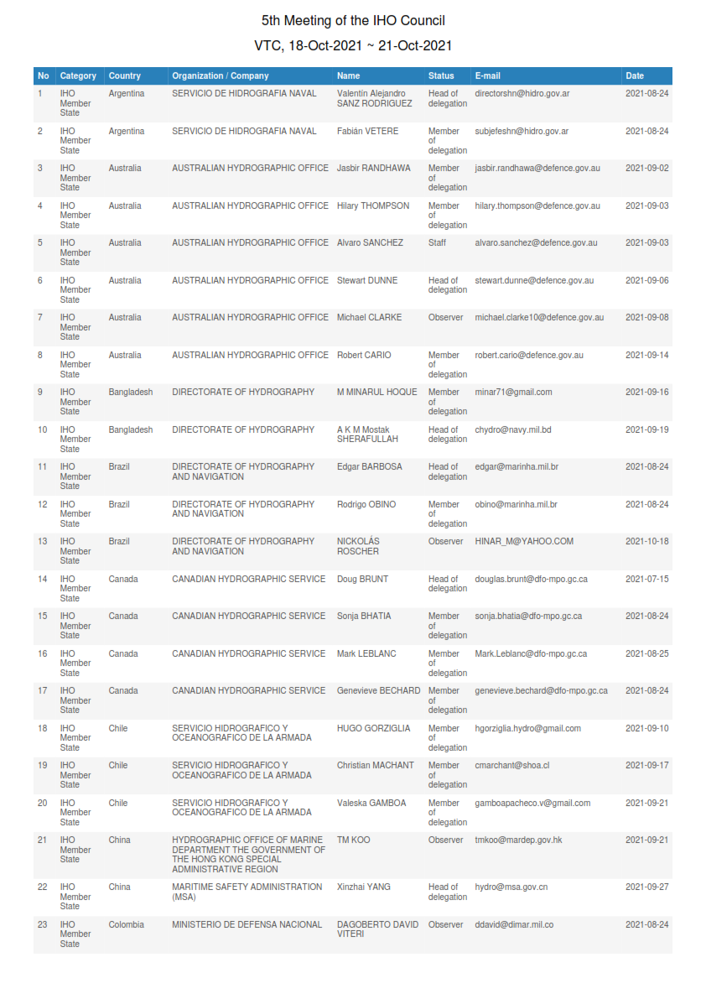

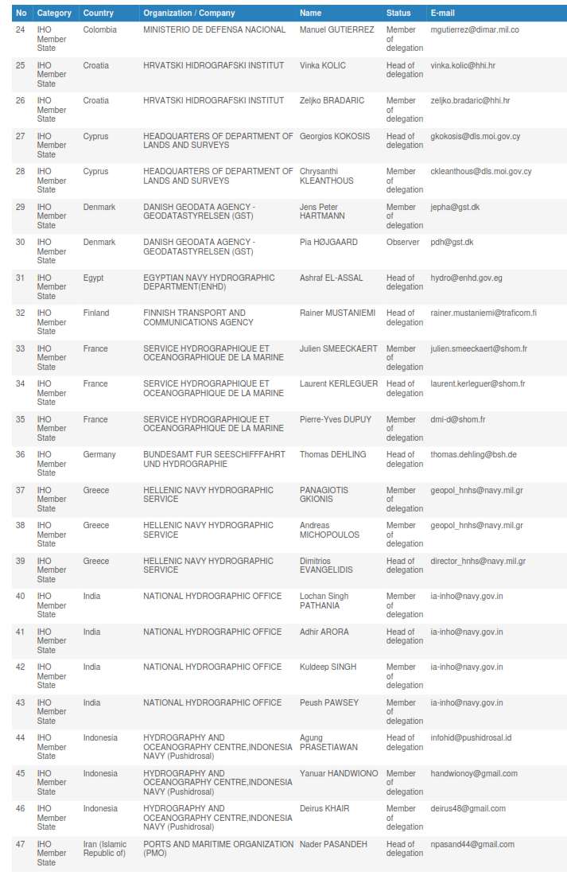

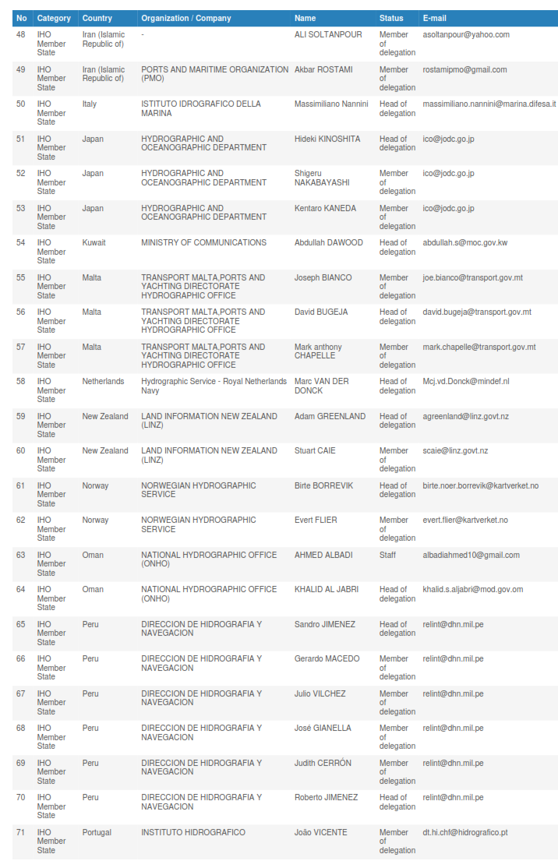
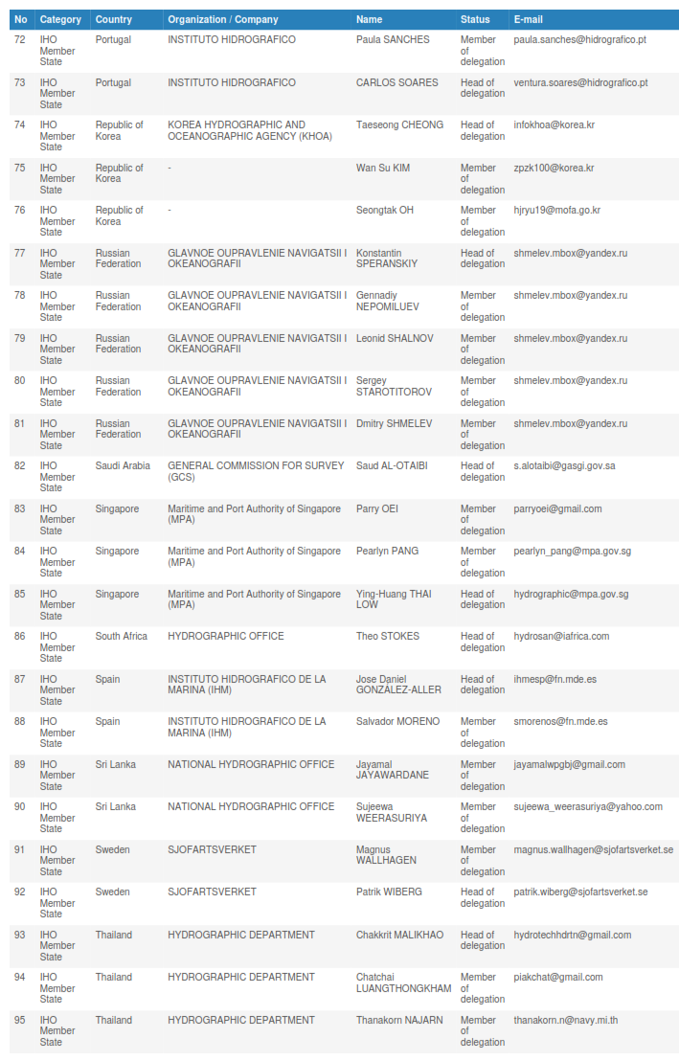

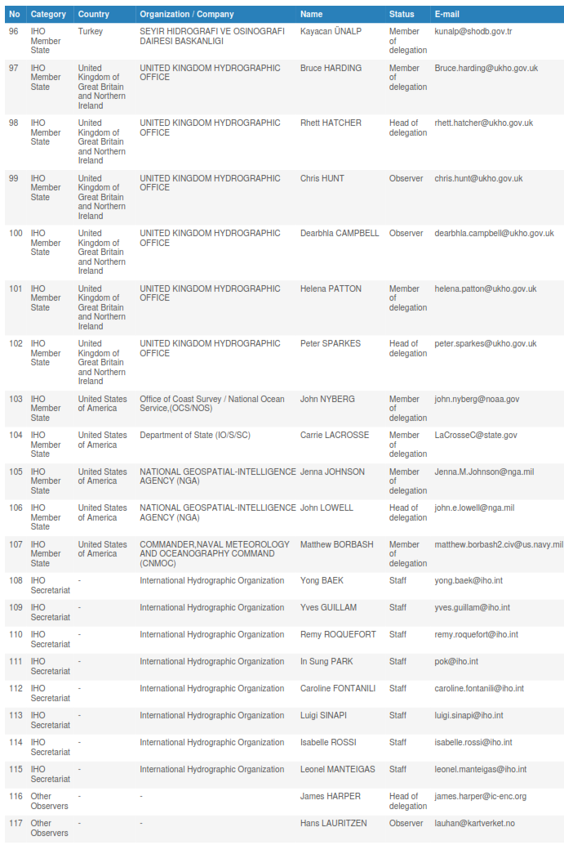

Annex B
5th Meeting of THE iho council

Video-Teleconference (VTC), 19 – 21 October 2021

FINAL AGENDA

References: Rules 7 and 8 of the Rules of Procedure of the Council.

- Opening
  - Secretary-General Opening Remarks.
  - Adoption of the Agenda and Timetable.
  - Chair’s Opening Remarks.
  - Administrative Arrangements.
- items REQUESTED BY the 2nd IHO Assembly
  - Decision A2/08: Update on the Joint IHO-Singapore Laboratory – Proposals from the Council to the Governing Board (To be discussed under agenda item 4.5).
  - Decision A2/12: Report on the Application of ISO 9001 Principles (To be discussed through the reports of HSSC and IRCC under agenda items 4.1 and 4.2).
  - Decision A2/14: Update on the best way forward for the definition of hydrographic interest.
  - Decision A2/20: Status report on the appropriateness and applicability of the new Strategic Performance Indicators (To be discussed under agenda item 6.1, taking into account recommendations from Secretary-General for Programme 1, HSSC and IRCC Chairs for Programmes 2 and 3).
  - Decisions A2/30&A2/31: Proposed version 1.x of the Roadmap for the S-100 Implementation Decade (To be discussed under agenda item 4.4).
  - Decision A2/33: Update on the Dual-Fuel Concept (transition from S-57 to S-101 ENCs) (To be discussed under agenda item 4.1).
  - Cumulative List of A-2 Decisions affecting the Council (Decisions A2/02, A2/04¹, A2/06¹, A2/08, A2/11¹, A2/12, A2/14, A2/20, A2/30, A2/31, A2/33).

- items REQUESTED BY the IHO COUNCIL
  - Review of the status of Decisions and Actions from C-4.
- items REQUESTED BY SUBSIDIARY ORGANS
  - Report and proposals from HSSC (including Update on the Dual-Fuel Concept in the transition from S-57 to S-101 ENCs.
- Annex A: Strategic Performance Indicators allocated to HSSC and proposed metrics.
- Annex B: Proposed Annex 2 (version 1.0, 7 July 2021) to the Roadmap for the S-100 Implementation Decade (2020-2030).

  - Report and proposals from IRCC.
- Annex A - Proposal for Amendment to Roadmap S-100.
- Annex B - Strategic Performance Indicators allocated to IRCC.
  - Left blank intentionally.
  - Proposed version 1.x of the Roadmap for the S-100 Implementation Decade.
  - Update on the Joint IHO-Singapore Laboratory – Proposals from the Council to the Governing Board.
- IHO Annual Work Programme and Budget
  - Review of the Current Financial Status of the IHO.
  - Proposed IHO Work Programme for 2022.
  - Proposed IHO Budget for 2022.
- IHO Strategic plan
  - Implementation and discussion of adaptions of the IHO Work programme and other affected IHO instruments resulting from the revised Strategic Plan with a specific focus on Goal 2 and Goal 3. Status report on the appropriateness and applicability of the new Strategic Performance Indicators. Secretariat´s recommendations on the implementation of the Strategic Plan (Work Programme 1)
- OTHER items PROPOSED by a Member state or by THE secretary-general
  - Update on the implementation of Decision A2/07: gender-inclusivity.
  - Update on the implementation of Decision A2/25: S-130 Polygonal demarcations of global sea areas.
  - US Proposal - Council role in Annual Assessment of the implementation of the IHO Strategic Plan in support of anticipated Report to be Assembly-3.
  - Information: UKHO (UK) & Shom (France) S-100 ECDIS Collaboration.
  - UKHO’s presentation on collaborative work underway with several other IHO Member States in relation to S100 and the various S1** datasets, products and services.
  - KHOA (ROK) & NOAA (US) Information on S-100 Testbed Project.
- NEXT MEETING
  - Dates and venue for the 6th meeting of the IHO Council (18 - 20 October 2022, Monaco) (Decision A2/11).
- ANY OTHER BUSINESS
- REVIEW OF ACTIONS AND DECISIONs OF THE MEETING
- CLOSURE OF THE MEETING

Annex C
LIST OF DECISIONS and ACTIONS FROM C-5

AGENDA  ITEM | SUBJECT | DECISION or ACTION  No. |  | DECISION or ACTIONS  (in bold, action by) | TARGET  DATE/EVENT |  | STATUS  (at October 2021)
1. OPENING
1.1 Secretary-General Opening remarks and introductions

1.2 Adoption of the agenda

 | Agenda | C5/01 |  | The Council adopted the agenda and the timetable as proposed and agreed to consider the information paper on S-100 Test Bed Project provided by KHOA (KR), and NOAA (US) (Doc. C5-07.6A INF refers) at the end of session 2 time permitting. |  |  | Decision
1.3 Chair’s Opening Remarks

 | Opening | C5/02 |  | Council Members welcomed the opening addresses by Dr. Geneviève Béchard, Council Chair and the Secretary-General and agreed on the participation of RENCs representatives as Observers. |  |  | Decision
1.4 Administrative Arrangements

 | Contact List | C5/03 |  | IHO Member States having a seat at the Council to provide the IHO Secretariat with their updates to the IHO Council List of Contacts. | Permanent
2. ITEMS REQUESTED BY THE 2nd IHO ASSEMBLY

2.1 Update on the Joint IHO-Singapore Laboratory – Proposals from the Council to the Governing Board (Decision A2/08)

 |  |  |  | See section 4.5
2.2 Report on the Application of ISO 9001 Principles (Decision A2/12)

 |  |  |  | See sections 3.1, 4.1, 4.2 and 6.1
6.1 | Strategic Plan 2021-2026 | C4/40 |  | The Council agreed to experiment the application of the ISO 9001 principles on a couple of Strategic Plan targets (one per Committee to be proposed). |  |  | Reminder
2.3 Discussion on the best way forward on the definition of hydrographic interest (Decisions A2/04 and A2/14).

 | Definition of Hydrographic Interest | C5/04 |  | The Council thanked Council Chair for the update on the ongoing work by the interested parties AR, BR, IN and UY and invited them to submit a consolidated report on possible ways forward, including impact assessment on IHO Basic Documents. | C-6 (- 3 months)
 | Definition of Hydrographic Interest | C4/08 |  | Council noted the task given by the A-2 to consider the best way forward with proposals A-2 PRO-1.4 and A-2 PRO-1.5 on the definition of hydrographic interest and report to A-3 in 2023 and by which the Council was empowered to establish a working group for this specific purpose. | A-3 |  | Reminder
 | Definition of Hydrographic Interest | C4/09 |  | Council invited interested parties (Argentina, Brazil, India, Uruguay …) in the development of a definition of hydrographic interest, to consider IHC17 outcome, PRO1.4 and 1.5, and come back with a single consolidated proposal to C-5 or C-6 for possible consideration at A-3. (deadline C-5, C-6). | C-5, C-6 |  | Reminder
2.4 Status report on the appropriateness and applicability of the new Strategic Performance Indicators (Decision A2/20)

 |  |  |  | See section 6.1
2.5 Proposed version 1.x of the Roadmap for the S-100 Implementation Decade (Decisions A2/30&A2/31)

 |  |  |  | See section 4.4
2.6 Update on the Dual-Fuel Concept (transition from S-57 to S-101 ENCs) (Decision A2/33)

 |  |  |  | See section 4.1
2.7 Cumulative List of Assembly Decisions affecting the Council.

 |  |  |  | For reference only
3. ITEMS REQUESTED BY THE IHO COUNCIL
3.1 Review of the status of Decisions and Actions from C-4 (pending actions)

 | IHO Resolutions on S-100 | C5/05  (former C4/12) |  | The Council to monitor the progress of the task given to HSSC and IRCC to review the IHO Resolutions with regard to PRO 2.3 when the operational implementation of the S-100 concept becomes mature enough.  HSSC and IRCC to make proposals for endorsement to Council when appropriate | C-6 as appropriate in preparation of A-3 |  | (Decision A2/32 refers).  In progress. Planned at HSSC-14 (2022)
4.2 | Capacity Building Activities | C5/06  (former C4/17, C3/25) |  | The Council invited the IRCC to instruct the CBSC to develop a system of performance indicators to measure, under the conduct of the CBSC and in accordance with the Revised Strategic Plan, the effectiveness and efficiency of CB activities. This system should be oriented to actual outcomes of CB support, not on quantity, or instances of CB activity. | C-6 |  | On going
 | S-100 Implementation Strategy | C5/07  (former C4/23) | Council to maintain and update the the S-100 implementation roadmap and resulting activities in liaison with MS and external bodies on an annual basis as a key priority of the Council activities.  SG/Council Chair to identify some key actions in support and report progress at C-5. |  |  | C-6 | (Decision A2/30 refers)  Ongoing
 | Application of ISO 9001 principles | C5/08  (former C4/40) |  | The Council invited the IRCC to identify a theme on which ISO 9001 Principles should be applied and to propose it to Council for endorsement. | IRCC-14/C-6
4. ITEMS REQUESTED BY SUBSIDIARY ORGANS
4.1 Report and proposals from HSSC (including Update on the Dual-Fuel Concept (transition from S-57 to S-101 ENCs))

 | Report of HSSC | C5/09 |  | The Council noted the report and commended the HSSC, its Working Groups and supporting organizations for the excellent achievements made in 2020-2021 despite the obstacles raised by the pandemic. |  |  | Decision
 | Dual Fuel Concept | C5/10 |  | The Council noted the actions in progress within HSSC for the development of a governance document in support of the dual fuel concept and associated actions.  HSSC to report on the outcome at the next meeting. | C-6
 | IMO ECDIS Documents on S-100 ECDIS | C5/11 |  | The Council noted the work in progress by HSSC Chair Group, CIRM, IEC, Intertanko, for the revision of the IMO MSC.1/Circ.1503/Rev1 – ECDIS Guidance for Good Practice and Resolution MSC.232(82) - ECDIS Performance Standard. | HSSC-14/NCSR-9 (June 2022), then C-6
 | Future of the Paper Nautical Chart | C5/12  (former C4/10) |  | The Council to continue the monitoring of the implementation by HSSC of the recommendations on the Future of the Paper Nautical Chart as appropriate.  The Council noted the development of a Baseline Symbology Project Team to support automated production of paper charts from S-101 data and the priority given to RHCs ICCWGs to focus on ENC schemes. | HSSC-14 / C-6 |  | (Decisions A2/27&28 refers)  Decision
 | S-57, S-101 | C5/13  (former C4/11) |  | The Council to monitor the progress of the task given to HSSC to prepare (done) now maintain the synoptic summary report on the various options offered to HOs for future production of S-101 ENCs in conjunction with S-57 maintenance/production. | C-6 |  | (Decision A2/33 refers)
 | HSSC&IRCC Reports and Proposals to C-6 | C5/14  (same as former C4/13, …and C1/06) |  | Considering the timelines between HSSC-14 and IRCC-14 meetings in 2022 and the countdown for submission of reports and proposals to C-6, the Council invited HSSC and IRCC Chairs to prepare their 2022 meeting minutes with the view that they will be used/submitted directly as reports and proposals to be considered at C-6. | July 2022
4.2 Report and proposals from IRCC

4.2  6.1 | Report of IRCC | C5/15 |  | The Council noted the report and commended the IRCC, the RHCs, and IRCC Sub-Committees for their achievements as well as the outcome of the IRCC October Workshop on the Strategic Plan.  The Council, acknowledging the need for further recommendations on the realization of the Strategic Plan in RHCs by Member States, invited the IRCC to provide these recommendations to the RHCs as a matter of priority.  The Council recognized the need for further IRCC workshops to support the realization of the IHO Strategic Plan. | By April 2022/IRCC-14/C-6 |  | Decision
4.2 | IHO e-Learning Centre | C5/16  (former C4/14) |  | The Council to monitor the progress made by IRCC to establish an IHO e-Learning Center based on A-2 PRO 3.3 and the related recommendations of IRCC/CSBC. | C-6 |  | (Decision A2/42 refers).
4.2 | Women in Hydrography | C5/17  (former C4/16) |  | The Council to monitor the progress made by IRCC on the CBSC work item of Empowering Women in Hydrography (EWH). | C-6 |  | (Decision A2/35 refers).
4.3 Left blank intentionally

4.4 Discussion on the S-100 Implementation Strategy – Proposals from HSSC and IRCC
 | S-100 Implementation Strategy – Products in 1st and 2nd step developments | C5/18 |  | Council agreed to the proposed amended list of S-100 products with special focus (e.g. route monitoring, planning) as cited in Table A of Annex A of the HSSC report. |  |  | Decision
 | S-100 Implementation Strategy –  S-101 | C5/19 |  | The Council agreed to the proposed amendment to the S-100 Implementation Roadmap to clarify the progress with S-101 as contained in Annex B of the HSSC report. |  |  | Decision
 | S-100 Implementation Strategy – new Annex 2 to Roadmap document | C5/20 |  | The Council approved the proposed Annex 2 to the Roadmap for the s-100 Implementation Decade (2020-2030) as described in Annex B of the HSSC report (S-1xx Products, Product Specifications Development Timeline and synoptic diagram from S-57 o S-101). |  |  | Decision
 | S-100 Implementation Strategy – Amendment from WENDWG | C5/21 |  | The Council endorsed the amendment to the S-100 Implementation Roadmap as proposed by the WENDWG and contained in Annex A of the IRCC report. |  |  | Decision
 | Roadmap for S-100 Implementation Decade | C5/22 |  | IHO Secretariat to upload version 2.0 of the Roadmap including approved amendments. | 31 January 2022
 | SOLAS Chap. V, Reg. 9 | C5/23 |  | The Council noted the statement made by the US calling for the IHO to accept some flexibility in the implementation of IHO standards (production, distribution and WEND-100 services in particular) as SOLAS Chap. V, Reg. 9 allows.
 | S-100 Implementation Strategy | C5/24  (former C4/18, C3/13) |  | Council/HSSC/IRCC Chairs/SecGen supported by subject matter experts and Member States as appropriate to maintain the S-100 Implementation Roadmap as an incremental version-controlled document (including narrative and timelines) on an annual basis. | Permanent
 | S-100 Implementation Strategy | C5/25  (former C4/20) | SG, Council Chair, HSSC, IRCC Chairs to maintain the three annexes related to the IHO WP 1, 2 and 3 to S-100 Implementation Roadmap. |  |  | C-6 | (Decision A2/31 refers)
 | S-100 Implementation Strategy | C5/26  (former C4/27) | The Assembly having noted the update on interrelations and tasks, Secretary-General to continue to liaise with [IMO and] other relevant stakeholders and organizations involved in the development of other S-100 based products. |  |  | Permanent | (Decisions A2/40&41 refer)
4.5 Update on the Joint IHO-Singapore Innovation and Technology Laboratory – Proposals from the Council to the Governing Board (Decision A2/08)
 | IHO-Singapore Innovation and Technology Laboratory | C5/27 |  | The Council noted the update on the Joint IHO-Singapore Innovation and Technology Laboratory including simplified procedures for submission of project proposals. |  |  | (Decision A2/08 refers)
 | IHO-Singapore Innovation and Technology Laboratory | C5/28  C5/29 |  | The Council endorsed the HSSC project proposals: a. Testing automated conversion of S-57 to S-101 in support of the dual-fuel concept; and b. Prototyping a S-131 database (and interface) for marine harbour information  The Council tasked HSSC to encourage ENCWG and NIPWG to manage their project applications respectively through the Lab. | HSSC-14/C-6 |  | (Decision A2/08 refers)
5. IHO ANNUAL WORK PROGRAMME AND BUDGET
5.1 Review of the Current Financial Status of the IHO
 | Financial Reporting Statement | C5/30 |  | The Council noted the information provided on the current financial status. |  |  | Decision
 | Financial Reporting Statement | C5/31 |  | The Council invited the Secretary-General to provide recommendations to the Council Members by Finance Circular Letter on the allocation of the anticipated surplus for 2021, with priority for additional funds going to capacity building. | April 2022
5.2 Proposed IHO Work Programme for 2022
 | Proposed IHO WP for 2022 | C5/32 |  | The Council agreed to and approved the IHO Work Programme for 2022, as presented by the Secretary-General, including the preparation of A-3 and IHO Work Programme 2024-2026. |  |  | Decision
 | Work Programme 2022 | C5/33  (former C4/31) |  | IHO Secretariat to issue an IHO CL making the IHO Work Programme 2022 available to the IHO MemberStates as approved by the Council. | Permanent |  | Reminder: See IHO CL 18/2021 as reference
 | World Hydrography Day | C5/34 |  | The Council noted the proposed theme for the 2022 World Hydrography Day by the Secretary-General “How hydrography can contribute to the United Nations Ocean Decade”  IHO Secretariat to circulate the theme for 2022 to the IHO MS by IHO CL and fine tune language of the theme as needed. | End of October 2021 |  | Decision
5.3 Proposed IHO Budget for 2022
 | 2022 IHO Budget | C5/35 |  | The Council approved the budget estimates provided by the Secretary-General. |  |  | Decision
 | Budget 2023 | C5/36  (former C4/35) |  | Secretary-General to secure funding to support EWH projects through negotiation of suitable cooperation agreements with interested Member States and/or partnering organizations. | C-6 |  | (Decision A2/39 refers)  Ongoing (Canada’s contribution noted)
6. IHO Strategic plan REVIEW
6.1 Implementation and discussion of adaptions of the IHO Work programme and other affected IHO instruments resulting from the revised Strategic Plan with a specific focus on Goal 2 and Goal 3. Status report on the appropriateness and applicability of the new Strategic Performance Indicators
 | SPI metrics - IHO Secretariat  (Action C4/37) | C5/37 |  | The Council acknowledged the submission of the IHO Secretariat’s recommendations on the Implementation of the Strategic Plan and noted the Secretariat’s achievements, e.g. the number of followers on social media, counting IHO website visitors and standards documentation downloads. |  |  | Decision
 | SPI Work Programme 1 | C5/38 |  | The Council approved the suggestion to measure the notable activities under WP1 in four categories (global outreach, regional outreach, stakeholder’s specific outreach + consultations) as SPIs. |  |  | Decision
 | SPI 2.1.1 | C5/39 |  | The Council noted the in-kind contribution/assistance requested by the IHO Secretariat to prepare the tools in support of SPI 2.1.1 and improve the attractiveness of the gateway.  Council Members to consider the provision of some support. | March 2022
 | Application of ISO 9001 principles (Action C4/40) | C5/40 |  | The Council endorsed the HSSC proposal that ISO 9001 principles will be experimented on the development of the Product Specification for ENCs S-101 ed. 2.0.0 | C-6
 | SPI metrics - HSSC  (Action C4/37 and C4/39) | C5/41 |  | The Council agreed to the SPI metrics as proposed by HSSC in Annex A of its report with the following considerations and tasked HSSC to provide tentative values and comments to the Council Chair for the preparation of the Annual Report (section Implementation of the Strategic Plan). | End of January 2022 |  | Decision
 | SPI metrics - IRCC  (Action C4/37) | C5/42a  C5/42b |  | The Council agreed to the SPI metrics as proposed by IRCC in Annex B of its report and tasked IRCC to engage with the RHCs to design relevant implementation procedures as appropriate.  The Council tasked the IRCC to provide tentative values and comments to the Council Chair for the preparation of the Annual Report (section Implementation of the Strategic Plan). | By April 2022  End of January 2022 |  | Decision
 | IRCC Strategic Workshop | C5/43 |  | The Council noted the information from IRCC to organize a workshop by April 2022 on the definition and design of SPIs methodologies and subsequent governance and automated GIS tools to implement them, by Members States within RHCs. | IRCC-14 / C-6
 | US Proposal - Council role in Annual Assessment of the implementation of the IHO Strategic Plan in support of anticipated Report to be Assembly-3. | C5/44  C5/45  C5/46  C5/47 |  | The Council endorsed the US proposal for Council Chair to organize and prepare an annual assessment of the implementation of the IHO Strategic Plan for 2021 and 2022.  Council Chair will establish a methodology for preparing an annual assessment, including, if required, creating a team to assist in this task.  IHO Member States to be invited by Council Chair to provide support and information, as required.  The Council noted the recommendation by Secretary-General that this report could be included in the Periodic Publication P7 - IHO Annual Report for Y replacing the current Annex B of P7 and requests the IHO Secretariat and the US assist in this matter. Other ways to make this report more prominent will be considered. | C-6  Ongoing  End of January Y+1 |  | Decision
6.1 | Strategic Plan 2021-2026 | C5/48  (former C4/36) |  | Following the adoption of the Revised Strategic Plan by A-2, the Council noted that the effective implementation of the Strategic Plan 2021-2026 is to be considered as the main theme of supervision and control of the Council until A-3, keeping in mind to apply the principles of ISO 9001. | A-3 |  | Decision  (Decisions A2/12&19 refer)
7. OTHER items PROPOSED by a Member state or by THE secretary-general
7.1 Update on the implementation of Decision A2/07: gender-inclusivity
 | Gender-inclusive Language | C5/49  C5/50  C5/51 |  | The Council endorsed the recommendations of Secretary-General presented in this report.  The Council agreed that to the greatest extent possible, the updating of gender references in existing IHO documents will take place in conjunction with other edits and revisions which have been received as proposals from IHO bodies. That is, there will be no systematic updating of all IHO documents for the single purpose of addressing gender language issues.  The Council agreed that guiding principles on gender-inclusive language, once approved, will apply to all new IHO documents, new Editions, and communications. |  |  | Decision  Decision  Decision
 | Gender-inclusive Language | C5/52 |  | The Secretary-General with assistance from CA will evaluate the UN Guidelines on gender-inclusive language and clean those relevant to the IHO to use as guiding principles. These will be incorporated into a new draft IHO Resolution on gender-inclusive language to be drafted by the Secretary-General to be reviewed by C-6 and proposed to A-3. | C-6
 | Gender-inclusive Language | C5/54 |  | Following a review by the Secretary-General and CA, the Secretary-General with assistance from CA, UK and US (and other Member States…) will propose gender inclusive wording in M1 and M-3 in keeping with the UN Guidelines on Gender-inclusive Language. These will be applied the next time the document is updated or revised. | C-6, C-7…
 | Gender-inclusive Language | C5/55 |  | The Secretary-General to prepare a report on the use of gender-inclusive language in IHO documentation and written communication to be reviewed by C-6 and submitted to A-3. | C-6
7.2 Update on the implementation of Decision A2/25: S-130 Polygonal demarcations of global sea areas
 |  | C5/56 |  | The Council noted the progress report by the Secretary-General on the establishment of the S-130 PT and welcomed the nominations for the Chair and Vice-Chair positions, from Belgium and China respectively. |  |  | Decision
 | S-23, A2 PRO1.9 follow-up | C5/57  (former C4/07) |  | Secretary-General to report on implementation of PRO 1.9. | C-6 / A-3 |  | (Decision A2/24&25 refer)
7.3 US Proposal - Council role in Annual Assessment of the implementation of the IHO Strategic Plan in support of anticipated Report to be Assembly-3.
 |  |  |  | Reference 6.1
7.4 Information: UKHO (UK) & Shom (France) S-100 ECDIS Collaboration.
 | 7.4 | C5/58 |  | The Council noted this report and encouraged UK and FR to pursue their efforts in this incremental experimentation.
7.5 Information: UKHO’s presentation on collaborative work underway with several other IHO Member States in relation to S100 and the various S1** datasets, products and services.
 | 7.5 | C5/59 |  | The Council noted this report and thanked UK for their presentation and video.
7.6 Information: Republic of Korea (KHOA) –US (NOAA) S-100 Test bed Project.
 | S-100 Test bed Project | C5/60 |  | The Council noted the approach proposed by the KHOA-NOAA S-100 Test bed project to measure the efficiency quantitatively for the use of S-100 data service and invited Member States to join the project and suggest other quantitative measures (safety of navigation, efficiency) as appropriate.
8. NEXT MEETING
8.1 Dates and venue for the 6th Meeting of the IHO Council
 | C-6 | C5/61 |  | The Council agreed to hold C-6 in Monaco, at the IHO Secretariat, from 18 to 20 Oct. 2022.  In the case of a remote/hybrid event, the Council agreed to consider arrangements similar to those made for C-5. | Go no-go decision 18 June 2022 |  | Decision
9. ANY OTHER BUSINESS
10. REVIEW OF ACTIONS AND DECISIONs OF THE MEETING
11. CLOSURE OF THE MEETING

for submission in accordance to Council ROP.
Complete.
Complete.
Future of S-23.

