**7th MEETING**

**OF THE IHO COUNCIL**

**Monaco, 17 – 19 October 2023**



**REPORT OF THE IHO HYDROGRAPHIC SERVICES AND STANDARDS COMMITTEE, HSSC**

**REPORT[1] Of THE IHO Hydrographic SERVICES AND Standards COMMITTEE  
TO THE 7th MEETING OF THE IHO COUNCIL**

***References****:*

1. [*List of Decisions and Actions from C-6 affecting HSSC*](https://iho.int/uploads/user/About%20IHO/Council/council6/LIST%20OF%20DECISIONS%20and%20ACTIONS%20FROM%20C6_v1.pdf)
2. [*List of Decisions from A-3 affecting HSSC*](https://iho.int/uploads/user/About%20IHO/Assembly/Assembly3/DOCUMENTS/DECISIONS_3rd_SESSION_OF_ASSEMBLY_Proceedings.pdf)

# [*List of Decisions and Actions of HSSC-15*](https://iho.int/uploads/user/Services%20and%20Standards/HSSC/HSSC15/LIST%20OF%20DECISIONS%20AND%20ACTIONS%20FROM%20HSSC15_19June2023_v1.1.pdf)

1. [*List of Actions, Decisions and Recommendations to RHCs of IRCC-15*](https://iho.int/uploads/user/Inter-Regional%20Coordination/IRCC/IRCC15/IRCC15-12_Draft_List_of_Actions_Decisions_Recomendations_v1.pdf)

***Annexes:***

1. *Draft revised version of the Roadmap for the S-100 Implementation Roadmap, Annex 2*
2. *Draft version of the HSSC Terms of Reference including proposed amendments*

# Introduction

1. The 15th Hydrographic Services and Standards Committee (HSSC) meeting took place from 5 to 9 June 2023 in Helsinki, Finland as a face-to-face meeting, as announced by the IHO CL 02/2023. An embedded Industry Stakeholders’ Session was arranged for two half day sessions themed “S-100 Industry Perspective”, which offered an opportunity to IHO Member States to interact with stakeholders regarding the concerns and challenges with S-100 implementation.  
     
   The meeting was guided by HSSC main principles dealing with the promotion and the coordination of the development of standards, specifications and guidelines for official products and services in order to meet hydrographic information requirements for navigation and other usage.

As consequence of inputs from Council-6 (see Reference A) and from IHO Assembly-3 (see Reference B), the 15th meeting of HSSC was characterized by two main levels of discussion:

* An operational/strategic level:

1. The establishment of a S-100 Infrastructure Centre Establishment Project Team (S-100 ICE PT), under HSSC, in accordance with decision A3/14.
2. The maintenance of the Roadmap for the S-100 Implementation Decade (2020-2030) and the associated Annex 2 related to Work Programme 2 (C6/37 and C6/38)
3. Following a submission paper from UK (HSSC15-05,1H), HSSC discussed the establishment of a S-100 Security Scheme PT, under HSSC, to review the IHO S-100 Security Scheme.
4. The establishment of an Electronic Chart System Project Team (ECS PT), under the ENCWG, aiming to develop a set of recommendations/issues to be considered by existing IHO bodies, external organisations, and Member States on ECS navigational requirements (A3/15 partly gives a background).
5. The implementation of the recommendations on the Future of the Paper Nautical Chart (C6/15) and a submission paper from Germany addressing several issues on paper charts (HSSC15-04C and HSSC14-04D).

* A technical level:
  1. Progresses in the development of the S-1xx Product Specifications
  2. Progress of the work plans, items outside S-100, of subordinate bodies

The list of Decisions and Actions from HSSC15 is provided in Reference C.

# Technical Programme Coordination

1. This document reports on the progress of the ongoing implementation of the IHO Work Programme 2023 and the three-year Work Programme for 2023 – 2026 that takes into account HSSC Work Plan inputs provided by WGs/PTs Chairs during the 15th HSSC meeting.

# Difficulties and challenges yet to be addressed

1. The S-100 timeline has been communicated by IHO with other international organisations such as IMO, IEC and CIRM. At the IMO MSC 106 Meeting in November 2023 the proposal, initiated by IHO, to include S-100 as a valid format in ECDIS was approved. The proposal to IMO has been based on the IHO S-100 timeline and it is now of utmost importance to keep to or improve on the communicated timeline for S-101 and associated S-100 product specifications. In parallel IEC is developing the ECDIS test standard (IEC61174) to include S-100 and in this process IEC is dependent on the finalization of several S-100 product specifications. A close cooperation between IHO and IEC is thus crucial to meet the IMO time frame that will allow for the optional use of S-100 ECDIS by 01 January 2026 with mandated use from 01 January 2029.
2. In order to meet the commitments made to other organizations it is therefore critical to encourage IHO Member States and wider stakeholders to actively support the development of S-101 and other product specifications to secure that IHO can deliver the operational editions in accordance with the current timeline and to accelerate where possible.
3. IHO MS active contribution in the technical WG/PTs should be increased. Active participation brings a fundamental benefit for HOs to be able implement new technology, standards and S-100 products and services. Industry partners in the WG/PTs are appreciated. Though, there is a risk to become too dependent on the industry when S-100 is developed. The involvement of the Member States is essential to ensure that the S-100 is implemented in the way HOs want.
4. S-100 is a complex ecosystem where IHO is the focal point. The IMO e-Nav strategy is dependent on S-100 and as such S-100 is a fundamental element of digitalisation of the shipping industry. IALA, WMO, IEC and others are contributing but they need support from IHO. Operational resources within IHO are limited. A sustainable structure is needed to maintain the technical and administrative infrastructure around S-100. Can we, IHO, contribute to the needed resources?

# Achievements/outputs/conclusions

***The implementation of the IHO Strategic Plan***

1. The IHO Strategic Plan was agreed upon by the IHO Assembly 2. Subsequently the following Council 4 meeting decided to implement the Strategic Performance Indicators (SPIs). SPIs allocated to HSSC has been reported in January 2023 and updated figures is shown in the dashboard below. In accordance with Decision A3/08e, the HSSC invited the HSSC Chair Group and its Members to brainstorm in preparation of inputs to the future IHO Strategic Plan 2027-2032. These draft inputs are planned to be considered at the next meeting HSSC-16 in 2024, and then to be submitted to Council-8.

**The Council is invited to note that HSSC has initiated an action for the preparation of the next IHO Strategic Plan. HSSC welcomes further instructions from Council-7 on this matter.**

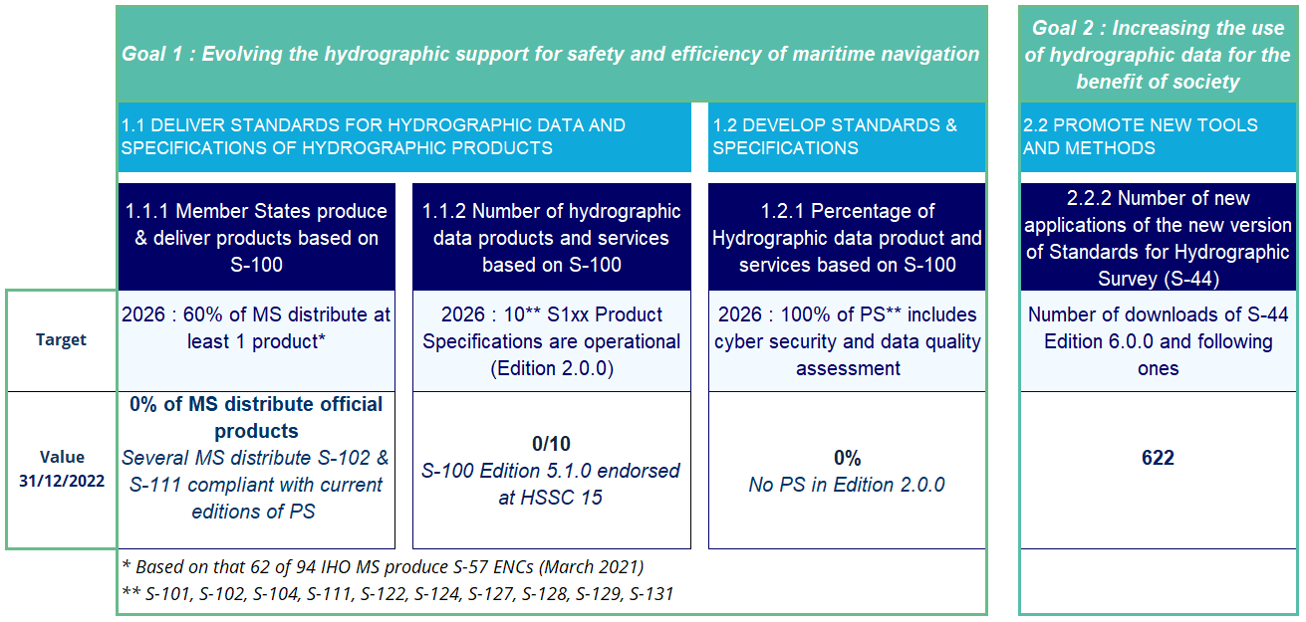

Figure 1; Dashboard on Strategic Performance Indicators allocated to HSSC. Updated 31st December 2022.

***The implementation of the Roadmap for the S-100 Implementation Decade (2020 – 2030)***

1. Following an A-3 proposal (PRO 2.2) by the ROK, the A-3 recognized the need to establish a S-100 Infra Center and approved the foundation of a new Project Team under HSSC to propose to the Council how such an Infra Center could be established (A3/14). At HSSC-15 the Committee approved TORs for this Project Team which will be established as the S-100 Infrastructure Center Establishment PT, S-100 ICE PT. The S-100 ICE PT will be chaired by the ROK (SE Vice-Chair) and several MS indicated already at HSSC-15 that they will contribute in the PT. The HSSC Chair and the IHO Technical Director will also be active participants. As described under paragraph 6 of this report, it is essential for the IHO to establish a stable structure for S-100. The setup, including management, of a S-100 Infra Center is an important part of this. Progress of the S-100 ICE PT will be reported by HSSC to the Council.  
     
   While noting that a sustainable business model of the S-100 Infrastructure Center will need to be defined and proposed by the S-100 ICE PT for approval, the IHO must secure firm and sustainable management of the administration and technology for S-100 and it is likely that additional funding will be needed. The A3 proposal by USA et al (PRO 3.5) suggested to explore options for alternative fund generation to support capacity building and other IHO initiatives. A-3 agreed to set up a project team under IRCC to work on this task. The A3 decision noted that funding could be used to support capacity building and other IHO initiatives. Thus it is important to recognize that additional funding resources should also be considered, if needed, for initiatives such as S-100 Infrastructure and is not limited to capacity building only. Therefore**, HSSC invites the Council to endorse the principle that additional funding resources (A3/20 and IRCC15 Decision 41) should be considered for the setup of a sustainable technical and administrative infrastructure around S-100 including standards development to meet the S-100 timeline.**
2. The preparation of S-100 product specifications is progressing according to the plan presented at Council 6, with some minor adjustments. In accordance with Council actions C6/37 and C6/38, HSSC is contributing to maintain the S-100 Roadmap. The development of the critical supporting framework is also progressing in accordance with the S-100 timeline. An updated S-100 timeline is available in Annex A to this report. At HSSC15 Stakeholders, such as CIRM and IEC, raised the issue that the Catalogue of Nautical Products, S-128, should preferably be ready in an operational edition before the existing planned deadline. NIPWG, as the responsible WG, will now speed up the development of this standard as can be seen in the updated S-100 timeline.   
     
   HSSC15 also endorsed the recommendation from S-100WG to amend the S-100 Roadmap Annex 2, to read Phase 1 / Route Monitoring and Phase 2 / Route Planning, noting that further Phases could be added in the future. Following proposals from DE and US, HSSC15 endorsed that the product specifications for Ice Information, S-411, and Weather and Wave Hazards, S-412, should be included as part of S-98 development for Phase 2 / Route Planning. S-411 and S-412 is developed by WMO as important S-100 metrology layers to be used in future S-100 ECDIS.   
   **The Council is invited to approve the revised version of the S-100 Roadmap, Annex 2:  
   - renaming to Phase 1 and Phase 2  
   - including S-411 and S-412 in Phase 2 / Route Planning  
   - the updated S-100 timeline.**   
   See Annex A to this report.

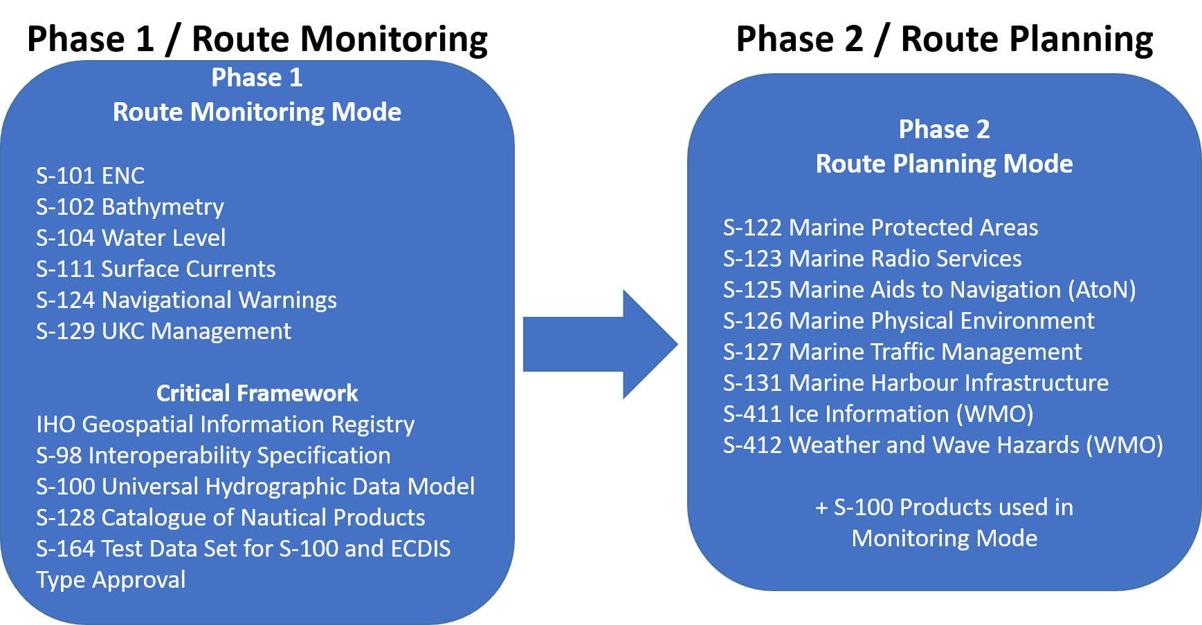

Figure 2; The S-100 Implementation Priorities should also reflect the Critical Framework needed for usage of S-100 products in future S-100 ECDIS.

|  |  |
| --- | --- |
| Table A – IHO list of S-100 products with special focus | |
| Phase 1 / Route monitoring | |
| **S-101** | Electronic Navigational Chart (ENC) |
| **S-102** | Bathymetric Surface |
| **S-104** | Water Level Information for Surface Navigation |
| **S-111** | Surface Currents |
| **S-124** | Navigational Warnings |
| **S-129** | Under Keel Clearance Management |
| Critical Framework | |
|  | IHO Geospatial Information Registry |
| **S-98** | Interoperability Specification |
| **S-100** | Universal Hydrographic Data Model |
| **S-128** | Catalogue of Nautical Products |
| **S-164** | Test Data Set for S-100 and ECDIS Type Approval |
| Phase 2 / Route planning | |
| **S-122** | Marine Protected Areas |
| **S-123** | Marine Radio Services |
| **S-125** | Marine Aids to Navigational (AtoN) |
| **S-126** | Marine Physical Environment |
| **S-127** | Marine Traffic Management |
| **S-131** | Marine Harbour Infrastructure |
| **S-411 (WMO)** | Ice Information |
| **S-412 (WMO)** | Weather and Wave Hazards |

Figure 3 The S-100 Implementation Priorities, as described in the S-100 Roadmap Annex 2, should be updated to reflect the renaming to Phase 1 / Route Planning and Phase 2 / Route Monitoring and the inclusion of S-411 and S-412..

1. As proposed by Council (PRO 2.1) A3 approved the Dual Fuel Concept for S-100 ECDIS. The Executive Summary is now included as an Annex 4 to the S-100 Roadmap and the full report as an appendix to annex 4. It will be maintained by HSSC, through the S-100WG, on a regular basis.
2. The HSSC ISO 9001 Cell has monitored the development of the product specification for ENC, S-101 during the last two years. This close monitoring has proven to be a very useful tool to secure development according to the S-100 timeline. At HSSC15 the Interoperability standard, S-98, and the Test data standard, S-164, development was identified to be on the critical path with high risk to not meeting 2024 for their Ed. 2.0.0. Given their interdependency with S-101 edition 2.0.0, HSSC agreed on the principle to expand the scope of the ISO Cell to S-164 and S-98 developments. One of the recommendations from the ISO Cell at HSSC15 was also to consider the establishment of an improved S-100 management structure, which is part of the background to the arguments raised in paragraph 8 of this report. There are clear benefits of having this HSSC ISO 9001 Cell and HSSC also invited IRCC, at IRCC15 in June 2023, to mirror such an ISO Cell to monitor the MS production of S-101 ENCs.
3. Following a proposal from UK, HSSC15 approved the establishment of the S-100 Security Scheme PT under HSSC, mainly to develop the S-100 appointment and termination process for data servers, OEMs and ENDS service providers, and to analyze the current IHO agreements to ensure they are legally binding. HSSC also invited the S-100 Security Scheme PT to ensure that the S100 Security Scheme rules and admin procedures are compatible with SECOM. For more information regarding SECOM see paragraph 13 below. HSSC will keep the Council updated on the outcome of the S-100 Security Scheme PT. **The Council is invited to note the establishment of the S-100 Security Scheme PT under HSSC.**
4. IMO MSC106, agreed in November 2022, on the revised IMO ECDIS Performance Standards (MSC. 530(106)) to include support for S-100. S-100 ECDIS will be legal to use after 1 January 2026 and from 1 January 2029 new systems must comply with the new IMO Resolution on ECDIS Performance Standards. In addition, NCSR10 in May 2023, endorsed the inclusion of a S-100/IEC standard, Route Plan S-421, for route exchange from ship to shore and from shore to ship into the IMO ECDIS Performance Standards. The amendment of the Performance Standards also includes a standard for secure communication between ship and shore, IEC SECOM (63173-2). SECOM would be relevant also for distribution of other applicable S-100 products. The inclusion of route exchange and the secure communication standard follows the same transition plan as S-100 ECDIS (2026 – 2029). Final approval is expected at MSC 108 in May 2024.
5. The inclusion of S-100 in the IMO regulatory framework is as a major success for IHO, but it also means that IHO with its Member States clearly need to meet the deadlines setup in the S-100 timeline. IHO has now commitments towards IMO and other stakeholders to achieve operational status on the prioritized S-100 product specifications. IMO NCSR10 requested that IHO provide a more detailed progress report of individual Product Specifications against the S-100 implementation roadmap in future updates. It means that the S-100 timeline, maintained in the S-100 Roadmap, Annex 2, should be used for the IHO annual update to IMO NCSR.

***The establishment of an Electronic Chart System Project Team (ECS PT)***

1. At A3 the proposal from UK et al (PRO 2.3) regarding the future of digital charting was discussed at length, but without reaching an agreement on the proposal (A3/15). As a consequence, UK, sponsored by Australia, Ireland, New Zeeland, Nigeria, Spain, Surinam and Türkiye, submitted a follow-up paper with a more limited scope for consideration to HSSC15. The discussion at HSSC15 included arguments for and against regulating the sub-ECDIS market, at which level IHO needs to be involved and if there are actually any implications for the IHO Standards. At the Stakeholders session one of the stakeholders presented a very relevant table to show that the sub-ECDIS market consist of at least three very different segments. It is important to apply different perspectives when discussing the need for regulation for these different segments.
   * smaller SOLAS vessels (not included in the ECDIS carriage requirements)
   * commercial vessels (e.g. tug boats, smaller passenger ferries, fishing vessels) and yachts larger than 300 GT
   * leisure craft smaller then above
2. HSSC15 decided to establish an ECS PT under the ENCWG. HSSC drafted the TORs of the new ECS PT in an ad hoc session, at HSSC15. The drafted objectives of the PT are:
   * + - 1. to identify and prioritize ECS navigation requirements;
         2. to analyse their impacts on current IHO hydrographic standards; and
         3. to develop a set of recommendations/issues to be addressed by existing IHO bodies, external organisations, and member states.
3. Following the establishment of ECS PT HSSC approved proposed amendments to the ENCWG TORs to encompass the ECS PT. HSSC will keep the Council informed of the outcome of the ECS PT through reporting from the ENCWG. **The Council is invited to note the establishment of the ECS PT under HSSC, ENCWG.**

***The implementation of the recommendations on the Future of the Paper Nautical Chart***

1. As requested by Council 6 (C6/15) the HSSC and the Nautical Cartography Working Group (NCWG) has continued to work on the implementation of the recommendations given in the Future of the Paper Nautical Chart report. The Baseline Portrayal Project Team, BSPT, under NCWG, is in progress to create a digital paper chart symbol library. The aim is to setup Baseline Symbology aiming to support the automated production of paper charts from S-101 data. BSPT is delayed and resources are needed from MS to speed up this work. There are no other status changes on the other recommendations since C-6.
2. As a consequence of the announcement by the UKHO on the withdrawal of Admiralty paper charts, planned in 2030 at the earliest, an input paper was submitted by Germany addressing several issues on paper charts carriage requirements, maintenance, updates and coverage in the context of IMO regulation. Similar input papers were also submitted by Germany to IRCC15 and IMO MSC 107. In the case of MSC 107 the input paper was also co-sponsored by ICS (International Chamber of Shipping). HSSC agreed that most of the issues raised in the input paper was better suited to be discussed at IRCC. However, the NCWG was invited to consider the need for a new standard for paper chart corrections (such as a XML format for Notices to Mariners developed by NIPWG a few years ago) then to be aligned with S-4, if and when appropriate.

***Progresses in the development of the S-1xx Product Specifications***

1. As mentioned above, the development of the S-1xx product specifications is progressing more or less as expected. The updated detailed timeline for all planned S-1xx specifications is found in Annex 2 to the Roadmap for the S-100 Implementation Decade (2020 – 2030). Most, if not all, of the Phase 1 product specifications will be ready for IHO MS approval in their operational editions in November 2024. Since June 2023, the report by the S-100WG to HSSC includes a comprehensive risk assessment (low, medium, high) if not meeting the 2024 target for the operational edition of several S-100 key components. MS can expect an IHO CL early in November 2024 with the request to approve this first package of the S-100 product specifications (expected S-101, S-102, S-104, S-111 and the critical framework product specifications S-98, S-128, S-164). In best case also S-124 (navigational warnings) and S-129 (UKC) will be ready for MS approval at this stage. Operational editions of these Phase 1 S-100 product specifications are expected to be endorsed by HSSC MS (September 2024 the latest) before the IHO CL is provided. See also the updated S-100 timeline in Annex A to this report. **The Council is invited to note that the Phase 1 S-100 product specifications are expected to be ready in an operational edition for IHO MS approval early November 2024.**
2. HSSC15 endorsed S-100, Ed. 5.1.0 - IHO Universal Hydrographic Data Model and approved a significant number of new Editions at this meeting, commending the work of the relevant WGs/PTs, and Member States involved in the outstanding developments achieved since HSSC14. In accordance with the principles stated in IHO Resolution 2/2007, it is reminded that all Editions enumerated as 1.0.0 were for initial implementation, testing and evaluation.  
     
   These Standards are:  
   - S-131, ed 1.0.0, Marine Harbour Infrastructure  
   - S-164, ed 1.0.0, IHO Test Data Set in S-100 ECDIS  
   - S-124, ed 1.0.0, Navigational Warnings  
   - S-130, ed 1.0.0, Polygonal Demarcations of Global Sea Areas
3. The development of the Product Specification of ENC S-101 is still following the timeline presented at Council-6. The operational edition will be ready for MS approval in 2024. However, there is still a critical need to encourage IHO Member States and wider stakeholders to actively support the development of S-101. The Project Team is under pressure and to speed up the development of S-101, approximately 40 k€ has been allocated from the Special Projects fund in support of Test Data Set production. The HSSC ISO 9001 cell follows the S-101 progress closely.
4. HSSC15 approved the product specification for Polygonal Demarcations of Global Sea Areas, S-130 edition 1.0.0, for initial implementation, testing, evaluation and comprehensive evaluation by IHO MS. HSSC confirmed the importance of producing an authoritative S-130 IHO-approved dataset in accordance with decisions taken at Assembly-2 and confirmed by A3. At HSSC15 some concerns were raised on how such an authoritative dataset could be produced. Testing should be considered in one or two regions, based on S-23 (ed 3), prior to the publication of the operational version of S-130 edition 2.0.0 and official production of the IHO authoritative dataset. **The Council is invited to agree upon the proposed way forward to test S-130 in one or two regions before the publication of the operational version of S-130 edition 2.0.0 and official production of the single IHO authoritative dataset.**
5. The MASS PT (Maritime Autonomous Surface Ships) delivered to HSSC a very comprehensive report identifying the regional situation with regard to MASS issues and requirements, as well as an S-100 gap analysis. The MASS Project Team was invited to co-operate with the IALA MASS Task Force and the IMO Joint MSC/FAL/LEG Working Group on MASS. For this purposes, the mandate of the Project Team was extended for one year, prior to the possible establishment of a WG, to be considered in 2024.

***Progress of the work plans (items outside S-100) of subordinate bodies***

1. Other work items outside the development of S-100 is progressing well within the HSSC working groups. An updated consolidated HSSC work plan is available at the IHO HSSC website (under Miscellaneous).
2. The ENCWG is working on an IHO ENC & ECDIS Cyber Security Guideline. Support from the Plymouth University’s Marine Institute/CyberSHIP Lab for this work is very much appreciated. In cooperation with the DQWG the ENCWG has progress with the new edition of IHO publication S-67, Mariners Guide to Accuracy of Depth Information in ENC. During this work it has been identified that a more general publication is needed for mariners to understand how to use ENC and ECDIS related to the content of ENC, including also cyber security aspects and others. Taking also in account the IHO publication S-66, Facts about Electronic Charts and Carriage Requirements, HSSC agreed to consider the endorsement to merge S-66 and S-67 and to include cyber security guidance and other relevant guidance into a new edition of S-66 and withdraw S-67. The main argument behind keeping S-66 as an IHO publication, and withdraw S-67, is that S-66 is referenced in an IMO document (MSC.1/Circ.1503/Rev 2 “ECDIS Guidance for Good Practice”).  
     
   The ENCWG will conduct an impact study to better understand the consequences of a suggested new edition of the S-57 ENC Test Data Set for ECDIS, S-64. A new edition will have the effect that existing S-57 ECDIS would need to be upgraded. In such case IHO would need to inform IMO and motivate the need for a new edition of S-64. At this stage we need to await the outcome of the impact study.
3. The work of the Hydrographic Survey Working Group, HSWG, is progressing well and the WG has a broad and active participation from IHO MS and industry representatives. HSSC commended the HSWG for their work and specifically regarding the new IHO publication B-13, Ed. 1.0.0 - Guidance to Satellite-Derived Bathymetry, which was approved by the Committee at HSSC15.
4. At C-6 HSSC reported that no MS had volunteered to take the responsibility as office bearers in the Data Quality Working Group (DQWG). Since then China has volunteered to take the Chair position and Canada has currently the role as the acting Secretary. The role as Vice-Chair is still vacant. MS are still encouraged to nominate representatives. In cooperation with the HSWG the DQWG has developed S-68, Ed. 1.0.0 - Guidelines and Recommendations for Hydrographic Offices for the allocation of CATZOC/QoBD Values from Survey Data, which was approved by HSSC15. This first edition is for initial implementation, testing and evaluation and IHO MS is invited to provide their feedback to the DQWG.
5. After fruitful discussions on the different options available for the future of the Hydrographic Dictionary Working Group (HDWG), the HSSC re-acknowledged the international recognition of the IHO Hydrographic Dictionary and the need to keep it as stand-alone IHO publication with the IHO Geospatial Information Registry (GI Registry) as a basis for maintaining its S-100-related component. HSSC thanked the outgoing Chair for his completion of the review of the IHO Hydrographic Dictionary, welcomed the incoming Chair (former Vice-Chair), and tasked the GI Registry Team and the HDWG incoming Chair to prepare the necessary steps to move the WG to a HD Correspondence Group (HDCG).

***HSSC Terms of Reference and Champions of Hydrography***

1. The RENCs have been invited to several HSSC meetings and their contribution have proven to be very valuable. At HSSC15 it was suggested, and subsequently endorsed, that the HSSC Terms of Reference and Rules of Procedures should be amended to include the RENCs in the HSSC Membership, and when there is no Open Stakeholders’ Session along HSSC meetings, Expert Contributors from industry on a case-by-case basis, by invitation of the Chair. **The Council is invited to approve the amended HSSC TORs and ROPs, including the RENCs in the HSSC Membership, as attached in Annex B to this report.**
2. Following a proposal from UK, HSSC endorsed the proposal for the IHO to consider the creation of a new award, more inclusive than the Medal of Prince Albert 1st, recognising once a year a champion of hydrography across HSSC and IRCC (WGs, SCs and PTs). The endorsement of this proposal was reported to IRCC15 and IRCC subsequently also endorsed to create such an annual award, IRCC15 Decision 8. If endorsed by the Council HSSC propose that the Chairs of HSSC and IRCC, supported by the IHO Secretariat, prepare a draft IHO Resolution on this matter. Once a draft resolution is prepared the IHO Secretariat will issue an IHO Circular Letter seeking approval from IHO MS. **The Council is invited to endorse the proposal for an annual champion of hydrography award and agree upon the proposed way forward.**

***Miscellaneous***

1. The Chair and Vice-Chair of HSSC were re-elected for a new 3-year mandate.
2. The Stakeholders’ session was enlightening. Some subject matter experts and manufacturers suggested possible risk mitigation measures to apply for supporting the transition to S-100 ECDIS as well as the business case of S-100 ECDIS (S-100 Data Services Coverage, etc.). This need to be addressed in preparation of NCSR meetings, both by IRCC and HSSC in support of the IHO Secretariat (not only PS development but expected coverage in 20xx). Noteworthy was the following quote from a manufacturer: “A roadmap that sunsets S-57 allows increased investment in S-100 ECDIS [and Data Services Provision]”.

***Next HSSC Meeting, HSSC16***

1. HSSC16 will take place in Tokyo, Japan 27 to 31 May 2024.

# *Actions required of the Council*

1. The Council is invited to note the Report
2. The Council is invited to note that HSSC has initiated an action for the preparation of the next IHO Strategic Plan. HSSC welcome further instructions from Council-7 on this matter.
3. HSSC invites the Council to endorse the principle that additional funding resources (A3/20 and IRCC15 Decision 41) should be considered for the setup of a sustainable technical and administrative infrastructure around S-100 including standards development to meet the S-100 timeline.
4. The Council is invited to approve the revised version of the S-100 Roadmap, Annex 2:  
   - renaming to Phase 1 and Phase 2  
   - including S-411 and S-412 in Phase 2 / Route Planning  
   - the updated S-100 timeline.  
   The S-100 timeline should be used as a basis for the IHO Secretariat for the annual IMO NCSR report to provide IMO with an annual status of the development of the S-100 standards. For future NCSR reports coverage of S-100 products should be considered to be reported. To be handled by IRCC.
5. The Council is invited to note the establishment of the S-100 Security Scheme PT under HSSC and the establishment of the ECS PT under HSSC, ENCWG.
6. The Council is invited to note that the Phase 1 S-100 product specifications are expected to be ready in an operational edition for IHO MS approval early November 2024.
7. The Council is invited to agree upon the proposed way forward to test S-130 in one or two regions before the publication of the operational version of S-130 edition 2.0.0 and official production of the single IHO authoritative dataset.
8. The Council is invited to approve the amended HSSC TORs and ROPs, including the RENCs in the HSSC Membership, as attached in Annex B to this report.
9. The Council is invited to endorse the proposal for an annual champion of hydrography award and agree upon the proposed way forward.
10. Take any other action as it may consider appropriate

1. Report to C-7 and also Summary Report of HSSC-15. See Action C6/20 that states “*Considering the timelines between HSSC-15 and IRCC-15 meetings in 2023 and the countdown for submission of reports and proposals to C-7, the Council invited HSSC and IRCC Chairs to prepare their 2023 meeting minutes with the view that they will be used/submitted directly as reports and proposals to be considered at C-7*”.