PART 2 SUBMISSION – S-57 TO S-101 CONVERSION PROJECT

Project title: S-57 to S-101 Conversion

Project description: The goal of the S-57 to S-101 Conversion Project is to thoroughly test, and propose refinements to, the "S-57 to S-101 Conversion Guidance" document, produced by the IHO ENC Working Group (ENCWG).

Using existing conversion tools test the Conversion Guidance document and produce outputs conformant to its contents. The goal of the project is not to compare technology offerings from different companies. Feedback will be produced for the companies involved, but the primary aim is to test and quantify the content of the Guidance Document. The aim is to measure the overall conversion rate when the guidance is applied effectively and to validate those results are valid, correct and safe.

A secondary objective is to also consider and propose methods by which ongoing co-production of S-57 and S-101 data and updates can be produced during the transition phase and any shortcomings or impacts this will have.

Summary of project objectives:
- Thorough testing of v1.0 Conversion Guidance Document against a broad set of representative ENCs and test datasets.
- Impact analysis. This should detail for data producers
  - The scale of likely automated and manual effort required to prepare and execute migration of existing data holdings to a form suitable for production of S-101
  - An initial examination of likely resource required for ongoing production during the transition period.
- Preparation of recommendations to guide version 2.0 of the Conversion Guidance Document
- Suggested conversion tool refinements

Summary of project deliverables:
- Full documentation on scope and content of testing performed within the project.
- Commentary on the existing S-57 to S-101 Conversion Guidance Document 1.0 and its recommendations
- Impact Analysis document
- Sample datasets showing
  - Testing results, scope achieved
  - Any issues encountered together with recommendations for resolution
  - Results of validation testing carried out
- Recommendations for production documentation.
- Recommendations for tool providers on implementation of Guidance Document.

Practical relevance to Hydrographic Community/Industry:

Implementation of IHO Strategic Plan for S-100 transition
- The current IHO plan is strongly focused on S-100 takeup and rollout of S-101 as a priority in order to tie in with development of S-100 based systems for primary navigation of SOLAS vessels.
- In order to implement the IHO Strategic plan Goal 1, implementation of the Universal Hydrographic Data Model is a priority. The vast majority of output from IHO member states, and its primary deliverable is production of updated Nautical Charts in an appropriate format.
- ENC requires particular consideration for migration to S-100 in the form of the S-101 product specification and in order to meet Goal 1, SPI 1.1.1 “operationalized production” a secure foundation for migration of existing ENC production systems and a roadmap for ongoing production must be in place for producing agencies.

Conformance with International Standards
- Official Nautical Charts currently satisfy SOLAS carriage requirements globally for many SOLAS vessels. With the submission of S-100 into a revision of the IMO Performance Standard, the process of introducing live operation of S-100 to the bridge of commercial vessels has begun.
- As part of conformance to such standards, data producers will be compelled to support S-101 production

Roadmap for ongoing production.
- The conversion guidance developed relates solely to the initial development of a database capable of supporting S-101 ENC. Little practical advice exists for data producers in terms of ongoing support for production of data in both S-57 and S-101 forms simultaneously during the dual fuel transition period.
- Therefore, of particular relevance, and in pursuit of IHO Strategic Plan SPI 1.1.1 (“operationalized production”) is the development of advice for producers on how to implement infrastructure for such production, and to minimize rework for ongoing production of updates and new editions of ENCs in both forms.

Current thinking (from discussions in the ENC conversion subgroup, and from the workshops for the ECDIS Dual Fuel Governance Document in 2021) have proposed broad options relating to conversion and hybrid models for ongoing production. These are illustrated in the following diagrams. The following is an ongoing “conversion” based model.

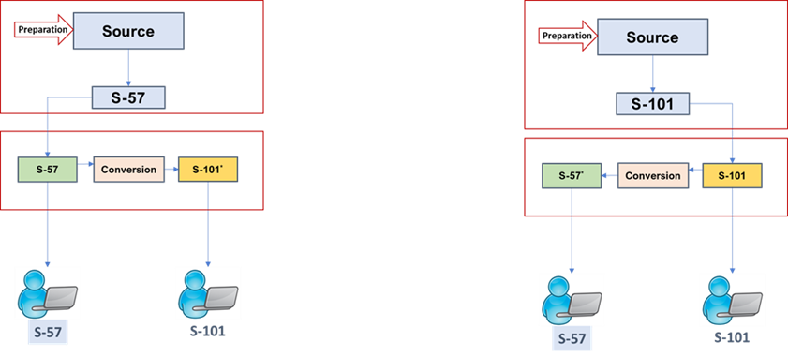
Figur: A "conversion" based model for ongoing production

A hybrid model, aggregating S-57 and S-101 catalogues to co-produce ENCs and their updates is shown in the following diagram.

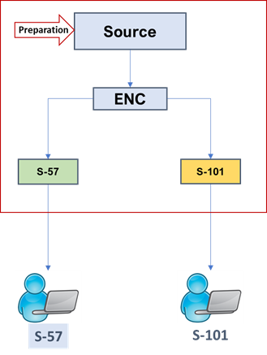
Figure 1: A Hybrid data model co-producing S-57 and S-101

Project team (Please include details of all team members in Appendix 1)

IHO Lab
Testing team, technical support and documenting results

Project governance:
Thomas Mellor, ENCWG Chairman

Team leaders:
Christian Mouden christian.mouden@shom.fr Head of S-101 development, Shom, ENCWG member

Jonathan Pritchard jonathan.pritchard@iictechnologies.com Senior Technical Manager at IIC Technologies, ENCWG member

Team members:
ENCWG S-57 to S-101 subgroup (IHO ENCWG Sec to supply full participation list if required)
Collaborator’s information:

S-57 to S-101 Converters
7Cs - Friedhelm Moggert-Kägeler, mo@sevencs.com, Solutions Director, Maritime Spatial Data
Dkart - Inga Fjellanger, inga.Fjellanger@i4-insight.com,
ESRI - Tom De Puyt, tdepuyt@esri.com, Maritime Standards
Caris - Hugh Astle, Astle, Hugh.Astle@Teledyne.com, Senior Development Manager

S-100 Viewers
S-1OOP - Izzy Kim izzykim@korea.kr
NIWC - Miroslav Stamenkovich (Mikan), mikan.stamenkovich@navy.mil

Summary of project cost (Please provide detailed breakdown of budget estimates and description of costs in Appendix 3

Resource | Description | Period | Cost
IHO lab technician x 3 | Develop test data and agree testing scenarios, document results and suggest improvements to conversion tools and data encoding | 9 months | €50K
Hardware – PCs x 3 | Standard desktop PCs to run testing and write reports | 12 months | €3K
Software | S-57 to S-101 conversion software | NA | Expected in kind support

Project items | Project costs | Funding support required
Manpower | 3 technical staff | €50k
Equipment |  | €1K
Other operating expenditure |  | NA
Total costs |  | €53K
Other source of funding

No other funding for the project has been sought

Do you require a Workspace at IHO Lab? If so please provide:
Work area needed (m³):

3 desk office spaces to host PCs

Declaration by applicants:
We the Applicants hereby declare that the information provided in this Application form, including the supporting documents attached hereto, are true and correct. We have read and understood the terms set out herein, including the Terms of Funding and we agree to be bound thereby.

Name of Applicant:
ENCWG - ENC STANDARDS MAINTENANCE WORKING GROUP

Thomas Mellor, UKHO, ENCWG Chair
Christian Mouden, Shom, S-57 to S-101 Project Lead
Jon Pritchard, IIC, S-57 to S-101 Project Lead

Date:

Appendix 1

PROJECT TEAM AND MEMBERS
United Kingdom Hydrographic Office
A) | Name | Thomas Mellor
B) | Designation | Project lead
C) | Education / Professional Qualifications | IHO ENCWG Chairman, BSc Surveying & Mapping Science, CMarTech, FIMarEST
D) | Department | Head of OEM Technical Support and Digital Standards
E) | Organisation | UKHO
F) | Postal Address | UK Hydrographic Office  Admiralty Way  TAUNTON  Somerset  TA1 2DN
G) | Tel No. | +44 (0)1823 484444
H) | Email Address | Thomas.Mellor@ukho.gov.uk

Shom
A) | Name | Christian Mouden
B) | Designation | Technical Lead
C) | Education / Professional Qualifications | Cartographic engineer
D) | Department | Cartography
E) | Organisation | Shom
F) | Postal Address | 13 rue du Chatellier – 29200 Brest - FRANCE
G) | Tel No. | +33 256 312 531
H) | Email Address | christian.mouden@shom.fr

IIC
A) | Name | Jonathan Pritchard
B) | Designation | Technical Lead
C) | Education / Professional Qualifications | BSc Mathematics, CMarTech, FIMarEST, Industry Subject Matter Expert
D) | Department | Senior Technical Manager
E) | Organisation | IIC Technologies UK
F) | Postal Address | The Catalyst, York Science Park, Baird Lane, York, YO10 5GA, United Kingdom
G) | Tel No. | +44 7464 371 695
H) | Email Address | jonathan.pritchard@iictechnologies.com

Appendix 2

PROJECT SCHEDULE
- Detailed project work plan
Phase | Activity | Time required | Resources
1 | Work preparation - Specifications | 1 month | Project team Lead and Members / IHO Lab  (possibly with the support of the IHO Conversion sub-group)
- Shared workspace organization schema for collaboration (data and results).
- Contact the converter and visualisation and validation tools providers for their interest in participating in the project this includes agreement on the licence terms (cost, duration, etc.).
- Infrastructure to be set up for hosting the various tools.
- Specification of the test datasets (geographical area, S-57 objects, etc.).
- Prepare a draft of the document that will contain the results of the conversions and the proposals for edition 2.0 of the “S-57 to S-101 conversion guidance”.
- It is recommended to split the test datasets in line with the S-57 UOC chapters (groupings to be defined) and to take account of the recommendations in the conversion document (S-64 and S-101 test datasets can also be examples).
- Test data sets will have to be pass to S-58 validation checks (validation reports to be stored).
2 | Test datasets creation  - Creation of test datasets in line with the specifications.  - Review of the datasets by the project team.  - Individual cells to test each element in the guidance documents. Establish groupings and note features/attributes.  - S-58 validation of ENCs supplied to the project.  - All test datasets created must also pass S-58 tests. | 2 months | IHO Lab + Project team
3 | Conversion  - The first phase of the conversions will be based on edition 1.0.2 of the S-101 Feature Catalogue and DCEG.  - Convert test datasets with the various tools available for the project.  - Analyse of each conversion log file.  - Validate S-101 content with the tools available.  - Analysis of results against the conversion document.  - Detail and calculate the amount of manual effort required to “finalise” S-101 datasets (“finalise” includes cross-validation of S-57 and S-101 and assessment whether they are navigationally equivalent).  - Report recommendations on possible conversion tool improvements, S-101 validation checks and guidance document improvements.  - Consider how automation of incremental updates and ongoing co-production of S-57 and S-101 can best be achieved within the boundaries of the conversion guidance document and the S-101 DCEG.  - Re-compile S-57 source data based on the rules in the guidance document and proceed with a second conversion and check the results. | 6 months | IHO Lab
4 | Results  - Review the recommendations based on the conversions and apply necessary changes to the guidance document (in view of edition 2.0.0).  - Liaise with the conversion tool providers to modify their software based on the recommendations. | 1 month | Project team + IHO Lab

- Overview in Gantt Chart format

 | Y1 M1 | Y1 M2 | Y1 M3 | Y1 M4 | Y1 M5 | Y1 M6 | Y1 M7 | Y1 M8 | Y M9 | Y1 M10 | Parties Involved
1 - Work preparation - Specifications |  |  |  |  |  |  |  |  |  |  | Project team + IHO Lab
2 - Test datasets creation |  |  |  |  |  |  |  |  |  |  | Project team + IHO Lab
3 - Conversion |  |  |  |  |  |  |  |  |  |  | IHO Lab
4 - Results |  |  |  |  |  |  |  |  |  |  | Project team + IHO Lab

Appendix 3

SUMMARY OF PROJECT COSTS (To Indicate Cash or In-Kind)
Qualifying Project Costs |  | Cost of Item  €K | Collaborator Contribution (If Any)  €K
Category* | Details of Items
Manpower  (Please provide itemised details and budget breakdown) | 3 technical staff | €50,000 | Request to IHO Lab
Equipment  (Please provide itemised details and budget breakdown) | 3 PCs | €3,000 | Request to IHO Lab
Other Operating Expenditure
(Please provide itemised details and budget breakdown)
Total €K |  | € | 53,000
*The Cost of Item indicated shall include any Collaborator Contribution(s) obtained for the same item.
*The Governing Board needs to discuss what are the qualifying expenses eligible for co-funding.

