PROPOSE PROOF OF CONCEPT: TO DEMONSTRATE AT SEA THE INTEROPERABILITY BETWEEN S-124/ S-125 AND S-101 BY ASSESSING THE S-124/S-125 STATUS CHANGE SYMBOLOGY AND PICK REPORTS OVERLAY/INTERLEAVING.
Background
The joint IALA/IHO workshop on S-100/200 development and portrayal was held between the 5 and 9 September 2022 at the Norwegian Coastal Administration in Ålesund, Norway.
The joint workshop agreed on the importance of cooperation between the two international organizations on marine digitization, and essential to inform the shipping domain of the cooperation efforts between the two bodies. Hence, it was recommended that the relevant working group and task group prepare presentations and demonstrations of S-201/S-125/S-124 data service.
Specifically on S-125, one of the important outcomes of the workshop was a clear and concise understanding of the purpose and use of S-125 was agreed upon. It was agreed that S-125 would be a suitable replacement for the List of Lights and Fog Signals and act as a bridging mechanism.
It was also agreed that the joint IHO/IALA development of S-125 should continue and the dataset should include, at a minimum, the same AtoN data contained in the S-101 Product Specification. S-125 should be tested at the earliest opportunity utilizing the services of the IHO-Singapore Innovation and Technology Laboratory.
Propose Area for the Sea Demonstration
Jong Fairway (See below ) could be used due to the availability of High Dense ENC that could be used for subsequent trials where there are more S-100 overlays to testbed. (e.g. S-102, S-104, S-111, S-129, etc)
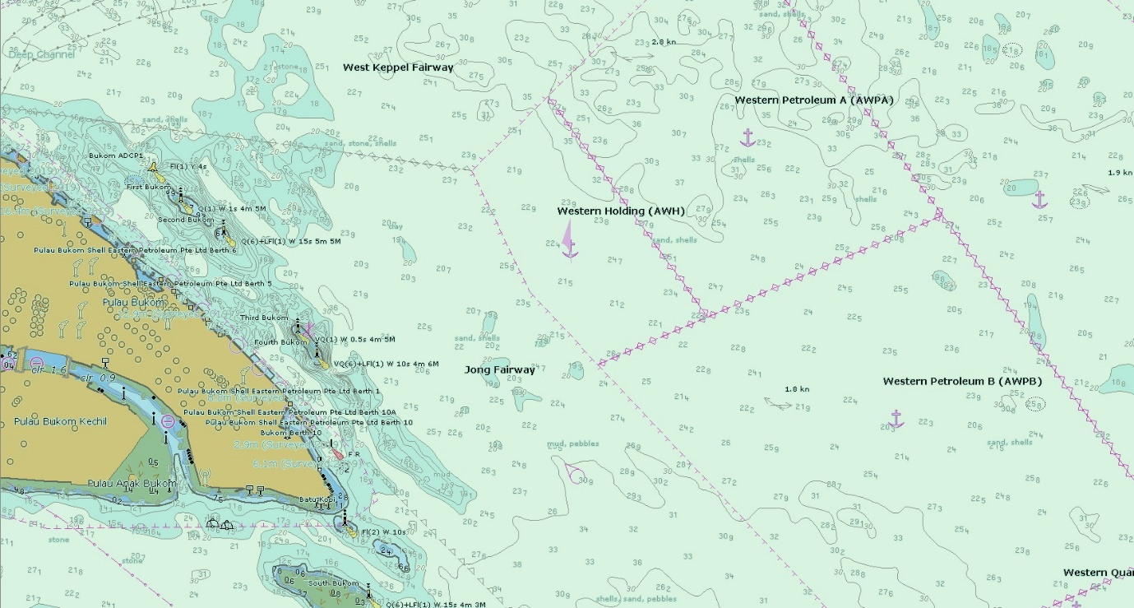
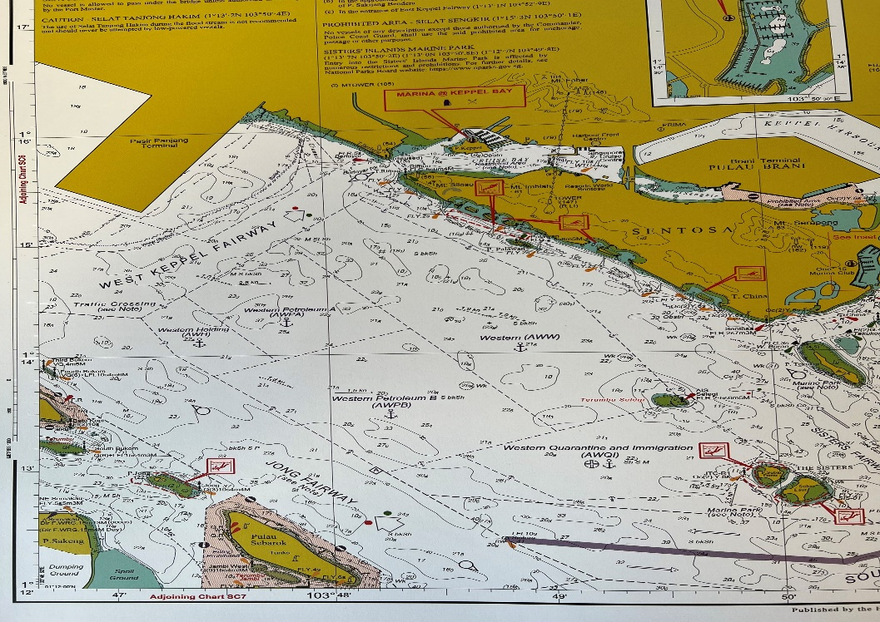
Objectives of the Proposed Proof of Concept: Demonstration Interoperability of S-101 and S-125 At Sea Using Wireless Updating via 4G/5G Telecommunications Links
- To support navigational safety to carry out supplementing of the S-101 ENCs using varying sizes of S-125 dataset, including overlays.

- To service S-125 datasets via 4/5-G telecommunications means.

- In the case where an S-124 NW and an S-125 AtoN Information overlap for the same aid, there was agreement that the S-124 NW should take priority over the S-125 AtoN Information. (Randomly generated S-124 NW messages)

- To operate an S-124 NW and S-125 Marine Aton in S-100 testbed system considering the S-98 interoperability

- To check the interoperability between S-125 and S-101 as interleaving and overlaying which was agreed from the joint IHO/IALA workshop

- To check the suitability of Aton status symbols in S-125 marine Aton product specification considering other symbols in ENC

- To test the technical specification for the provision of Aton information service to end-users in terms of e-Navigation maritime service
Funding Support
Participating agencies will provide following support for the Sea Demonstration.
South Korea – 4 x Researchers (2 from KRISO and 2 from BLUEMAP)
Software and hardware

IHO-Singapore Lab - Vessel and Crew for Sea Demonstration
Production of S-101 ENCs covering Demonstration Area
4/5-G network

