PART 2 PROJECT PROPOSAL - TO DEMONSTRATE AVAILABILITY OF ENCs (S-101 and S-57) in S-100 ECDIS for DUAL FUEL ALONG MAJOR SHIPPING ROUTES

Project Objectives:

- The main objectives of the proposed project are to:
- coordinate and provide S-57 and S-101 covering the planned routes;

- demonstrate to the shipping community and other users that the IHO and our stakeholders stand ready to make available ENCs in S-100 for Dual Fuel covering major shipping routes ahead of the 1 January 2026 commitment to the IMO.

- carry out testing of wireless updating of the S-101 ENCs and applying the latest IHO standards at sea.

Project Deliverables

Phase 1 (April 2024 – October 2024)
- In this Phase, the 3 Littoral States of Indonesia, Malaysia and Singapore agreed to produce ENCs (S-57 and S-101) covering the Malacca and Singapore Straits (MSS) from One Fathom Bank to the Eastern approaches of the Singapore Straits. Details of proposed implementation will be worked out.
- The ENCs produced for S-100 ECDIS will use the latest joint hydrographic survey results that were recently acquired covering waters shallower than 30 metres along the entire traffic separation scheme in the Malacca and Singapore Straits. In addition, the 3 Littoral States will provide S-101 and S-102 (Bathymetric Surface) datasets that could be used in the demonstration of possible interoperability. A sea trial will be conducted to test the dual fuel mode in S-100 ECDIS using the S-101 and S-57 ENCs.
- The MSS ENCs was designated with its own ID code and differs from the ENCs produced by the 3 littoral States. In addition, MSS ENCs are produced in different scale band in order to eliminate any potential conflict arising from Producer ID, scale or coverage overlaps.

Phase 2 (June 2024 – January 2025) – Details of planned route and ports of call of Italian Naval vessel “Amerigo Vespucci”
- In Phase 2, the Italian naval vessel i.e. Amerigo Vespucci will circumnavigate the world to demonstrate the availability of S-101 and S-57 ENCs along the planned major shipping routes.
- The IHO-Singapore Lab together with the Italian Navy will work with the RENCs i.e. IC-ENC and PRIMAR to provide S-57 and S-101 ENCs covering the planned route of the Amerigo Vespucci. The ENCs will also incorporate the ENCs of the Malacca and Singapore Straits provided under Phase 1. Amerigo Vespucci will call on ports around the world.
- For both Phases, dual fuel S-100 ECDIS provided by Korea Hydrographic and Oceanographic Agency (KHOA) will be deployed for the field testing at sea, including the testing of real-time wireless updating datasets and standards (catalogues). The S-100 ECDIS will be provided by the OEM and/or research institutes.

Practical relevance to Hydrographic Community/Industry:

- The main impact of the proposed demonstration would be to highlight IHO’s commitment to IMO and IEC in providing ENCs for S-100 ECDIS along major shipping routes before 1 January 2026.

- The proposal will clearly show the high-level cooperation among the stakeholders eg. IHO Member States, RENCs and OEM working together towards a common goal of providing official ENCs covering major shipping routes.

- Besides providing both S-100 and S-57 ENCs, the project will also carry out wireless updating of the ENCs and IHO standards at sea. The updating will be done using the S-100 ECDIS provided by the OEM and Research Institute.

- Main beneficiaries would be the shipping community for safer navigation and other users of the ENCs.

- Publicity to the project is necessary to showcase the commitment and readiness of hydrographic offices to deliver the ENCs for S-100 ECDIS covering major shipping routes would be timely. Project results will be shared and discussed with the Lab GB and participating organizations before making them public.

Members of Project team (Phase 1) (See Appendix 1a for details)

Joint Project Lead: Hydrographers from Indonesia, Malaysia and Singapore

Advisor to Project: Parry Oei

Hydrographic Offices: Hydrographic Offices from Indonesia, Malaysia and Singapore

Dual fuel S-100 ECDIS partner: KHOA

Members of Project team (Phase 2) (See Appendix 1b for details)

Advisor to Project: Parry Oei

Hydrographic Offices: Italian Navy

RENCs: PRIMAR, IC-ENC

Dual fuel S-100 ECDIS partner: KHOA

Collaborator scope of work:

(Phase 1)
To jointly produce S-57 and S-101 ENCs based on the latest joint hydrographic survey results that were recently acquired covering waters shallower than 30 metres along the entire traffic separation scheme in the Malacca and Singapore.

(Phase 2)
To provide S-57 and S-101 ENCs covering the planned routes and ports of call by the Italian naval vessel Amerigo Vespucci, including scoping simple testing of wireless updating at sea.

(Phase 1 and Phase 2)
To demonstrate ENCs in S-100 ECDIS for dual fuel mode along major shipping routes and updates of ENCs and IHO standards (FC/PC).

Project schedule (See Appendix 2 for details)

Estimated project duration: Twelve (12) months.

Summary of project cost (See Appendix 3 for details)

IHO-Singapore Lab funding the logistics for the hosting of the joint production and validation of the S-101 ENCs against to S-57 ENCs.

Sea trials will be conducted, one for Phase 1 and one for Phase 2

Other source of funding
(Have you attempted, applied for or obtained any other form of incentives/funding for this project or any similar project)

Self-funded participating applicants will provide their respective in-kind support/contribution.

Do you require a workspace at IHO Lab? (If so, please elaborate):

Work area needed at the Lab (physical or virtual)
- Workspace for the production and carrying out of quality assurance.

Declaration by applicants:
We the Applicants hereby declare that the information provided in this Application form, including the supporting documents attached hereto, are true and correct. We have read and understood the terms set out herein, including the Terms of Funding and we agree to be bound thereby.

Name of Applicant:

Date:

Appendix 1a

PROJECT TEAM LEADER AND MEMBERS (Phase 1)

Pushidrosal – Indonesian Navy Hydrographic and Oceanographic Center
A) | Name | Commander Mohammad Qisthi Amarona
B) | Designation | ENC Manager
C) | Education / Professional Qualifications | Geodesy and Marine Cartographer
D) | Department | Charting Division
E) | Organisation | Pushidrosal
F) | Postal Address | Jalan Pantai Kuta V No 1, Ancol Timur, Jakarta
G) | Tel No. | +62 81281212075
H) | Email Address | qisthi.amarona@gmail.com

National Hydrographic Centre, Malaysia
A) | Name | Lt Cdr Muhammad Aizat bin Azmi RMN
B) | Designation | In-charge of ENC Production
C) | Education / Professional Qualifications
D) | Department | Electronic Navigational Chart
E) | Organisation | National Hydrographic Centre
F) | Postal Address | Pulau Indah, 42009 Port Klang, Selangor
G) | Tel No.
H) | Email Address | aizat.azmi@navy.mil.my

Maritime and Port Authority of Singapore
A) | Name | Mr. Lee Weng Choy
B) | Designation | Deputy Chief Hydrographer
C) | Education / Professional Qualifications | Degree
D) | Department | Hydrographic Division
E) | Organisation | Maritime and Port Authority of Singapore
F) | Postal Address | 7B Keppel Road #20-00 (S 089055)
G) | Tel No. | 65-63252031
H) | Email Address | Lee_Weng_Choy@mpa.gov.sg

Korea Hydrographic and Oceanographic Agency (KHOA)
A) | Name | Dr Sewoong Oh
B) | Designation | Principal Research Engineer
C) | Education / Professional Qualifications | Industrial System Engineering, PhD
D) | Department | Maritime Digital Transformation Research Centre
E) | Organisation | Korea Research Institute of Ships and Ocean Engineering
F) | Postal Address | (34103) 32, Yuseong-daero 1312 beon-gil, Yuseong-gu, Daejeon, Republic of Korea
G) | Tel No. | +82-42-866-3692
H) | Email Address | osw@kriso.re.kr

Appendix 1b

PROJECT TEAM LEADER AND MEMBERS (Phase 2)

Istituto Idrografico della Marina – Italian Navy Hydrographic Institute
A) | Name | Cdr Erik BISCOTTI
B) | Designation | Head of Survey Production Department
C) | Education / Professional Qualifications
D) | Department | Survey Production Department
E) | Organisation | IIM - Istituto Idrografico della Marina - Italia
F) | Postal Address | Passo dell'Osservatorio 4, 16134 Genova
G) | Tel No. | +39 010 244 3277
H) | Email Address | erikd.biscotti@marina.difesa.it

Istituto Idrografico della Marina – Italian Navy Hydrographic Institute
A) | Name | Lt Cdr Cosmo PELUSO
B) | Designation | Head of Production Department
C) | Education / Professional Qualifications
D) | Department | Production Department
E) | Organisation | IIM - Istituto Idrografico della Marina - Italia
F) | Postal Address | Passo dell'Osservatorio 4, 16134 Genova
G) | Tel No. | +39 010 244 3279
H) | Email Address | cosmo.peluso@marina.difesa.it

International Centre for ENC (IC-ENC)
A) | Name | James Harper
B) | Designation | General Manager
C) | Education / Professional Qualifications
D) | Department | -
E) | Organisation | IC-ENC
F) | Postal Address | Taunton TA1 2DL, United Kingdom
G) | Tel No. | +47 51 85 88 78
H) | Email Address | james.harper@ic-enc.org

PRIMAR
A) | Name | Hans Christoffer Lauritzen
B) | Designation | Director
C) | Education / Professional Qualifications
D) | Department | -
E) | Organisation | PRIMAR
F) | Postal Address
G) | Tel No. | +47 51 85 88 78
H) | Email Address | hans.christoffer.lauritzen@kartverket.no

Korea Hydrographic and Oceanographic Agency (KHOA)
A) | Name | Dr Sewoong Oh
B) | Designation | Principal Research Engineer
C) | Education / Professional Qualifications | Industrial System Engineering, PhD
D) | Department | Maritime Digital Transformation Research Centre
E) | Organisation | Korea Research Institute of Ships and Ocean Engineering
F) | Postal Address | (34103) 32, Yuseong-daero 1312 beon-gil, Yuseong-gu, Daejeon, Republic of Korea
G) | Tel No. | +82-42-866-3692
H) | Email Address | osw@kriso.re.kr

Appendix 2

PROPOSED PROJECT SCHEDULE – PHASE 1 & 2
Phase 1
Task | Year 1 Q1 | Year 1 Q2 | Year 1 Q3 | Year 1 Q4 |  |  |  | Parties Involved
Host Coordinating meeting |  |  |  |  |  |  |  | - HOs from 3 Littoral States
Production of S-101 ENCs covering the traffic separation scheme in Malacca and Singapore Straits. |  |  |  |  |  |  |  | - HOs from 3 Littoral States
Validation of ENCs |  |  |  |  |  |  |  | - HOs from 3 Littoral States
Conduct sea demonstration |  |  |  |  |  |  |  | - HOs from 3 Littoral States,  - KHOA
Project documentation |  |  |  |  |  |  |  | - HOs from 3 Littoral States, KHOA

Phase 2:
Task | Year 1 Q1 | Year 1 Q2 | Year 1 Q3 | Year 1 Q4 |  |  |  | Parties Involved
Host Coordinating meeting |  |  |  |  |  |  |  | - IHO-SG Lab, Italian Navy
Provision of S-101 ENCs and incremental updates covering the planned route of the ITS Amerigo Vespucci |  |  |  |  |  |  |  | - IHO-SG Lab, Italian Navy, IC-ENC, PRIMAR
Conduct sea demonstration |  |  |  |  |  |  |  | - IHO-SG Lab, Italian Navy, IC-ENC, PRIMAR, KHOA
Project documentation |  |  |  |  |  |  |  | - IHO-SG Lab, Italian Navy, IC-ENC, KHOA

Planned route and ports of call of Amerigo Vespucci
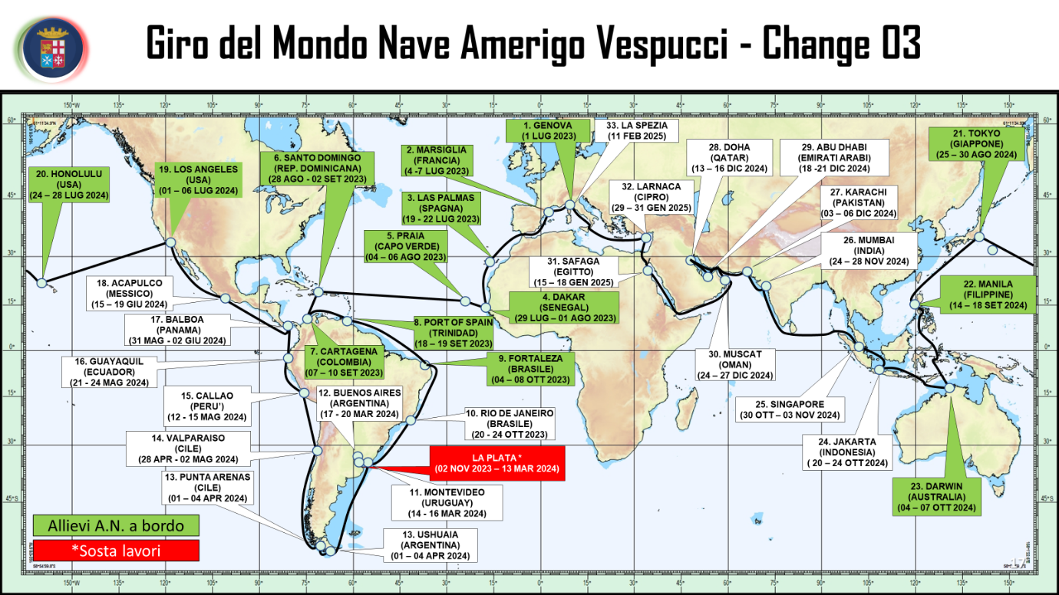
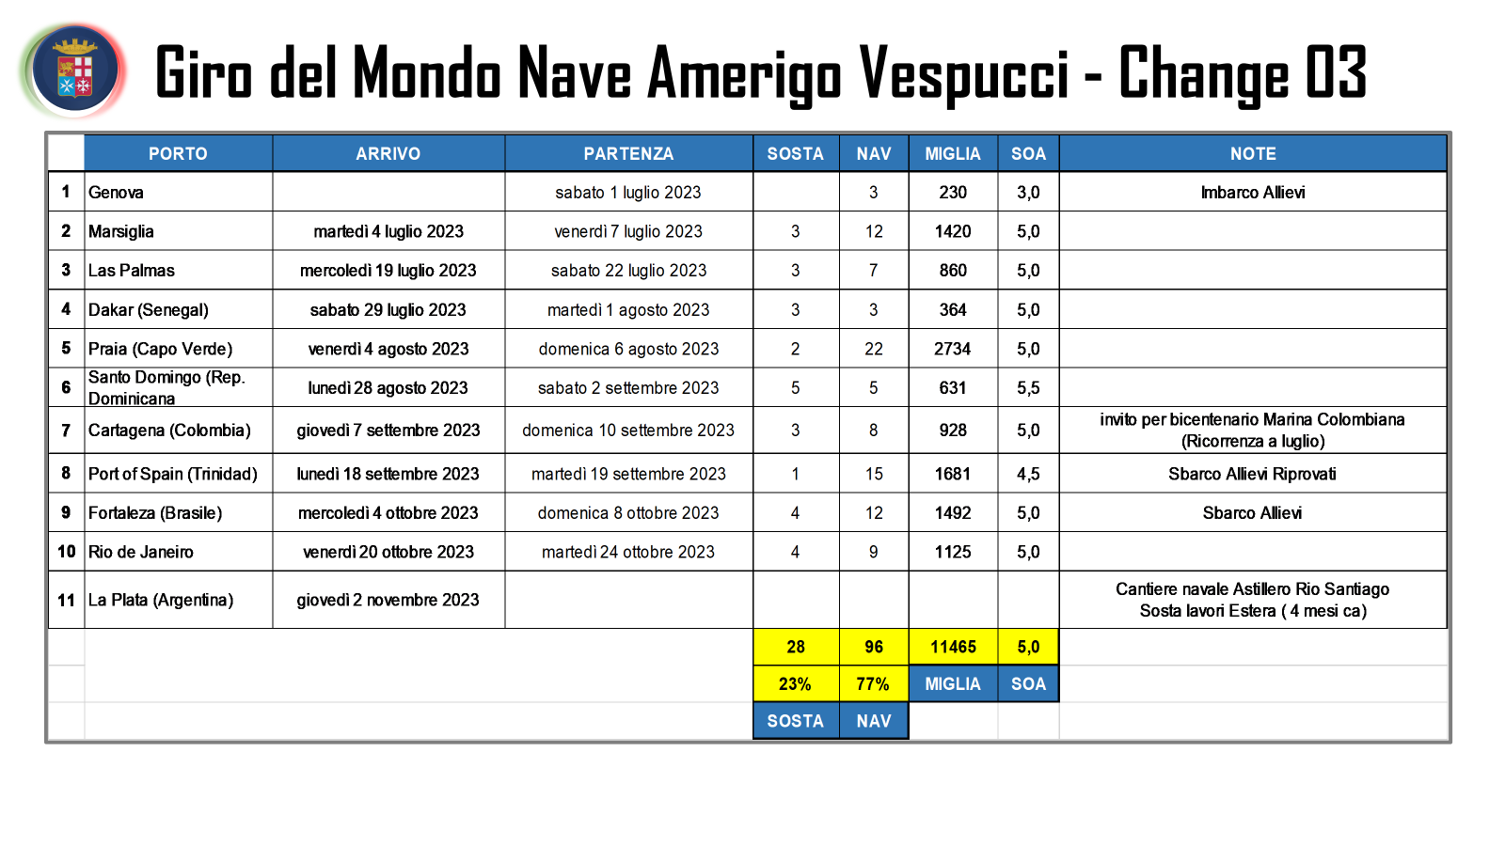
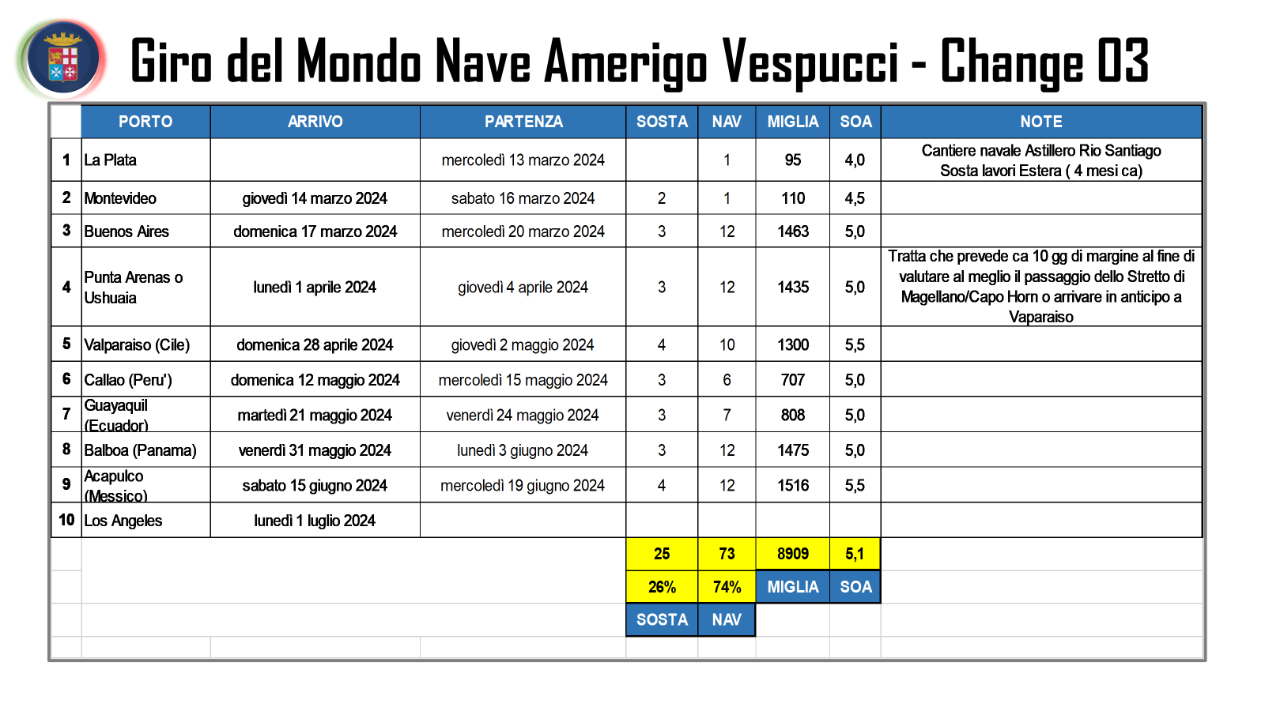
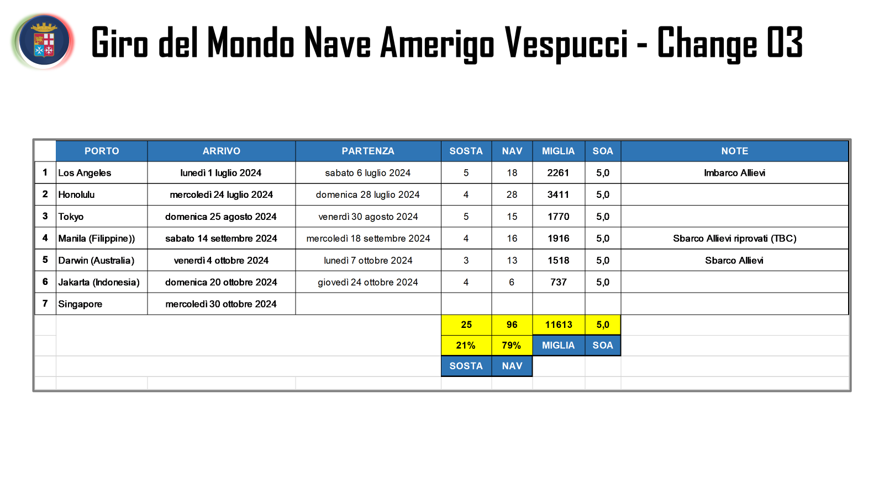
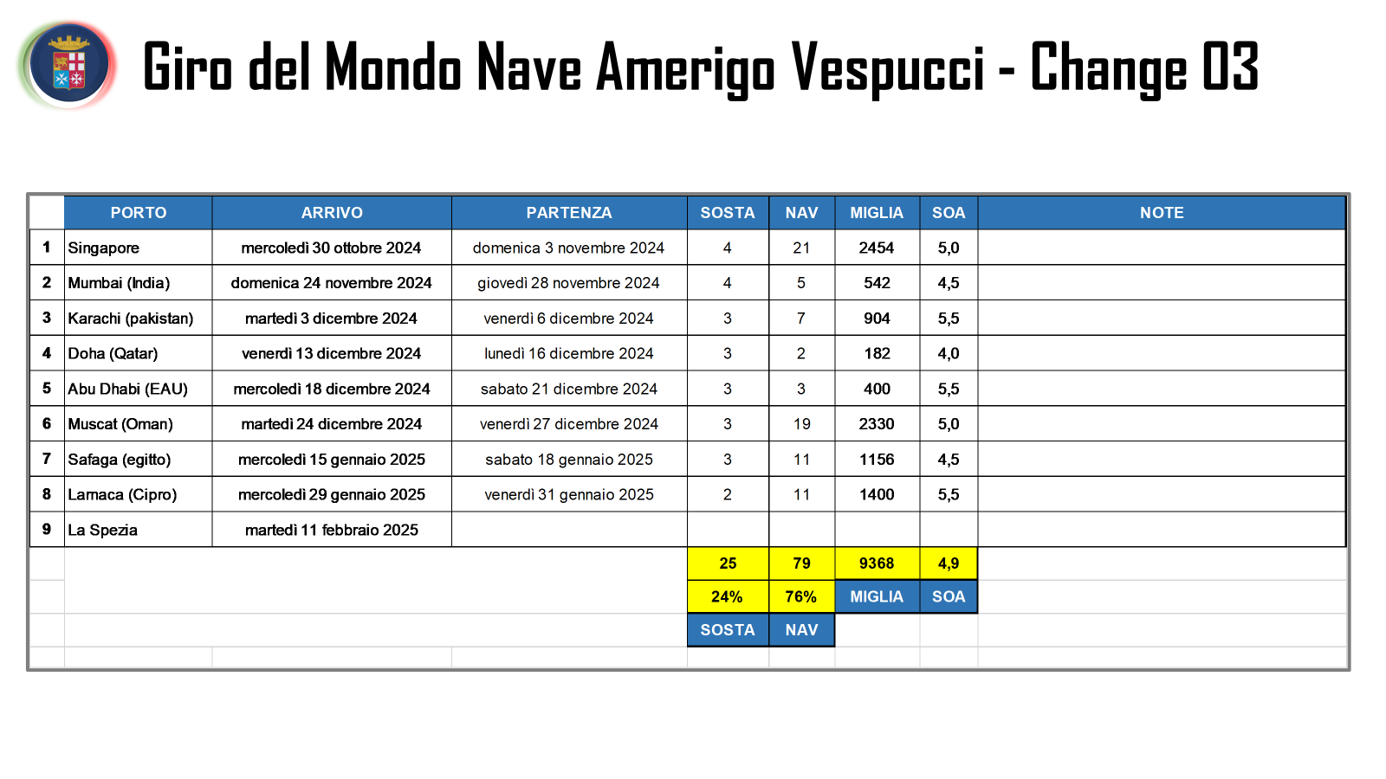

Appendix 3a

SUMMARY OF PROJECT COSTS FOR PHASE 1 (To Indicate Cash or In-Kind)
Qualifying Project Costs |  | Cost of Item  €K | Collaborator Contribution (If Any)  €K
Category* | Details of Items
Manpower  (Please provide itemised details and budget breakdown) | Cartographic Officers from 3 Littoral States. To cover travel, accommodation, and Subsistence allowance. | €XX | In-kind
Equipment  (Please provide itemised details and budget breakdown) | CARIS and 7Cs tools  2 x Testbed S-100 ECDIS | €XX  €XX | In-kind
Other Operating Expenditure  (Please provide itemised details and budget breakdown) | Logistics and IT support | €XX | In-kind
Total €K |  | €XXK
*The Cost of Item indicated shall include any Collaborator Contribution(s) obtained for the same item.

Appendix 3b

SUMMARY OF PROJECT COSTS FOR PHASE 2 (To Indicate Cash or In-Kind)
Qualifying Project Costs |  | Cost of Item  €K | Collaborator Contribution (If Any)  €K
Category* | Details of Items
Manpower  (Please provide itemised details and budget breakdown) | Hydrographic Officers of the Member States from which the ENCs are provided, or  RENCs personnel | €XX | In-kind
Equipment  (Please provide itemised details and budget breakdown) | CARIS and 7Cs tools  2 x Testbed S-100 ECDIS (one for each sea trial) | €XX  €XX | In-kind
Other Operating Expenditure  (Please provide itemised details and budget breakdown) | Logistics and IT support | €XX | In-kind
Total €K |  | €XXK
*The Cost of Item indicated shall include any Collaborator Contribution(s) obtained for the same item.

