**B-12 Edition 2.0.3**

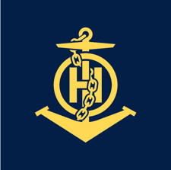

Published by the

International Hydrographic Organization

4b quai Antoine 1er

Principauté de Monaco

Tel: (377) 93.10.81.00

Fax: (377) 93.10.81.40

info@iho.int

www.iho.in

**Guidance on Crowdsourced Bathymetry**

|  |
| --- |
| © Copyright International Hydrographic Organization 2022 |
| This work is copyright. Apart from any use permitted in accordance with the Berne Convention for the Protection of Literary and Artistic Works (1886), and except in the circumstances described below, no part may be translated, reproduced by any process, adapted, communicated or commercially exploited without prior written permission from the International Hydrographic Organization (IHO) Secretariat. Copyright in some of the material in this publication may be owned by another party, and permission for the translation and/or reproduction of that material must be obtained from the owner. |
| This document, or partial material from this document, may be translated, reproduced or distributed for general information, on no more than a cost recovery basis. Copies may not be sold or distributed for profit or gain without prior written agreement of the IHO Secretariat and any other copyright holders. |
| **In the event that this document or partial material from this document is reproduced, translated or distributed under the terms described above, the following statements are to be included:** |
| *“Material from IHO publication B-12 Edition 1.0.0 is reproduced with the permission of the IHO Secretariat (Permission No ……./…) acting for the International Hydrographic Organization (IHO), which does not accept responsibility for the correctness of the material as reproduced: in case of doubt, the IHO’s authentic text shall prevail. The incorporation of material sourced from IHO shall not be construed as constituting an endorsement by IHO of this product.”* |
| *“This publication is a translation of IHO B-12 Edition 1.0.0 – IHO Guidance on Crowdsourced Bathymetry. The IHO has not checked this translation and therefore takes no responsibility for its accuracy. In case of doubt the source version of IHO publication B-12 Edition 1.0.0 in English should be consulted.”*  **The IHO Logo or other identifiers shall not be used in any derived product without prior written permission from the IHO Secretariat.** |

# IHO Statement on Crowdsourced Bathymetry

Crowdsourced bathymetry(CSB) is the collection of depth measurements from vessels, using standard navigation instruments, while engaged in routine maritime operations. The International Hydrographic Organization[1] (IHO) has a long history of encouraging the collection of crowdsourced bathymetry, to help improve mankind’s understanding of the shape and depth of the seafloor.

The General Bathymetric Chart of the Ocean[2] (GEBCO) project was initiated in 1903 by Prince Albert I of Monaco to provide the most authoritative, publicly available bathymetry (depth maps) of the world's oceans. Over the years, the GEBCO project, now jointly overseen by the IHO and the Intergovernmental Oceanographic Commission[3] (IOC) of UNESCO, has produced maps of the ocean floor from depth measurements collected by vessels as they journeyed across the oceans. These “passage soundings” have enabled the creation of progressively more-detailed seafloor maps and digital data grids. More recently, systematic surveys have also been used to improve the maps and grids.

Unfortunately, despite the multitude of data that have been collected since 1903, the vast majority of the world’s oceans have not been directly sounded; the rest of the data used to compile seafloor maps are estimated depths. These estimated depths are largely derived from satellite gravity measurements, which can miss significant features and provide only coarse-resolution depictions of the largest seamounts, ridges and canyons. Progress in mapping coastal waters is only marginally better. IHO publication C-55, Status of Surveying and Charting Worldwide[4], indicates that about fifty percent of the world’s coastal waters shallower than 200 metres remain unsurveyed.

While the hydrographic and scientific community lament this lack of data, the world’s interest in seas, oceans and waterways continues to increase. The concept of a blue economy is firmly established, along with an ever-growing public awareness of mankind’s dependence upon, and vulnerability to, the sea. Several high-level global initiatives are now in place that seek to address ocean issues, including the United Nation’s 2030 Agenda for Sustainable Development Goals[5], the Paris Agreement under the United Nations Framework Convention on Climate Change[6], the Sendai Framework for Disaster Risk Reduction 2015-2030[7] and The GEBCO Programme[8]. In this context, the shortfall in bathymetric data is even more significant, as it is now recognised that knowledge of the depth and shape of the seafloor underpins the safe, sustainable, and cost-effective execution of almost every human activity on, beneath and beside the sea.

In 2014, the IHO, at its Fifth Extraordinary International Hydrographic Conference (EIHC-5), determined to improve this situation by progressing actions to improve the collection, quality and availability of hydrographic data worldwide. One of these actions, Proposal 4, concerned crowdsourced bathymetry. The EIHC-5, considering Proposal 4, and the comments made during the Conference, decided, in Decision 8, to task the Inter-Regional Coordination Committee (IRCC)[9] to establish a working group to prepare a new IHO publication on policy for crowdsourced bathymetry. The resulting guidance as presented by means of this document has formed the basis for the global uptake of CSB as citizen science in the digital age.

The International Maritime Organization (IMO) Safety of Life at Sea (SOLAS) [10] carriage requirements oblige all commercial vessels to be equipped with certified echo-sounders and satellite-based navigation systems. As a result, the world’s commercial fleet represents a significant, untapped source of potential depth measurements in the same way that mariners currently and routinely observe the weather and make other marine environmental observations.

The practical application of B-12 is also fundamental for the conduct of the collaborative Nippon Foundation GEBCO Seabed 2030 Project. As part of the project, simple data loggers are provided to local vessels operating near shore that do not fall under IMO regulations. Aiming to bring together all available bathymetric data to produce the definitive map of the world ocean floor by 2030 and make it available to this project is in full compliance with the targets of the GEBCO Programme.

While CSB data may not meet accuracy requirements for charting areas of critical under-keel clearance, it holds limitless potential for myriad other uses. If vessels collect and donate depth information while on passage, the data can be used to identify uncharted features, to assist in verifying charted information, and to help confirm that existing charts are appropriate for the latest traffic patterns. Crowdsourced bathymetry can also provide vital information to support national and regional development activities, and scientific studies in areas where little or no other data exists.

Recognizing the relevance of bathymetry to international maritime policy and the blue economy and noting that crowdsourced bathymetry may be useful for many potential users of the world’s seas, oceans and waterways, the IHO has developed this guidance document to state its policy towards, and provide best practices for collecting, crowdsourced bathymetry. It is hoped that this document will provide volunteer data collectors and interested parties with guidelines for gathering and assessing the quality of CSB data.

**This document provides technical guidelines only that in no way supersede national or international laws and regulations.**

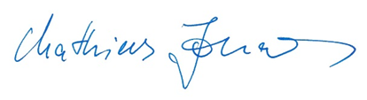

Secretary-General  
20 January 2020

|  |
| --- |
|  |

# Introduction

## I. Purpose and Scope

The purpose of this document is to provide guidance to mariners to help them collect and contribute crowdsourced bathymetric data in a format that is useful to the broadest possible audience. Hopefully this document will help mariners optimise data collection and sharing following recommendations promoted by the International Hydrographic Organization for gathering and contributing CSB data.

This document is *not* meant to provide advice or recommendations on systematic bathymetric data acquisition and processing, for these the interested reader is invited to consult the IHO C-13 and IHO S-44 6th edition. With the main aim of this document being to optimize the acquisition, processing and use of opportunistic bathymetric information, it has been decided to refrain from focusing on a specific technology or software, but rather provide information on general concepts about crowdsourced bathymetric data acquisition, metadata content and data uncertainty, to help data collectors and data users better understand quality, completeness, and accuracy issues with crowdsourced bathymetry.  Additional considerations related to crowdsourced bathymetric data logging and data sharing are also briefly explored.

This document is not intended to provide definitive guidance on how best to use crowdsourced data, as the scope of CSB is far-reaching and has many potential future applications.

## II. Target Audience

The IHO seeks to inform and guide all stakeholders of crowdsourced bathymetry data. Organizations (also referred to as ‘Trusted Nodes’) interested in serving as liaisons between data collectors and the IHO may also find the information helpful. Users of crowdsourced bathymetry data may find this document informative, as well, although they are not the primary audience.

## III. Document Structure

This document addresses several topics related to crowdsourced bathymetry. Chapter One, “*Data Contribution*,” provides information about how to send crowdsourced bathymetry to the IHO Data Centre for Digital Bathymetry (DCDB), via Trusted Nodes.

Chapter Two, “*Data Collection**,”* provides an overview of the general principles as well as best practices and recommendations for collecting CSB. Chapter Three, “*Data and Metadata**,”* describes the importance of data and metadata, and details the information that is required for submitting CSB to the DCDB, as well as additional information that should be collected whenever possible.

"Chapter Four, “Data Quality Assessment”, delves into data quality concepts like uncertainty and data consistency, and discusses how to provide feedback and suggestions to the CSB data contributor for improving future contributions." Chapter Five, “*Additional Considerations*”, discusses issues that collectors and Trusted Nodes may wish to consider before engaging in CSB activities.

Additional detail and further reading are provided via Annexes and external links. This guidance document is intended to be a living document and will be updated in light of further experience and feedback from data collectors, Trusted Nodes and data users.

|  |
| --- |
|  |

# 1. Data Contribution to the IHO DCDB

This chapter details the process, guidance and requirements for contributing crowdsourced bathymetry (CSB) data to the IHO Data Centre for Digital Bathymetry (DCDB). These data will in turn be made openly available through the IHO DCDB Map Viewer[11]

Hydrographic and bathymetric data collected by the National Antarctic Programmes’ ships and others linked with their activity in the Antarctic, should be forwarded by the National Antarctic Programmes, or by other means, to the national hydrographic services using the IHO Collection and Rendering of Hydrographic Data Form available via the IHO website[12]. This process and form, which are safety-of-navigation and charting oriented, do not prevent ships of opportunity from applying guidelines given in B-12, which are multi-purpose oriented as far as bathymetric data are concerned.

## 1.1 IHO Data Centre for Digital Bathymetry

The DCDB was established by the IHO in 1990 to steward the worldwide collection of open bathymetric data. The Centre archives and shares, openly, depth data contributed by vessel owner/operators or their authorized agents from across the world. The contributors of these data, like the users, can come from various sectors of the community, such as fishing, commercial shipping, hydrographic offices, recreational boating, super yachts, cruise ships, marine scientific research, marine contractors and others and in the context of this document are referred to as “crowdsourced bathymetry (CSB) data contributors”. The DCDB is hosted by the US National Oceanic and Atmospheric Administration’s (NOAA) National Centers for Environmental Information (NCEI)[13] in Boulder, Colorado, USA. Data archived by the DCDB on behalf of the IHO are discoverable and accessible online via the IHO DCDB Map Viewer.

## 1.2 Overview of CSB Data Flow

CSB data, identified as being of the seabed and ocean floor beyond the limits of national jurisdiction, will be ingested into the DCDB database and made publicly discoverable and accessible without restriction on its use. When CSB data is collected within a country’s jurisdiction, the IHO DCDB receives and redistributes the data in a manner that is consistent with national legislation and related caveats as communicated to and via the IHO. Figure 1 illustrates possible scenarios that may be applied to contributed CSB data that is acquired within maritime zones subject to national jurisdiction. The flow diagram is of generic nature. The distribution flow of CSB data will be based on the information received by the IHO Secretariat from individual coastal States on request.

Further details of which coastal States support the distribution and access of CSB data collected within their waters of national jurisdiction, along with any caveats they have articulated, are available from the IHO website[14]. CSB data, collected within waters of national jurisdiction of coastal States that did not notify the IHO Secretariat of their support for CSB within their national waters, will not be made publicly discoverable or accessible. This data will be stored and only made available at such time as authorization is received by the IHO from the respective coastal State.

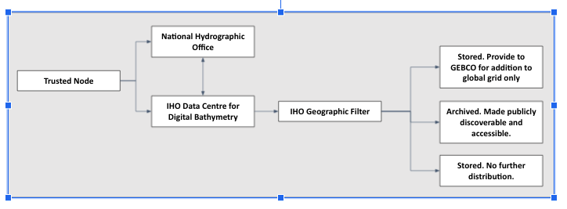

Figure 1. A schematic of a filtered flow schematic of a filtered flow of CSB data based on the response provided by a coastal State to an IHO CSB questionnaire.

## 1.3 The Trusted Node Model

The DCDB currently accepts CSB contributions through a network of Trusted Nodes (Figure 2). An IHO DCDB Trusted Node is an approved organization or individual who systematically receives CSB data collected by vessels or other platforms and delivers them to the IHO DCDB. Trusted Nodes may assist the mariner by providing access to data logging or transmission equipment, providing technical support to vessels, downloading data from data loggers, and providing the information to the DCDB. The DCDB works with each Trusted Node to standardize metadata and data formats and define data delivery requirements. This model normalises data contributions and minimizes the requirements and effort for mariners.

The concept of 'Trusted Node' came from the understanding that it would not be feasible for every individual CSB data contributor to approach the DCDB to discuss their data exchange individually and be expected to learn about data formats, how to formulate metadata, how to establish a data transfer, etc. At the same time, grouping a number of CSB data contributors from a same geographic area or sector could allow for a central coordinator (ie: Trusted Node) to motivate, incentivise and provide feedback - e.g. a visualisation of the group's contributed data.

The Trusted Node is tasked with staying up to date with methods and formats in order to exchange data with the DCDB. They are also charged with promoting contributions and maintaining interest and involvement of those potentially interested in contributing CSB data. Ideally, the Trusted Node is able to contact a CSB data contributor when the DCDB receives data with an obfuscated identifier (rendering the contribution practically anonymous). The Trusted Node can query the contributor about anomalies in its contributed dataset and watch over the good operation of the technology used to log. The Trusted Node is also the CSB data contributor’s first point of contact in case of questions or a need for technical support.

To achieve this, the Trusted Node may need to have, or develop, technical skills (software) to shape the incoming contributions into the data format required by the DCDB - however, it is not the Trusted Node's responsibility to correct (e.g. for tide or offsets), curate or clean the data to any extent. It is this working group's guidance that raw data, with a good indication of what the observer's offsets and context were, are preferable as a contribution to DCDB (refer to section 3.2.1).

Lastly, since Trusted Nodes may also be part of the IHO's CSB Working Group, they are the ideal conduit to bring feedback directly from the CSB data contributors and push for policy improvements and possibly changes.

When CSB data is collected within a country’s jurisdiction, the Trusted Node should operate in a manner that is consistent with national legislation and related caveats such as (but not necessarily limited to) communicated to and via the IHO.

While individual data contributions may be accepted, CSB data contributors will be encouraged to join an existing Trusted Node if possible.

Parties interested in becoming a Trusted Node or learning about what existing Trusted Node they might be able to join should contact the DCDB at bathydata@iho.int.

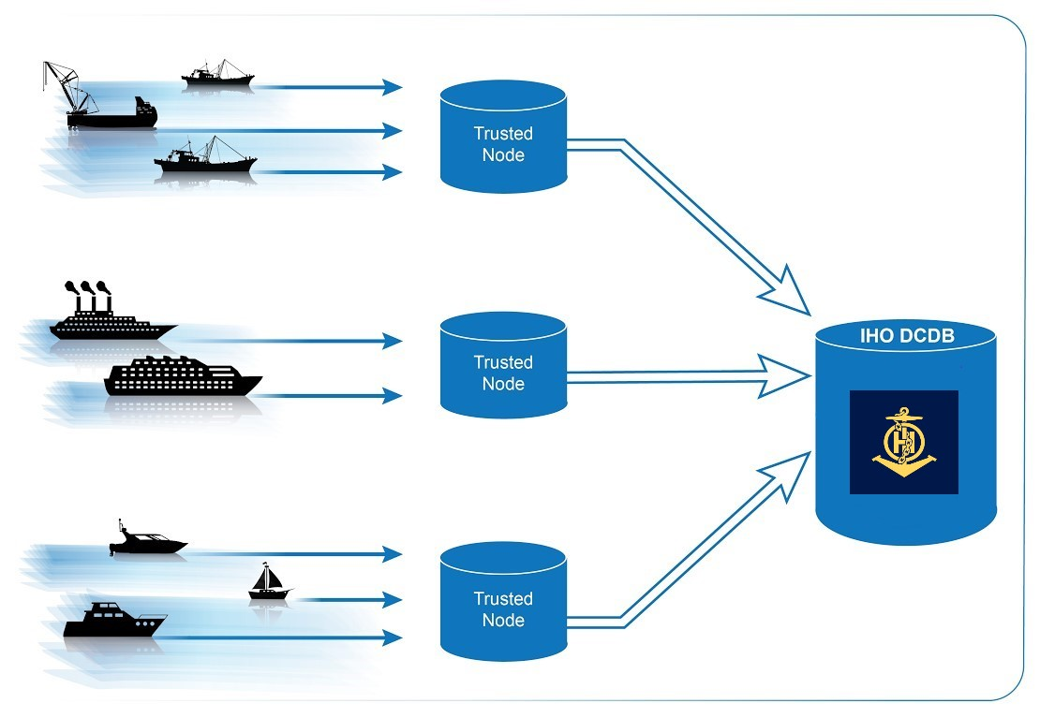

Figure 2. Data flow from vessels, through Trusted Nodes, to the DCDB.

## 1.4 Submitting Data as a Trusted Node

An *IHO CSB* *Trusted Node Agreement Form* will be provided to all potentially interested Trusted Nodes. This document captures the frequency of data submissions, potential data transfer solutions, data formatting, licensing agreements and confirms the understanding that these data will be made publicly available unless identified as “restricted” by the geographic filter described in Section 1.2. If both parties are in agreement, the *IHO CSB Trusted Node Agreement Form* will be signed thus establishing the CSB data contributor as an IHO CSB Trusted Node. An example of the current *IHO CSB Trusted Node Agreement Form* can be found on the IHO DCDB website[15].

The new Trusted Node will be encouraged to review Chapter 3: Data and Metadata of this document to understand how to conform to the required data format and metadata standards and also the *CSB Data Submission to the IHO DCDB Guidance Documentation*, also found on the IHO DCDB website[16]. The latter includes technical detailed instructions on how to make either frequent or infrequent data submissions. The DCDB will then continue to work with the new Trusted Node on establishing the correct data format required to ingest the contributed data into the CSB database.

1.5 Accessing CSB Data

The DCDB map viewer is an online tool where users can search for, identify and obtain CSB data. To help users search for specific data that they are looking for, the map viewer contains filters that correspond to a specified time range or submitting vessel (unless the submitting vessel chooses to remain anonymous). Users can also identify data files geographically, using the Identify tool, which allows users to click on a single point, draw a rectangle or polygon, or input geographic bounds.

Once a selection has been made, a pop-up window shows the corresponding files. Clicking on a file name yields additional information about the file. Users can select “Extract CSB Data Files” from the drop down menu in order to receive all files listed in the pop-up window. The user will be taken to a Data Access page, where they can edit or finalize their order. The application then sends this data request, along with the requestor’s email, to the data delivery system, which verifies that the request is well formed and then queues the work in the processing system. When data retrieval and preparation are complete, the user is notified via email and is provided with a URL where they can retrieve the data package. The data package will include the actual geojson and/or csv data files. The CC0 1.0 data license will be included in the license field of the metadata. More information on the IHO licensing guidance for CSB data can be found in Chapter 5: Additional Considerations.

CSV format data files are also available in an Amazon S3 bucket courtesy of NOAA’s Big Data Program[17] and Amazon’s Registry of Open Data[18]. The files are organised by the date of ingest and can be accessed via standard tools such as the AWS Command Line Interface[19] or SDKs in various programming languages. The contents of the bucket can also be browsed[20] and individual files downloaded.

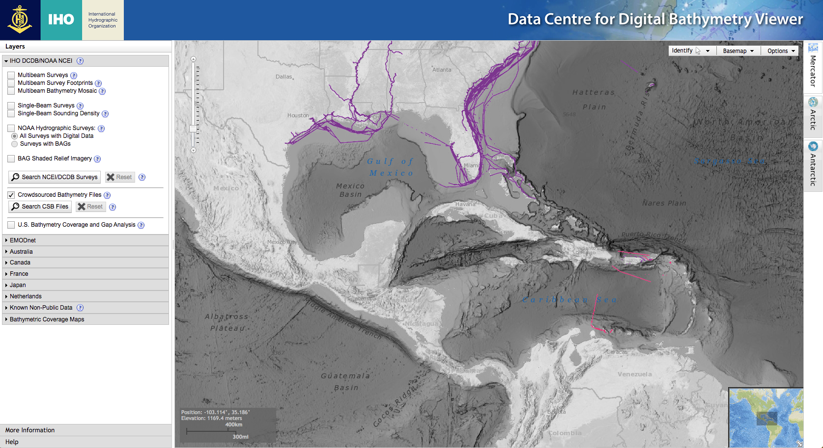

# Figure 3. The IHO CSB Data Viewer, which enables discovery of, and access to, crowdsourced bathymetry.

# 2. Data Collection

## 2.1 Systems and Sensors

Bathymetric measurements have two components: 1) a vertical one (depth) and 2) a horizontal one (geographical position). In order to assist in navigation and continuously monitor the safety state of the vessel, many vessels or platforms already possess the minimum equipment (echosounder and positioning system, respectively) needed to collect crowdsourced bathymetry (CSB). They might need only to install a data logger, or enable logging software and/or a data modem to begin collecting and transferring CSB. The intent is to collect observations from the vessels using data from the vessel’s standard navigation equipment as they perform their routine operations. The following sections provide basic information about sensors, as well as best practices and recommendations for collecting CSB. If more in-depth information about systems and sensors is needed, please refer to the IHO publications C-13, Manual on Hydrography[21] (Chapters 2 and 3) and the S-44 IHO Standards for Hydrographic Surveys[22].

### 2.1.1 Echosounders

Echo-sounders, or depth sounders, determine the water depth by transmitting sound pulses from a transducer, and recording the time it takes for the sensor to receive the return echo from the seafloor. Transducers are usually mounted on the hull of a vessel, but can be mounted on other platform, as well. There are two main types of echosounders: singlebeam and multibeam.

### 2.1.2 Positioning and motion sensors

Positioning systems help mariners determine their location on the Earth’s surface and provide vital information for CSB. Without accurate location information, CSB has little value. Most vessels carry a Global Navigation Satellite System (GNSS), which obtain positional data automatically. GNSS positions are typically provided once per second and are accompanied by a date and time stamp. CSB data collection systems should provide a position and timestamp with every depth reading. This allows data users to accurately position depth measurements and apply corrections to the data if needed. The GNSS can also output information about course over ground, speed over ground, vessel heading, the quality of the signal and interruptions in service, and eventually roll and pitch. All these data should also be logged, if possible.

Some vessels may be equipped with motion sensors. Motion sensors measure the movement of a vessel caused by the waves and swell. Motion sensor data capture vertical movement (heave) and any movement in three dimensions (pitch, roll and yaw) of the vessel. Accurate measurement of three dimensions is particularly needed when the echo-sounder emits narrow beams out of the nadir. In this case, heave, pitch, roll and yaw of the vessel are applied to the sounder measurements in order to locate horizontal and vertically the depth measurement, within the boat reference frame. Vessels that are equipped with a motion sensor should include motion sensor data at the time of data collection in the dataset they send to their Trusted Node, as it can greatly improve the quality of the final dataset.

## 2.2 Hardware and Software

In addition to depth, positioning, and motion data, there are several hardware and software variables that mariners should consider, when collecting CSB data.

### 2.2.1 Data Loggers

Crowdsourced bathymetry data loggers are electronic devices or software that connect to a vessel’s echo-sounder, the positioning system and, if available, the motion sensors and record the sensor outputs. They write to files in a format designated by the designer of the data logger or software, such as NMEA 0183. The recorded data are then relayed to a Trusted Node, who prepares the data for contribution to the DCDB. Software-based data loggers may be available in an ECDIS, integrated navigational system or electronic chart system that already incorporates input from the echo-sounder, the GNSS and, if available, the motion sensors. Vessels that do not possess a suitable electronic chart system, or data logging software, will need to install a standalone logger. Current hardware-based data loggers typically require the installation of a simple, small plug-and-play electronic component that connects to the echo-sounder, the GNSS and, if available, the motion sensors and records their output.

Their main characteristics are:

* Data logging (translating if needed) messages from all the sensors into a standardized format.
* Accurate computer time as all the messages are synchronized through time
* Potentially allow for data format export facilities [GeoJSON](http://geojson.org/), CSV, or XYZT (longitude, latitude, depth, time)

### 2.2.3 Onboard Data Storage

With onboard data loggers, vessel owners and operators should ensure that they have adequate onboard data storage capabilities to log depth and positioning data until they can transfer the data to shore or directly to a Trusted Node. Conducting one or two days of trial data logging may help the mariner identify the average file sizes logged by their unique systems and derive an estimate of data storage requirements for longer voyages. If a vessel is installing a hardware-based data logger, the mariner should consult with the data logger provider (or seek advice from the Trusted Node) to determine the logger’s data storage limits.

### 2.2.4 Data Transfer

After the CSB data are logged, the files should be transmitted to shore (or directly to a Trusted Node). Logging and transmitting processes should be as simple and automated as possible to encourage continued contribution of data. Sending and receiving data at sea can be challenging, and communication systems and bandwidth may be limited or expensive. Because of this, it is important to note that CSB data are not normally time-sensitive; the most important factor is ensuring that the data are shared. Some mariners may wish to leverage communications systems to transfer data while still underway; however, the method of data transmission could also be as simple as mailing a USB storage device to the Trusted Node. Mariners are encouraged to work with their Trusted Node or data logger supplier to identify the preferred method for data transfer.

### 2.2.5 Continuity of Electrical Power

Continuous power aboard vessels is never a guarantee. Some vessels invest in, or are required to carry, an Uninterruptable Power Supply (UPS) to provide power to navigation equipment in the event of a loss of vessel power. However, not all vessels have a UPS, and even with a UPS, there are times when the transition from shore power to a ship-board generator causes a momentary loss in power. When this happens, data loggers and instruments must reboot and recover. Consider using a data logger that will recover automatically if there is a power interruption, or one that has a back-up battery.

## 2.3 Relative location of the sensor within the acquisition platform frame

The horizontal and vertical measurements between the GNSS antenna and the echosounder transducer, and between the waterline and the transducer, are key components of the quality and accuracy of the data. Figures 4 and 5 below illustrate unproper determination of vertical and/or horizontal offsets are sources of biases in the georeferenced bathymetric measurements. Some ECDIS or chart plotter systems are programmed to incorporate these measurements when the sensors are installed. If they do not, mariners should record these offset measurements separately as best as possible, and include them in their metadata. The following sub-sections provide information about these measurements, and best practices for collecting and recording them.

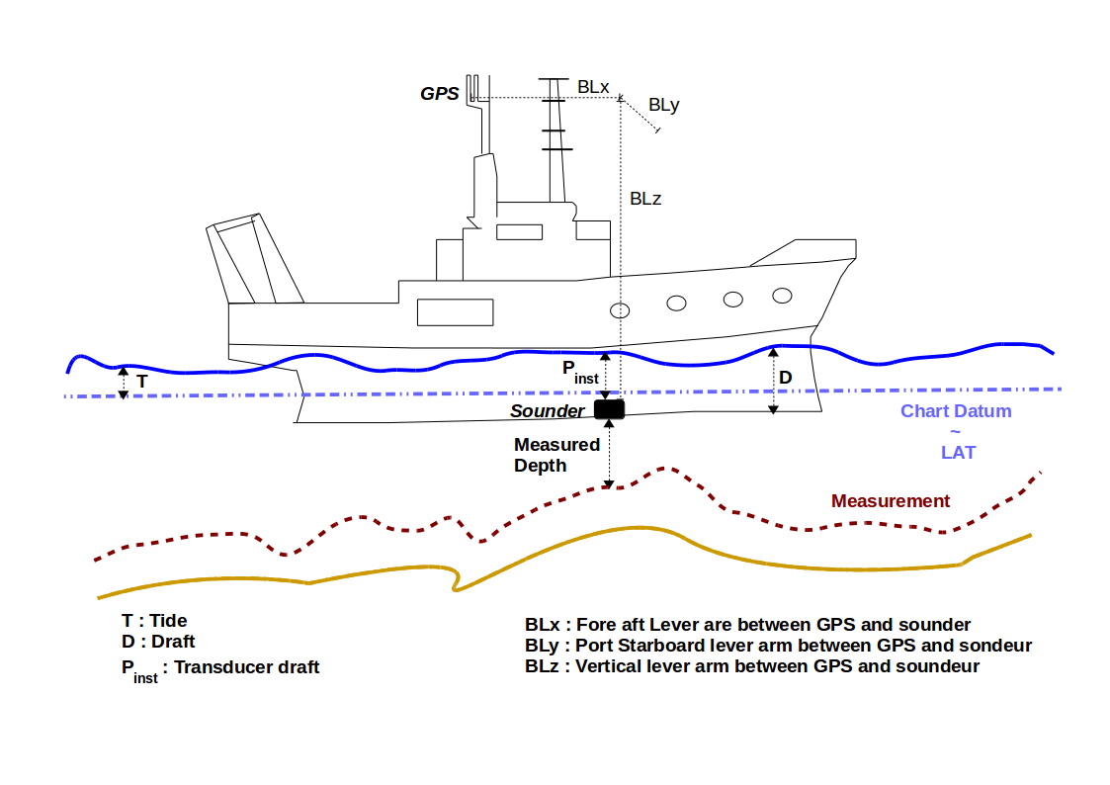

Figure 4. Examples of the effects of not correcting for vertical offsets. Here, not correcting for the offset of the transducer from the waterline leads to a measurement (red line) that differs significantly from reality (yellow line). This gives a bias (systematic) uncertainty to the measurements.

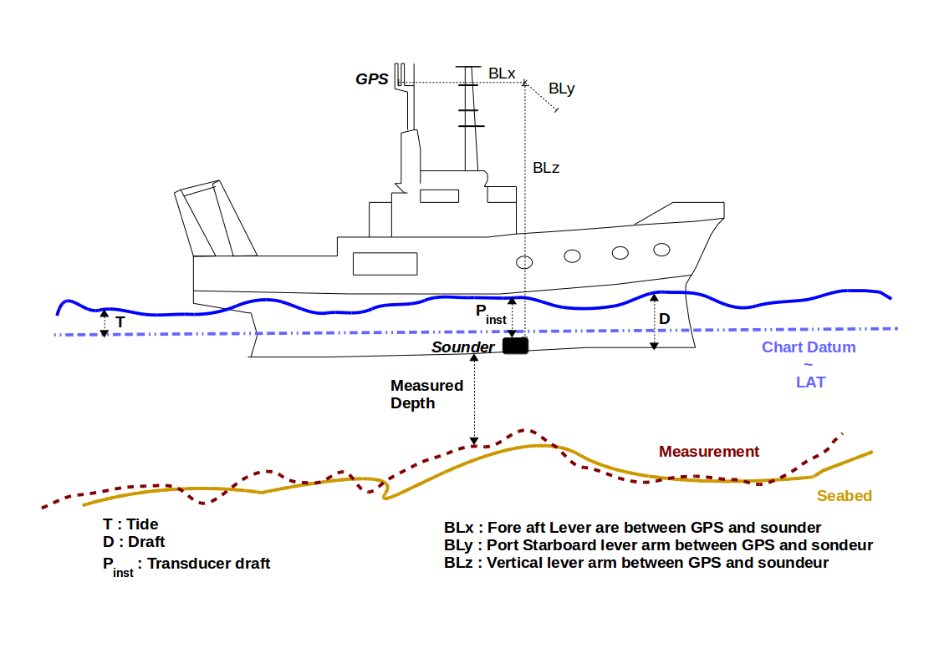

Figure 5. Effects of not correcting for horizontal offsets. Here, not measuring the horizontal offset between the GNSS receiver position and the echo-sounder results in along-track offsets of seafloor features. Red line: measured; yellow line: reality.

### 2.3.1 Sensor offsets

Sensor offsets refer to the fore-and-aft and port-and-starboard distances between vessel’s GNSS antenna and the transducer. When measuring offsets, it is important to record the axial directions of positive and negative values, as these conventions can vary. The graphic below (Figure 6) shows an example where measurements are taken from the GNSS antenna to the echosounder transducer, with positive values towards the bow and to starboard. In some systems, the GNSS antenna offset is already incorporated into the echosounder’s measurements. If this offset is not automatically integrated, most likely through the configuration options of the echosounder software, mariners should record their sensor offsets, plus the vertical measurement between the transducer and the waterline, and relay that information to their Trusted Node. These offset measurements help correct the bathymetric data so that the position indicated by the GNSS is the same as the position of the transducer, and the transducer-waterline measurement adjusts the depth to the waterline. This greatly improves the positional and vertical accuracy of the depth data.

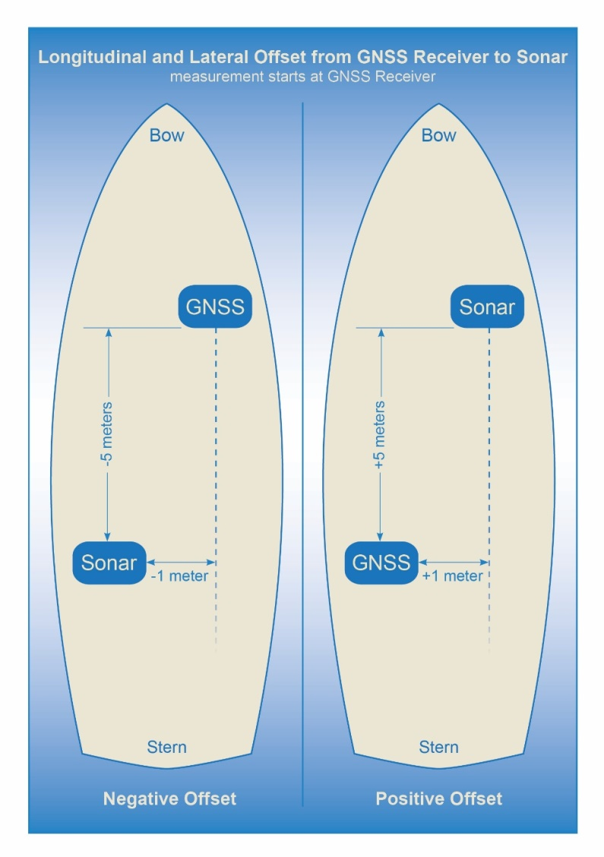

Figure 6. How to measure offsets between GNSS antenna and echo-sounder transducer. Note the convention used for the horizontal framework (RefP stands for Reference Point)

### 2.3.2 Variations in Draft

If a vessel takes on cargo, fuel, or supplies, the draft of the vessel will vary, which changes the depth of the echo-sounder transducer below the waterline. This change in depth can make the transducer record measurements that are deeper or shallower than the expected depth. As with the sensor offsets, it is important for the mariner to record this information, so that vertical adjustments can be made to the data during post-processing. This can be accomplished by recording the draft of the vessel, together with the time and date at the beginning and end of a voyage, and providing that information to the Trusted Node (Figure 7).

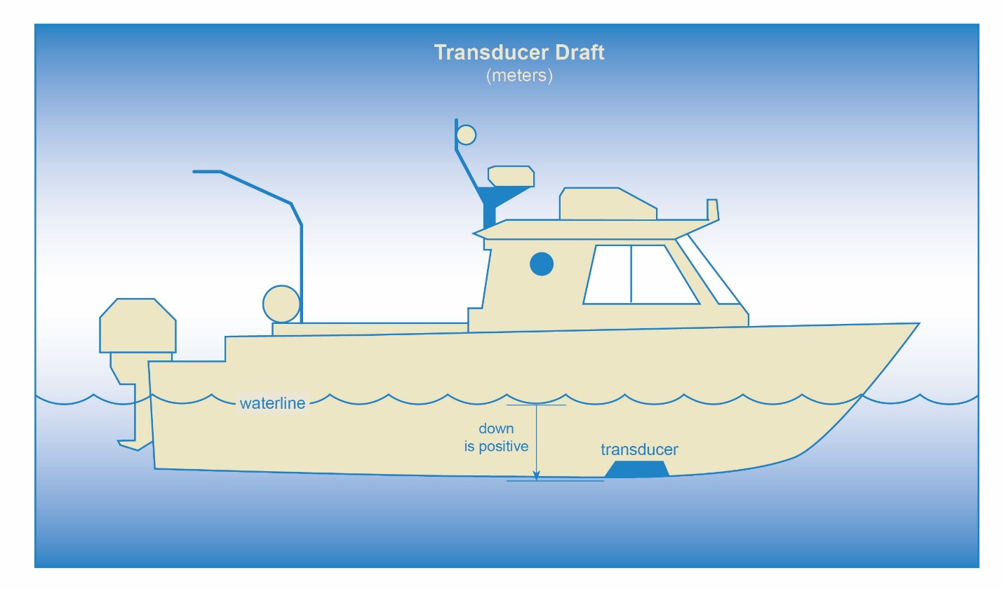

Figure 7. How to measure the depth of the transducer below the waterline.

Note that when using a multibeam echosounder all the above elements remain to be considered. An extra complexity is added because of the angular offsets between the respective reference frames of the sounder, the inertial motion unit and the boat. The calibration of the different angles composing this integrated system can be done through the so-called “patch test calibration” process, which is beyond the scope of this document.

# 3. Data and Metadata

## 3.1 Data vs. Metadata

It is important to understand the difference between data and metadata. Data are the core information, and metadata describes the data. For crowdsourced bathymetry, the data are the depths and geographic positions collected by a vessel, along with the date and time when collected. The metadata provides additional, supporting information about the data, such as the make and model of the depth sensor and GNSS, the vessel’s draft, offset measurements where the sensors were installed on the vessel, and so forth.

## 3.2 The Importance of Metadata

Metadata provides information to data users that helps them determine the quality of the data, and therefore use the data for more applications than would be possible with depth and position information alone. If the metadata are also consistent, it is easier to incorporate the data into a database, and for users to manipulate the data for their own purposes.

It is this working group's guidance that raw or “as captured” data (i.e., as close in form to the data presented to the data logger as possible), with a good indication of what the observer's offsets and context were, are preferable as a contribution to the DCDB.

3.2.1 Tidal Information

Data, without tidal corrections and with a good indication of what the observer’s offsets and context were, are preferable as a contribution to the DCDB. If the data collector provides information about the time and date when a depth measurement was collected, it allows future data users to apply tidal corrections to the data, if they so choose. If corrections are made, detailed information should be captured in recommended metadata fields as outlined in sections 3.3.3 and 3.3.4.

3.2.2 Sensor Offsets

Information about a transducer’s vertical offset from the waterline, or its horizontal offset from a GNSS antenna, allows users to apply vessel draft and horizontal positioning corrections to the data.

By applying corrections based on information in the metadata, data users can greatly improve the accuracy and value of the bathymetric data for research, industry, or other applications. Refer to section 2.3.1 for more information about sensor offsets.

## 3.3 Metadata and Data Formats

This section provides guidance to data collectors and Trusted Nodes about the standard metadata that is required for submitting data to the DCDB. In addition, it provides information about additional metadata that would enhance the value of the data for end users. CSB data contributors should collect and forward this information whenever possible. Recognizing that translating metadata fields to files for submission to the DCDB can be complex, Trusted Nodes are encouraged to review the *CSB Sample Data Contribution Formats Document* which can be found on the IHO DCDB website, and includes the latest conventions and examples of acceptable data formats. The International System of Units (SI) should be used, with the allowed addition of knots (nautical miles per hour, specified to be exactly 1.852 km/h, or approximately 0.514 m/s). As such, depth and offsets measurements should be in metres.

### 3.3.1 Mandatory Metadata from Trusted Nodes

Trusted Nodes should assign additional metadata to crowdsourced bathymetry before they deliver data to the DCDB. Table 1 lists metadata that Trusted Nodes should provide. Note that the Data Field, “Data License”, shall list only the Creative Commons 1.0 Universal public domain dedication (CC0). More information on data licensing can be found in Chapter 5: Additional Considerations.

*Table 1.* Trusted Node Metadata

|  |  |  |
| --- | --- | --- |
| **Data Field** | **Description** | **Example** |
| Provider Contact Point Organization Name | The Trusted Node’s name, in free-text format. | Example Cruises Inc. |
| Provider Email | A free-text field for the Trusted Node’s email address, so that data users can contact the Trusted Node with questions about the data. | support@example.com |
| Unique Vessel ID | Generated by the Trusted Node, this number identifies the Trusted Node and uniquely identifies the contributing vessel. The characters preceding the hyphen (-) identify the Trusted Node, followed by a hyphen (-), and then the vessel’s unique identifier. The UUID assigned by the Trusted Node is consistent for each contributing vessel, throughout the life of service of the vessel.However, **if the vessel chooses to remain anonymous to data users, the Trusted Node does not need to publish the vessel name in association with the UUID**. | EXAMPLE-*UUID* |
| Convention | This field describes the format and version for the data and metadata, such as GeoJSON, CSV, or XYZT. Reference the version of the CSB data convention (eg: CSB 2.0, CSB 3.0) where possible. | GeoJSON CSB 3.0 |
| Data License | The Creative Commons public domain dedication under which the Trusted Node is providing CSB data to the IHO DCDB. Additional information on licensing can be found in Chapter 5: Additional Considerations. | CC0 |
| Provider Logger | The software program or hardware logger used to log the data. | Rose Point ECS |
| Provider Logger Version | The software or hardware logger version. | 1.0 |
| CRS of navigation data | The EPSG code referring to the Coordinate Reference System (CRS) of the navigation data | EPSG: 4326 |
| Vertical reference of depth | The vertical reference of the depth. The vertical reference will most likely be the transducer (ex: NMEA DBT string) or the waterline (ex: NMEA DPT string). | Transducer/Unknown |
| Vessel Position Reference Point | Position Reference Point (PRP) is the reference point where the navigation data is output. Most likely the reference point will be the location of the GNSS antenna. | GNSS / Transducer / ReferencePlate |

### 3.3.2 Mandatory Data

A minimum of information is required to enable crowdsourced bathymetry to be accepted by the DCDB. Table 2 lists the mandatory information.

*Table 2.* Mandatory Information

|  |  |  |
| --- | --- | --- |
| **Data Field** | **Description** | **Example** |
| Longitude | The vessel’s PRP (Position Reference Point) longitude, in decimal degrees, to a precision of six decimal places. This can be extracted from the NMEA RMC, GGL or GGA String. Negative values are in the western hemisphere; positive values are in the eastern hemisphere. | -19.005236 |
| Latitude | The vessel’s PRP (Position Reference Point) latitude, in decimal degrees, to a precision of six decimal places. This can be extracted from the NMEA GGA, GLL or RMC String. Negative values are in the southern hemisphere; positive values are in the northern hemisphere. | 40.914812 |
| Depth | The distance from the depth sensor to the seafloor. Should be collected as a positive value, inmetres, with decimetre precision. This can be extracted from the NMEA DBT, DBK or DBS data string. DBT will require additional information about the draft of the vessel. DBS incorporates the draft of the vessel into the overall depth measurement. | 7.3 |
| Date & Timestamp | The date and UTC time stamp for the depth measurement as well as can be determined, ideally to millisecond precision in RFC3339 format. | 2015-08-06T22:00:00Z |

### 3.3.3 Recommended Metadata - Vessel Information and Sensor Configuration

Additional information about the vessel, sensors, and sensor installation allows data users to assess the quality of the data, and apply corrections, if necessary. This greatly increases the potential applications of the data for oceanographic research, scientific and feasibility studies and other uses. Table 3 lists metadata that CSB data providers should include whenever possible.

*Table 3.* Recommended Metadata - Vessel Information and Sensor Configuration

|  |  |  |
| --- | --- | --- |
| **Metadata Field** | **Description** | **Example** |
| Vessel Type | The type of vessel collecting the data, such as a cargo ship, fishing vessel, private vessel, research vessel, etc. | Private vessel |
| Vessel Name | The name of the vessel, in open string format. | White Rose of Drachs |
| Vessel Length | The length overall (LOA) of the vessel, expressed as a positive value, in metres, to the nearest metre. | 65 |
| ID Type | ID numbers used to uniquely identify vessels. Currently, only two types are available: Maritime Mobile Service Identity (MMSI) or International Maritime Organization (IMO) number. The MMSI number is used to uniquely identify a vessel through services such as AIS. The IMO number is linked to a vessel for its lifetime, regardless of change in flag or ownership. Contributors may select only one ID Type. | MMSI |
| ID Number | The value for the ID Type. MMSI numbers are often nine digits, while IMO numbers are the letters “IMO,” followed by a seven-digit number. | 369958000 |
| Sensor Description | Composite element containing all information about a given sensor in use on the collection platform. Minimum specification of fields as shown; some sensors may have additional fields (e.g., frequency for an echosounder). Position is given from the PRP (Position Reference Point) in metres. The offsets are positive NED (North (Bow), East (Starboard), Down)[23]. | Type: Sounder  Make: Garmin  Model: GT-50  Position: [4.2, 0.0, 5.4]  *Optional Fields for a Sounder:*  Draft: 1.4  DraftUncert: 0.2  Frequency: 200000 |
| Sound Speed Applied | Some systems may have the ability to provide sound speed data and correct the sounding. This field allows the data contributor to state whether sound speed corrections were applied during data collection (‘True’) or if they were not (‘False’). If ‘True’, review additional metadata fields in section 3.3.4. | False |
| Position Offsets Applied | This field describes whether the final vessel position (longitude and latitude) has been corrected for the lateral and longitudinal offsets between the GNSS receiver and the transducer (“True”), or if they were not (“False”). | False |
| Data Processed | Raw data, without tidal corrections or additional processing, are preferable as a contribution to the DCDB. This field allows the data contributor to state whether the data has been processed or corrected (‘True’) or not (‘False’). If ‘True’, detailed information should be captured in optional metadata fields as outlined in section 3.3.4. If ‘False’, information in section 3.3.4 is not needed. | True |
| Contributor comments | If the contributor believes there were any problems or events that may have degraded the quality of the position or depth measurements, they can enter that information in this free-text field. | On 2022-03-08, at 20:30 UTC, the echo-sounder lost bottom tracking after the vessel crossed another vessel’s wake. |

### 3.3.4 Recommended Metadata - Data Processing

Data “as captured” (i.e., as close in form to the data presented to the data logger as possible) is preferred for entry into DCDB archives. However, if data is modified (“processed”) in any way, this should be indicated by the “DataProcessed” element referenced in Table 3. Additional information regarding processing should be captured in the recommended metadata for processed data (Table 4). Any level and style of processing is allowed, so long as the methods used, algorithms, software, parameters, etc. are adequately recorded in the metadata so that potential users can assess whether the data are appropriate for their purpose. The intent should be to provide sufficient information to allow the processing to be reversed if required.

Table 4 captures a non-exhaustive, but normative, list of recommended metadata for processed data.

*Table 4.* Recommended Metadata for Processed Data

|  |  |  |
| --- | --- | --- |
| **Processing Step** | **Description** | **Example Fields** |
| Time Stamp Interpolation | Method by which times are assigned to data being recorded. | Method: Interpolated RMC Messages  Algorithm: ?  Version: 1.0 |
| Coordinate Reference Change | Processing that changed the reference system of the data. Must include the original and destination coordinate reference system, and the method used to change. | Original: EPSG:4326  Destination: EPSG:8252  Method: GeoTrans |
| Vertical Reduction | Steps taken to reduce raw data to a vertical reference system (Chart Datum, MSL, ellipsoid, water level, etc). Must include the vertical reference system, and method used. | Reference: ChartDatum  Datum: CANNORTH2016v1HyVSEP_NAD83v6_CD  Method: EllipsoidReduction | Observed Waterlevel | Predicted Waterlevel  Model: CANNORTH2016v1HyVSEP_NAD83v6_CD | Waterlevel Reference Station (Number?) |
| GNSS Processing | Steps taken to post-process or improve horizontal and vertical positioning. | Algorithm: RTKLib | CSRS-PPP  Version: 1.2.0 |
| Sound Speed Correction | Correction to soundings for sound speed in the water. | Source: Model | Profile | Geometric Mean | Fixed | Carter’s Tables | Matthew’s Tables | ...  Method: CIDCO-Ocean  Version: 1.1.0 |
| Data Processing | General algorithm used to triage data | Name: Deduplicate | Uncertainty Estimation | Manual Editing | ...  Parameters: None  Version: 1.0 |

# 4. Data Quality Assessment

## 4.1 Introduction

Data Quality relates to the extent to which a data set is fit for its intended purpose. Good data quality does not necessarily mean that the quality of the data has to be good rather it means that the end user is well informed regarding how good the quality of the data is. The best available data for an area may not be the best possible quality data according to standards, but as long as the quality of this data is quantified or qualified, it offers the best available data if nothing else exist. To allow for a comprehensive assessment of the quality of the data, it is necessary to record or document certain information together with the data. This data is called metadata.

The metadata associated with a dataset provides valuable supporting information relating to how the data collection was performed and will enable appropriate processing, corrections and an informed assessment of the data quality to be made. This highlights the importance for crowdsourced bathymetry (CSB) data contributors to provide as much information as possible about a dataset (See Chapter 3: Data and Metadata).

The quality assessment of CSB data is mainly based on the uncertainty evaluation and consistency assessment of a CSB dataset and related metadata.

There are two aims with assessing and reporting data quality of CSB data: (1) to provide CSB data contributors with feedback to demonstrate the value of their efforts and encourage continued submission, (2) to help with an assessment of the added value of CSB data as a way of determining the potential issuance of navigational warnings of potentially uncharted hazards to navigation and/or inclusion in future products (i.e.: bathymetric grids, official nautical products, etc.).

## 4.2 Uncertainty Evaluation

In a scientific context, “error” is the difference between the measured and the true value of the thing being measured. Unfortunately, it is usually impossible to directly, physically verify the true value, and therefore the actual error is unknown, and unknowable. Instead, we can estimate the likely amount of error in the measurement, which is called the “uncertainty”, and report it with the measurement. A quantified uncertainty is essential in understanding and qualifying a measurement for use.

Many different measurements are combined to create a depth estimate. As a result, there are many potential sources for error and therefore uncertainty. It is helpful to categorise the different types of uncertainties that could affect these measurements, and then estimate their individual magnitudes, before combining them into a general estimate of uncertainty.

For each source of uncertainty, the most common method for categorising the uncertainty type is to estimate the precision (or variance) and accuracy (or bias) of observations. *Precision* – is the degree to which [repeated](https://en.wikipedia.org/wiki/Repeatability) (or [reproducible](https://en.wikipedia.org/wiki/Reproducibility)) measurements under unchanged conditions show the same results. *Accuracy* – is the closeness of agreement between the measurement and the true value. All observations have the potential for both types of uncertainty, although any given observation might be dominated more by one or the other type (which can make estimation simpler). Ideally, estimates of precision and accuracy would be tracked separately for each observation, until all sources of uncertainty are combined.

Figures 8 and 9 show illustrative examples of precision and accuracy. By preference, all depth observations would be both accurate and precise. However, for many reasons, depth measurements may be precise, but not accurate. For example, if the speed of sound is assumed to be some fixed value, and is not actually measured, depth measurements will be offset from the true depth (i.e., of poor accuracy), even though consecutive measurements appear similar (i.e., of high precision).

Conversely, depth measurements may be accurate (i.e., close to the true depth), but not precise (i.e., random variations in measurements).

Ultimately, it may be difficult to conduct a full analysis of the uncertainty for each measurement. So long as what was done is documented, however, any information provided is still valuable as long as the inaccuracy and imprecision can be either quantified or qualified to categorize the quality of all information available. Especially in areas where very few or no other data exist.

Fundamentally, the contribution of all quality assessed CSB data has value and is indeed much better than no data. The data can be used for a range of uses from simply highlighting dangers that require further investigation right up to inclusion in official nautical charts and publications. The broad spectrum of applications for improving knowledge underlines the importance and value of contributing crowd-sourced data.

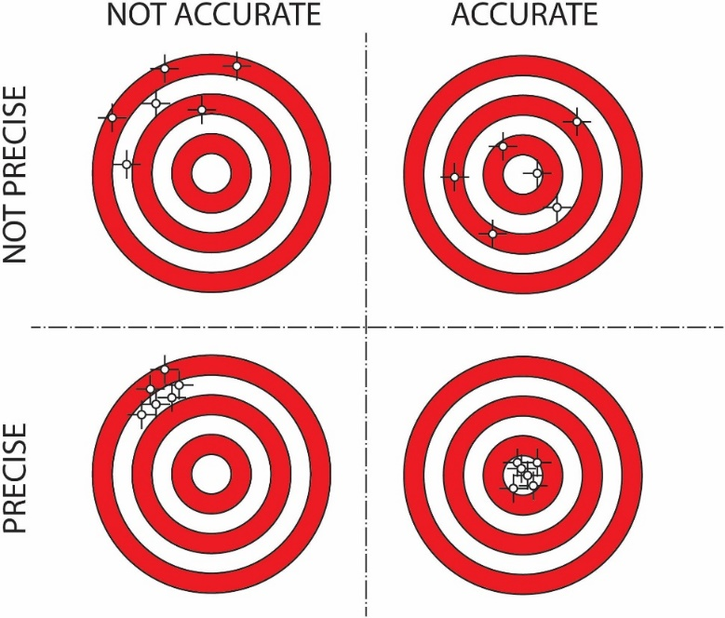

Figure 8. Effects of accuracy and precision (bias and variance) of measurements on the ability of a system to measure.

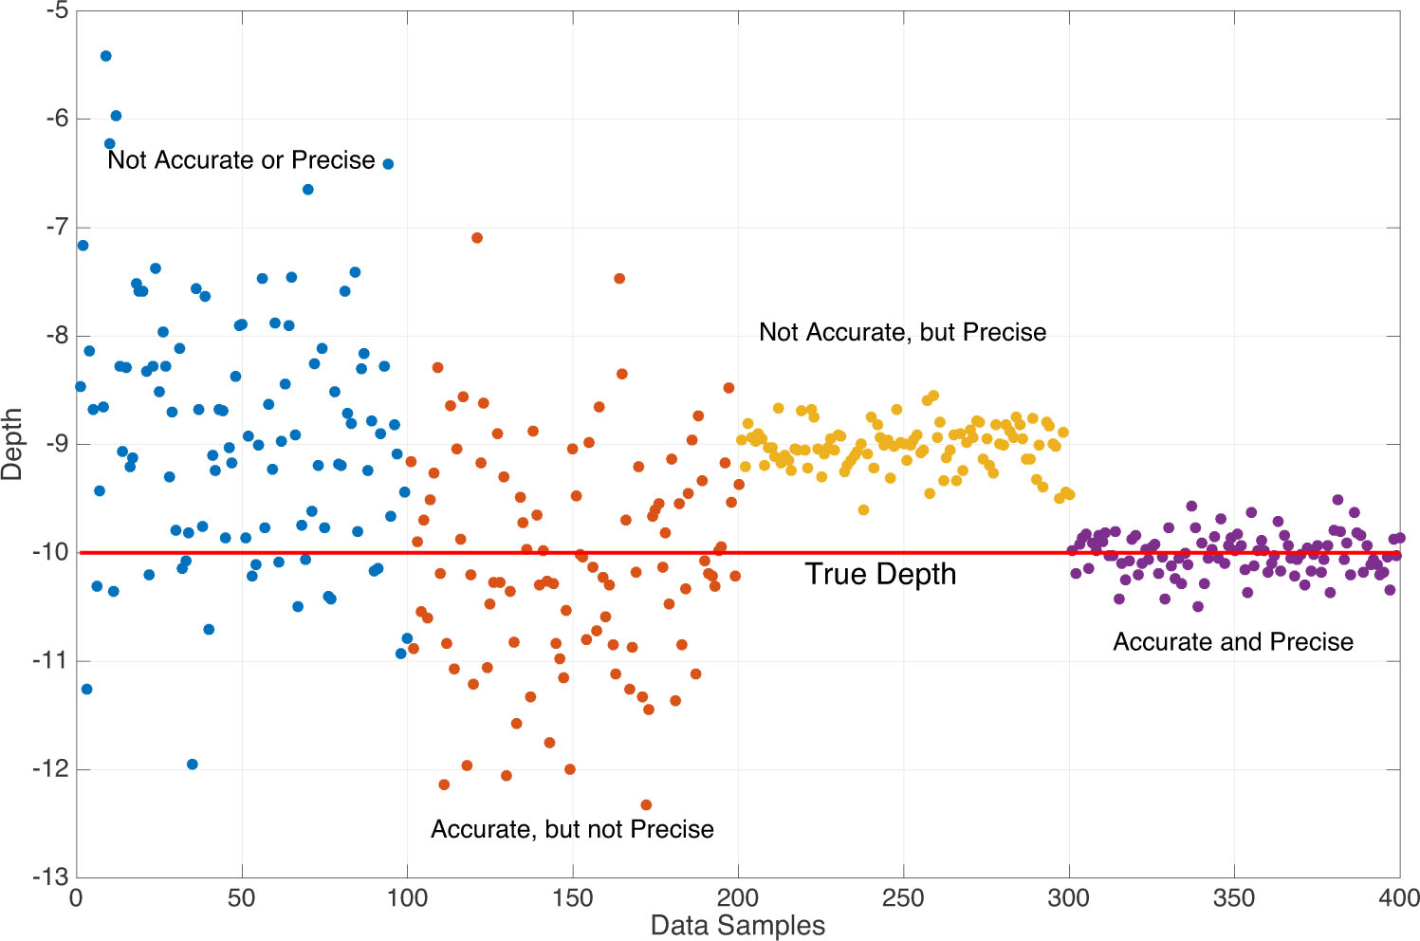

Figure 9. Example of depth measurements, from the four quadrants of Figure 1.

The topic of uncertainty can become quite involved. This document provides an overview of the topic, but IHO Special Publication S-44 (Standards for Hydrographic Surveys, 6th ed., 2020, IHO Publication C-13 (Manual on Hydrography, 2010), and the ISO Guide to Uncertainty in Measurements (ISO, 1995) contain additional background material, and may be consulted for further details.

## 4.3 Data Consistency

In addition to evaluating uncertainty, data quality can also be assessed using self-consistency and peer-consistency:

* *Self-consistency*: Data should maintain integrity and positional consistency, at least when coming from the same data provider.
* *Peer-consistency*: Data from different sources should be spatial consistent.

The **self-consistency assessment** of a dataset is performed on redundant measurements. In practice, this is often done by analyzing lines of soundings that cross each other. So when applicable, CSB data contributors may consider including cross-lines in their route planning.

The **peer-consistency assessment** of a dataset is performed on areas overlapping with official data (often hosted in Hydrographic Offices databases). So when applicable, CSB data contributors may consider including an area that overlaps with a known reference surface, close to their location.

## 4.4 Data Quality Report

Providing feedback to the CSB data contributors in the form of a short and easy-to-read data quality report may be considered. Such a report would provide the CSB data contributors with a summary of the quality of the contributed CSB data, based on the supplied metadata and the self-consistency and/or peer-consistency assessments. The provision of such reports is not mandated but should be considered as they can serve to help encourage CSB data contributor engagement.

An example report is provided in Annex C.

# 5. Additional Considerations

*The following notes, which are not exhaustive, are intended for information only, and may be updated periodically.*

Since charts were first produced, mariners have noted and highlighted any inconsistencies with published information, identified during their passage, in the form of a Hydrographic Note. The IHO crowdsourced bathymetry (CSB) initiative has transformed this collective approach in favour of safety at sea into the digital era. The principles of the initiative are similar to many others where environmental data and information are collected on a voluntary basis by users and the public, and provided under an open data license in the interests of the common good. In particular, the collection and forwarding of bathymetric data by mariners as part of “passage sounding” in support of global initiatives such as the GEBCO Programme has already been taking place for more than a century without issue. Measurement and communication technology improves steadily, and so has this guidance to be revised accordingly. This revision of this CSB guidance document is designed to assist the CSB data contributor on how to improve the quality and consistency of any bathymetric information they may wish to contribute to the public.

When considering participation in the IHO CSB initiative, CSB data contributors should understand the following:

* Mariners proposing to record (collect) and share bathymetric data as a CSB activity, should make themselves aware of any relevant local restrictions or considerations, especially as relates to operating within waters subject to national jurisdiction.
* Those involved in the IHO CSB Initiative, whether as the one who collects the data, contributes the data (either as a Trusted Node or individual) or as a user, need to be aware of the conditions of the licensing regime under which the bathymetric data submitted to the DCDB will be made available to the public.
* Those using data from the IHO DCDB need to consider the nature and the quality of the data and whether it is fit for the purposes intended.

In order for users to be clear on their rights and obligations while using these data, the IHO CSB initiative has selected an open license from the Creative Commons. Data supplied to the IHO DCDB by vessels, are most often provided through Trusted Nodes, which aggregate such data and ensure necessary permission from vessel owners. However, regardless of whether the data are provided to the IHO (via the IHO DCDB) by a Trusted Node or an individual, the data is dedicated to the public domain in accordance with the “Creative Commons Zero” universal public domain dedication (CC0 1.0)[24]. By voluntarily supplying CSB data to the IHO, the CSB data provider consents to the public release of those data under these terms. The data license will be captured in the metadata and included in the CSB data package downloaded from the DCDB. The IHO may, in the future, update its selected licenses as the versions and terms of the Creative Commons licenses change.  Publication of any updates to the license in B-12 will be an administrative change to the document, and CSB stakeholders will be notified by IHO Circular Letter and on the DCDB Website.

CSB data providers (either as Trusted Nodes or individuals) are expected to acknowledge that by providing their data for inclusion in the IHO DCDB database, they are doing so in good faith and for the purpose of increasing bathymetric knowledge of the world’s seas, oceans and waterways. By consenting to the *IHO CSB Trusted Node Agreement Form*, the Trusted Node agrees that the IHO, and by proxy the IHO DCDB, may use and disseminate their CSB data to the public, and that the public may use and disseminate the data consistent with the licensing framework described above. If the data provider is not a Trusted Node, the IHO will provide a similar agreement form. In no event is the IHO or the IHO DCDB liable to the data provider for third-party use of data provider-provided data.

The IHO will also make it clear that that data is being made available on a “user-beware” basis; in particular, emphasizing that the user must carefully consider the nature and the uncertainty of the data being used in relation to any use proposed by the user.

In conveying this information to data users, it should be noted that the IHO, as an intergovernmental organization, enjoys certain rights and privileges, which include immunity from the jurisdiction of national courts.

Annex A – Abbreviations

AIS - Automatic Identification System

CI - Confidence interval

CSB - Crowdsourced bathymetry

CSV - Comma separated values

DBT - Depth Below Transducer (NMEA sentence)

DCDB - IHO Data Centre for Digital Bathymetry

ECDIS - Electronic Chart Display and Information System

FTP - File Transfer Protocol

GGA – position fix information (NMEA sentence)

GEBCO - General Bathymetric Chart of the Ocean

GLL - Geographic position, latitude / longitude (NMEA sentence)

GNSS - Global Navigation Satellite System

GPS - Global Positioning System

HTTP(S) - Hypertext Transfer Protocol (Secure)

IHO - International Hydrographic Organization

IOC - Intergovernmental Oceanographic Commission of UNESCO

IMO - International Maritime Organization

MMSI - Maritime Mobile Service Identity

NCEI - National Centers for Environmental Information

NMEA - National Marine Electronics Association

NOAA - National Oceanic and Atmospheric Administration

RMC – Recommended minimum data for GPS (NMEA sentence)

UNESCO - United Nations Education Scientific and Cultural Organization

UPS - Uninterruptable Power Supply

UTC - Coordinated Universal Time

UUID - Unique Uniform Identification

Annex B – Glossary

**Automatic Identification System (AIS).** A tracking system that broadcasts, via VHF, the position, course and speed of a vessel to other vessels in the vicinity, to reduce the risk of collisions.

**Confidence Interval (CI).** A range of values so defined that there is a specified probability that the value of a parameter lies within it.

**Crowdsourced bathymetry (CSB).** The collection of depth measurements from vessels, using standard navigation instruments, while engaged in routine maritime operations.

**Electronic Chart Display and Information System (ECDIS).** A computer-based navigation system that complies with IMO requirements and can be used for navigation instead of paper navigation charts.

**General Bathymetric Chart of the Ocean (GEBCO).** Publicly-available bathymetric map, and associated products, of the world's oceans. GEBCO is an IHO and IOC joint Project that relies largely on the voluntary efforts of an international collaborating community of scientists and hydrographers with the support of their parent organizations.

**Global Navigation Satellite System (GNSS).** A satellite navigation system with global coverage, such as the United States’ NAVSTAR Global Positioning System (GPS), the Russian Federation’s GLONASS, and the European Union’s Galileo.

**International Hydrographic Organization (IHO).** The IHO is the intergovernmental consultative and technical organization that was established in 1921 to support safety of navigation and the protection of the marine environment. The principal aim of the IHO is to ensure that all the world’s seas, oceans and navigable waters are surveyed and charted.

**International Maritime Organization (IMO).** The IMO is the United Nations specialized agency with responsibility for the safety and security of shipping and the prevention of marine pollution by ships. It is the global standard-setting authority for the safety, security and environmental performance of international shipping. Its main role is to create a regulatory framework for the shipping industry that is fair and effective, universally adopted and universally implemented.

**Intergovernmental Oceanographic Commission of UNESCO (IOC-UNESCO).** The IOC is the United Nation’s competent body for marine science. The IOC’s role is to promote international cooperation and to coordinate programmes in research, services and capacity-building, in order to learn more about the nature and resources of the ocean and coastal areas and to apply that knowledge for the improvement of management, sustainable development, the protection of the marine environment, and the decision making processes of its Member States.

**National Marine Electronics Association (NMEA).** The US-based marine electronics trade organisation

setting standards of communication between marine electronics.

**Trusted Nodes.** Organizations or individuals that serve as data liaisons between mariners (data collectors and the DCDB. Can provide mariners with data loggers, installation and data download assistance, recommendations on best practices for collecting CSB, and providing the information to the DCDB.

# Annex C – Example of Data Quality Report

The following is an example of what a data quality report could look like. It is based on a real contribution provided by Aqqiumavvik Society in Arviat, NU, Canada. The report shows an overall rating of the dataset (from 0 to 100%), the potential for use of the dataset, and a series of recommendations to help the CSB data contributor increase his potential next contribution.

|  |  |  |  |  |  |
| --- | --- | --- | --- | --- | --- |
| **Data Quality Assessment Report** | **General rating**  **85%** | | | | |
| Location | Qi'ngu'juaq Inlet near Arviat, NU | | | | |
| Provider | Aqqiumavvik Society | | | | |
| Date | August 12, 17, 18 and September 22, 23, 24 2020 | | | | |
| Chart (General View) | Chart (Area View) | | | | |
|  |  | | | | |
| **Usability rating** |  | | | | |
| Charting update | 80% |  |  |  |  |
| NavWarn Detection | 60% |  |  |  |  |
| GEBCO Grid gap filling | 100% |  |  |  |  |
| DCDB Integration | 100% |  |  |  |  |
| … |  |  |  |  |  |
| **Self-Consistency Assessment (precision)** |  | | | | |
| Number of intersections | 231 | | | | |
| Average difference at intersections | 0.058m | | | | |
| Standard deviation of differences | 0.044m | | | | |
| **Peer-Consistency Assessment (accuracy)** |  | | | | |
| Surface of Reference | CHS BathyDataBase | | | | |
| Average difference wrt Surface of Reference | 0.3m | | | | |
| Standard deviation of differences | To be completed | | | | |

|  |  |
| --- | --- |
| **Recommendations for next contribution** | |
| Sensor Offsets | Correct |
| Sounder Draft | To be measured – will help water level sounding reduction |
| … |  |

|  |  |
| --- | --- |
| **Metadata** | |
| Vessel Type | Fishing vessel |
| Vessel Name | n/a |
| Vessel Length | To be completed |
| ID Type | n/a |
| ID Number | n/a |
| Sensor Type Sounder | Sounder |
| Sounder Make | Imagenex |
| Sounder Model | 852 |
| Sounder Frequency | To be completed |
| Sounder Draft | n/a |
| Uncertainty of Sounder Draft | n/a |
| Sounder Draft Applied | False |
| Sound Speed Applied | False |
| Reference point for Depth | Transducer |
| Sensor Type GNSS | GNSS |
| GNSS Make | Hemisphere |
| GNSS Model | Eclipse P326 |
| Longitudinal Offset from GNSS to Sounder | 0 |
| Lateral Offset from GNSS to Sounder | 0 |
| Vertical Offset from GNSS to Sounder | +2.17 |
| Position Offsets Applied | False |
| CSB data contributor comments | n/a |

# Annex D – Document Contributors

1. Iho.int
2. gebco.net/
3. ioc-unesco.org/
4. iho.int/iho_pubs/CB/C-55/index.html
5. [sustainabledevelopment.un.org/post2015/transformingourworld](https://sustainabledevelopment.un.org/post2015/transformingourworld)
6. unfccc.int/process-and-meetings/the-paris-agreement/the-paris-agreement
7. undrr.org/publication/sendai-framework-disaster-risk-reduction-2015-2030
8. gebco.net/
9. iho.int/en/ircc
10. imo.org/en/KnowledgeCentre/ConferencesMeetings/Pages/SOLAS.aspx
11. ncei.noaa.gov/maps/iho_dcdb/
12. [iho.int/mtg_docs/rhc/HCA/HCA_Misc/HCA_HPWG/HCA_Hydrography_Priorities_WG.htm](https://www.iho.int/mtg_docs/rhc/HCA/HCA_Misc/HCA_HPWG/HCA_Hydrography_Priorities_WG.htm)
13. ncei.noaa.gov/
14. iho.int/uploads/user/Inter-Regional%20Coordination/CSBWG/MISC/B-12_2020_EN_Acceptance_of_CSB_Data_in_NWJ_v3.0.pdf
15. ngdc.noaa.gov/iho/
16. ngdc.noaa.gov/iho/
17. [noaa.gov/information-technology/big-data](https://www.noaa.gov/information-technology/big-data)
18. registry.opendata.aws/odp-noaa-nesdis-ncei-csb/
19. aws.amazon.com/cli/
20. noaa-bathymetry-pds.s3.amazonaws.com/index.html#csv/
21. iho.int/uploads/user/pubs/cb/c-13/english/C-13_Chapter_1_and_contents.pdf
22. iho.int/uploads/user/pubs/standards/s-44/S-44_Edition_6.0.0_EN.pdf
23. Specific sensor descriptions: (confirm consistency with notes in other chapters)

    **Sensor Type:** Sounder. Preferred: Make, Model, Position, Draft, DraftUncrt. Suggested: Frequency, PulseLength

    **Sensor Type:** IMU. Preferred: Make, Model, Position.

    **Sensor Type:** GNSS. Preferred: Make, Model, Position. Suggested: Antenna Model.
24. creativecommons.org/publicdomain/zero/1.0/).