Paper for Consideration by SCUFN-35.1

Follow-up SCUFN34/VTC02/19 etc.:

A proposal for nuanced decision-making rules to be applied to features named in scientific publications that do not align with current definitions of generic feature terms, do not conform to current principles for specific names, or have antecedent specific names that remain in common use in the scientific literature.

Submitted by: Mike Coffin (SCUFN Member) and Yasuhiko Ohara (SCUFN Vice-Chair)

Executive Summary: This proposal recommends revisions to the draft Cookbook as appropriate.

Related Documents: None

Related Projects: Cookbook (e.g., Actions SCUFN33/06, SCUFN33/15, SCUFN33/32, SCUFN33/52)

Introduction/Background

- SCUFN considers proposals for some features that use generic feature names that do not align with current generic feature names and for some features that do not conform to current principles for specific names. SCUFN has also approved new names for previously named features, and in some cases the antecedent names continue to dominate usage in the scientific literature. Consideration and disposition of such proposals, as well as how to address features with multiple generic feature terms and specific names, present challenges, and SCUFN’s decisions are of broad interest to the global marine research and user communities.

- At the same time, we do need to remind that SCUFN has a right to stick with the older, more-established names that it has in the past under B-6 IC: “Names used for many years may be accepted even though they do not conform to normal principles of nomenclature. Existing names may be altered to avoid confusion, remove ambiguity or to correct spelling“.

- The current version of the draft Cookbook prepared by Vaughan Stagpoole and Kevin Mackay includes a ’25-year rule’ in three instances, i.e.,

Names in long-standing use

Names in peer-reviewed papers
Undersea features that have been named in peer-revied papers for long-standing use (>= 25 years) shall have precedence over new proposed names. The generic name of these long-standing undersea feature names may be changed if newer data shows that they are manifestly wrong.

Many of these long-standing undersea feature names can be named for associated land features. Naming Authorities of coastal states may rename these associated land features (e.g., to recognise the original native language names). In which case, the specific name of these long-standing undersea feature names may be renamed in accordance to that of the Naming Authority of the relevant coastal state.

Names in hydrographic charts
Undersea features that have been named in official hydrographic charts for long-standing use (>= 25 years) shall have precedence over new proposed names. The generic name of these long-standing undersea feature names may be changed if newer data shows that they are manifestly wrong.

Many of these long-standing undersea feature names can be named for associated land features. Naming Authorities of coastal states may rename these associated land features (e.g., to recognise the original native language names). In which case, the specific name of these long-standing undersea feature names may be renamed in accordance to that of the Naming Authority of the relevant coastal state.

Terms used for harmonization with other gazetteers
Generic Terms that have been used in the past that are no longer recommended for undersea feature names are listed below. These Generic Terms are acceptable for undersea feature names that are being adopted into the GEBCO Gazetteer from other gazetteers or where long-term usage (25 years) can be clearly demonstrated. They are kept in the B-6 publication to facilitate harmonization between gazetteers, but where possible usage of these terms should be avoided.

No underlying rationale for this ’25-year rule’ is provided in the draft Cookbook. The 2019 SCUFN-32 Report (4.8.6, pdf page 9) states "...names that have existed for 25 years or more should generally be accepted," whereas the draft Cookbook does not include the word "generally."

Analysis/Discussion

- In the past, SCUFN has made some questionable decisions concerning both generic feature terms and specific feature names, e.g.:

- “Leclaire Rise” (SCUFN-11, 1995). The feature had long been known as “Skiff Bank” in the scientific literature before 1995; however, SCUFN-11 changed both the generic term to Rise and the specific name to “Leclaire.” The rationales for these changes were not documented. The name “Leclaire Rise” has been completely disregarded by the scientific community since 1995. That is, every scientific paper published since 1995 has utilized the name "Skiff Bank" instead of "Leclaire Rise."

- “Asquith Rise” (SCUFN-13, 1999). The feature had long been known as ‘Wilkes Rise” in the scientific literature before 1999; however, SCUFN-13 changed the specific name to “Asquith,”, noting that the feature was “formerly known as “Wilkes Rise.” The rationale for this change was not documented. The name “Asquith Rise” has been mostly disregarded by the scientific community since 1999. That is, nearly every scientific paper published since 1999 has utilized the name “Wilkes Rise” instead of “Asquith Rise.”

- “Amami Rise” (SCUFN-14, 2001). The feature had long been known as "Amami Plateau" in the scientific literature before 2001; however, SCUFN-14 changed the generic term to "Rise" on the basis of updated bathymetry. Although bathymetry indicates that this feature meets the definition of a “Rise” as opposed to that of a “Plateau,” the name “Amami Rise” has been completely disregarded by the scientific community since 2001. That is, every scientific paper published since 2001 has utilized the name "Amami Plateau" instead of "Amami Rise."

- “Philippine Basin” (SCUFN, undocumented). The feature is a significant oceanic basin that occupies the western half of the Philippine Sea tectonic plate. The feature has long been known as the “West Philippine Basin,”, and SCUFN meeting reports do not document when SCUFN changed the name. However, the feature has long been known as "West Philippine Basin," and that name continues to be used in the scientific literature.

- A matter of considerable concern is that if SCUFN makes decisions contrary to persistent generic feature and specific name usage in the global marine research and user communities, then these communities will ignore future as well as past SCUFN decisions. This carries strong reputational risk for SCUFN to maintain its role as the sole global authoritative body for naming undersea features.

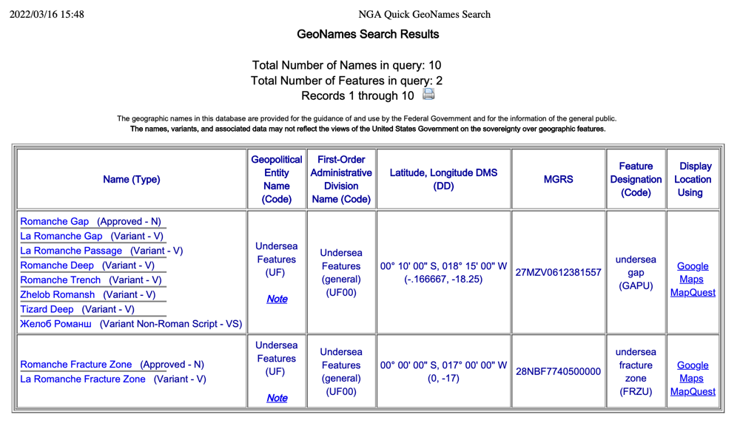
- Instead of imposing arbitrary (e.g., 25-year) rules for generic feature terms and specific names, a more nuanced, case-by-case decision-making process could be considered by SCUFN. Such a process would include consideration of longevity and prevalence of usage of feature terms and specific names in the scientific literature, publication history, and publication metrics (e.g., total citations, journal impact factor, etc.).

- Another solution is to add to the GEBCO Gazetteer, called “variant” or “alternate” name section.

Recommendations

- The draft Cookbook will prove to be most helpful for the SCUFN decision-making process. Recommended revisions include:

- Changing the “25-year rule” to a more nuanced, case-by-case consideration, taking into account longevity and prevalence of usage of generic feature terms and specific names in the scientific literature, publication history, and publication metrics (e.g., total citations, journal impact factor, etc).

- Consideration of adding to the GEBCO Gazetteer, called “variant” or “alternate” name section.

Justifications and Impacts

- The proposed revisions would strengthen SCUFN’s credibility, reputation, and respect in the global marine research and user communities. Implementation of the proposed revisions would impact the draft Cookbook.

Action required of SCUFN

- SCUFN is invited to:
- Note this proposal.
- Consider the recommendations in section 7.

