



### **IHO-IOC GEBCO**

### **Sub-Committee on Undersea Feature Names**

### **36th SCUFN Meeting**

### **6 – 10 November 2023, Wollongong, Australia**

### **Travel Information and Logistics**

The Australian Hydrographic Office is pleased to welcome SCUFN delegates and interested observers to Wollongong, Australia for the SCUFN-36 meeting.

**LOCATION**

Wollongong is a coastal city in Australia, just over an hour’s drive south of Sydney. The local area offers a coastline of beautiful beaches and rocky headlands, all with the magnificent forest backdrop of the Illawarra Escarpment. Surfing, swimming, boating and numerous water activities are available. Stunning lookouts occur along many parts of the escarpment, and trails encircle the forests and rocky cliffs of Mt. Keira which stands overlooking the city. Wollongong has a vibrant culture and thriving urban scene, including eats, arts, golf and iconic attractions. The CBD, restaurants & cafes, and many local attractions are all within easy walking distance of the meeting venue.

For more information visit: <https://www.visitwollongong.com.au/>

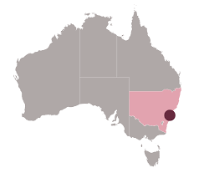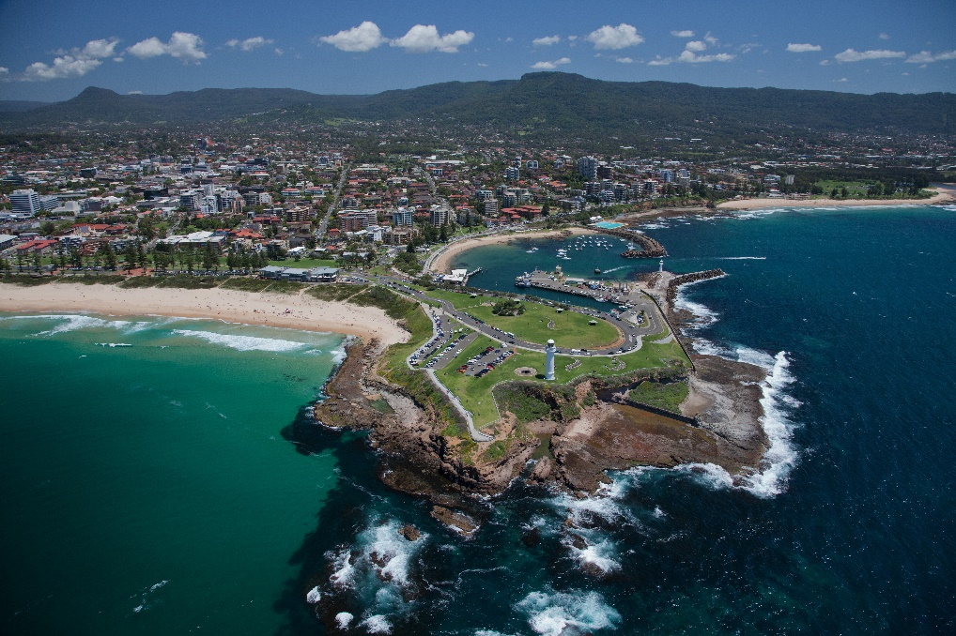

***We look forward to welcoming you to Australia***

**MEETING VENUE**

The meeting will be held at: **Sage Hotel Wollongong - “Watersedge Room”**

60-62 Harbour Street, Wollongong, NSW 2500, Australia

**T:** +612 4201 2111  
**M:** +61 0405 167 687  
**W:** <https://www.nexthotels.com/sage/wollongong/>  
**FB:** facebook.com/SageHotelWollongong

A map of Wollongong showing the location of the venue is at **Annex A**.

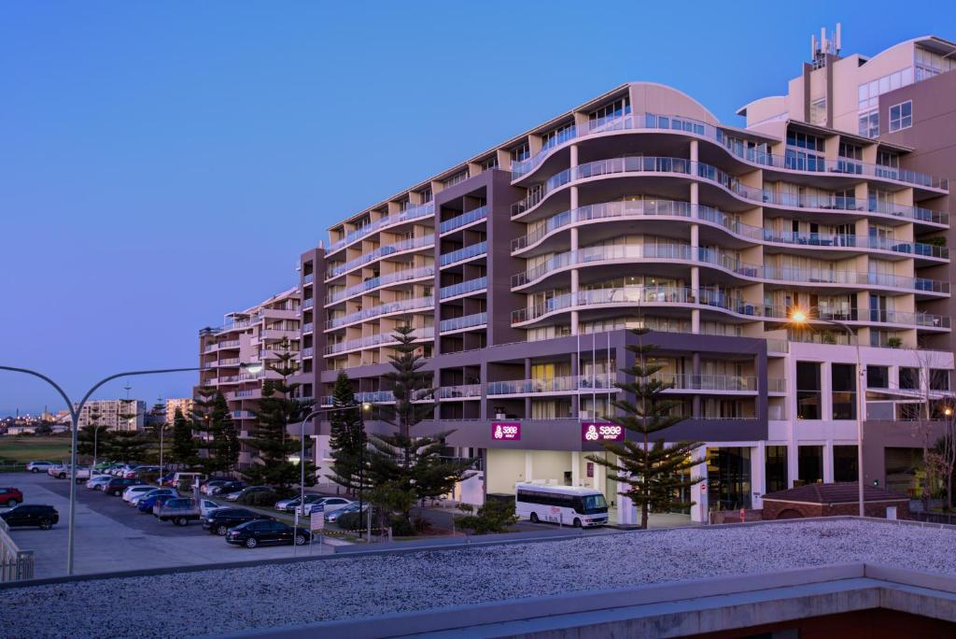

**MEETING SESSIONS**

The official event will commence on the morning of Monday the 6th November and conclude on Friday the 10th of November. Morning and afternoon tea, and a working style lunch will be provided at the hotel each day of the meeting.

**INTERNET**

Wireless LAN is planned in the meeting room.

**SOCIAL EVENTS**

An ice-breaker cocktail reception is planned for **MONDAY 6th November** at the Sage Hotel in their Five Islands Restaurant and Terrace from 6-8pm (time to be confirmed).

A social evening will be organised for the Thursday evening. Dinner will be at the delegates own expense and further information will be made available on day 1 of the meeting.

**REGISTRATION**

All members and/or observers intending to attend the meeting must register via the IHO online registration system. Please visit: <https://iho.int/en/scufn36-2023>

Please note the registration deadline is the **5th of September**.

**ACCOMMODATION**

The Sage Hotel is offering a discounted room rate to people attending the meeting. The following link can be used to make a booking and should automatically apply the discount:

[Sage Hotel Wollongong - Australian Hydrographic Office Booking Link](https://be.synxis.com/?Hotel=3214&Chain=23501&promo=SCUFN36)

Alternatively, the promotion code **SCUFN36** can be used in the online booking form as below:

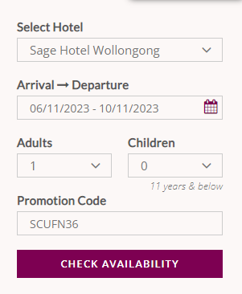

There are a number of alternate accommodation venues within 10-15 minute walk from the meeting venue, which should suit any budget.

* Novotel Wollongong Northbeach - 2/14 Cliff Rd, North Wollongong NSW 2500 <https://www.novotelnorthbeach.com.au/> (15 min walk)
* Adina Apartment Hotel - 19 Market St, Wollongong NSW 2500 <https://www.adinahotels.com/en/> (8 min walk)
* The Belmore All-Suite Hotel - 39 Smith St, Wollongong NSW 2500 <https://www.belmore.net/> (10 min walk)
* Wollongong Serviced Apartments - 54 Kembla St, Wollongong NSW 2500 <https://www.wsa.com.au/> (12 min walk)
* Astra Apartments – Beatson Street, Wollongong, NSW 2500 [https://www.astraapartments.com.au/apartments](https://www.astraapartments.com.au/apartments/wollongong-1-bed-sa-bs/) (7 min walk)

**SMOKING**

Smoking is not permitted within public buildings, including clubs and pubs, and is also not permitted on any public transport, including domestic air flights.

**TIPPING**

Tipping is not obligatory. It is at your own discretion and only for very good service. As a guide, add 5-10% to a restaurant bill.

**CONTACT DETAILS**

The local point of contact regarding the conference details, more specific logistics, visa and accommodation queries are provided below.

|  |  |
| --- | --- |
| **Alper Celebi**  Email: [alper.celebi@defence.gov.au](mailto:alper.celebi@defence.gov.au)  Mobile/WhatsApp: +61 414 482 654 | **Melanie Pender**  Email: [melanie.pender@defence.gov.au](mailto:melanie.pender@defence.gov.au)  Mobile/WhatsApp: +61 405 435 771 |

**GENERAL TRAVEL INFORMATION**

**PASSPORTS, VISAS AND VACCINATIONS**

**Please check the latest information** from the Australian Department of Home Affairs website, <https://www.homeaffairs.gov.au>. Your passport must be valid for at least 6 (six) months. Vaccinations are not required unless you have come from, or have visited, a yellow fever infected country or zone within 6 days prior to arrival.

**For visa requirements, please check** <https://immi.homeaffairs.gov.au/visas/getting-a-visa/visa-finder/visit>. If you need a letter of invitation to support your visa application, please contact us using the email address above. People requiring a visa should ensure it is granted before travelling to Australia.

**COVID-19**

Regulations are often changing. Visitors from some countries may be required to show evidence of a negative pre-departure test for COVID-19. **For the latest information, please check** <https://www.homeaffairs.gov.au/covid19> .

**ENTERING AUSTRALIA**

Australia is an island continent, well protected from most animal and agricultural pests and diseases. To help maintain this, strict quarantine regulations apply, and the casual importation of food, seeds, animals, plants and animal or plant products is prohibited. Quarantine regulations are strictly enforced, and penalties are very high. When you arrive in Australia, if you have any doubts about an item in your possession, **declare it**, and one of our helpful Customs Officers will assess it.

In common with most other countries, Australia allows in-bound passengers to import modest amounts of duty free alcohol, tobacco and perfume. High value gifts imported into Australia may be subject to a tax

**More information at**: [https://www.abf.gov.au/entering-and-leaving-australia/can-you-bring-it-in](https://www.abf.gov.au/entering-and-leaving-australia/can-you-bring-it-in/overview%20).

**CURRENCY AND CREDIT CARDS**

The unit of currency in Australia is the Australian Dollar (AUD$). Notes come in AUD$100, AUD$50, AUD$20, AUD$10 and AUD$5 denominations. Coins come in 5, 10, 20, 50 (cents), AUD$1 and AUD$2 denominations.

Major credit cards such as American Express, Visa, MasterCard and Diners Club are widely accepted. ATMs (Cashpoints) are very commonplace throughout Australia, and generally accept a wide range of cards, including Cirrus/Maestro cards. Always take care early in the morning and at night when using ATM machines.

Currency converters such as Travelex can be found at the airport and throughout Sydney city. The Travelex nearest to Wollongong is located in Figtree (10 min drive).

**More information at:** <https://www.travelex.com.au/stores-by-state>

**DEPARTING AUSTRALIA**

All persons 12 years and older departing Australia must pay various Departure Taxes. This should be included in the price of your air fare, but it is advised that you check.

**TAX REFUNDS**

Australia has a Goods and Services Tax (GST) of 10%, which by law is always included in the displayed or marked price. For tourists buying goods in excess of AUD$300 as part of a single purchase, a refund of the tax is available when the goods are exported. This can be obtained through the Tourist Refund Scheme (TRS) desk at your airport of departure.

**WOLLONGONG TRAVEL INFORMATION**

**TRANSPORT from SYDNEY or SYDNEY AIRPORT**

There are no public buses connecting the airport with Wollongong and for this distance, taxis are very expensive. Airport transfers are offered by a Wollongong company, in cars or small group buses (from AUD$80.00 one way). These can be arranged and booked online, and the driver will personally meet you at the airport. <https://leisurecoastlimousine.com.au/airport-transfers/>.

For train buffs, Wollongong is on the South Coast line out of Sydney. Trains run approximately hourly, and it is about a 90 minute journey depending on the time of day. From Sydney Airport, follow the signs to the train station, located directly below the terminals. You will need to catch the train to Wolli Creek, then switch at this change point to a train on the South Coast Line to Wollongong. **For schedules and a trip planner visit:** <https://transportnsw.info/trip#/>

Self-drive rental cars are available at Sydney Airport and in the city (Avis, Budget, Eurocar, Hertz etc.) starting at about AUD$165.00 per day. Advance booking is recommended and make sure you confirm whether you plan to return the car to their Wollongong office, or back to the Sydney Airport at the end of the week. And remember – we drive on the left hand side of the road!

**TRANSPORT AROUND WOLLONGONG**

Many restaurants, cafes, beaches and shops are within walking distance of the Sage Hotel. Taxis and Ubers are easy to find or can be arranged by your accommodation. A taxi rank can be found on the eastern side of the Wollongong train station if you are arriving by train. A free Wollongong Shuttle bus also runs in both directions (clockwise and anti-clockwise) on a loop around the main city of Wollongong, connecting the Train Station, CBD, University and Boat Harbour. See <http://www.premierillawarra.com.au/shuttle.html>, or route map and timetable at **Annex B.**

**CLIMATE**

November in Australia is late-Spring and the weather is generally very nice at this time of year. There are many beaches nearby and ocean swimming pools if you are a swimmer. The average temperature ranges from about 16ºC minimum to about 23ºC maximum. Being late-Spring, the weather may vary so come prepared for warmer temperatures or rainy conditions. Average rainfall in Sydney in November is about 74mm. Additional information on Australian climate can be found at <http://www.bom.gov.au/nsw/forecasts/illawarra.shtml>.

**TOURIST INFORMATION AND SIGHTSEEING TOURS**

Local sightseeing and tourist information will be available at your Hotel for Wollongong and the surrounding area. All arrangements should be made and paid for individually.

If you are planning to spend the weekend in Sydney there is a tourist information available in the airport, and a good tourist information centre in “The Rocks” area of Sydney. For further information on tourist activities go to [www.sydney.com.au](http://www.sydney.com.au).

**ELECTRICITY**

Electrical voltage is 240V AC, 50Hz. Power outlet boards will be available for use in the meeting room. You will need an adaptor to fit your plug into an Australian 3 pin socket (plug type ‘I’).

 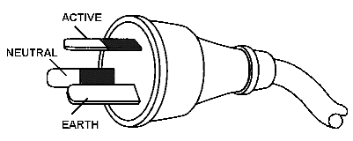 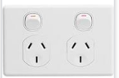

**ANNEX A:**

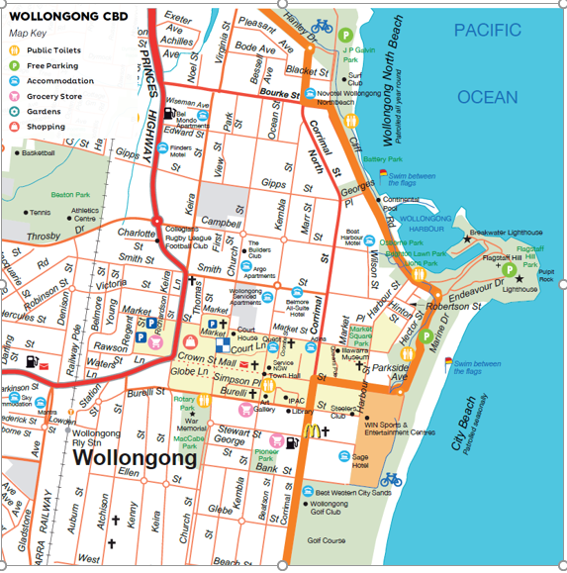

**ANNEX B:**

**Sage Hotel**

