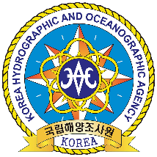

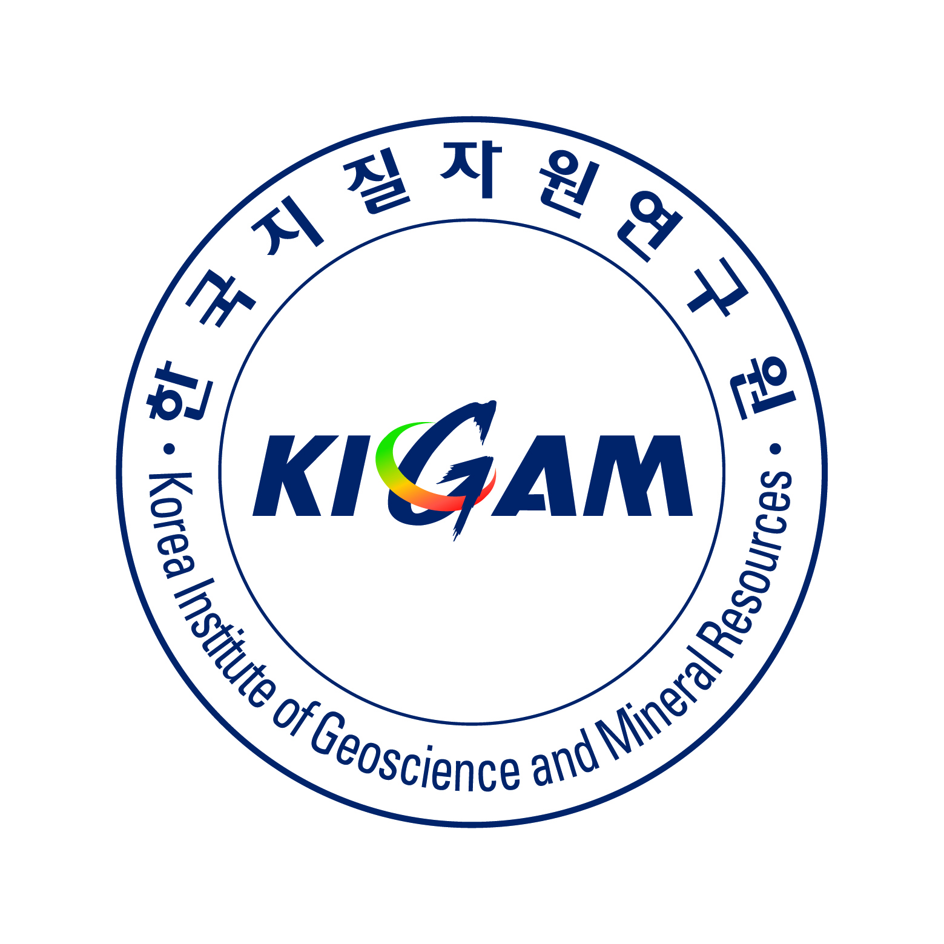

### **IHO-IOC GEBCO**

### **Sub-Committee on Undersea Feature Names**

### **37th SCUFN Meeting**

### **24 – 28 June 2024, Jeju, Republic of Korea**

### **Travel Information and Logistics**

The Korea Institute of Geoscience and Mineral Resources is pleased to welcome SCUFN delegates and interested observers to the beautiful Island Jeju, Republic of Korea for the SCUFN-37 meeting.

**ABOUT JEJU**

Jeju Island is the largest volcanic island in Korea and it has a mild oceanic climate throughout the year with the smallest annual temperature range in the Republic of Korea. Officially called Jeju Special Self-Governing Province, this best tourist destination boasts mild weather, as well as scenic beauties of beaches, waterfalls, cliffs and caves. The island is 73km wide and 31km long with a total area of 1,848.85km2. Jeju is the largest island in the Republic of Korea.

Mt. Halla rises in the center of Jeju to 1,950m above sea level. The rest of the island slopes down from its summit and is covered with dark gray volcanic rocks and volcanic ash soil. Seongsan Ilchulbong Peak with breathtaking views is also one of the most scenic areas, and Manjanggul Cave, the world’s longest lava tube has been registered as a UNESCO World Natural Heritage. Meanwhile, Jeju has recently won the Global Geopark certificate, and also has been selected as the new 7 Wonders of Nature.

For more information visit: https://www.visitjeju.net/en



***We look forward to welcoming you to Jeju Island***

**MEETING VENUE**

The meeting will be held at: **Maison Glad Jeju - “Jade Room”**

80, Noyeon-ro, Jeju-si, Jeju-do, Republic of Korea

**T:** +82 64 747 5000  
**W:** <https://www.glad-hotels.com/maisongladjeju/index.do>

A map of Jeju showing the location of the venue is at **Annex A**.

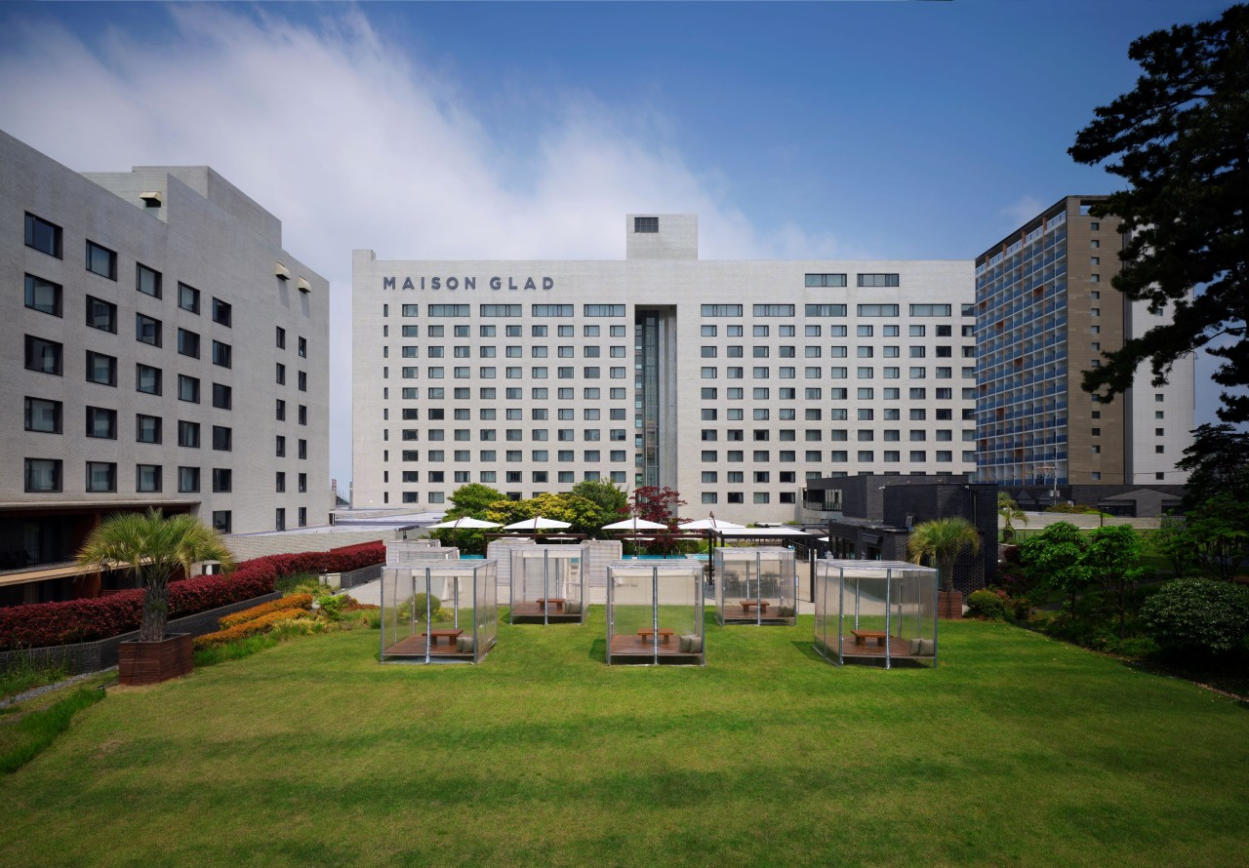

**MEETING SESSIONS**

The official event will commence on the morning of Monday the 24th June and conclude on Friday the 28th of June. Afternoon tea will be provided and luncheon will not be provided during the meetings. The hotel has restaurants for lunch, and there are lots of local restaurants which are within walking distance near the hotel.

**INTERNET**

Wireless LAN is planned in the meeting room and hotel rooms.

**SOCIAL EVENTS : TBA**

**FIELD TRIP : TBA**

**REGISTRATION**

All members and/or observers intending to attend the meeting must register via the IHO online registration system. Please visit: <https://iho.int/en/scufn37-2024>

Please note that the registration deadline is the **15th of March, 2024**.

**ACCOMMODATION**

The Hotel Maison Glad Jeju is offering a discounted room rate to people attending the meeting. Please check the attendance form for more details about the room.

**SMOKING AREA**

Smoking is not permitted within public buildings, including pubs, and is also not permitted on any public transport. Please use designated smoking areas inside and outside the buildings or places outside where there are no people around.

**TIPPING**

Tipping is not obligatory in the Republic of Korea.

**CONTACT DETAILS**

The local point of contact regarding the conference details, more specific logistics, visa and accommodation queries are provided below.

|  |  |
| --- | --- |
| **Ms. Soyoung Kim**  Email: sykim@kigam.re.kr  Phone: +82-42-868-3272 | **Dr. Yoonmi KIM**  Email: ymkim1@kigam.re.kr  Phone: +82-42-868-3138 |

**GENERAL TRAVEL INFORMATION**

**PASSPORTS and VISAS**

**Please check the latest information** from the Ministry of Korean Affairs (Ministry of Foreign Affairs, Republic of Korea (mofa.go.kr). Your passport must be valid for at least 6 (six) months. Vaccinations are not required unless you have come from, or have visited, a yellow fever infected country or zone within 6 days prior to arrival.

**For visa requirements,** depending on your nationality, you should apply for either K-ETA or Visa to enter Jeju island and the Republic of Korea. To check which nationalities are eligible for K-ETA, please visit the official K-ETA website (k-eta.go.kr) or contact the Korean embassies or consular offices

Also, Jeju Island has a visa-free program that allows foreigners to enter and stay legally on Jeju Island for 30 days without a visa. However, if you enter Jeju Island via another city such as Seoul, you may need a visa for the city. In order to check if you are allowed to enter the Republic of Korea and Jeju Island without a visa and for other requirements, please contact the Korean Embassy or Consulate in your country. Upon your request for the visa, the local organizer will email an invitation letter to your affiliated organization. Please email the local organizer in advance if you need the invitation letter.

* Local Organizer: Ms. Soyoung Kim, Administrator of KIGAM, sykim@kigam.re.kr

**COVID-19**

Face coverings are not required anymore indoors and outdoors, **except in hospitals** in the Republic of Korea. For further details about COVID-19 Regulations in the Republic of Korea, please check the Ministry of Foreign Affairs of the Republic of Korea website.

**CURRENCY AND CREDIT CARDS**

The unit of currency in the Republic of Korea is the Korean Won (KRW₩). Notes come in KRW₩ 50000, 10000, 5000, 1000 denominations. Coins come in KRW₩ 500, 100, 50, 10, 1 denominations.

The exchange of foreign currency can be done at local banks and money changers. ATMs are can be found easily all over the Republic of Korea and operated 24 hours a day except for some ATMs inside the banks.

Credit cards(VISA, Mater Card, etc.) are widely accepted by most shops and hotels in Jeju.

**ELECTRICITY**

Electrical voltage is 220V, 60 Hz in the Republic of Korea. The power plug sockets works with C, E, and F. For the other power plugs, please prepare electrical adapters.

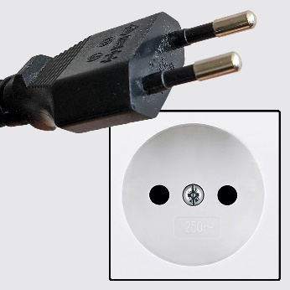(C) 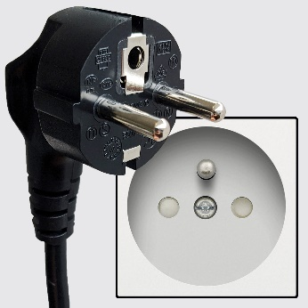(E) 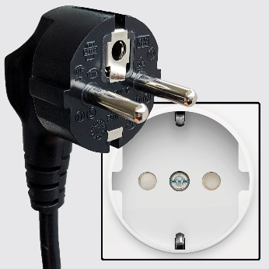(F)

**JEJU TRAVEL INFORMATION**

**TRANSPORT from INCEHON INTERNATIONAL AIRPORT to JEJU**

Since Incheon International Airport doesn’t have domestic lines, you may transfer to Gimpo International Airport to get Jeju. You have three typical options to go to Gimpo International Airport.

**Subway(Airport railway)** There is an airport railway line between Incheon International Airport and Gimpo International Airport. It takes 38-44 minutes depending on the Terminal. For more information about airport railroad, please check https://www.arex.or.kr/ .

**Bus** There are lots of airport limousine buses such as Bus no. 8829, 8842, 8843, 8844, 8849, 6003, 6014, 6008, etc. Detailed information can be easily found in the airport information centers in the airport. It takes 30-50 munites depending on the Terminal and traffic condition.

**Taxi**  It takes about 40 minutes by taxi and costs about KRW₩ 35,000~40,000 (about USD$ 25~30). Please not that cost can be more expensive depending on the traffic condition.

**TRANSPORT from JEJU INTERNATIONAL AIRPORT to the VENUE**

**Shuttle bus** will be operated from Jeju International Airport to the meeting venue, Maison Glad Jeju by the hotel. Please check the timetable below.

|  |  |  |  |
| --- | --- | --- | --- |
| Airport -> Hotel | 10:30 | 15:30 | 19:30 |
| Hotel -> Airport | 09:30 | 14:30 | 18:30 |

If you take **taxi**, it takes 10 minutes and cost about KRW₩ 5,000 (about USD$ 4). Please not that cost can be more expensive depending on the traffic condition

**TRANSPORT AROUND JEJU**

Many restaurants, cafes, beaches and shops are within walking distance of Maison Glad Jeju. Taxis are easy to find near the meeting venue or can be arranged by your accommodation.

**CLIMATE**

The average minimum temperature in Jeju in June is 15℃ and the average maximum daytime temperature lies around 25℃.

**ANNEX A:**

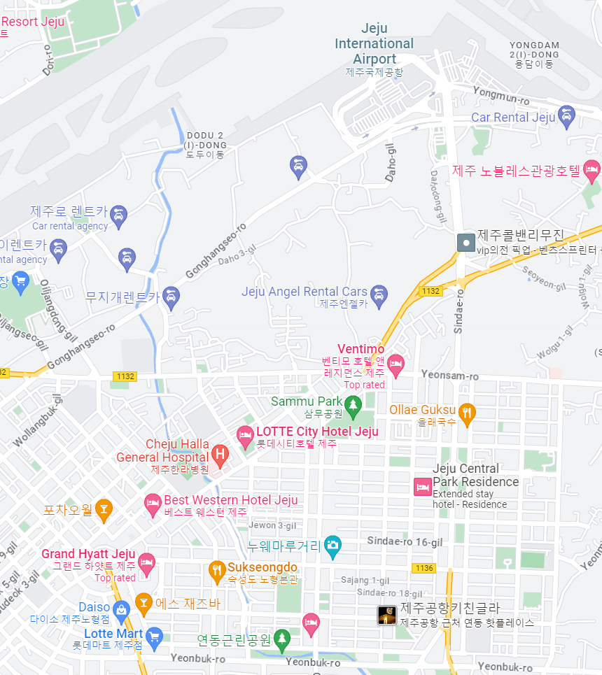

**Maison Glad Jeju**