Report by the International Hydrographic Organization (IHO)

Report by the Secretariat of the International Hydrographic Organization as Chair of the IHO Hydrographic Commission on Antarctica
ATCM Resolutions 5 (2008), 5 (2014) and 6 (2019) – What’s next?

Introduction
The International Hydrographic Organization (IHO) is an intergovernmental consultative and technical organization. It comprises 94 Member States. Each State is normally represented by its National Hydrographer.
The IHO coordinates on a worldwide basis the setting of standards for hydrographic data and the provision of hydrographic services in support of safety of navigation and the protection and sustainable use of the marine environment. The principal aim of the IHO is to ensure that all the world's seas, oceans and navigable waters are surveyed and charted.
Importance of Hydrography in Antarctica
Hydrographic information is a fundamental pre-requisite for the development of successful and environmentally sustainable human activities in the seas and oceans. Unfortunately, there is little or no hydrographic information for a number of parts of the world, especially in Antarctica.
IHO Hydrographic Commission on Antarctica (HCA) and even more
The HCA is the main body in the hands of the IHO to deal with Antarctica matters.
The HCA comprises 24 IHO Member States (Argentina, Australia, Brazil, Chile, China, Colombia, Ecuador, France, Germany, Greece, India, Italy, Japan, Republic of Korea, New Zealand, Norway, Peru, Russian Federation, South Africa, Spain, United Kingdom, Uruguay, USA, Venezuela), all of them have acceded to the Antarctic Treaty and are therefore also directly represented in the ATCM.
The IHO Hydrographic Commission on Antarctica (HCA) was formed in 1998 aimed at coordinating activities between its Member States to improve the quality, coverage and availability of nautical charting and other marine geospatial and hydrographic information and services covering the Antarctic region.
The IHO is engaged in Polar Regions activities in general, through the HCA for the Antarctic, but also through the Arctic Regional Hydrographic Commission (ARHC) for the Arctic Region in support of the Arctic Council and its Working Group for the Protection of the Arctic Marine Environment Working Group (PAME) in particular. This dual commitment in Polar Regions in the IHO is a key enabler for the development of synergies in various domains (seabed mapping autonomous technologies, development of new S-100 operational services and geospatial portals in support of user requirements).
HCA and GEBCO IBCSO
Dr Boris Dorschell (Alfred Wegener Institute for Polar and Marine Research, Germany) is responsible for the compilation of the 2nd version of the GEBCO International Bathymetric Chart of the Southern Ocean (IBCSO), a new high resolution (500 m) gridded bathymetric model. A plea was made by the HCA early 2021 to HCA Members to share their data with the project manager in order to support the compilation phase. This plea applies not only to the Hydrographic Offices representing their nations at the IHO but also to the scientific and research institutes around the world.
HCA and ATCM
HCA has established good links with ATCM, the Secretariat of the Antarctic Treaty and other supporting organizations (IAATO, SCAR, COMNAP, Quantarctica, …) for many years through data collection, information exchange, regular participation in ATCM consultative meetings as observer or running seminar and workshops back-to-back to ATCM Working Groups meetings.
Following up an offer made by the IHO at ATCM XL in Beijing in 2017, the IHO was invited to run an awareness seminar at ATCM XLII in Prague in 2019. Since, the Executive Secretary of the Antarctic Treaty kindly invited the IHO to consider sending experts to the ATCM XLIII in Paris in 2021.
The IHO is pleased to confirm that the 17th Conference of the HCA is planned to be held in Paris on 14-15 June 2021, kindly hosted by Shom, the French Hydrographic and Oceanographic Service. This event will give a good opportunity to HCA Members to attend ATCM XLIII and provide support to their delegation.
From an ATCM perspective, the main outcome of this long standing cooperation between the ATCM and the IHO can be summarized simply by reminding 3 important ATCM Resolutions adopted from 2008 to 2019. They are:
- ATCM Resolution 5 (2008): Improving Hydrographic Surveying and Charting to Support Safety of Navigation in the Antarctic Region.
- ATCM Resolution 5 (2014): Strengthening Cooperation in Hydrographic Surveying and Charting of Antarctic Waters.
- ATCM Resolution 6 (2019): Hydrographic Mapping of Antarctic Waters.
No doubt that recommendations provided in these Resolutions are key enablers for some nations involved in scientific research in Antarctic waters. They are also key drivers for some hydrographic offices of the IHO. They are well identified by stakeholders in the weeks, months, following ATCM annual meetings but then they tend to “sediment” and get forgotten…until the next seminar, workshop, lobbying by the IHO …followed by another ATCM Resolution.
So the question should be: what’s next?
In the IHO Seminar in Prague (ATCM XLII, 2019), the Secretary General of the IHO suggested in his conclusive words:
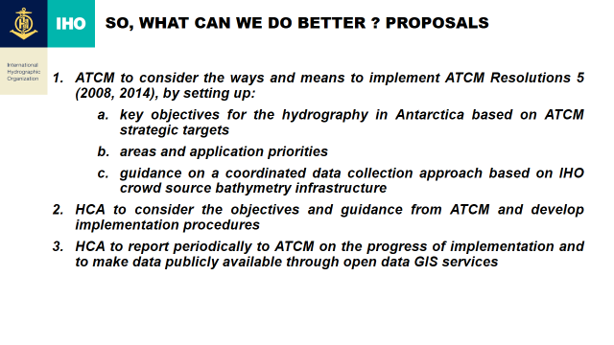
To transform the Resolution into an effective operation plan that can be supported by the IHO, an operational plan meeting ATCM requirements, the 1st step is certainly to identify, collect and prioritize these requirements. This task is under the responsibility of ATCM.
Proposals for consideration by ATCM
In accordance with ATCM Resolutions 5 (2008), 5 (2014) and 6 (2019), the IHO stands ready to support the implementation by the ATCM of step 1a, 1b and 1c (see above) and remains at the disposal of the Secretariat of the Antarctic Treaty to do so.
ATCM is kindly invited to note the work in progress with the compilation of the version 2.0 of the GEBCO IBSCO high resolution bathymetric grid and to share their bathymetric data with the project manager in application of ATCM Resolutions. Technical requirements can be provided on request (adcs@iho.int or boris.dorschel@awi.de)
Finally, for more information on IHO activities in Antarctica: https://lnkd.in/dQEzM2h

General Bathymetric Chart of the Oceans, an IHO-IOC programme.

