STATUTES OF THE IHO HYDROGRAPHIC COMMISSION ON ANTARCTICA (HCA)
(As approved by correspondence, following HCA-17, VTC, 14 June 2021)

Article 1: THE COMMISSION AND THE ANTARCTIC TREATY SYSTEM
GENERAL
  - The Hydrographic Commission on Antarctica (HCA or the Commission) is a unique Regional Hydrographic Commission (hereinafter RHC) recognized by the International Hydrographic Organization (IHO). The HCA is established in conformity with IHO Resolution 2/1997 as amended “Establishment of Regional Hydrographic Commissions (RHC)” (Appendix A) and shall be governed according to these statutes. The Commission should provide, in pursuance of the resolutions and recommendations of the IHO, and the Antarctic Treaty System, regional coordination in the provisioning of hydrographic services, freedom of scientific investigation, cooperation, free exchange of, and access to, scientific observations in support of safe maritime navigation and for broad scientific use.
  - ARTICLE 8 (a) of the International Hydrographic Organization’s General Regulations states that RHCs are regional bodies, established by IHO Member States and recognized by the IHO Assembly to improve regional coordination, enhance exchange of information and foster training and technical assistance.” Additionally, ARTICLE 8 (e) stipulates the membership requirements for RHCs, including the HCA.
  - The Antarctic Treaty and related agreements, collectively known as the Antarctic Treaty System, provide a legal framework for international relations with respect to Antarctica, Earth's only continent without a native human population. The Treaty applies to the area south of 60° South Latitude, including all ice shelves and islands. The principle aims of the Antarctic Treaty System, of interest to the IHO, are the focus on cooperative relations with International Organizations, scientific research and the free exchange of data.
  - The geographic limits of the HCA are defined by the IHO International (INT) Charting Scheme Region M. The geographic limits of this region are illustrated at Appendix B.

Article 2

MEMBERSHIP
  - As per ARTICLE 8 (e) of the IHO General Regulations, Full Membership is reserved for IHO Member States whose governments have acceded to the Antarctic Treaty and contribute resources to the provision of hydrographic data, products and services supporting marine safety of navigation within, and/or the wider use of marine geospatial information of the Antarctic region.
  - Associate Membership is open to any non-IHO Member State who are Antarctic Treaty Contracting Party, and other States which contributes resources and/or data to IHO INT Chart and ENC coverage of Region M, and which becomes a signatory to the Statutes of the HCA. Associate Members may take part in the discussions but shall not have voting rights, except as contained in Articles 4.2 and 4.3.
  - Other States and international organizations active in the region may be invited by the HCA to participate as Observers. Observer status is available to organizations and individual experts,
having professional involvement in marine data, products or services in Region M either by contributing to those activities, or by providing support to those activities, or as users of derived products. The Observers may take part in HCA discussions, but shall not have voting rights.

Article 3
AIMS
The mission of the HCA is:
“To achieve the improvement of the quality, coverage and availability of nautical charting and other hydrographic information and services covering the region”.
This mission will be achieved by the following aims:
  - The Commission, which is an integral element in achieving the objectives of the IHO and which promotes the aims of the Organization at the regional level, shall have an advisory, scientific and technological character. Activities shall complement the work of the IHO Secretariat, align with and support the intent and objectives of the approved IHO Work Programme, and shall not extend to matters concerning international political issues.
  - The HCA will endeavor to align its mission activities to the intent of the IHO Strategic Plan, IHO Resolution 2/1997 and the Antarctic Treaty System. Freedom of scientific investigation and cooperation, and free exchange of and access to scientific observations and results are considered key objectives of the HCA.
  - The aims of the Commission are: To promote technical co -operation in the domain of hydrographic surveying, marine cartography, and nautical information within the region.
  - To stimulate the Full Members, Associate Members and Observers forming the HCA to widen hydrographic activity in the region in accordance with relevant Antarctic Treaty Consultative Meeting (ATCM) Resolutions (Appendix C). Encourage them to seek technical advice and assistance from the IHO Secretariat in establishing and strengthening their hydrographic capabilities and policies, including the acquisition of scientific, commercial and crowdsourced survey resources and all types of advancing technology designed for systematic survey.
  - To facilitate the exchange of information between Hydrographic Authorities and with other organizations concerning surveys, research or scientific, technical and operational developments regarding marine information broadly, and, to aid in the planning and organization of hydrographic activities in the widest sense of the term.
  - To encourage Full Members, Associate Members and Observers forming the HCA to participate actively, of their own free will, on all possible occasions – whether in the form of advice or of assistance – in those hydrographic programmes requiring concerted action, but without prejudice to or interference with their national activities.
  - To examine the implications, in its area of interest, of matters of general interest with which the IHO is concerned, avoiding any interference with the prerogatives of the IHO Secretariat and any other Regional Commissions recognized by the IHO.
  - To coordinate INT chart and ENC schemes, and other developing universal hydrographic data model (S-100) data, products and services for the region and to monitor their suitability.
  - To define the needs for new surveys and if necessary to develop co -operative approaches to meet those needs.
  - To facilitate the provision and wide dissemination of information for scientific purposes and to consider the potential of Marine Spatial Data Infrastructure (MSDI) concepts for regional implementation.
  - To align regional activities with the approved IHO Strategic Plan and Work Programme, taking into account the actions, recommendations and outcomes of the IRCC.
  - The HCA may establish committees or working groups as appropriate, to advance regional priorities. If created, subordinate bodies will have approved Terms of Reference, and progress work under the direction of the HCA. Participation within the subordinate bodies will be open to participants of the HCA and other Subject Matter Experts (SME)s as decided by the Full Members.

Article 4
CONFERENCES
  - The HCA shall meet in plenary conference in the country of one of its Full Members or Associate Members, or such other venue as may be selected, at least once between two successive ordinary sessions of the IHO Assembly. Members may hold the HCA conference, and informal discussions, via VTC connections by agreement.
  - At the end of each conference the Full Members, Associate Members and Observers desirous of hosting the following conference shall put forward their candidatures. Consideration should include locations that collocate the HCA with other international Antarctic discussion venues associated with the Antarctic Treaty System. Priority shall be given to a country that has not yet hosted a conference, or to the one that did so the longest time ago. In cases of equal priority, a vote shall be held, with the decision being taken by a simple majority of Full Members and Associate Members present.
  - Full Members and Associate Members should designate an official representative, preferably the head of a hydrographic office, or where such services do not exist, by heads of national authorities responsible for hydrography and navigation. They may be accompanied by advisors, but it is most desirable that their number be kept to a minimum.
  - The presence of a half of the Full Members of the HCA shall constitute a quorum at all conferences.
  - The Chair shall invite the Chairs of adjacent RHCs to send representatives to attend the Commission conferences as Observers if appropriate. Any Member or Associate Member may propose to the Chair the invitation of technical experts as Observers.

Article 5
CHAIR, VICE-CHAIR AND SECRETARIAT
  - The activities of the Commission shall be conducted by the Chair, who shall be the Secretary-General of the IHO or a Director of the IHO appointed by the Secretary General of the IHO. The Chair shall also preside over the conference.
  - The Chair shall be assisted by a Vice-Chair from a Full Member of the HCA. At the conclusion of the first Conference after each IHO Assembly, the Vice Chair shall be elected by a simple majority of those Full Members present, and serve until the conclusion of the first Conference after the next IHO Assembly.
  - The IHO Secretariat shall provide the Secretariat for the Commission. The Chair will prepare a Provisional Agenda for the next conference and will present, as the first item, his report on the activities of the Commission since the last conference.
  - The Chair will report the activities and future plans of the HCA to the relevant bodies of the IHO. Between sessions, reports of studies or other activities, which may be considered of general interest to all IHO Member States, should be reported through the Chair to the IHO Secretariat for general dissemination.

Article 6
ORGANIZATION OF CONFERENCES
  - The Chair shall issue invitations at least four months before the conference.
  - Proposals to be included in the agenda of a conference shall be sent to the Chair and Secretary at least three months before the date fixed for the opening of the conference.
  - The Chair shall prepare the Provisional Agenda in consultation with the Vice-Chair and host nation, and forward it to the participants at least six weeks before the opening of the conference.
  - The Chair shall be responsible for the organization of the conference, in conjunction with the Vice-Chair and meeting host.
  - The host nation shall provide the Rapporteur and the secretarial facilities for the conference.
  - The host shall be responsible for the expenses of the conference except those expenses described in Article 6.8 below.
  - The host will assist with the arrangement of authorizations and visas, so as to facilitate attendance at the conference.
  - All expenses connected with the participation of the Chair and the delegates in the conference shall be defrayed by their respective organizations.

Article 7
CONFERENCE AGENDA
  - The Agenda shall be adopted by the HCA at the beginning of each conference.
  - The HCA may modify in the course of the conference the order in which Agenda items are to be discussed.

Article 8
DECISIONS, ACTIONS AND RESOLUTIONS
  - Decisions taken during each conference should be prepared in written form by the Chair and presented the next day to the participants present.
  - At the end of the conference, the Chair shall circulate the decisions taken during the conference. These decisions shall be adopted by means of a simple majority of the members present. Votes in favor shall be indicated by a show of hands unless a secret ballot is requested by any Member present. However, when the Chair, or a majority of Members present, decide that the decision so requires, the decision shall be made by correspondence. Such decision will be approved by a simple majority of the Members who have responded by the due date, provided that the number of votes received is at least equal to the quorum indicated in Article 4.5.
  - Only Full Members are entitled to vote, each having the right to one vote. The exception to this rule is found at Articles 4.2.
  - All decisions become operative immediately.
  - The Chair shall dispatch within one month of the close of the conference a copy of the Summary Report containing the discussions, decisions and recommendations of the conference for verification or comment, to each Full Member, Associate Member and Observer. Comments are to reach the Chair within one month of the receipt of the Summary Report. The final version of the Minutes shall be forwarded within four months of the close of the conference.
  - Any decision, which may be of interest to the IHO Member States as a whole, shall be brought to the attention of the IHO Secretariat. This fact shall be mentioned as part of the text of the decisions reached.

Article 9

EXTRAORDINARY MEETINGS
  - By majority agreement of the Full Members, the Chair may call a meeting of the HCA when their representatives are assembled for a session of the IHO Assembly or IHO Council inviting others qualified to attend as Observers. The Chair may also propose a meeting or VTC when agreed by majority of Full Members.
  - In the case of urgent matters, which cannot be treated by correspondence, VTC or other scheduled event, and which cannot be postponed until the next conference, the Chair, with majority agreement of the Full Members, may request that an extraordinary meeting be held in a place considered most appropriate.
  - The provisions applicable to the conference shall apply to all extraordinary meetings.
  - When these extraordinary meetings do not meet quorum and number of votes for decisions as per Sections 4.5 and 8.2, the decisions reached shall be circulated to all Full Members for comment prior to being taken. All decisions shall be reported by correspondence.

Article 10

STATUTES
  - The IHO Secretariat shall be the custodian of these Statutes.
  - Members of the HCA may propose amendments to the Statutes. The Chair shall submit the proposal(s) to all Members for decision at conference, or voting via CL. Two-thirds (2/3) of Full Members of the HCA is required for approval. If an amendment is approved, the Chair will update the Statutes and circulate them to all Full Members, Associate Members and Observers.
  - Updated versions of the IHO and ATCM resolutions will be added to the Statutes, as appropriate, by the Chair without the approval of the Members of the HCA. The changes would not constitute formal amendments to the Statues.

Article 11

LANGUAGE OF THE HCA
11.1 The working language of the HCA shall be English.

Approved by the Commission at the IHB, Monaco, September 2003
Amendments approved at the HCA-7, Buenos Aires, Argentina, October 2007
Amendments approved at the HCA-12 Montevideo, Uruguay, October 2012
Amendments approved at the HCA-13 Cádiz, Spain, December 2013
Amendments approved at the HCA-14 Tromsø, Norway, June 2016
Amendments approved by correspondence, following HCA-17, VTC, 14 June 2021

Annex: Signature Pages

Appendices:
- IHO Resolution 2/1997, as amended
- Geographic Limits of IHO INT Charting Scheme Region M
- Resolutions 5 of the 31st Antarctic Treaty Consultative Meeting 2008, 5 of the 37th Antarctic Treaty Consultative Meeting 2014 and 6 of the 42nd Antarctic Treaty Consultative Meeting 2019

Annex to the HCA Statutes

Signature Pages (Updated to 28 June 2016)

IHO HYDROGRAPHIC COMMISSION ON ANTARCTICA (HCA) MEMBERS

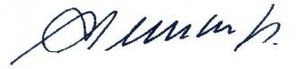
 | COUNTRY |  | SIGNATORY | DATE OF SIGNATURE
 | Argentina |  | Capt. Miguel Enrique CLEMENTS Director SHN | 29 March 2004
 | Australia |  | 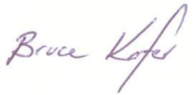  Capt. Bruce KAFER Director AHS | 9 September 2003
 | Brazil |  | Vadm. Edison LAWRENCE Mariath Dantas Director DHN | 6 November 2006
 | Chile |  | 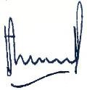  Capt. Pablo SALZMANN Pineda Acting Director SHOA | 27 February 2004
 | China |  | 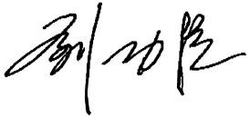  Capt. LIU Gongchen Executive Director-General, China MSA | 1 June 2005
 | Colombia |  | 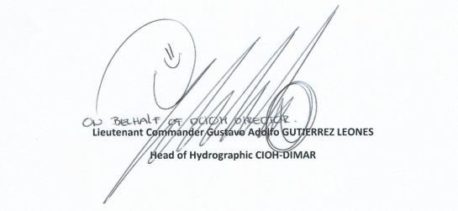 | 28 June 2016
 | Ecuador |  | 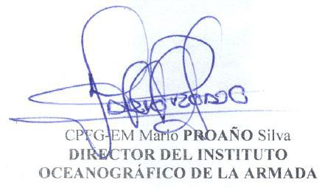 | 5 July 2006
 | France |  | 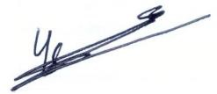  IGA Yves DESNOES  Director SHOM | 7 April 2004

Germany | 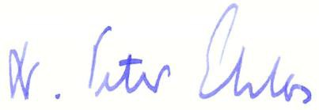  Dr. Peter EHLERS President BSH | 2 September 2004
Greece | 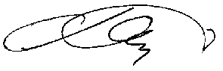  Commodore A. SKLAVIDIS Director HNHS | 26 August 2004
India | 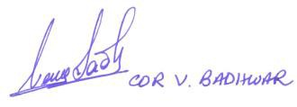  Cdr. V. BADHWAR | 9 September 2003
Italy | 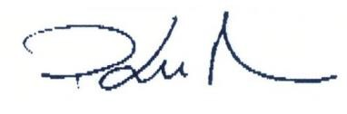  Cdr. Paolo LUSIANI | 5 August 2003
Japan | 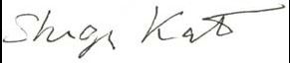  Dr. Shigeru KATO Director JHOD | 2 September 2008
Korea (Rep. of) | 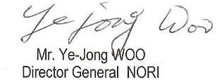 | 7 November 2008
New Zealand | 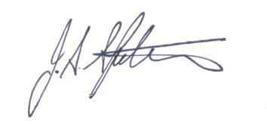  Mr. John SPITTAL  Chief Topographer/Hydrographer LINZ | 23 August 2004
Norway | 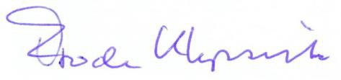  Mr. Frode KLEPSVIK Director NHS | 10 September 2003

Peru | 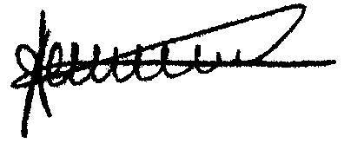  Radm Augusto ZEGARRA Director DHN | 31 October 2007
Poland
Russian Federation | 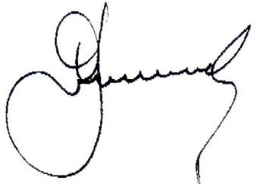  Radm. Boris FRIDMAN Deputy Chief HDNO | 27 August 2004
South Africa | 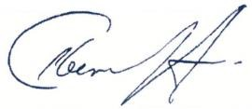  Capt. Abri KAMPFER Director SANHO | 27 October 2003
Spain | 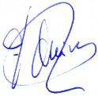  Capt. Fernando QUIROS Cebriá Director IHM | 17 December 2003
Ukraine
United Kingdom | 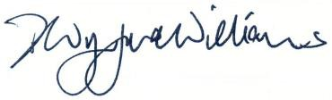  Dr. D. Wynford WILLIAMS Director UKHO | 17 September 2003
USA | Radm. Christian ANDREASEN Chief Hydrographer, NGA | 11 May 2007

Uruguay | 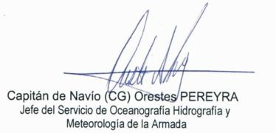 | 28 August 2008
Venezuela | 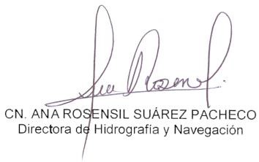 | 6 February 2009

APPENDIX A

RESOLUTION 2/1997 OF THE IHO, AS AMENDED

ESTABLISHMENT OF REGIONAL HYDROGRAPHIC COMMISSIONS (RHC)

1.- It is resolved that the IHB shall encourage Member States having common regional interests in data collecting or nautical charting to form Regional Hydrographic Commissions (RHC) to cooperate in the undertaking of surveys and other projects. As part of IHO, the RHC shall complement the work of the Bureau.

2.- RHCs are intended to provide, in pursuance of the resolutions and recommendations of the IHO, regional co-ordination with regard to nautical information, hydrographic surveys, production of nautical charts and documents, training, technical cooperation and hydrographic capacity building projects. They (RHC) should enable the exchange of information and consultation between the hydrographic services concerned. Geographically adjacent RHCs should liaise with each other.

2b.- Where Capacity Building is required in a region, RHCs are recommended to establish an internal body to deal with CB matters and to designate a focal point to ensure continuity in the CB process. This part-time allocation to assi^{st} RHCs should come primarily and ideally from IHO within the region. If that is not possible then the RHC might agree to request support from another RHC or IHO that might wish to take that responsibility.

These regional contact points, the responsibilities of which should be given directly and in detail by the RHC concerned, shall have the support of the RHCs; shall be nominated having in mind the importance of continuity; shall be in permanent contact with the corresponding RHC Chairman as well as with the CBC Chairman. Ideally should be a CBC member with access to RHC meetings.

In the absence of any other viable alternative and despite its limited human resources availability a request of support could be requested to the IHB.

3.- RHCs shall be properly constituted and have activities in line with the objectives of the IHO as described in Article II of the Convention on the IHO and in accordance with the approved IHO Work Programme. Geographical areas of the RHC will normally coincide with INT chart regions, modified as appropriate to meet regional requirements and special circumstances. There are special provisions for Region M (Antarctica) because of its special status.

4.- RHC membership may include full members, associate members, and observers, all willing to contribute to the safety of navigation in the fields of hydrography, nautical charting, nautical information or navigational warnings in the region concerned. The roles of full members, associated members and observers will be defined by each RHC.

Full membership is reserved for IHO Member States within the region who sign the statutes of the RHC.

Associate membership is available to other IHO Members States or States of the region who are non- IHO members, both being signatories of the statutes of the RHC.

Other States and International Organizations active in the region concerned may be invited by the RHC to participate as observers.

The invitation procedures should be established by each RHC.

5.- The working languages used by the RHC shall be agreed upon by their members and designated to ensure the best communication between participants. The reports and IHO documents relating to RHC activities shall be in at least one of the official languages of the IHO. For correspondence with the Bureau, one of the official languages of the IHO shall be used.

6.- A representative of the Bureau shall be invited to attend meetings of RHCs.

6b.- RHCs shall assess regularly the hydrographic capacity and requirements within their region.

7.- Chairs of RHCs shall report to the I.H. Conference on RHC activities, hydrographic capacity and requirements within their region, future plans and the agreed key targets that support RHC tasks detailed in the IHO Work Programme. The Chairs of RHC’s shall also submit an annual report to the IHB indicating progress made against the agreed key targets in the IHO Work Programme for general dissemination. Between sessions of the IHC, reports of studies or other activities, which may be considered of general interest to all IHO Member States, shall be sent by Chairs of RHCs to the Bureau for general dissemination.

8.- The following structure is to be used for National Reports made to those RHCs that wish to receive such reports:

Structure for National Reports to Regional Hydrographic Commissions

Executive summary
- Hydrographic Office / Service: General, including updates for the IHO Yearbook
e.g.reorganization
- Surveys: Coverage of new surveys.
New technologies and /or equipment. New ships
Problems encountered
- New charts & updates: ENCs
ENC Distribution method RNCs
INT charts
National paper charts
Other charts, e.g. for pleasure craft Problems encountered
4. New publications & updates: New Publications
Updated publications
Means of delivery, e.g. paper, digital Problems encountered
- MSI Existing infrastructure for transmission
New infrastructure in accordance with GMDSS Master Plan Problems encountered
Note: Use the WWNWS template for this section

- C-55 Latest update (Tables)
- Capacity Building Offer of and/or demand for Capacity Building
Training received, needed, offered
Status of national, bilateral, multilateral or regional development
projects with hydrographic component. (In progress, planned, under evaluation or study)
Definition of bids to IHOCBC
- Oceanographic activities General
GEBCO/IBC’s activities Tide gauge network New equipment Problems encountered
- Other activities Participation in IHO Working Groups Meteorological data collection Geospatial studies
Disaster prevention Environmental protection Astronomical observations Magnetic/Gravity surveys International
Etc.
- Conclusions

APPENDIX B

GEOGRAPHIC LIMITS OF IHO INT CHART REGION M

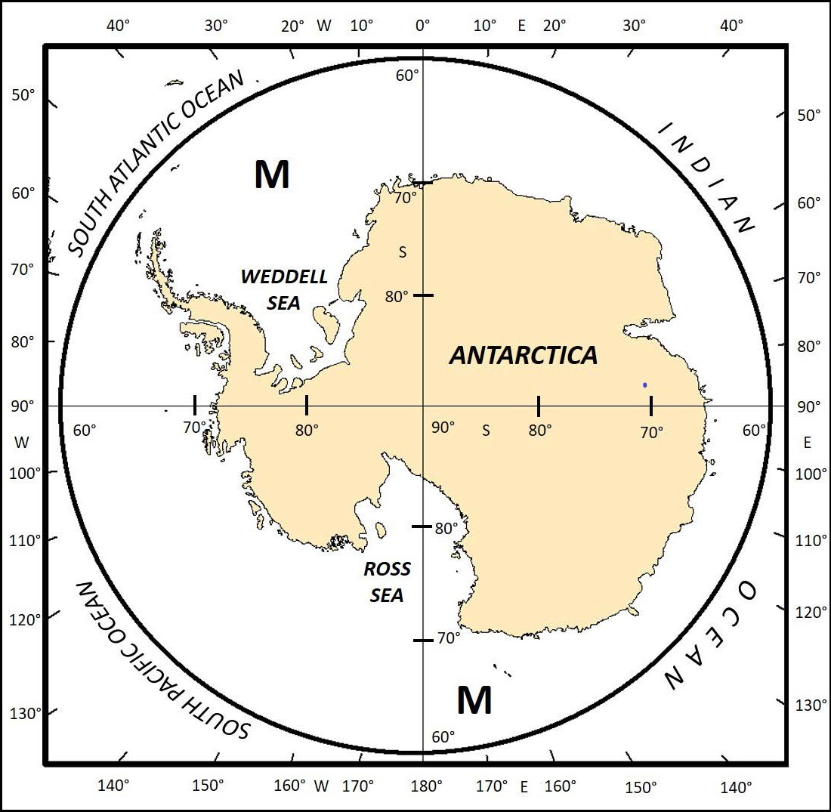

31st Antarctic Treaty Consultative Meeting (ATCM), Kyiv, Ukraine, 01-13 June 2008 Resolution 5 (2008)

IMPROVING HYDROGRAPHIC SURVEYING AND CHARTING TO SUPPORT SAFETY OF NAVIGATION IN THE ANTARCTIC REGION

The Representatives,

Considering that reliable hydrographic data and nautical charts are essential to safe maritime operations;

Noting the increase in marine traffic, particularly tourist vessels, in the Antarctic region;

Concerned about the increased risk of harm to ships, persons and the environment in inadequately charted waters in the region;

Noting that the collection of accurate survey data will improve navigational safety and support scientific research;

Recognising the role of the International Hydrographic Organization Hydrographic Commission on Antarctica (HCA) in the coordination of hydrographic charting in the Antarctic region and the value of cooperating with relevant expert bodies;

Recommend that their Governments:

- cooperate with the HCA to improve hydrographic surveying and charting in the Antarctic region, including working to:
  - clarify HCA requirements for the collection of hydrographic data of sufficient quality for use in the
development of electronic navigation charts, and
  - identify priority areas for the collection of additional hydrographic and bathymetric data;

- encourage their national programme vessels and other vessels, as appropriate, to collect hydrographic and bathymetric data on all Antarctic voyages, as practicable;

- forward any Antarctic hydrographic and bathymetric data collected to the relevant international chart producer for charting action; and

- endeavour to find additional resources towards improving hydrographic surveying and charting in the Antarctic region.

37th Antarctic Treaty Consultative Meeting (ATCM), Brasilia, Brazil, 28 April - 07 May 2014

Resolution 5 (2014)

Strengthening Cooperation in Hydrographic Surveying and Charting of Antarctic Waters

The Representatives,

Considering that reliable hydrographic data and nautical charts are essential to safe maritime operations;
Noting the increase in marine traffic, particularly tourist vessels, in the Antarctic region;
Concerned about the increased risk of harm to ships, persons and the environment in inadequately charted waters in the region;
Noting that the collection of accurate survey data will improve navigational safety and support scientific research;
Recognising the role of the International Hydrographic Organization Hydrographic Commission on Antarctica (HCA) in the coordination of hydrographic surveying and nautical charting in the Antarctic region, and the value of cooperating with the Scientific Committee on Antarctic Research (SCAR) and other relevant expert bodies;
Recalling Recommendation XV-19 (1989), Resolution 1 (1995), Resolution 3(2003), Resolution 5 (2008) and Resolution 2 (2010), which encouraged cooperation on hydrographic surveying and charting of Antarctic waters;

Recommend that the Parties:

- support and promote contacts and liaison between national Antarctic programs and national hydrographic offices;

- increase their mutual cooperation in the hydrographic surveying and charting of Antarctic waters in order to contribute to safety of navigation, safeguarding life at sea, protection of the Antarctic environment, support of scientific activities, and furtherance of responsible economic activity; collaborating within, as appropriate, the framework(s) of national Antarctic programs, national hydrographic offices, the HCA and the International Chart scheme;

- co-ordinate their hydrographic surveying and charting activities through the HCA and cooperate with it to:
  - clarify requirements for the collection of hydrographic data of sufficient quality and accuracy for use in the development of electronic and paper navigational charts, being cognisant of the emerging challenges and opportunities faced in the digital navigation era;

  - identify priority areas for the collection of additional hydrographic and bathymetric data;

  - complete their inventory of data holdings and give high importance to liaison between Parties on future planned hydrographic surveys in order to avoid duplication of effort; and

- encourage national Antarctic program vessels and all other vessels operating in the Antarctic Treaty area to collect hydrographic and bathymetric data including passage soundings on all Antarctic voyages, as practicable; to forward any hydrographic and bathymetric data collected to the relevant international chart producer for charting action; and to endeavour to find additional resources to improve hydrographic surveying and charting in the Antarctic region.

42nd Antarctic Treaty Consultative Meeting (ATCM), Prague, Czech Republic, 01 – 11 July 2019

Resolution 6 (2019)

Hydrographic Mapping of Antarctic Waters
The Representatives,
Recalling Recommendation XV-19 (1989) and Resolutions 1 (1995), 3 (2003), 5 (2008), 2 (2010), and 5 (2014) which contain general provisions regarding cooperation on hydrographic surveying and charting of Antarctic waters, noting their continued validity;
Considering that reliable hydrographic data and nautical charts are essential for safe maritime operations and the protection of the marine environment;
Noting that the collection of accurate bathymetric data will improve navigational safety and support scientific research;
Concerned about the lack of progress on hydrographic mapping and bathymetric data collection of Antarctic waters and the risk of harm that may befall ships, people and the environment within inadequately chartered waters in the region;
Acknowledge the efforts of the IHO Data Center for Digital Bathymetry, the GEBCO Seabed 2030 project and the IHO Crowdsource Data Working Group
Recognizing the role of the International Hydrographic Organization Hydrographic Commission on Antarctica (HCA) in the coordination of hydrographic surveying and nautical charting in the Antarctic region, and the value of cooperating with SCAR and other relevant expert bodies;

Recommend Parties to give priority to reviewing existing bathymetric data holdings and collecting new bathymetric data in the Antarctic region by
- Encouraging their national programme vessels and other vessels including non-governmental vessels, as appropriate, to:
  - Review existing bathymetric data holdings for inclusion in the IHO DCDB
  - Undertake hydrographic and bathymetric data collection on all their Antarctic voyages, as practicable.
  - Utilize IHO guidelines where appropriate, including the IHO Publication B-12 – Crowdsourced Bathymetry Guidance Document.
  - Share all data collected with the IHO Data Center for Digital Bathymetry, either directly or through their national hydrographic office.

- Encouraging cooperation between national research institutions and mapping institutions/authorities on hydrographic surveying and charting in the Antarctic region, in order to secure the highest value of collected data for the widest possible (re)use by following basic hydrographic survey guidelines.
Recommend Parties to endeavor to find additional resources put towards improving hydrographic surveying and charting in the Antarctic region;
Encourage those Parties who are also Parties to CCAMLR to consider possible actions within CCAMLR’s mandate, to ensure that fishing vessels and research vessels operating in the CCAMLR Convention area undertake hydrographic and bathymetric data collection on all their Antarctic voyages, as practicable.

