IHO HYDROGRAPHIC COMMISSION ON ANTARCTICA (HCA)
18TH CONFERENCE BERLIN, GERMANY, 24 – 26 MAY 2022

NATIONAL REPORT FROM REPUBLIC OF SOUTH AFRICA TO THE HCA18

Reference: 1. IHO CL 25a/2006 dated 27 February 2006 (Annex B)
2. IHO Administrative Resolution T1.3 (Para. 8)

EXECUTIVE SUMMARY

1. HYDROGRAPHIC OFFICE / SERVICE

a. Name of the institution. South African Navy Hydrographic Office (SANHO)

b. Description. The SA Hydrographic Service is a government-funded service and is part of the SA Navy. The major assets for the Hydrographic Service are as follows:

Hydrographic Survey Vessel: One Hecla Class Hydrographic Survey Vessel, named SAS PROTEA. She carries onboard two smaller survey motor boats that are deployed for shallow water surveys. There is an additional survey motor boat on a trailer and equipment that is used as a mobile survey unit (MSU).

Hydrographic Office, with the following principal functions:
- Conduct hydrographic surveys;
- Produce paper nautical charts and electronic navigation charts (ENCs;)
- Produce hydrographic publications including List of Lights and Radio Signals, three volumes of Sailing Directions;
- Maintain a tide gauge network and provide tidal information;
- Collect GEBCO data;
- Issue monthly Notices to Mariners;
- Provide hydrographic survey training;
- Provide a Maritime Safety Information (MSI) and
- Provide a Chart Depot and Chart Agent service.

Personnel, with the following principal functions:

- Cartographic Personnel. The SANHO has 7 degree/national diploma qualified marine cartographers and 7 junior IHO/FIG CAT B qualified cartographers in the Chart Production Department working on paper chart and ENC production.

- Survey Personnel. The SA Navy Hydrographic Service has 5 IHO/FIG CAT A qualified survey officers and 1 IHO/FIG CAT B survey officer, supported by 8 survey officers with Basic Hydrographic Survey Training. The team is further assisted with 33 qualified survey recorders.

c. Submitted by. Captain (SAN) Theo Stokes, hydrosan@iafrcia.com

Detailed information for IHO Publication P-5 (Yearbook) is up to date.

2. HYDROGRAPHIC SURVEYS

a. Coverage of new surveys. No new surveys were conducted in the RSA area of responsibility.

b. New technologies and /or equipment. The replacement of legacy cartographic software with a fully integrated software solution catering for paper charts and electronic navigation charts was addressed through the Hydrographic Capability Replacement Project. Teledyne CARIS chart production software has been installed at the SANHO and will be fully integrated with the new survey acquisition and processing software on board the new HSV and SMBs, realising the “ping to chart” philosophy and capability. This will also assist in the collection and formatting of geospatial data in aid of marine spatial planning. The acquisition of high-end large format inkjet printers to support the print-on-demand (POD) requirements of paper chart products was also being addressed as a priority through the Hydrographic Capability Replacement Project. Procurement for the new S100 standard development software package is underway. The SANHO has developed a Roadmap and Implementation Plan for the introduction of the S-100 family of services and standards.

c. New ships. Also as part of the Hydrographic Capability Replacement Project, the acquisition of a new hydrographic survey vessel and 3 x survey motor boats is well underway, and is intended to be completed by 2024. Operational Test and Evaluation of the first SMB has commenced before it will be accepted into service by the SANHO.

d. Challenges and achievements. As noted.

3. NEW CHARTS & UPDATES

The South African geographical area of interest in Antarctica is concentrated in Dronning Maud Land and the South African Hydrographic Office has published paper chart SAN 2004 (INT 9056) – Approaches to Dronning Maud Land and an ENC, covering the region between 69° 10’ 00”S to 71° 41’ 00”S and 05° 30’ 00”W to 00° 10’ 00”W at a scale of 1:300 000. The standard land area (buff) has been substituted with a greyscale RADARSAT image supplied by the South African Satellite Application Centre (SAC). The main purpose of the chart is to cover the approaches to the area negotiated by scientific research vessels to land scientists and equipment for deployment at the South African Research Station SANAE IV. The bathymetric data within the area of the approaches to Dronning Maud Land is based on satellite derived altimetry and bathymetric contours from the Alfred-Wegener Institute, Germany and trackline bathymetric cruise data from the US National Geophysical Data Centre, Boulder, Colorado, USA (GEODAS) and the South African Department of Forestry, Fisheries and the Environment (DFFE): Antarctica and Islands, Cape Town.

a. Electronic Navigational Charts (ENC). Currently the SANHO utilizes Teledyne CARIS production software for electronic navigational chart (ENC) production and maintenance consisting of five HPD Source Editor licences and three HPD Product Editor licences. ENC validation tools used by SANHO are dKart Inspector, one licence each of Seven C’s Analyser and eGlobe (ECDIS).

ENC Production. South Africa has the following paper chart - ENC relationship:

Chart Series ENC Usage Band
SAN Harbour charts Harbour
SAN Approaches charts Approaches
SAN 100 000 and 150 000 Series charts Coastal
SAN 300 000, 600 000 Series General
SAN 1 000 000 Series and all other small scales Overview

All ENCs conform to the current international guidelines for SCAMIN and data consistency. In addition, SAN ENCs also encode M_SREL (survey reliability) and CATZOC in the Harbour, Approaches and Coastal usage bands and maintain the products for (T) and (P) notices.

ENC Coverage.

Note: Text highlighted in bold and red is new work since the previous HCA meeting.

IC-ENC Cell Title
Product No
ZA300300 Approaches to Dronning Maud Land (NE published 2021)

A new edition of ZA300300 was published in September 2012 based on a much-improved geo-referenced TerraSAR-X image of 2011 (Figure 1).
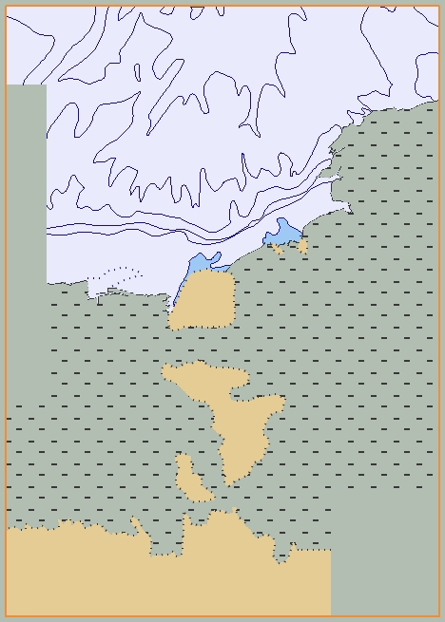
Figure 1. ZA300300

Ongoing/Outstanding ENC production.

- S100 Roadmap and Implementation Plan. The roadmap for SANHO’s S-100 implementation has been drafted and approved with five identified products of interest, namely S-101, S102, S122, S-124 and S-104. The S-101 implementation plan has been submitted to the hydrographer for approval. The timeline for implementation relies on the acquisition of the S100 software, and the SANHO aims to start producing S100 compliant products by 2024, starting with S101.

- Vectorising. The project to vectorise paper charts information within the CARIS HPD is in progress. Larger scale paper charts are prioritised. The SANHO aims to achieve 100% vectorisation by the end of 2023.

b. ENC Distribution method. South African commercial ENCs are distributed through IC-ENC. The South African Hydrographic Office maintains its own web site (www.sanho.co.za) which provides information concerning ENC, Charts and Carriage Requirements. Information on MSI, chart products (paper and ENCs), publications and tidal data are also made available on the SANHO web site.

c. RNCs. SANHO does not produce RNCs.

d. International (INT) Charts. South Africa is the co-ordinator for international charting within Region H but also the producer nation of a single paper chart and an ENC within charting Region M, which is based on the WGS 84 ellipsoid.

Region M:

Small Scale : 1:1 000 000
INT No SAN No Title
9056 2004 Antarctica. Approaches to Dronning Maud Land

A new edition of SAN 2004 (INT 9056) was published in September 2012 based on a much-improved geo-referenced TerraSAR-X image of 2011 (Figure 2).
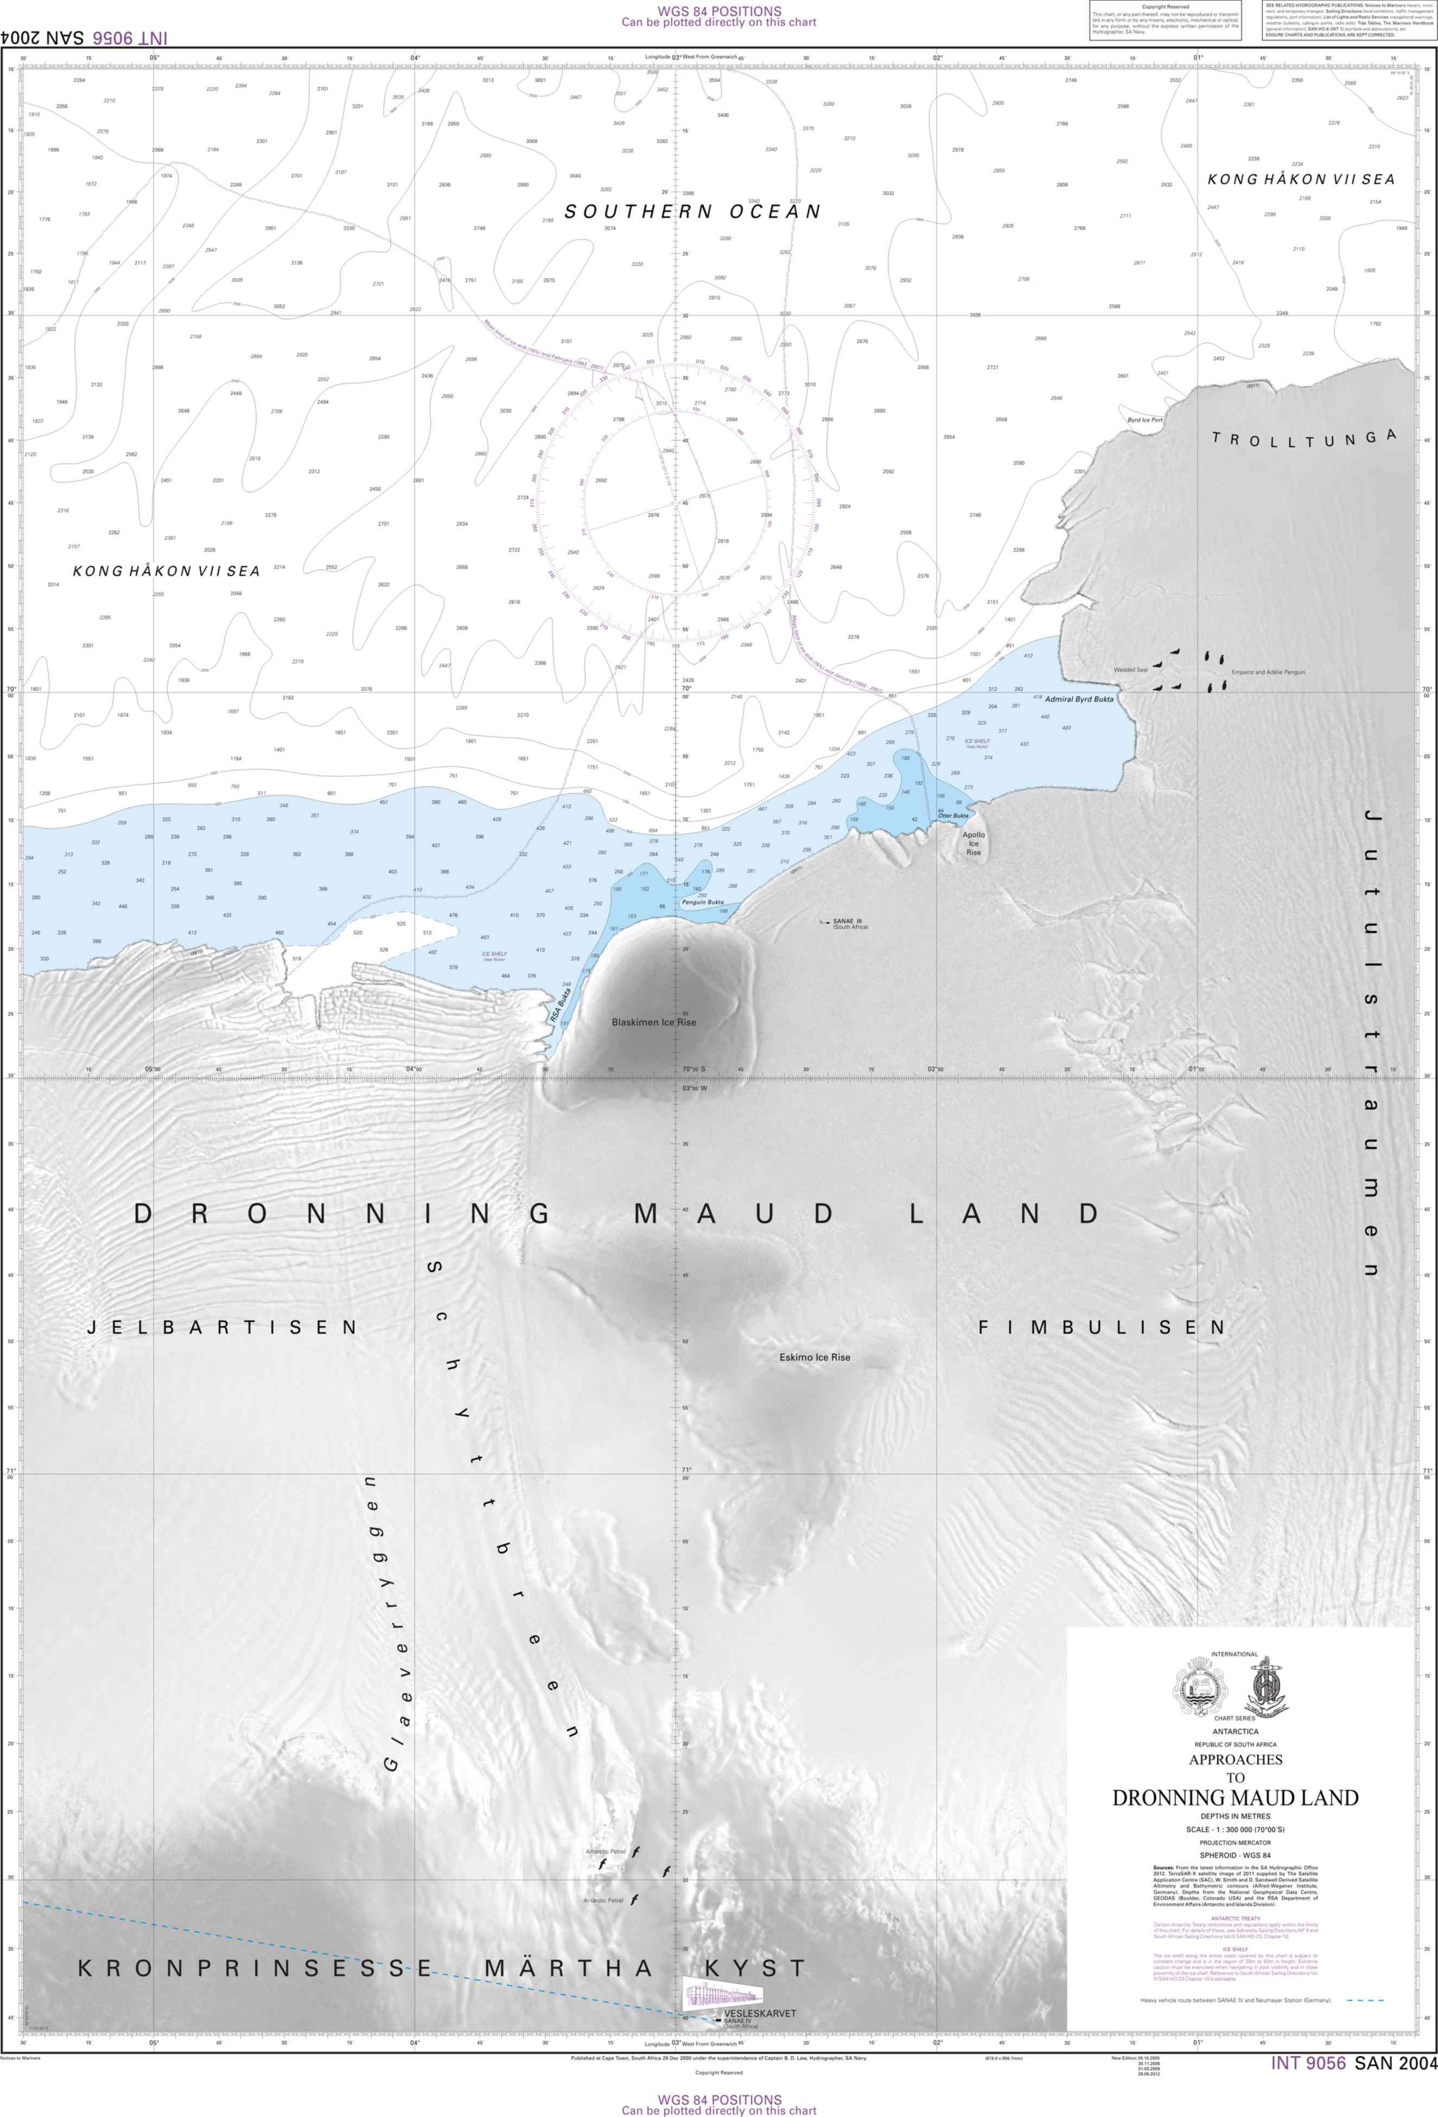
Figure 2. Paper Chart SAN 2004-INT 9056

e. National paper charts. Nothing to report.

f. Other charts, e.g. for leisure craft. Nothing to report.
g. Challenges and achievements. As noted.

Detailed information about charting for IHO Publications P-5 (Yearbook) and C-55 (Status of Hydrographic Surveying and Charting Worldwide) is up to date.

4. PUBLICATIONS

South Africa has since 2001 published, in its South African Sailing Directions Vol III (SAN HO–23) Chapter 10, information on the Antarctic Region. The scope of this chapter encompasses that part of NAVAREA VII south of the 60° parallel and the Antarctic Coast between 20°W and 80°E. It consists of seven sections that provide essential information on the regulations/Antarctic Treaty, aircraft operations, general scientific and environmental information, natural conditions, sea ice, navigation in ice and a section on Bouvet Island (Bouvetøya).

a. New Publications. Nil.

b. Updated publications. Publications are maintained through the promulgation of monthly NM’s in paper format (available through SANHO Chart Agents) and in PDF format, which can be downloaded from the SANHO web site (www.sanho.co.za).

The present status of SANHO Publications is as given in the table below (Note: Text highlighted in bold and red is new work since the previous HCA meeting):
SANHO Ref No | Title | Edition
SAN HO-1 | South African List of Lights and Radio Signals | 2022
SAN HO-2 | South African Tide Tables | 2021 & 2022
SAN HO-3 | Catalogue and Indexes of SAN Charts, ENCs and Hydrographic Publications | 2022
SAN HO-6 (INT 1) | Symbols and Abbreviations used on SA Charts | 2017
SAN HO-15 | International Regulations for Preventing Collisions at Sea 1972 (COLREGS) | 2020
SAN HO-21 | SA Sailing Directions Vol I – General Information | 2005
SAN HO-22 | SA Sailing Directions Vol II – Namibia and West Coast | 2014
SAN HO-23 | SA Sailing Directions Vol III – South and East Coasts | 2014
- | Annual Summary of SA Notices to Mariners | 2021 & 2022
- | Cumulative List of SA Notices to Mariners (updated monthly) | 2022

c. Means of delivery, e.g. paper, digital.

SANHO Ref No | Title | Format
SAN HO-1 | South African List of Lights and Radio Signals | Paper
SAN HO-2 | South African Tide Tables | Paper
SAN HO-3 | Catalogue and Indexes of SAN Charts, ENCs and Hydrographic Publications | Digital
SAN HO-6 (INT 1) | Symbols and Abbreviations used on SA Charts | Paper
SAN HO-15 | International Regulations for Preventing Collisions at Sea 1972 (COLREGS) | Paper
SAN HO-21 | SA Sailing Directions Vol I – General Information | Paper
SAN HO-22 | SA Sailing Directions Vol II – Namibia and West Coast | Paper
SAN HO-23 | SA Sailing Directions Vol III – South and East Coasts | Paper
- | Annual Summary of SA Notices to Mariners | Digital
- | Cumulative List of SA Notices to Mariners | Digital

All digital publications are available in PDF format for downloading from the SANHO web site (www.sanho.co.za).

d. Challenges and achievements. The SA Navy Printing Unit (NPU) in Simon’s Town is the primary means of chart and publication printing. However, the onboard POD facility, through the rejuvenation project, is now able to meet the day-to-day demands for paper chart stock replenishment, and not publications. Currently the SANHO POD facility is not capable of printing and/or procuring publications, and this remains a challenge if/when NPU cannot meet SANHO printing requirements.

Detailed information about charting for IHO Publications P-5 (Yearbook) is up to date.

5. MSI

a. Existing infrastructure for transmission. The SANHO, Coordinator of NAVAREA VII, in conjunction with the South African Meteorological Service, promulgates and disseminates shipping safety messages and weather information. Cape Town Radio, via Telkom Radio Services, is the GMDSS service provider and as such, transmits all MSI on behalf of the Coordinator.

SafetyNET II
MSI transmission is to Indian Ocean Region (IOR) and to Atlantic Ocean Region East (AOR-E).
Meteorological Forecasts and NAVAREA VII Warnings: 0940 and 1940 UTC.
Land Earth Station 12 Burum; Service Provider: Stratos Mobile Networks.

SafetyCAST
SafetyCAST satellite broadcast service provider: Iridium.
Meteorological Forecasts and NAVAREA VII Warnings: 0940 and 1940 UTC.
These broadcasts form part of NAVAREA VII and Iridium test and evaluation operations.

NAVTEX
NAVTEX coverage out to 200 nm from the Namibian and South African Coasts is passed from the Coast Radio Stations at Cape Town (C), Port Elizabeth (I) Durban (O) and Cape Columbine (U). The Coast Radio Station at Walvis Bay, Namibia (B) NAVTEX service is operational since 28 June 2019. Cape Town Radio includes Namibian Maritime Safety Information with its scheduled NAVTEX and SafetyNET II MSI broadcasts.

Station | Transmitter Identification Character (T.I.C) – B1 Character | Contact No
Walvis Bay Maritime Radio | B | +264 64 203581 (24H)  Mobile: +264 811242697
Cape Town | C | +27 21 551 0700  Port Elizabeth, Cape Columbine and Durban is remotely controlled from CT Radio.
Port Elizabeth | I
Durban | O
Cape Columbine | U

Radio Telephony

South Africa
For the benefit of non-GMDSS adapted vessels, the Cape Town, Port Elizabeth and Durban Radio Coastal Weather Bulletins and Navigational Warnings in force are combined and presented as one single-voice broadcast from Cape Town Radio at 1015 and 1815 UTC daily. The coastal weather report as at 1200 UTC is broadcast at 1333 UTC. Transmission is on HF on 4375, 8740 and on 13146 kHz and on 29 VHF traffic channels sited around the South African coast from Alexander Bay in the West to Kosi Bay in the East.

Namibia
All RT MSI broadcasts are on VHF LZ Ch23; WVS Ch26 & 27 and on HF: 4357 & 8719 kHz
0903 UTC: Navigational Warnings
0935 UTC: Weather Forecasts and Traffic List
1235 UTC: Coastal Weather Reports
1635 UTC: Weather Forecasts and Traffic List
Newly received navigational warnings are broadcast on receipt and thereafter are included in the once daily navigational warning broadcast at 0903 UTC.

Geographical Limits of NAVAREA VII:

Southern Africa – South Atlantic Ocean (AOR-E):
6° 00’S, 020° 00’W (Angola international border with The Democratic Republic of the Congo (DRC),
(West Coast) to the coast of Antarctica

and

Southern Africa – Indian Ocean (IOR):
10° 30’S, 055° 00’E (Mozambique international border with Tanzania, (East Coast) to
30° 00’S, 055° 00’E to
30° 00’S, 080° 00’E to the coast of Antarctica.

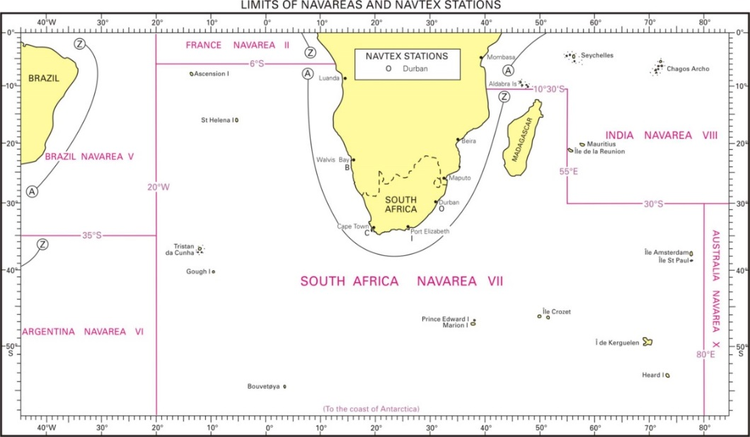

c. New infrastructure in accordance with GMDSS Master Plan. South Africa has participated in Iridium training in June 2020, and again refresher training in April 2021. No agreement between South Africa (represented by Telkom Radio Services) and Iridium has been signed yet. Despite not having an agreement in place, South Africa commenced with broadcast trials in April 2021, with Telkom Radio Services broadcasting all NAVAREA VII messages as well as METAREA messages, and the SANHO broadcasting test messages while monitoring Telkom Radio Services’ broadcasts. There has been no issues of note, and Iridium has reported that the system is functioning as designed, with periodic remote checks on NAVAREA/METAREA VII broadcasts. There has also been several commercial vessels that has confirmed receipt of Iridium broadcasts within NAVAREA VII as promulgated. South Africa will consider IMO and IHO directives regarding the implementation of Iridium as a GMDSS provider.

d. Challenges and achievements. No NAVAREA VII messages were transmitted for the Antarctic Region in the reporting period.

6. C-55

The South African Hydrographic Office acknowledges the importance of the constant review of C-55 to improve hydrographic services along the maritime routes in the region. The table with the latest information to update IHO Publication C-55 (Status of Hydrographic Surveying and Charting Worldwide) is provided in Annex B.

7. CAPACITY BUILDING OFFER OF AND/OR DEMAND FOR CAPACITY BUILDING

a. Offer of and/or demand for Capacity Building. The SANHO, in collaboration with IMT, developed and launched a MSI eLearning initiative in 2021. The objective of the eLearning package is to facilitate basic MSI capacity building initiatives, especially for the region. This initiative was strongly supported by both Chairpersons of the WWNWS and SAIHC. Member States are invited to contact the SANHO to make use of this eLearning package. South Africa has also joined the IHO Capacity Building eLearning Project Team to share information and knowledge. A similar eLearning package is under development for basic Tidal and Oceanography theory, as well as basic hydrographic surveying principles and practices.

b. Training received, needed, offered. Nothing to report.

c. Status of national, bilateral, multilateral or regional development projects with a hydrographic component. (In progress, planned, under evaluation or study). South Africa will welcome any additional survey data including satellite imagery (geo-referenced) within their charting area from neighbouring countries to update chart SAN 2004 (INT 9056) and ENC ZA300300.

- Hydrographic data received from other organizations: Nothing to report.

- Hydrographic data provided to other primary charting authorities and/or GEBCO: Nothing to report.

- Discussions were held between SA Navy Hydrographer and Department of Forestry, Fisheries and the Environment (DFFE) regarding information and data sharing on 25 July 2018. The following pertinent points were discussed and highlighted to improve cooperation between the SA Navy Hydrographer and the DFFE, and the matter is ongoing:

- SAN Chart 2004 (INT 9056): The DFFE can provide critical data to maintain this chart to the SANHO form data collection during the SA Agulhas II’s missions to that region.

- New HSV for the SA Navy: When the new hydrographic survey vessel is delivered to the SA Navy, she will be able to assist in scientific and hydrographic missions to Antarctica and the Islands as she will also be strengthened for summer ice conditions.

- AIS Data: South Africa is a signatory to the Antarctic Treat Consultative Meeting (ATCM), and as such, provides input regarding vessel traffic in the Antarctic region. The SA Agulhas II is viewed by the Hydrographer a source of AIS data while deployed in the Antarctic, and requested whether the DFFE would be willing to share any AIS data for submission to the ATCM.

- Global Maritime Distress Signal Services. Currently, the SANHO does not include any radio or other aids to navigation at SANAE base in its SAN HO-1 List of Lights and Radio Signals publication. Talks between the Hydrographer and the DFFE highlighted the need for closer cooperation to streamline information and data sharing regarding aids to navigation as well as search and rescue plans for the Antarctic region.

d. Description of requests to be considered by the IHO/CBSC. Nothing to report.

8. OCEANOGRAPHIC ACTIVITIES

a. General.

- Scientific and polar institutes. SA’s polar issues are mainly administered through Department of International Relations & Cooperation (DIRCO), Department of Forestry, Fisheries and the Environment (DFFE) and Department of Science & Technology (DST). DST manages the relations with academic institutions or research grants. To date, DFFE in cooperation with DIRCO and DST is leading the development of an overarching Integrated Antarctic and Southern Ocean Strategy.

- Research and Supply vessels. A replacement supply vessel, SA AGULHAS II (Figure 3), commissioned in South Africa in July 2012, is used by the DFFE Directorate: Antarctica and Islands to transport equipment and supplies to the researchers at SANAE IV and conducts research in the waters surrounding Antarctica. The servicing of the SANAE base on the Antarctic mainland and the two weather stations on Marion and Gough Islands is carried out once per year. During these voyages, meteorologists accompany the vessel to collect data and deploy ocean drifting weather buoys. While the re-supply functions consume some 180 days per year, the ship can spend up to 120 days per year on dedicated deep water oceanographic and geological research cruises to depths of 6 000 metres. These cruises take place in the Southern Ocean, but the ship has been designed to operate in tropical waters to enhance its ability to serve a wider user community. Approximately 800m2 of space has been set aside for dedicated research laboratories and up to six specialist container laboratories. The ship is a multi-purpose vessel and it can carry 100 passengers, 4000 m³ of cargo space to supply the three remote stations and two Super Puma class helicopters.

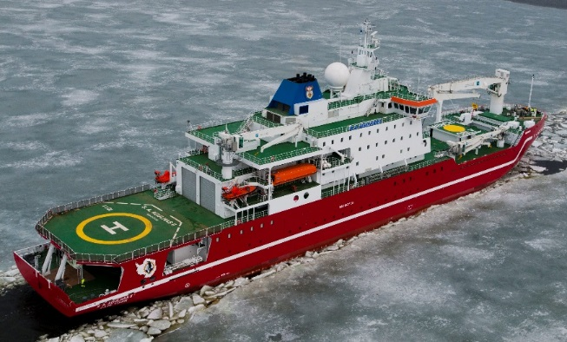
Figure 3. M/V SA AGULHAS II

- SA Antarctic bases: SANAE IV. Nothing to report.

b. GEBCO/IBC’s activities, GEBCO Seabed 2030 activities. Since 1991, South Africa has, in accordance with IHO Resolutions, ceased to maintain the 20 GEBCO Collector Plotting Sheets (passage soundings) for which the RSA is responsible. The analogue sheets of South Africa’s GEBCO data holdings have been converted into digital format.

- Status of data collection. The SANHO, in collaboration with NOAA and Institute of Maritime Technology (IMT), is conducting a CSB data collection pilot project as part of Seabed 2030. IMT has received 100 data loggers from NOAA, field trials was competed and there are currently 5 data loggers deployed on vessels of opportunity. The SANHO has also received bathymetry data from several external sources, which have been collated into a single data set and submitted to GEBCO as part of Seabed 2030 (Figure 4). Note the detailed CSB report submitted to SAIHC18 for further details.

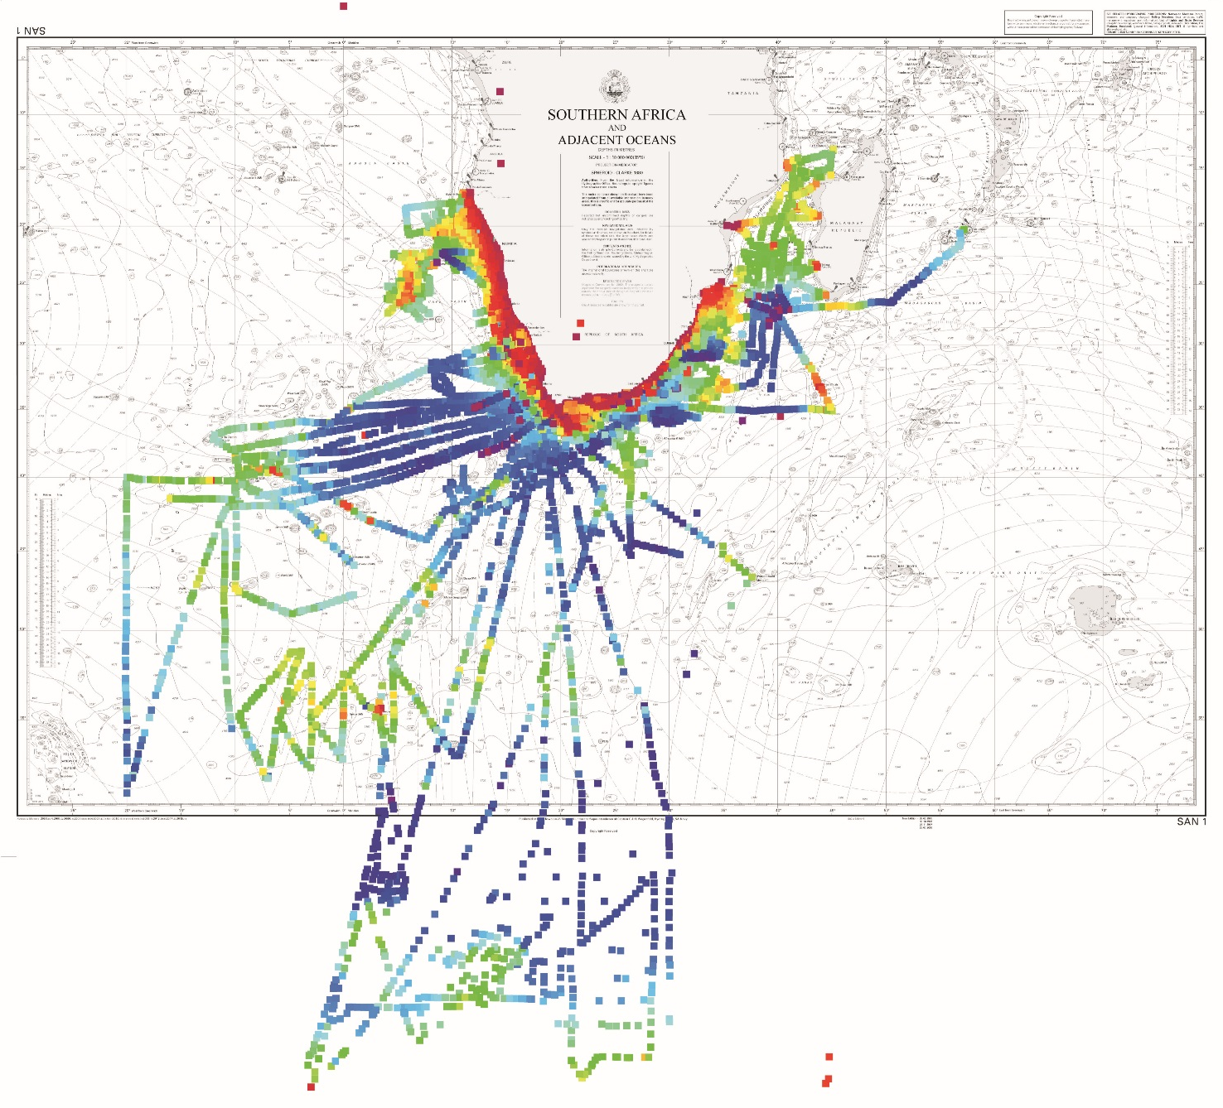
Figure 4.

c. Tide gauge network. The tide gauge network is critical in the calculation of the tidal predictions for South Africa and Namibia, and spans from Walvis Bay on the West Coast to Richards Bay on the East Coast. At the request of the IOC, satellite transmitters were installed at three tidal stations, two of which are Global Sea Level Observing System (GLOSS) stations. The one minute data from the Port of Port Elizabeth (Gqeberha) and Simon’s Town is transmitted in real time for use in the Indian Ocean Tsunami Early Warning System (IOTWS).

Chart Datum for all SA Ports is Lowest Astronomical Tide (LAT) as from 1 January 2003.

d. New Equipment. Nothing to report.

e. Challenges and achievements. As noted.

9. OTHER ACTIVITIES

a. Participation in IHO meetings. SANHO is fully committed to providing continued support and participation to IHO meetings and working groups.

b. Meteorological data collection. Nothing to report.

c. Geospatial studies. Nothing to report.

d. Disaster prevention. Nothing to report.

e. Environmental protection. Environmental protection areas, marine reserves, etc. are indicated on SANHO charts and publications. South Africa is also a signatory to MARPOL conventions and are published as such in charts and publications.

f. Astronomical observations. Nothing to report.

g. Magnetic and gravity surveys. Nothing to report.

h. Status of MSDI. SANHO is fully committed to providing continued support to ensure the successful implementation of initiative 6, Marine Spatial Planning (MSP) and initiative 10 Oceans and Coastal Information Management System (OCIMS) project by providing access to accurate, complete, current and well maintained spatial information. SANHO plays a crucial role in MSP and is actively involved by attending meetings of the National Working Group (NWG) and also participating in the South African Spatial Data Infrastructure (SASDI) workshops and meetings to ensure compliance and adherence to policies, standards and specifications for the base data sets, in order to accomplish South Africa’s national and international priorities.

i. International engagements. The SA Agulhas II, chartered by the Falklands Maritime Heritage Trust, located the wreck of Sir Ernest Shackleton’s ship, the Endurance, in the Weddel Sea on March 5, 2022, at a Depth of 3008m during the joint Endurance 22 Expedition (Figure 5).

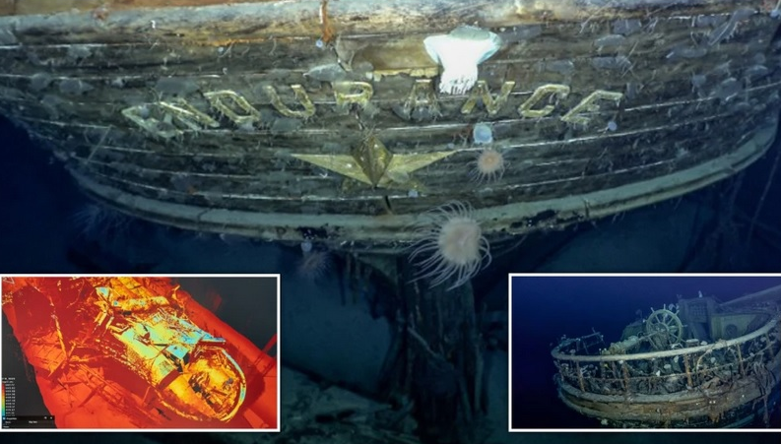
Figure 5. The stern of the Endurance, during the Endurance 22 Expedition (Picture: PA/Getty).

10. CONCLUSIONS

a. Areas of Significant Achievement. Validated crowd-sourced bathymetry data that meets IHO survey standards are being incorporated if and when available. These steps forward in crowd-sourced bathymetry shared by 3rd parties compliment the South Africa’s efforts in the GEBCO Seabed 2030 pilot project, and the SANHO will continue to provide feedback on local and regional initiatives in this regard as the CSB Coordinator for SAIHC.

Teledyne CARIS chart production software has been installed at the SANHO and will be fully integrated with the new survey acquisition and processing software on board the new HSV and SMBs, realising the “ping to chart” philosophy and capability. This will also assist in the collection and formatting of geospatial data in aid of marine spatial planning in support of national Blue Economy initiatives. The acquisition of high-end large format inkjet printers to support the print-on-demand (POD) requirements of paper chart products was also being addressed as a priority through the Hydrographic Capability Replacement Project, enabling in-house printing of paper charts. The procurement for the new S100 standard development software package is underway, and the SANHO has developed a Roadmap and Implementation Plan for the introduction of the S-100 family of services and standards.

The SA Agulhas II, chartered by the Falklands Maritime Heritage Trust, located the wreck of Sir Ernest Shackleton’s ship, the Endurance, in the Weddel Sea on March 5, 2022 during the joint Endurance 22 Expedition

b. Areas of Particular Concern. Nothing to report

c. Any other matters of interest to the HCA. Participation in Seabed 2030 and CSB activities in the region is highly encouraged and promoted.

