16th May 2023
HCA Hydrographic Priorities Working Group
Letter No. 1/2023

To: Members of the Hydrographic Commission on Antarctica
Subject: HCA Request for Bathymetric Data – Australia INT 9034 & Chile INT 9151

Dear Members,
- This circular letter accompanies requests from Australia and Chile for bathymetric survey data for charting.

- Two HCA data request forms (HCA12-07.1E), accompany this e-CL along with two .shp files extracted from INTtoGIS defining the chart limits.

- The images below show the survey metadata held in the HCA GIS providing indicative coverage for the requests above.

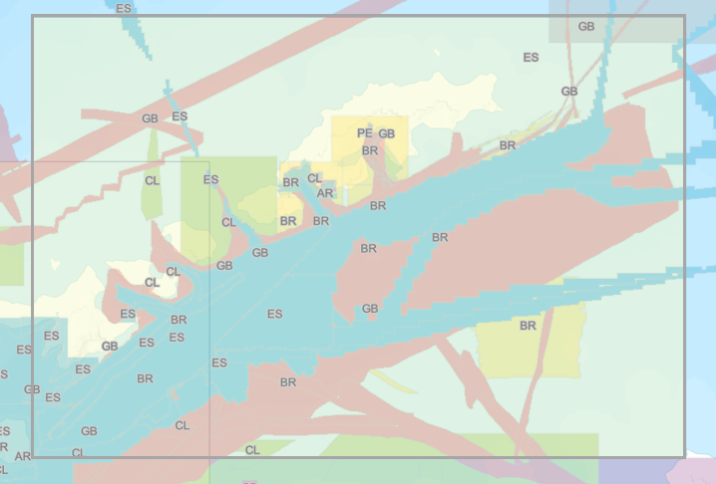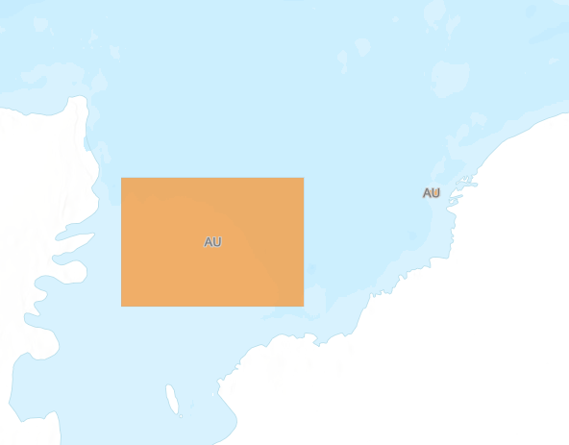

- Please respond directly to the requestors listed below and copy me into your response:
Chile: cmarchant@shoa.cl & jpolivares@shoa.cl
Australia: Robert.cario@defence.gov.au

Best Regards,
Lee Truscott
Chairman IHO HCA HPWG Chair

