Annex A to PRO 3.Y

Proposed new IHO Resolution

RECOGNITION OF THE SOUTHERN OCEAN AND CONSEQUENCES ON THE LIMITS OF SOME GLOBAL SEA AREAS | xx/2023 | A-3

Taking note of the acknowledged long lasting existence of IBCSO - International Bathymetric Chart of the Southern Ocean as a GEBCO regional mapping project and the wide and generalized usage of Southern Ocean by the international scientific community and medias, the IHO recognizes the Southern Ocean as the global sea area surrounding the continent of Antarctica.

Despite the seasonal changes of the latitude of the Antarctic Convergence Zone around Antarctica, it is generally agreed that the Northern geographic limit of the Southern Ocean is defined by the parallel of Latitude 60°S.

As a consequence, the Southern limits of the Atlantic, Indian, and Pacific Oceans are defined by the Northern limit of the Southern Ocean. This limit supersedes those mentioned in Publication S-23, Ed. 3, 1953 for the areas concerned.

However, since these limits have no political significance whatsoever, Hydrographic Offices may adopt their own limits as long as these limits remain technically consistent with the data model of the polygonal demarcation of global sea areas (S-130). Current national reservations on the limits of the Atlantic, Indian, Pacific, and Southern Oceans are provided in Appendix 1.

--

Appendix 1

National positions and reservations
on the limits of the Atlantic, Indian, Pacific, and Southern Oceans

Australia
Australia’s position on the limits of the Southern Ocean and the southern limit of the South Pacific Ocean [and Tasman Sea] and Indian Ocean in accordance with the [national] ICSM Resolution ROO/11/06 - Limits of Oceans and Seas and Offshore Undersea Features [April 2001].

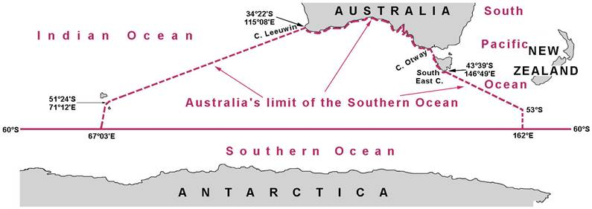

United Kingdom

The UK uses the parallel of Latitude 55°S as the Northern limit of the Southern Ocean [and therefore the Southern limit of the Atlantic, Indian, and Pacific Oceans]. (to be confirmed)

https://ibcso.org/
See « The Oceans » on page 5.
Interdepartmental Committee of Surveying and Mapping [ICSM]

