Annex A to PRO 3.Y

Proposed new IHO Resolution

RECOGNITION OF THE SOUTHERN OCEAN AND CONSEQUENCES ON THE LIMITS OF SOME GLOBAL SEA AREAS | xx/2023 | A-3

Taking note of the acknowledged long lasting existence of IBCSO - International Bathymetric Chart of the Southern Ocean as a GEBCO regional mapping project recognized and supported by GEBCO and the wide and generalized usage dominant use of the denominator Southern Ocean by the international scientific community and medias, the IHO recognizes the Southern Ocean as the global sea area surrounding the continent of Antarctica.

Despite the seasonal changes of the latitude of the Antarctic Convergence Zone around Antarctica, Noting the established northern limit of the IHO INTernational Charting Region M, it is generally agreed that the northern geographic limit of the Southern Ocean is defined by the parallel of Latitude 60°S.

As a consequence, the southern limits of the Atlantic, Indian, and Pacific Oceans are defined by identical with the northern geographic limit of the Southern Ocean. This joint limit supersedes those mentioned in Publication S-23, Ed. 3, 1953 for the areas concerned.

However, Since these limits have neither political nor oceanographic significance whatsoever, Hydrographic Offices may adopt their own limits as long as these limits remain technically consistent with the data model of the polygonal demarcation of global sea areas (IHO S-130). Current national reservations and/or comments on the limits of the Atlantic, Indian, Pacific, and Southern Oceans are provided in Appendix 1.

--

Appendix 1

General information, national positions and reservations
on the limits of the Atlantic, Indian, Pacific, and Southern Oceans

General Information
It is acknowledged that the Commission for the Conservation of Antarctic Marine Living Resources (CCAMLR) defines, in Art. 4 of its Convention, the limits of the Antarctic Convergence. Despite the seasonal and annual changes of its latitude, this major oceanographic feature creates a distinct biological boundary beyond the parallel of 60°S, applicable to the description of the Antarctica marine ecosystem.

Australia
Australia’s position on the limits of the Southern Ocean and the southern limit of the South Pacific Ocean [and Tasman Sea] and Indian Ocean in accordance with the [national] ICSM Resolution ROO/11/06 - Limits of Oceans and Seas and Offshore Undersea Features [April 2001].

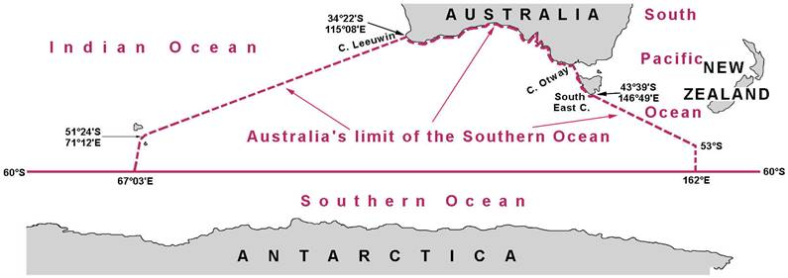

United Kingdom

With this Resolution in force, the UK confirms that the comment from the S-23, edition 3, 1953 “The UK uses the parallel of Latitude 55°S as the Northern limit of the Southern Ocean [and therefore the Southern limit of the Atlantic, Indian, and Pacific Oceans]” does not apply anymore.

https://ibcso.org/
IHO Publication S-4, section A-204.8 refers.
See « The Oceans » on page 5.
Interdepartmental Committee of Surveying and Mapping [ICSM]

