Background document for the discussions on establishing an Arctic Council Data Policy, to be held at the Arctic Science Summit Workshop in Tromsø, Norway, 30 March 2022

Background and introduction
The 2020 request from SAO to the Arctic Council (AC) Secretariat and the working groups
”to start exploring how cooperation can be strengthened with Arctic SDI at the operational level to ensure data is accessible, open and widely shared”.
The May 2021 Arctic Council Ministerial Declaration (52):
“recognize that adequately responding to rapid changes in the Arctic environment requires access to […] reliable data to facilitate understanding and informed decision making, welcome progress on implementing guiding principles on management of and access to data and facilitate that data, generated by the council, is findable, accessible, interoperable, reusable, and widely shared.”
The May 2021 Arctic Council Strategic Plan (63):
“the Arctic Council will […] encourage public access to, and sharing of, Arctic relevant data, including through implementation of the Agreement of enhancing International Arctic Scientific Cooperation”(63).

  - Starting points for an Arctic Council Data Policy
- 2017 Agreement on Enhancing International Arctic Scientific Cooperation
- International Arctic Science Committee Statement of Principles and Practices for Arctic Data Management April 16, 2013
- Alignment of Polar Data Policies – Recommended Principles (2021)
- General global data principles
- FAIR (Findable, Accessible, Interoperable, Reusable),
- TRUST (Transparency, Responsibility, Use Community and Sustainability and Technology)
- CARE (Collective benefit, Authority to Control, Responsibility, Ethics)
including principles for management of data about and collected by the Arctic Indigenous peoples.
  - Purpose, content and processes of an Arctic Council Data Policy
Data is vital to the work in Arctic Council. The Arctic Council Working Groups and task forces is using scientific data from a broad variety of sources to process and analyze political topics and present conclusions and recommendations to the Arctic Council. Collecting data in the Arctic environment is costly. Open access to data has a large economic potential and is one of the important elements in creating a digital Arctic.
A data policy can establish processes to clarify obligations and stipulate norms with respect to data ownership, data sharing, access, management, preservation, and acknowledgment. A clarification and agreement on roles, responsibilities and data sharing principles as well as introduction of data management tools will facilitate collaboration and serve to increase the outcomes and benefits from data for scientific, operational, management and decision-making purposes.
SAON, IASC/SAON Arctic Data Committee and Arctic SDI – in agreement with the Arctic Council Secretariat – has joined forces to facilitate a process with the Arctic Council Secretariat and relevant Arctic Council entities and arctic stakeholders. The aim is to develop data policy recommendations across the data domains and draft an Arctic Council Data Policy through an inclusive, participatory, transparent, and open process.

Method
Input for this document was collected by Peter Pouplier of the Danish Agency for Data Supply and Efficiency, Kåre Kyrkjeeide of the Norwegian Mapping Authority and Kjersti Nordskog (Agenda Kaupang AS, Norway) in meetings that were held with the Arctic Council working groups (WG) [SDWG] ACAP, AMAP, CAFF, EPPR, PAME, the Arctic Council Indigenous Peoples Secretariat and the Arctic Council Secretariat during December 2021. Main findings is summarized below.
The meetings were unstructured conversations on data use, data management, and other matters considered important for the development of an Arctic Council data policy. All the meetings lasted for approx. one hour. All meetings had from two to five WG participants. The AC Secretariat representative Sue Novotny sat in on all the meetings.
Data is an essential element in the vast majority of the work of the expert groups as part of the documentation delivered in their reports to the Arctic Council through the working groups. The expert groups often handle a substantive amount of different data from different sources ranging from national government agencies, research institutions, international organizations to private companies. In the reports, data from the 8 Arctic countries is often compiled, analyzed and presented in a Pan Arctic context.

Current situation
Processes of the Arctic Council Working Groups are structured differently and the working groups operate differently due to their respective organizational history and tasks. Thus, the approach to data and data management differs both between the working groups as well as within the expert groups/projects of each working group depending on the purpose and the organization of projects.
Thus, in the work processes the expert groups do consider a wide range of data questions, e.g. data accessibility, ownership rights and licenses, harmonizing data from many different sources, data quality and data publishing including data sensitivity and limitations in sharing.
Depending on the subject, the expert groups often develop new data derived from data owned by national and international institutions and organizations. Data is being compiled and often Pan Arctic conclusions are drawn from scientific data and presented for example in reports.
Data management is considered on a project-to-project basis. Among the working groups there is examples of operating guidelines and an explanatory note on data and data use as well as a data sharing agreement.
Distribution of data and securing data accessibility has to some extent been developed over the year by the Arctic Council working groups. Examples are the CAFF Arctic Biodiversity Data Service and PAME Arctic Shipping Traffic Data, which extends beyond project/expert group level, and AMAP Thematic Data Centres, which is linked to monitoring projects.
All working groups acknowledges the importance and challenges concerning intellectual property in general and traditional knowledge specifically.
A lot of work focuses on the verification of data and output to ensure that data is used and understood in the intended scientific context. To avoid this and to avoid use of data out of context one working group shares data with researchers, on request, and asks for a copy/link to the report in return. This includes a document describing the intended use of data.
This naturally leads to considerations about access to and use of data to produce scientific based information to the Senior Arctic Officials and the Council as well as how to ensure the quality and integrity of the reports delivered.
To support improved conditions for the expert groups the working group secretariats over the years have been engaged in developing the Statement of Principles and Practices for Arctic Data Management (International Arctic Science Committee 2013) and in the development of the multilateral Agreement on Enhancing International Arctic Scientific Cooperation (2017).
This has also led to the establishment of the Arctic Data Committee, a joint venture between IASC and SAON, and this committee works closely together with Arctic SDI (the cooperation between the 8 national mapping agencies of the Arctic countries on the spatial data infrastructure for the Arctic).
This being said, data management within expert groups/project is not a focus area at the level of the Senior Arctic Officials, the management boards of and representatives of national governmental agencies and the permanent representatives in the working groups.
Thus, data management and often not considered up front in the planning of work processes of expert groups. This also is reflected in the lack of data and information management considerations in the Working Group Common Operating Guidelines (Arctic Council 2016/2018).

Findings
Meeting the Arctic Council Secretariat and the working group secretariats has given the following statements and observations including input to possible purpose and content of a data policy for the Arctic Council:
- Arctic Council have about 150 active projects and probably more than 100 data sources.

- With the exception of the CAFF Arctic Biodiversity Data Service, the limited distribution of data from reports or services are hosted by institutions outside of Arctic Council

- Most of the reports produced by expert groups are published without public access to the original scientific data behind the compiled Pan Arctic data and without digital distribution of the compiled and analyzed Pan Arctic data and information

- Resources is not being allocated to secure data management in the expert groups and to host, maintain and distribute compiled and analyzed data from projects.

- There is a growing demand internally for access to reusable data from CAFF and AMAP

- Data sharing is an emerging issue including data from permanent participants

- There is a need to address traditional knowledge intellectual copyright through development of operational guidelines and best practices for management of data about and collected by the Arctic Indigenous peoples.

- Expert Groups do usually not collect their own data, but do their work on data collected by others where other data policies and/or preferences might be dominating.

- The working groups do not have the authority to oblige member states and/or scientific organizations to follow a certain policy. An Arctic Council Data Policy might come in addition to, or will conflict with, existing data sharing interests. Avoid complicating expert group data management processes.

- In general the working group secretariats do not have the knowledge, time, and access to the right tools, to involve in data management. Relevant tools is for example data analysis software, data storage facilities, data distribution infrastructure, standards, best practices and guidance documents. A data policy should avoid generating processes that require economic transactions between organizations.

- Possible topics to be covered by a data policy:
  - Data Management principles and processes to be included in the Working Group Operating Guidelines
  - Data management plans for expert groups/projects
  - principles for management of data about and collected by the Arctic Indigenous peoples, including the issue of intellectual property rights
  - Common platform and tools to host, maintain and share data
  - Access across the secretariats to data management advice and expertise, including maintenance of metadata and cartographic support and training
  - Harmonization of data management across the working groups (respecting the differences - one size do not fit all).
  - Considerations on how to facilitate the implementation of the 2017 Agreement on Enhancing International Arctic Scientific Cooperation
  - Alignment to the FAIR, TRUST and CARE data principles
- An Arctic Council Data Policy should consider the role of the Arctic Council in the Arctic digital ecosystem and should explore options for a common data platform.
- In order to nuance the different approach and ownership to scientific data and data developed for policy advice, a data policy could also include Information Management.
- Issues to be explored in the process of developing a data policy for Arctic Council:
- Describe and illustrate the Arctic Council processes incl. expert group work processes with respect to data
- Main policy challenges using external (national/other) scientific data
- General data management challenges related to all WG’s and specific challenges related to fewer or one WG
- Main challenges concerning intellectual property right and traditional knowledge
- Challenges managing sensitive data
- Possible ways of developing an Arctic Council data distribution platform

Annex 1 Arctic Council Data management solutions – examples.

5.1. PAME: Access and usage guidelines to the ASTD Data
This brief document offers a description of the data in the Arctic Shipping Traffic Data (ASTD) system and how they should be used. See the Access and usage guidelines to the ASTD Data. The document is sent alongside the data requested by academics and researchers the world over. In return, PAME asks to be sent the link to the finished report where the data are used. In that way they have control and an overview of how the data are used. The Arctic Shipping Traffic Data is hosted by the Norwegian Coastal Administration.

5.2. PAME: Publishing the data along with the pdf-report
As seen in this example, PAME publishes the data used in the 2017: Indicator Report, along with the report itself, to make it easier to access the data and use it for new purposes: 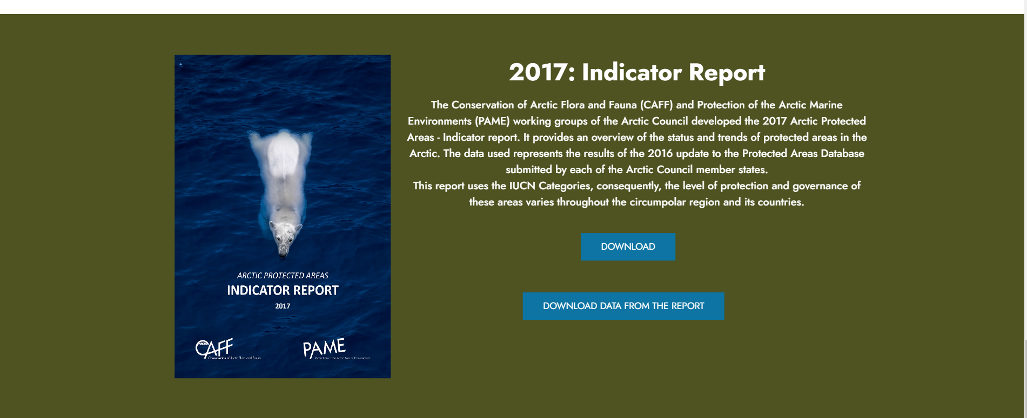

CAFF: Arctic Biodiversity Data Service (ABDS)
The ABDS is the online, interoperable data management system for biodiversity data generated via the activities of CAFF, including its Circumpolar Biodiversity Monitoring Programme (CBMP). The goal of ABDS is to facilitate access, integration, analysis and display of biodiversity information for scientists, practitioners, managers, policy makers and others working to understand, conserve and manage the Arctic's wildlife and ecosystems.

5.4 CAFF: Data distribution portal
CAFF has a data distribution portal where they offer their geodata through a metadata portal, along with data from the Ocean Biodiversity Information System and Global Biodiversity Information Facility.
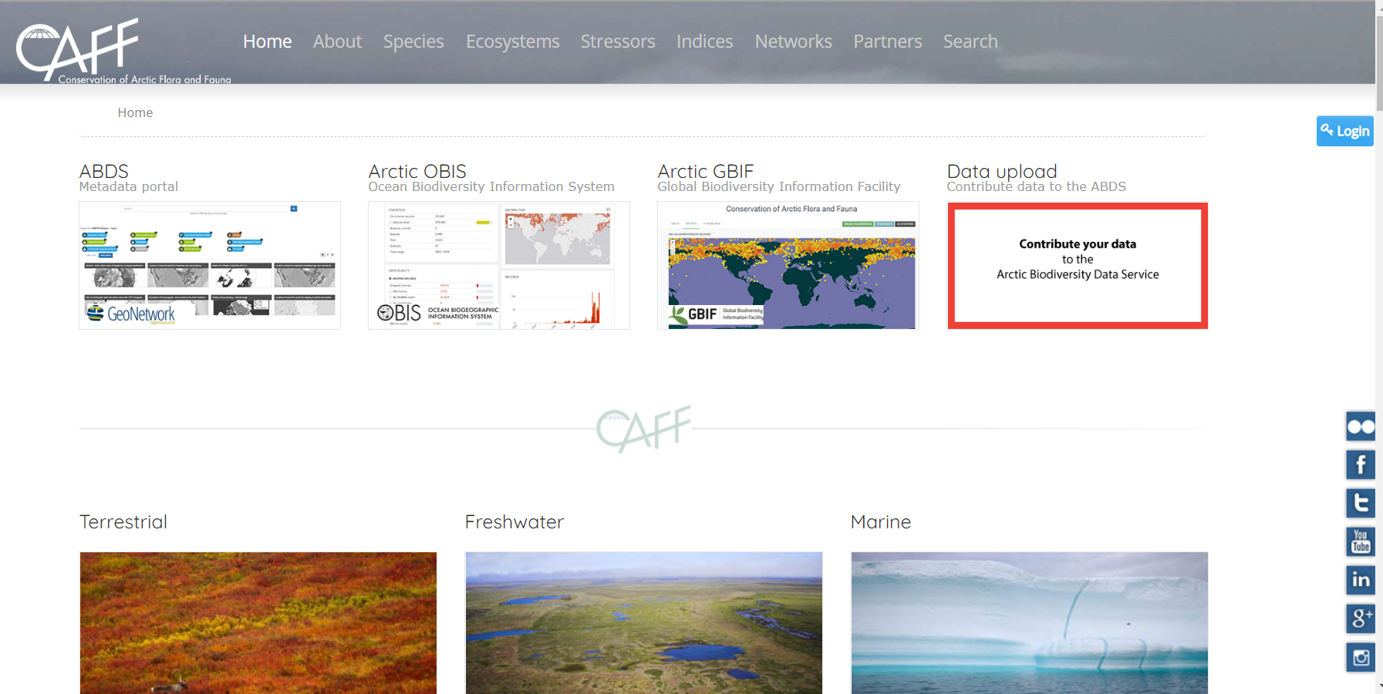

AMAP Mercury Emissions dataset
AMAP published datasets on mercury emissions data in 2010
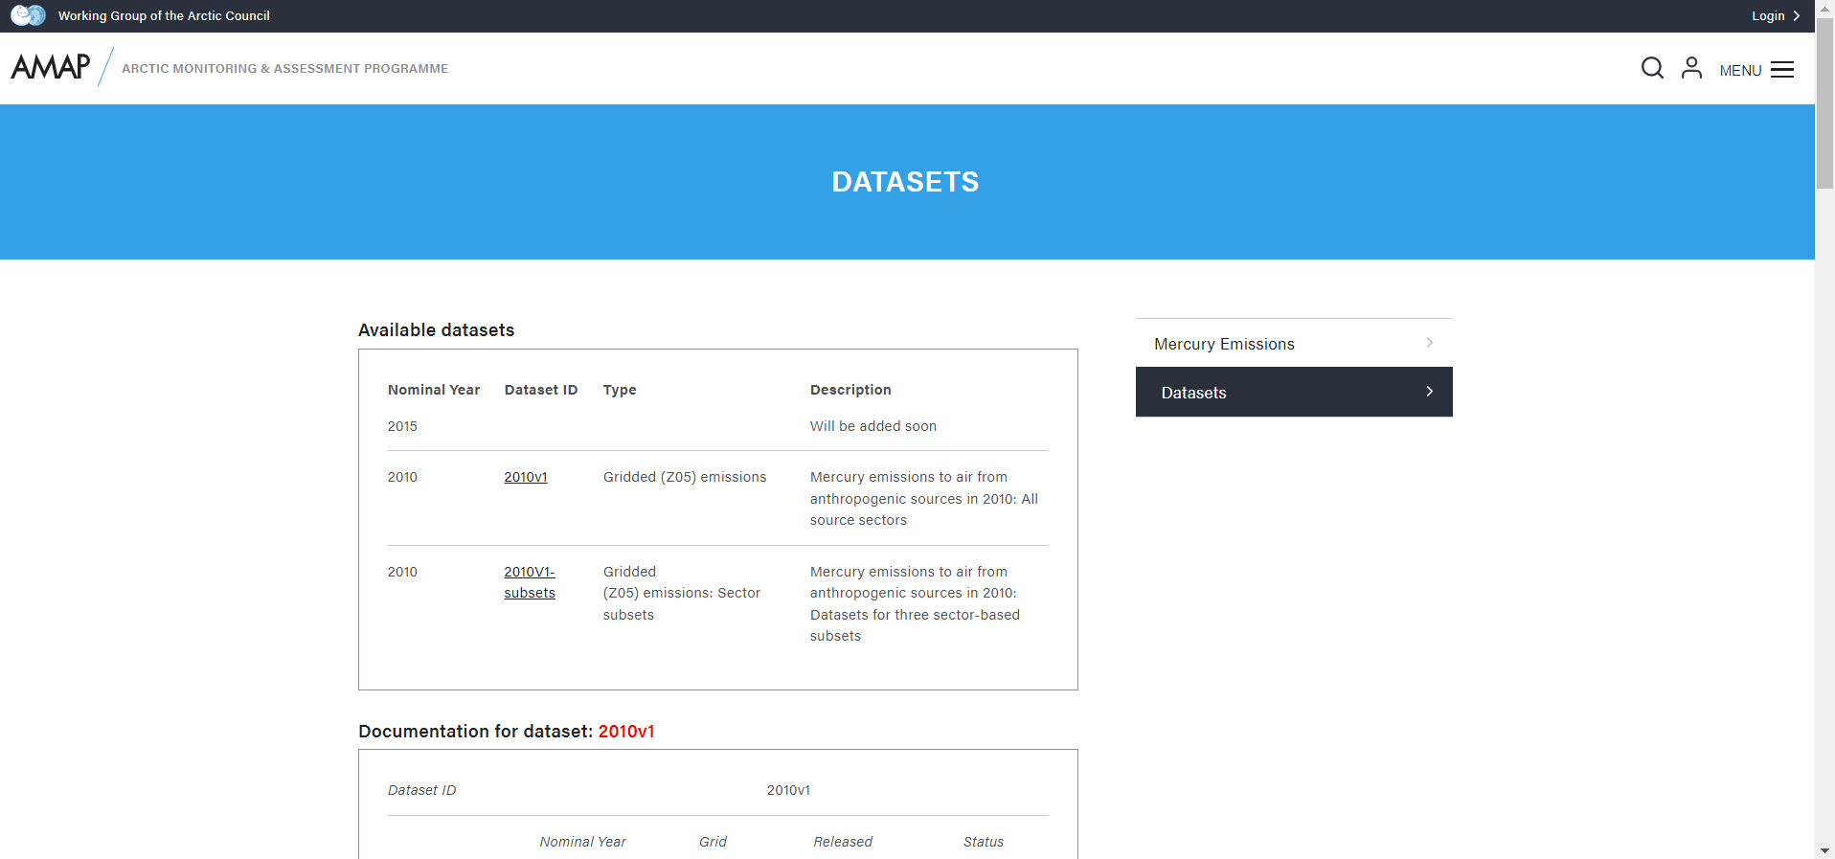

AMAP Thematic Data Centres
The AMAP Data Centres compile data from relevant monitoring and research activities and make them available to scientists engaged in AMAP assessments under strict conditions that protect the rights of data originators (according to the AMAP Data Policy):
- atmospheric contaminants data: at the Norwegian Institute for Air Research (NILU), Kjeller, Norway, and are accessible through their EBAS database;
- marine contaminants data: at the International Council for the Exploration of the Sea (ICES), Copenhagen, Denmark, and are accessible through their online EcoSystemData warehouse;
- radioactivity data, including both sources and levels and trends: at the Norwegian Radiation Protection Authority (NRPA), Oslo, Norway.
Read more: https://www.amap.no/about/data-compilation

EPPR: Western Response Resource List
EPPR has published several datasets as geodata available in a map viewer. The corresponding reports and raw data is also published in the map viewer:
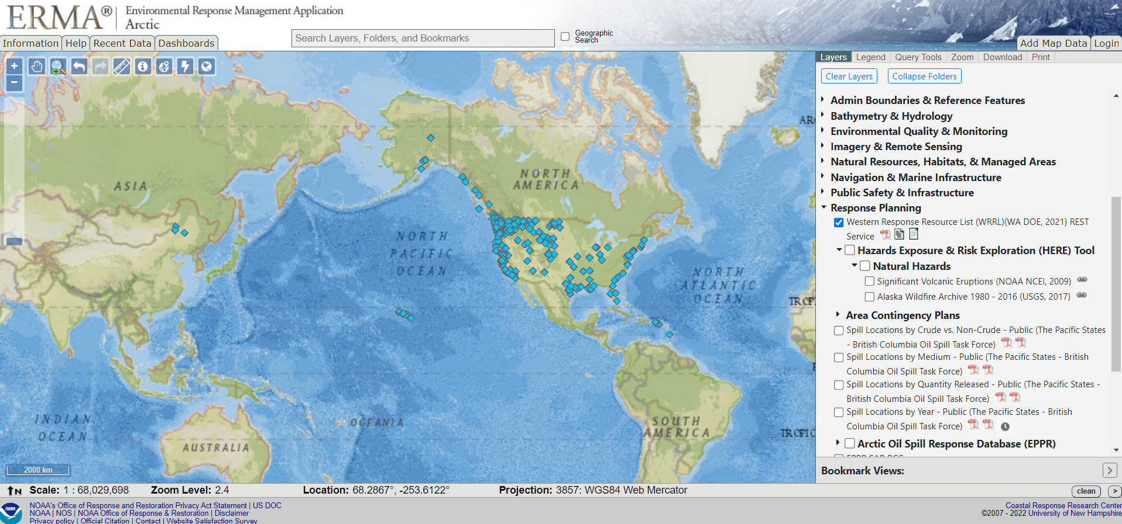

Examples of data policies from other organizations
This section lists selected examples of data policies from different organizations, to illustrate what a data policy could entail.
- US Geological Survey Data Sharing Policy tells of the organization’s expectations to the researchers on sharing data, dealing with sensitive data and projects including “Tribal partners”. The policy refers to a Data Management manual for details on metadata, standards and formats and data citation.
- US National Institutes of Health Data Policy is quite elaborate and deals with goals for sharing, implementation, methods for data sharing, data documentation, human subjects and privacy issues, funds for data sharing and a handful of examples and definitions.
- The Royal Society Data Policy deals with the organization’s policy towards open data. FAIR-principles are mentioned, and the policy deals with topics such as licensing of data and code, data accessibility and citation rules, plus different repositories for storing and sharing.
- The data management policy of Wageningen University & Research also builds on the FAIR-principles, but emphasizes that data should be “as open as possible, as closed as necessary” and offer guidelines on the sharing of “open”, “restricted” and “closed” data. A flow chart to illustrate the process has been made.
- The First Nation Principles of OCAP® describes principles of ownership, control access and possession of Canadian First Nations to control over data collection processes, ownership and control over how this information is used. (See the full principles report here)

