S T A T U T E S O F T H E
Annex A
CIRCULAR LETTER No 2/2024
27th February 2024

E A S T A S I A H Y D R O G R A P H I C C O M M I S S I O N ( E A H C )
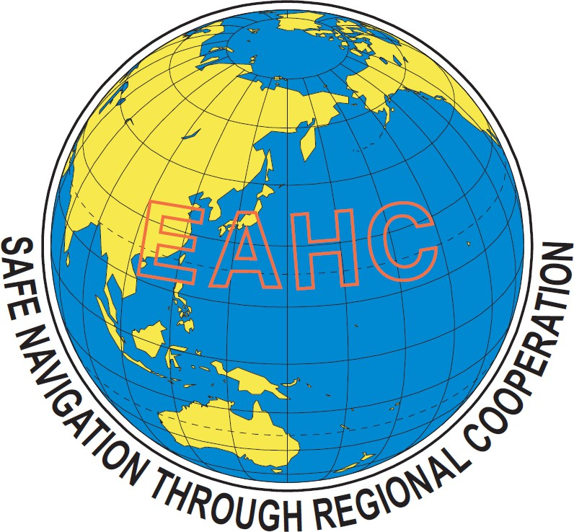

STATUTES OF THE EAST ASIA HYDROGRAPHIC COMMISSION ( E A H C )
* * * * *

A R T I C L E I NATURE AND PURPOSE
- The East Asia Hydrographic Commission (hereinafter referred to as "the Commission") shall be placed within the framework of the International Hydrographic Organization (hereinafter referred to as "the IHO"), and shall be a regional hydrographic commission which shall be composed of the Hydrographers of the countries bordering the Northwest Pacific Ocean, Japan Sea, Yellow Sea, Eastern China Sea, South China Sea, Philippine Sea, Malacca Strait, Northeastern Indian Ocean and adjacent waters (hereinafter referred to as "the region") in conformity with the Resolution S9 of the Ninth International Hydrographic Conference.

- The Commission shall not endeavour to become a separate group within, or duplicate the work of, the IHO.

- The purpose of the Commission shall be:
  - To coordinate the activities of national hydrographic offices in the region without influencing the internal affairs of the respective hydrographic offices or diminishing their national responsibilities;
  - To facilitate the mutual exchange of information regarding surveys, research, new
developments and technical details related to hydrography;
  - To encourage mutual assistance for the development of techniques in hydrographic work;
  - To cooperate for activating capacity building activities for the development of hydrographic technology.
  - To work out regional cooperative programmes in hydrographic work. Such regional cooperative programmes shall be subject to approval of the Government of the member concerned.

- The Commission shall be concerned solely with matters of purely technical nature pertaining to the field of hydrography, including descriptive oceanography.

- The Commission has no authority over the national hydrographic offices in the region.

A R T I C L E I I MEMBERSHIP
- The Commission shall be composed of the Hydrographers of the Member States of the IHO in the region defined in Article I paragraph 1, whose representatives are responsible for hydrography in their respective countries who accept these Statutes (hereinafter referred to as "the Members").

- Membership of the Commission shall be open for accession by all other Hydrographers who fulfill the requirements mentioned in paragraph 1 of this Article. The admission of the new Members to the Commission shall be decided unanimously by the members.

A R T I C L E I I I CONFERENCE
- The Commission shall hold a Conference (hereinafter referred to as "the Conference") regularly once between two successive IHO Assemblies. In addition, the Chair of the Commission (hereinafter referred to as "the Chair") may call special Conferences when urgent questions arise.

- The time of the Conference shall be decided upon by the Chair after consultation with the Members. The Conference shall be held in the country to which the Chair belongs.

- If, due to unfavourable circumstances, the Conference cannot be held in the country of the Chair, it shall be held in the country of the Vice-Chair.

- If it is also not feasible to hold the Conference in the country of the Vice-Chair, the Chair shall offer other Members to host the Conference. The offer shall be done by correspondence at an appropriate time prior to the conduction of the Conference.

- If the offer as referred to in the preceding paragraph is accepted by one of the members and agreed by the others, the Chair shall transfer their duties to the Member hosting the Conference.

- The members shall preferably attend the Conferences in person or otherwise send a representative.

- The members may be accompanied by one or more assistants at the Conference.

- The presence of at least two-thirds (2/3) of the Full Members of the Commission shall constitute a quorum.

- Expenses necessary to organize and conduct the Conference shall be met by the hydrographic office of the Chair.

A R T I C L E I V OBSERVERS
A Member may propose to invite observers to the Conference. Such invitations shall be sent only when the proposal is accepted by the Commission unanimously. The Observers may participate in the discussion but shall not have the voting rights.

A R T I C L E V CHAIR
- The term of office of the Chair shall begin at the end of the Conference and shall terminate in the end of the next Conference.

- The Vice-Chair shall be elected at the end of the Conference and shall assume office as the Chair at the end of the next Conference.

- If the Chair is unable to perform their functions during the interval between Conferences, their successor or the deputy hydrographer of their country shall take the chair for the rest of the period.

- If the Chair is unable to act at the Conference or any part thereof, the Vice-Chair shall act as the Chair.

- The Chair shall conduct the Conference. They shall prepare the provisional agenda of the Conference in consultation with the Vice-Chair.

- The Chair shall open the Conference by giving a report of the activities and their results of the Commission during the interval since the last Conference.

- The Chair shall prepare the Record of the Conference. This Record shall contain a very general outline of the discussions that took place as well as the conclusions that were approved. The Record shall be signed by the Chair of the Conference.

- The Chair's hydrographic office shall be responsible for the organization and operation of the Conference.

- The permanent Secretariat of the Commission shall be located at the Hydrographic Office of Japan.

A R T I C L E V I AGENDA OF THE CONFERENCE
- Proposals for putting items on the agenda for the next Conference should be sent to the Chair at least six months prior to the date fixed for the opening of the Conference.

- The Chair, in consultation with the Vice-Chair, shall prepare the final agenda. It should reach the Members as well as the IHO at least three months prior to the date fixed for the opening of the Conference.

- Proposals may also be submitted during a Conference to the Chair; they shall be signed by at
least two Members.

- The Commission shall, at the beginning of each Conference, adopt the agenda for that Conference. It may, during the Conference, modify the order of items on the agenda.

A R T I C L E V I I VOTING
- Conclusions shall be arrived at by unanimous agreement of the Conference. Such conclusions, unanimously agreed, shall be part of the Record of the Conference.

- Only the Members or their representatives shall be allowed to vote. Each shall have one vote.

A R T I C L E V I I I EXPENSES
- Apart from the expenses mentioned in previous articles, every Member shall meet their own expenses.

- Matters regarding the common projects of the Commission which are agreed unanimously in the Conference, and which require the expenditure of money shall be part of the Conclusion of the Conference.

A R T I C L E I X RELATIONS WITH THE IHO
- An invitation shall be sent to the Secretariat of the IHO (hereinafter referred to as "the Secretariat") for attendance of its representatives at the Conference.

- Any conclusion in which Member States of the IHO might have an interest shall be brought to the attention of the Secretariat. The decision to do so shall be part of the Conclusion.

- The Commission may be asked to undertake suitable studies as a Regional Hydrographic Commission of the IHO.

A R T I C L E X MISCELLANEOUS
- The Commission may create, for examination and execution of specific projects, committees composed of the Members interested in such projects.

- The Commission may discuss any matter of interest by correspondence during the period between Conferences. In this case, the Conclusion can only be arrived at by unanimous agreement of the Commission.

Copy of the correspondence on matters which require no unanimous decision shall be sent to the other Members by the originator.

- The Commission may determine - when circumstances call for such action – rules of procedure that shall be an annex to these Statutes.

- These Statutes may be amended. Such amendments shall become effective only by the unanimous decision of the Commission.

- English shall be the working language of the Commission, as well as during the Conference.

Done at Tokyo, 12 ♙pril 1971.
(Signed by Capt. Yeh Yuan-ta), Director, Chinese Naval Hydrographic Office. (Signed by Col. ♙ris Moenandar), Chief Hydrographer, Indonesian Naval Hydrographic
Office.
(Signed by Mr. Kiyoshi Kawakami), Chief Hydrographer, Hydrographic Department of
Japan
(Signed by Mr. Ho-Chin Kang), Director, Republic of Korea Hydrographic Office. (Signed by Cmdre Cayetano Palma), Director, Bureau of Coast and Geodetic Survey of the
Philippines.
(Signed by V♙dm. Ying Srihong), Director, Hydrographic Department of Thailand.

- ♙mended at Tokyo, 14 ♙pril 1971.
- ♙mended by correspondence in accordance with the decision of Informal Meeting, Jakarta, 4 November 1976.

- ♙mended by 3rd Conference, Seoul, 5 September 1980.

- ♙mended by 14th Conference, Tokyo, 28 September 2022.

