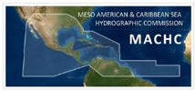

INTERNATIONAL HYDROGRAPHIC ORGANIZATION
MESO AMERICAN - CARIBBEAN SEA HYDROGRAPHIC COMMISSION

22nd CONFERENCE OF THE MESO AMERICAN - CARIBBEAN SEA HYDROGRAPHIC COMMISSION

Table of Contents | Page #
MACHC22 Pre-Conference Meetings and Conference Schedule | Page 1
MACHC22 Conference Timetable | Page 2
MACHC22 Conference Agenda | Pages 3-8

MACHC22 PRE-CONFERENCE MEETINGS AND CONFERENCE SCHEDULE

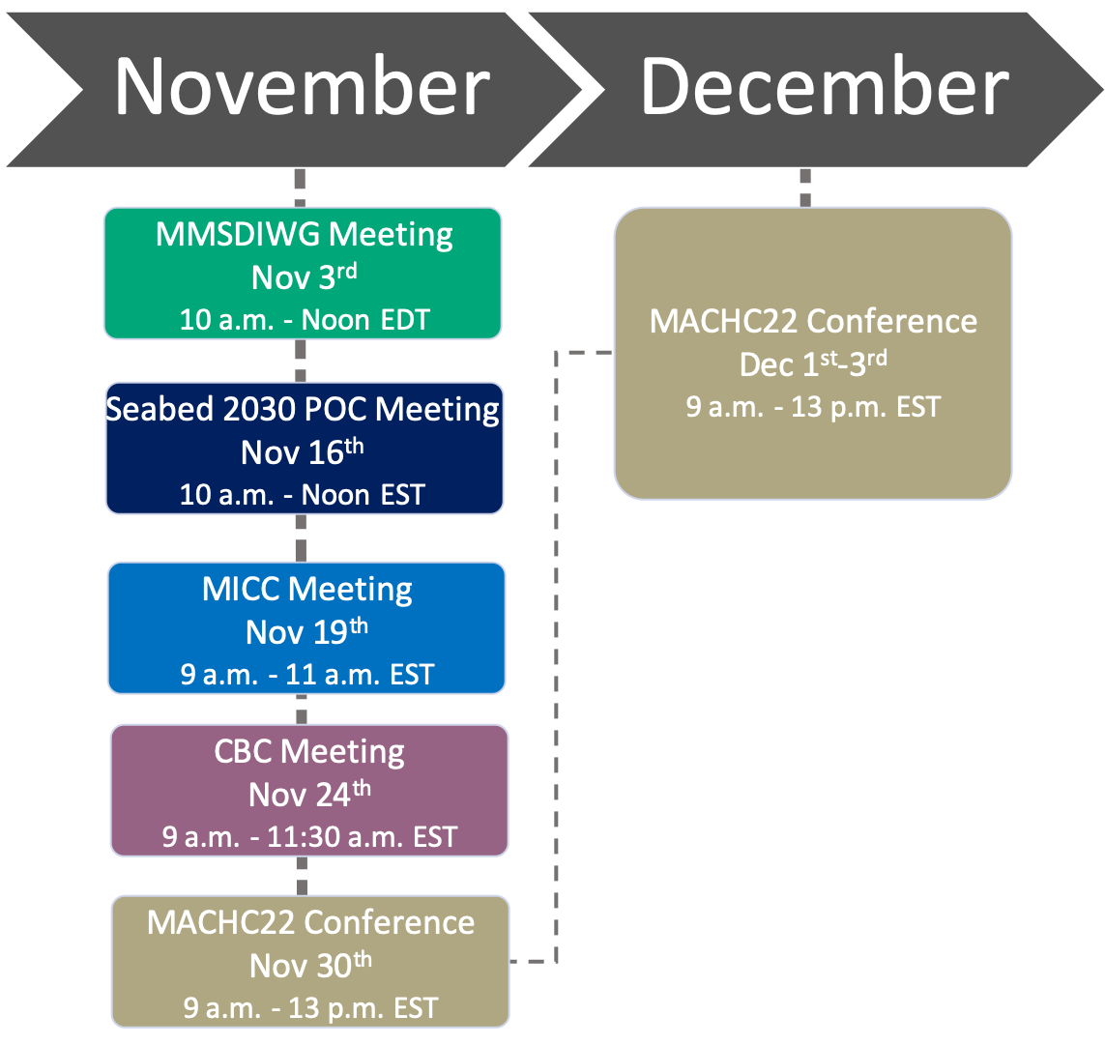

MACHC22 CONFERENCE TIMETABLE
(UTC/GMT -5 hours and US EASTERN STANDARD TIME)

Tuesday, November 30 |  |  | Wednesday, December 01 |  |  | Thursday, December 02 |  |  |  |  | Friday, December 03
Time | Activity |  | Time | Activity |  | Time | Breakout Group A: | Breakout Group B: | Breakout Group C: |  | Time | Activity
8:00 - 9:00 | Early Log In: Testing of video and audio equipment |  | 8:00 - 9:00 | Early Log In: Testing of video and audio equipment |  | 8:00 - 9:00 | Early Log In: Testing of video and audio equipment | Early Log In: Testing of video and audio equipment | Early Log In: Testing of video and audio equipment |  | 8:00 - 9:00 | Early Log In: Testing of video and audio equipment
9:00 - 9:15 | Formal Opening |  | 9:00 - 9:15 | Announcements/Logistics |  | 9:00 - 9:10 | Introduction | Introduction | Introduction |  | 9:00 - 9:15 | Group Report Outs/Q&A
9:15 - 9:30 | MACHC Admin & Org Issues |  | 9:15 - 10:00 | MICC Report, Presentation and Discussion |  | 9:10 - 10:30 | National Reports and Q&A #1-4 | National Reports and Q&A #1-4 | National Reports and Q&A #1-4 |  | 9:15 - 10:00 | Survey and Risk:  Seabed 2030 and CSB
9:30 - 10:30 | IHO & MACHC  Developments and Policies
 |  |  | 10:00- 10:30 | Industry Support for Charting Challenges
 |  |  |  |  |  |  |  |  |  |  | 10:00 - 10:30 | Industry Support for Survey and Risk
10:30 - 11:30 | Break |  | 10:30 - 11:30 | Break |  | 10:30 - 11:30 | Break | Break | Break |  | 10:30 - 11:30 | Break
11:30 - 12:15 | MMSDIWG Report, Presentation and Discussion |  | 11:30 - 12:15 | CBC Report, Presentation and Discussion |  | 11:30 - 12:45 | National Reports and Q&A #5-8 | National Reports and Q&A #5-8 | National Reports and Q&A #5-8 |  | 11:30 - 12:15 | Disaster Response
12:15 - 13:00 | Industry Support for MSDI Challenges |  | 12:15 - 13:00 | Industry Support for Capacity Building Challenges |  |  |  |  |  |  | 12:15 - 13:00 | Closing Activities
 |  |  |  |  |  | 12:45 - 13:00 | Closing Discussion | Closing Discussion | Closing Discussion

MACHC22 CONFERENCE AGENDA
DAY ONE OF MACHC22
Tuesday, November 30th, 2021
FORMAL OPENING OF THE MACHC
(Times are UTC/GMT -5 hours and United States Eastern Standard)

TIME | DAY ONE OF MACHC22  Tuesday, November 30th, 2021 | RESPONSIBLE
08:00-09:00 | Early Log In: Testing of Audio/Visual Equipment  Reminders on use of Virtual Conference Platform | All Participants/  Organization
09:00-09:15 | FORMAL OPENING OF THE MACHC  ADDRESSES | MACHC Chair  IHO Director  Host
09:15-09:30 | 1. MACHC Administration/Organizational issues  1.2 Approval of Agenda  Chair invites participants to comment on the agenda and timetable in case updates are necessary.  Agenda is adopted.  Doc: MACHC22-01.2 Agenda  2 minutes  1.3 List of documents  Docs: MACHC22-01.3A List of Documents  MACHC22-01.3B List of Participants  - List of Documents as on the IHO MACHC site  - List of Documents is updated as necessary  3 minutes  1.4 Matters arising from Minutes of MACHC21 Conference  Doc: MACHC22-01.4 Minutes of MACHC21  5 minutes  1.5 MACHC21 Action List review  Doc: MACHC22-01.5 Action List from MACHC21  5 minutes | Chair/All  Chair/All  Chair/All  Chair/All
09:30-10:30 | 2. MACHC Developments, IHO bodies, Policy aspects  2.1 IHO Secretariat Report  IHO Secretariat provides a briefing on current IHO matters.  Doc: MACHC22-02.1  10 minutes  2.2 Council update  Doc: MACHC22-02.2  10 minutes  2.1.1 IRCC update  Doc: MACHC22-02.1.1  10 minutes  2.1.2 HSSC update  Doc: MACHC22-02.1.2  10 minutes  2.3 Maritime Safety Information/WWNWS-SC Report  Doc: MACHC22-02.3  10 minutes  2.4 Q&A  10 minutes  General Remark  Chair invites the representatives of the above IHO bodies to present the key (policy) developments, decisions, actions or implications that affect the MACHC region. | IHO Director  Chair  Brazil  Brazil  Chair,  WWNWS-SC  All
10:30-11:30 | Break
11:30-12:15 | 8. Marine Spatial Data Infrastructure  8.1 MMSDIWG Report  Chair presents results and recommendations to Plenary.  Doc: MACHC22-08.1  15 minutes  8.2 MSDI Presentation  Doc: MACHC22-08.2  15 minutes  8.3 Q&A  15 minutes | MMSDIWG Chair  TBD  All
12:15-13:00 | Industry Support for MSDI Challenges  Presentations and panels TBD | Industry Partners
TIME | DAY TWO OF MACHC22  Wednesday, December 1st, 2021 | RESPONSIBLE
08:00-09:00 | Early Log In: Testing of Audio/Visual Equipment  Reminders on use of Virtual Conference Platform | All Participants/  Organization
09:00-09:15 | Announcements/Logistics | Organization
09:15-10:00 | 9. Nautical Cartography  9.1 MICC Report  Chair presents results and recommendations to Plenary.  Doc: MACHC22-09.1  15 minutes  9.2 Nautical Cartography Presentation  Doc: MACHC22-09.2  15 minutes  9.3 Q&A  15 minutes | MICC Chair  TBD  All
10:00-10:30 | Industry Support for Charting Challenges  Presentations and panels TBD | Industry Partners
10:30-11:30 | Break
11:30-12:15 | 5. Capacity Building  5.1 Capacity Building Report  Chair presents results and recommendations to Plenary.  Doc: MACHC22-05.1  15 minutes  5.2 Capacity Building presentation  Doc: MACHC22-05.2  15 minutes  5.3 Q&A  15 minutes | CBC Chair  TBD  All
12:15-13:00 | Industry Support for Capacity Building Challenges  Presentations and panels TBD | Industry Partners

TIME | DAY THREE OF MACHC22  Thursday, December 2nd, 2021 |  |  | RESPONSIBLE
 | Breakout Group A: | Breakout Group B: | Breakout Group C:
08:00-09:00 | Pre-Testing of Audio/Visual | Pre-Testing of Audio/Visual | Pre-Testing of Audio/Visual | All
09:00-09:10 | Introduction | Introduction | Introduction | Breakout Group Chairs
09:10-09:30 | National Report  and Q & A #1 | National Report  and Q & A #1 | National Report and Q & A #1 | All
09:30-09:50 | National Report  and Q & A #2 | National Report  and Q & A #2 | National Report and Q & A #2 | All
09:50-10:10 | National Report  and Q & A #3 | National Report  and Q & A #3 | National Report and Q & A #3 | All
10:10-10:30 | National Report  and Q & A #4 | National Report  and Q & A #4 | National Report and Q & A #4 | All
10:30-11:30 | Break
11:30-11:50 | National Report  and Q & A #5 | National Report  and Q & A #5 | National Report and Q & A #5 | All
11:50-12:10 | National Report  and Q & A #6 | National Report  and Q & A #6 | National Report and Q & A #6 | All
12:10-12:30 | National Report  and Q & A #7 | National Report  and Q & A #7 | National Report and Q & A #7 | All
12:30-12:50 | National Report  and Q & A #8 | National Report  and Q & A #8 | National Report and Q & A #8 | All
12:50-13:00 | Breakout Group Discussion: Overall Points of synergy, collaboration, and implications for MACHC | Breakout Group Discussion: Overall Points of synergy, collaboration, and implications for MACHC | Breakout Group Discussion: Overall Points of synergy, collaboration, and implications for MACHC | All

TIME | DAY FOUR OF MACHC22  Friday, December 3rd, 2021 | RESPONSIBLE
08:00-09:00 | Early Log In: Testing of Audio/Visual Equipment  Reminders on use of Virtual Conference Platform | All Participants/  Organization
09:00-09:15 | Summary of Breakout Group Common Themes/Issues and Plenary Discussion | Breakout Group Chairs/All
09:15-10:00 | 6. Survey and Risk  6.1 MACHC-IOCARIBE Seabed 2030 (including Crowdsourced Bathymetry)  Coordinator presents results and recommendations to Plenary.  Doc: MACHC22-06.1  15 minutes  6.2 Survey and Risk presentation  Doc: MACHC22-06.2  15 minutes  6.3 Q&A  15 minutes | Seabed 2030/CSB Coordinator  TBD  All
10:00-10:30 | Industry Support for Survey and Risk  Presentations and panels TBD | Industry Partners
10:30-11:30 | Break
11:30-12:15 | 7. Disaster Response  7.1 CDEMA Presentation  Doc: MACHC22-07.2  15 minutes  7.2 MapAction Presentation  Doc: MACHC22-07.2  15 minutes  7.3 Q&A  15 minutes | CDEMA  MapAction  All
12:15-13:00 | 10. Closing Activities  10.1 Any Other Business  10 minutes  10.2 Review of Actions and Decisions  15 minutes  10.3 Next Meeting  10 minutes | Chair/Members  Chair/All  Chair/All

