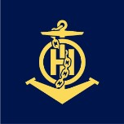
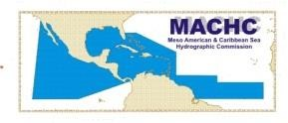
INTERNATIONAL HYDROGRAPHIC ORGANIZATION
MESO AMERICAN & CARIBBEAN SEA HYDROGRAPHIC COMMISSION

MACHC Maritime Safety Information Working Group (MSIWG)
Tuesday, 12 December 2023—11:00-12:30 Local Time
Location: The Royal Ballroom, Torarica Resort
Dress code: Business casual or daily working uniform

Tuesday, 12 December 2023
Time | Subject | Responsibility
1100 | 1. Meeting Commences  - Welcome / Introductions  - Record of attendees Approval of Agenda  - Review/approve ToR | Acting Chair (United States)
1120 | 2. Recent Developments in the work of the WWNWS-SC  - WWNWS15 outcomes  - NCSR10 outcomes  - Space Activities Working Group  - IRCC SPI/capacity building needs | Acting Chair (United States)
1150 | 3. CARIBE WAVE Tsunami Exercise overview | Ms. Marie Raveau Ms. Regina Browne
1210 | 4. S-124 overview and update  a) Marlin Demonstration  5. Approval for intersessional Virtual Meeting  a) July 2024 – Virtual, S-124 roadmap  6. Open floor for future topics  7. Draft Work plan for 2024  8. Election of Chair/Vice Chair  9. Closure of the Meeting. | Acting Chair (United States)

We look forward to talking to you all at the MSIWG Meeting!

Best wishes
Christopher Janus
Chair WWNWS-SC
NAVAREA IV/XII Coordinator

