23th Mediterranean and Black Seas Hydrographic Commission (MBSHC) Conference
Hotel Intercontinental, Ljubljana (Slovenia),
29 March - 01 April 2022

The 23th MBSHC conference will be held in Hotel Intercontinental,
Slovenska cesta 59, Ljubljana – Slovenia

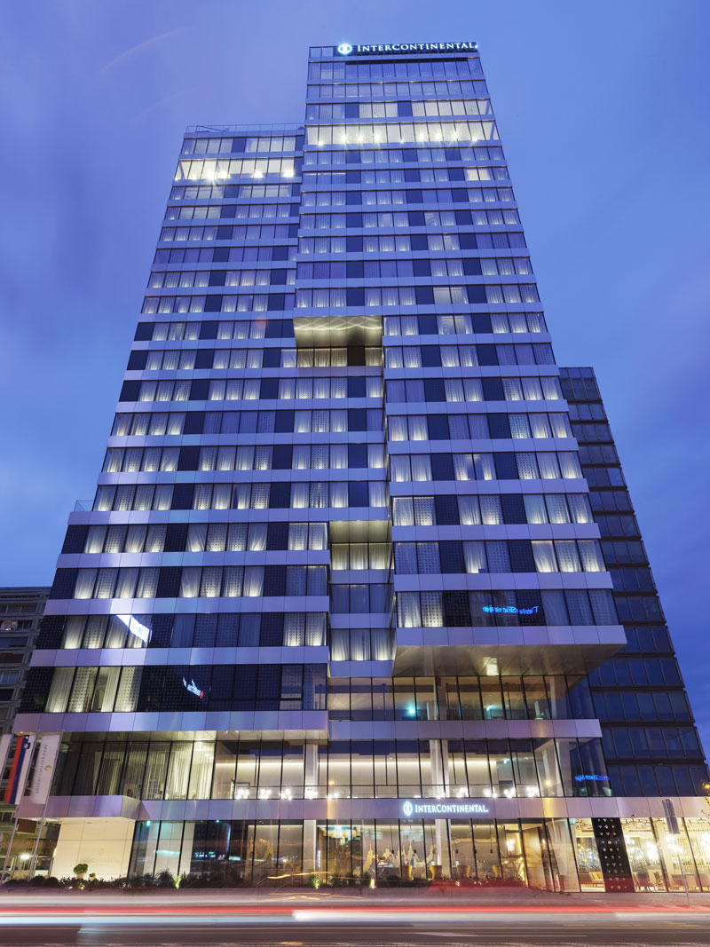 | 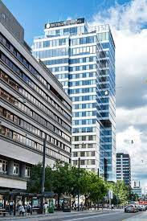

- History of Ljubljana
Ljubljana (also known by other historical names) is the capital and largest city of Slovenia. It is the cultural, educational, economic, political and administrative centre of the country.

During antiquity, a Roman city called Emona stood in the area. Ljubljana itself was first mentioned in the first half of the 12th century. Situated at the middle of a trade route between the northern Adriatic Sea and the Danube region, it was the historical capital of Carniola, one of the Slovene-inhabited parts of the Habsburg Monarchy. It was under Habsburg rule from the Middle Ages until the dissolution of the Austro-Hungarian Empire in 1918. After World War II, Ljubljana became the capital of the Socialist Republic of Slovenia, part of the Socialist Federal Republic of Yugoslavia. It retained this status until Slovenia became independent in 1991 and Ljubljana became the capital of the newly formed state.

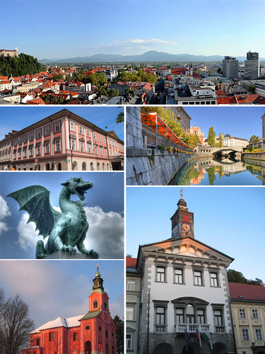 | 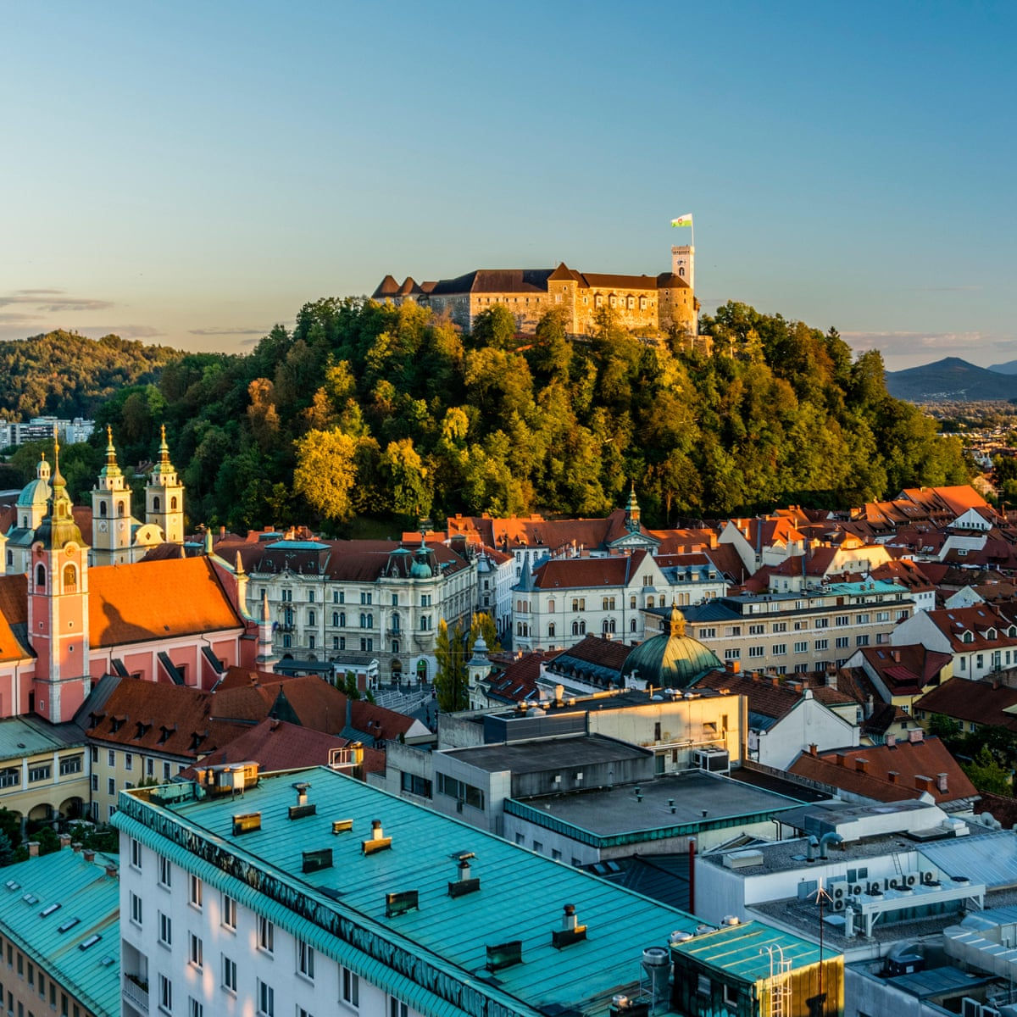
More info. about Ljubljana city https://www.visitljubljana.com.

- Meeting Venue and Accommodation

Special accommodation rates at the Hotel Intercontinental have been negotiated for duration of MBSHC23 from 29. March to 01. April 2022.
https://www.ihg.com/intercontinental/hotels/gb/en/ljubljana/ljuha/hoteldetail

Intercontinental Ljubljana, Slovenska cesta 59, 1000 Ljubljana, Slovenia
Phone: +386 59 128 000 e-mail: Ljuha.info@ihg.com

Check in: 3PM (Early check in available)
Check out: 12PM (Late check in available)

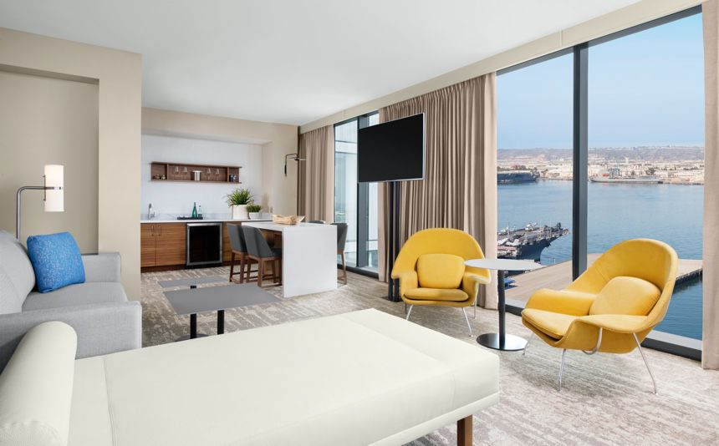 | 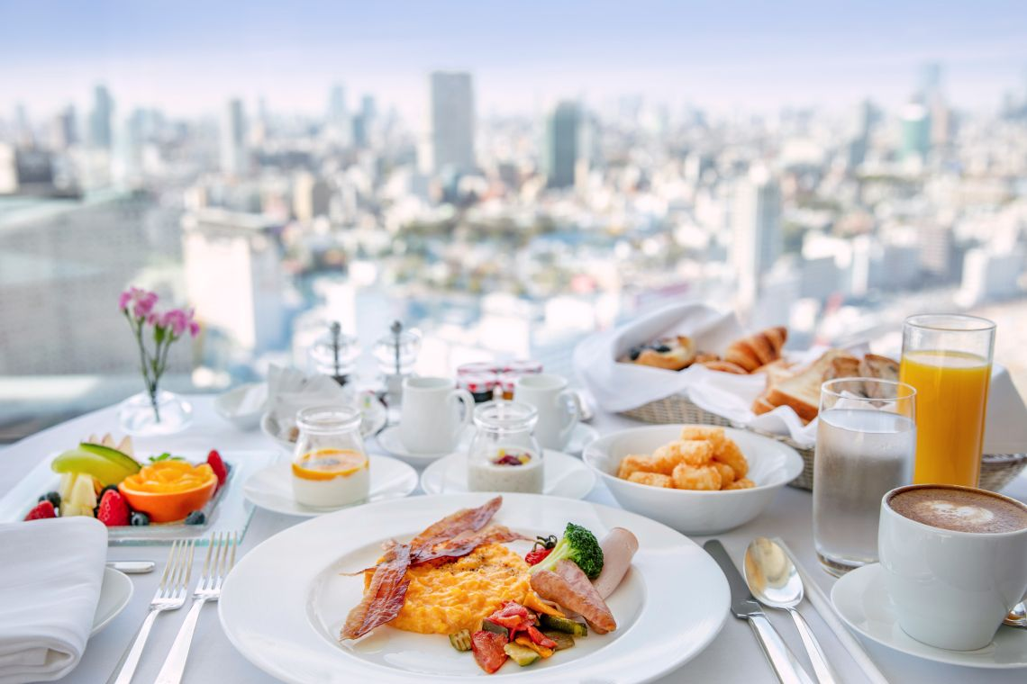
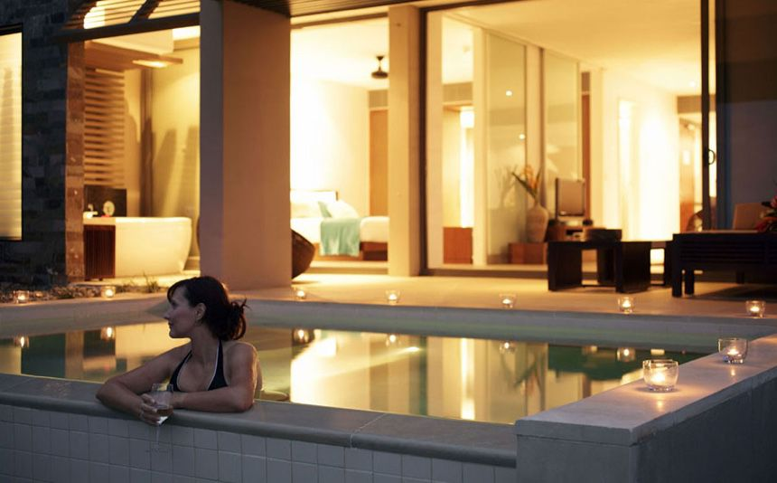 | 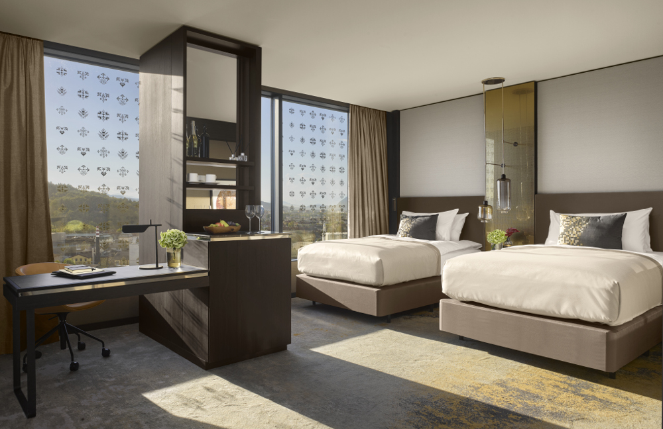

More information:
Geodetic institute of Slovenia, Jamova cesta 2, 1000 Ljubljana, Slovenia
e-mail: igor.karnicnik@gis.si ; Phone: +386 51 304 303

IMPORTANT: Please complete the information requested in the “Participant registration form” document, and forward it to the GIS igor.karnicnik@gis.si no later than 28 February 2022, copy also to e-mail ihmesp@fn.mde.es / ihmrelin@mde.es and IHO Mr. Yves Guillam yves.guillam@iho.int .

The following options are available:
Rooms | No. of . rez. | Price | Tourist tax/per day
Single room | 25 | 165,00 € | 3,13 €
Double room | 25 | 185,00 € | 3,13 €

Special room rates for conference attendees are agreed with the conference hotel and represent the best price in terms of availability, number of rooms, length of stay and season.
All prices include 9.5% VAT and include breakfast.
In case of changes in the amount of tourist tax, the hotel will inform the guest in writing and the prices will be adjusted accordingly.
Listed special room rates will only be valid for the above mentioned dates of the event.
Accommodation in a higher room category is possible with extra charge, at the prices below and is subject to availability. An additional charge is per room per night.

Additions to rooms:
Deluxe room | 30,00 €
InterContinental room | 70,00 €
Junior Suita | 110,00 €
Executiv Suita | 200,00 €

Reservation procedures:
Conference delegates can book their accommodation by sending an inquiry with the code X9B to secure a special price to:
ljubljana.reservations@ihg.com , and copy to igor.karnicnik@gis.si
Reservation of rooms is submitted by the hotel up to 45 days before arrival (12.2.2022). Up to this date the cancelation of is free of charge.

Restaurant & Bar
7:30 am – 11:30 am  Restaurant:  Michelin star chef Alfredo Russo supervised the menu, combining culinary artistry with a chic rooftop setting to celebrate. | 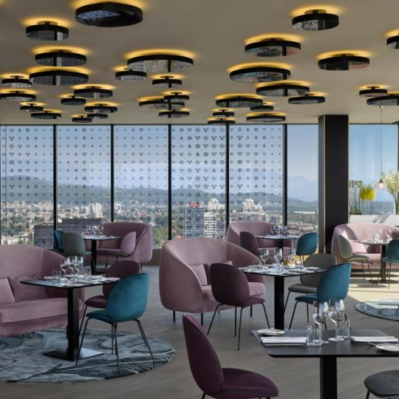
1: pm – 11: am  B-Bar:  Is the ideal place to relax after a day of meetings or sightseeing. Settle back on the outdoor terrace with an expertly missed cocktail or a glass of wine to enjoy dazzling views of the Old Town, the castle and the surrounding Alps. | 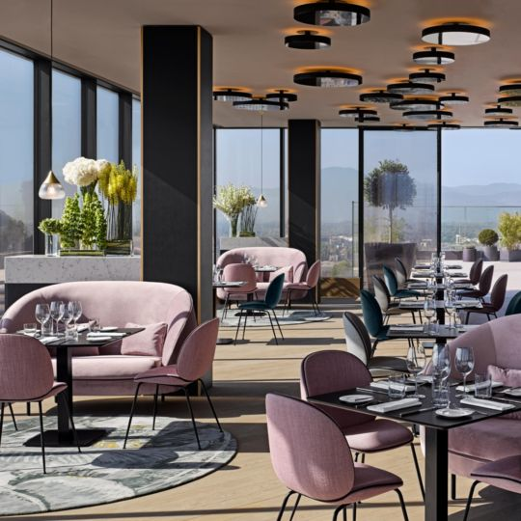
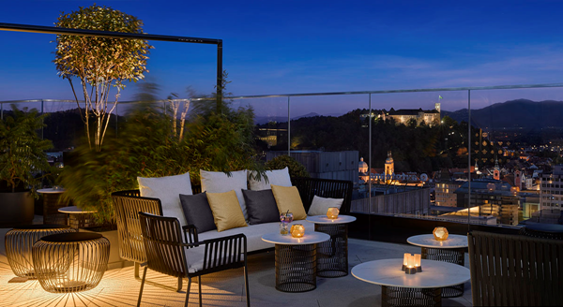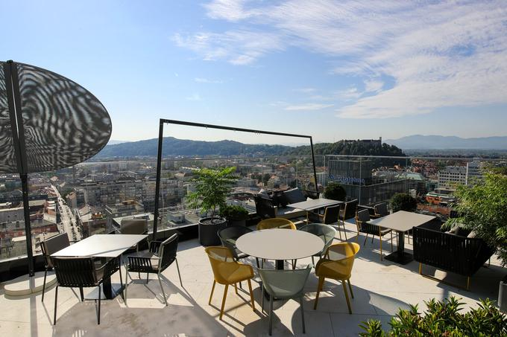

- TRANSPORTATION DETAILS

ARRIVING BY CAR - ONSITE PARKING AVAILABLE
For convenient parking service a public garage is just across the street of InterContinental Ljubljana hotel, priced at €33 per night. Alternatively, other parking options are available in walking distance of the hotel.

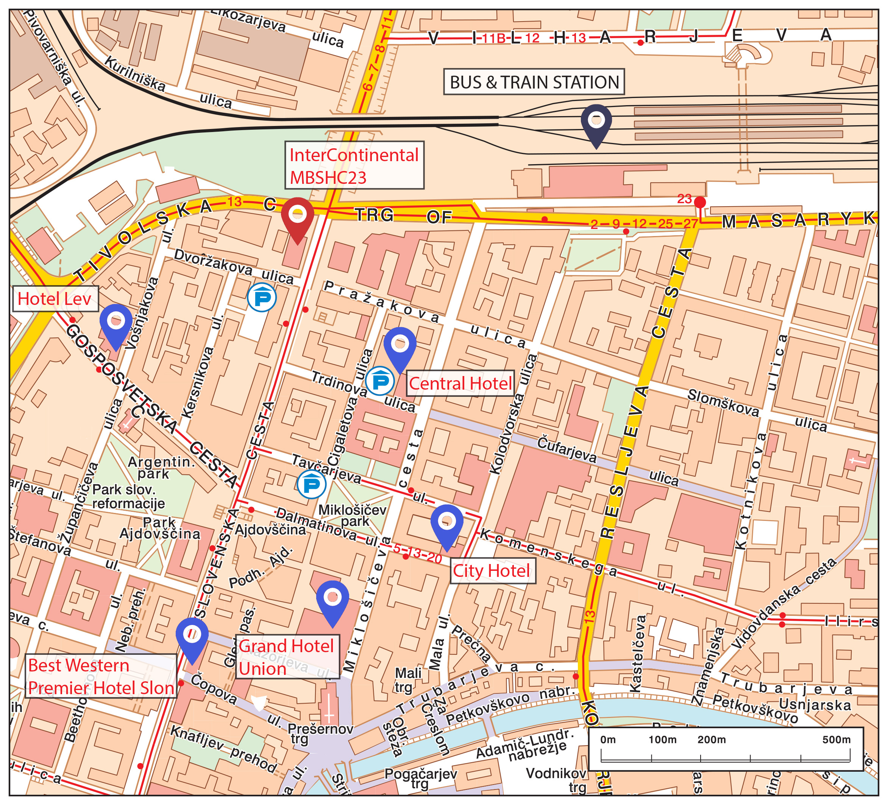

ARRIVING TO LJUBLJANA JOŽE PUČNIK AIRPORT
Ljubljana Jože Pučnik Airport (LJU) is about 25 km from Ljubljana center. The central bus and railway stations are right in the vicinity the hotel.

OTHER AIRPORT OPTIONS
Other airports close to Ljubljana are:
- Trieste (IT) Ronchi dei Legionari airport, about 120 km from Ljubljana
- Klagenfurt (AT) airport, about 110 km from Ljubljana
- Zagreb (HR) airport, about 150 km from Ljubljana

BUS
The bus station is in the immediate vicinity of the passenger airport arrival terminal, in the direction of the parking garage. Buses run directly to Ljubljana. Bus stops about 5 min walk from the hotel. Click on the links below for details and timetable.
ARRIVA
Phone: +386 (0)4 20 13 210
e-mail: info@arriva.si more: https://arriva.si/

NOMAGO
Phone: +386 (0)1 43 17 700
e-mail: info@nomago.si
more: https://www.nomago.si/avtobusne-vozovnice,

RENT-A-CAR
At Ljubljana Jože Pučnik Airport, you can rent a vehicle from one of the Rent-a-car providers, who will be happy to provide you with any additional information regarding their offer.

TAXI
For easier organization of transport and, above all, an affordable solution, we suggest Metro taxi transport. Contact number : +386 51641 882 or. E-mail; info@taximetro.si
Other taxi companies are in the immediate vicinity of the passenger arrival terminal at the airport.

TRAIN
Arriving by train is also an affordable solution. Ljubljana Train Station is in the walking distance (about 500 m) from the hotel.

OTHER NEARBY ACCOMMODATION POSSIBILITIES
There are many accommodation options if you wish to stay at an alternative hotel:
- Urban Hotel ****https://www.urbanhotel.si/?lang=sl
- Hotel Lev ****https://www.uhcollection.si/
- Galerija rooms ***https://www.galeriarooms.com/
- Hotel Union ****https://www.uhcollection.si/sl/grand-hotel-union
- City Hotel *** https://www.cityhotel.si/slo/

ELECTRICITY SUPPLY IN SLOVENIA
Slovenia uses 220/230 volts AC 50 Hz electricity supply. The plugs are type F.
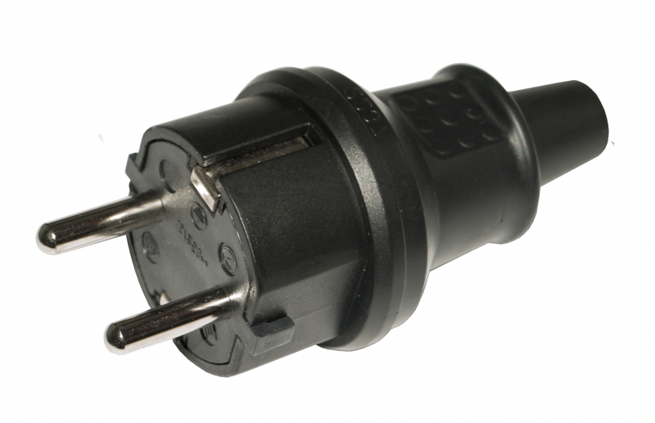 | 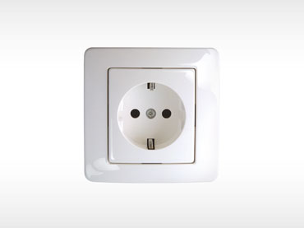

TAX SYSTEM
VAT
In accordance with Slovenian VAT legislation, VAT on supplies of goods or services is calculated and paid at the general rate of 22%, except for supplies of goods and services for which a lower rate of 9.5% is set.

Can I drink the water?
All water in the Slovenia can be drunk straight from the taps, however if you prefer bottled water it is readily available from all shopping malls, pubs, cafés and small stores.

Social events during conference
The following social events are under consideration:
- 29. March, Ice-breaker in hotel terrace
- 31. March, Conference dinner (walking distance from hotel)

