MEDITERRANEAN AND BLACK SEAS
HYDROGRAPHIC COMMISSION

22th CONFERENCE

ROMANIA
NATIONAL REPORT

Approved by:

HEAD OF MARITIME HYDROGRAPHIC DIRECTORATE

Captain (PhD) Nicolae VATU

Prepared by:

PCC Paraschiv Paula

MARITIME HYDROGRAPHIC DIRECTORATE

No.1 Fulgerului Street, Constanta, 900218, Romania
TEL/FAX: + 40 241 513 065
TEL: + 40 241 651 040
E-mail: hidro@dhmfn.ro
Web: www.dhmfn.ro

Page left intentionally blank

AGENDA:

 |  | Page No.
- HYDROGRAPHIC OFFICE | … | 4
- SURVEYS | … | 4
Coverage of new surveys | … | 4
Survey platforms and equipment | … | 4
Ships | … | 5
New technologies and /or equipment | … | 7
3. CHARTS | … | 7
ENCs | … | 7
RNCs | … | 10
INT Paper Charts | … | 10
National Paper Charts | … | 13
Special Naval Charts | … | 14
Cartographic Production | … | 14
4. NAUTICAL PUBLICATIONS | … | 15
MHD Official Nautical Publications | … | 15
New Publication/Edition Of Nautical Publications | … | 16
5. MARITIME SAFETY INFORMATION (MSI) | … | 17
Existing infrastructure for transmission | … | 17
NAVTEX | … | 17
MSI Equipment | … | 17
New infrastructure in accordance with GMDSS Master Plan | … | 18
Problems encountered | … | 18
6. CAPACITY BUILDING | … | 18
Training received through capacity building program | … | 18
Training received outside the capacity building program: | … | 18
Training needed | … | 18
7. OCEANOGRAPHIC ACTIVITIES | … | 19
8. OTHER ACTIVITIES | … | 19
9. CONCLUSIONS | … | 20

1. HYDROGRAPHIC OFFICE

According to the Romanian Law no 395/2004, Romanian Maritime Hydrographic Directorate is the national authority in the field of hydrography and marine cartography. Romanian Maritime Hydrographic Directorate has also the statute of Lighthouses Authority.
Maritime Hydrographic Directorate operates under the leadership of the Naval Forces within the Romanian Ministry of National Defence.
The Directorate is committed to bilateral arrangements, developed in co-operation with other international government hydrographic authorities, regarding data exchange.
Contact details:
Maritime Hydrographic Directorate
No. 1, Fulgerului St.,Constanta, 900218
Phone: 0040-241-651.040
Fax: 0040-241-513.065
E-mail: hidro@dhmfn.ro

- SURVEYS
Coverage of new surveys
Hydrographic, oceanographic and topographic surveys were executed in the Romanian area up to the 500 m bathymetric and at this time we have completed up to 45% of the Romanian coast where the bathymetry has an effect on the safety of navigation, and several surveys were done for military exercises.
In 2020 we have performed the following surveys:
- Topographic survey of the entire Romanian coastline (yearly activity). During this activity we verify the erosion process and the effects of sediments from Danube River;
- Hydrographic and oceanographic surveys for military purposes;
- Shoreline surveys for military exercises;
- Hydrographic surveys, in order to update the national database in the following areas:
- Mangalia Harbor;
- Midia Harbor Approach;
Also, in 2020 we performed the specific measurements for expanding and updating the database managed by the "Department for Data Analysis and Evaluation for Anti-Mine Warfare" in order to increase the safety of navigation in the Romanian territorial waters.
Other surveys done by other national authorities based on Romanian national law:
- Surveys of Constanta and Midia Ports - done by Port Authority (the data has been provided to RO MHD);
- Navigation Channel surveys for the Danube River- done by Romanian Danube Administration.

Survey platforms and equipment
The surveys were done using the following platforms and equipment:

The Romanian Hydrographic ship Cpt.Cdor ALEXANDRU CĂTUNEANU
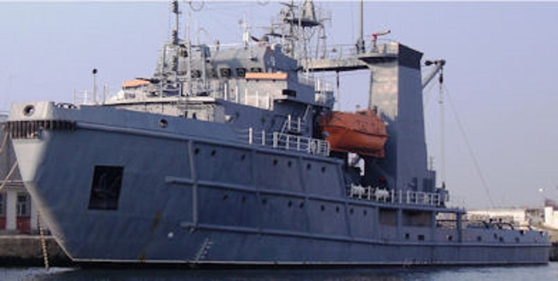

Equipment: EM 3000 Multi-beam
EA 400 Single-beam
Edgetech 4200 side scan sonar
Magnetometer – Marine Magnetics
Gradiometer- Marine magnetics
This survey vessel will be retrofitted with new sensor in 2021

Survey Launch Cpt. Cdor. ALEXANDRU CĂTUNEANU II
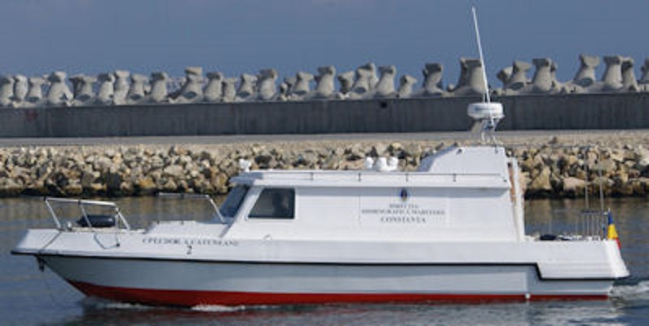
Equipment: EM 3002 Multi-beam
EA 400 Single-beam
MS 1000 underwater scanner
Edgetech 4200 side scan sonar
Magnetometer – Marine Magnetics

Survey Launch Hidrografica 3
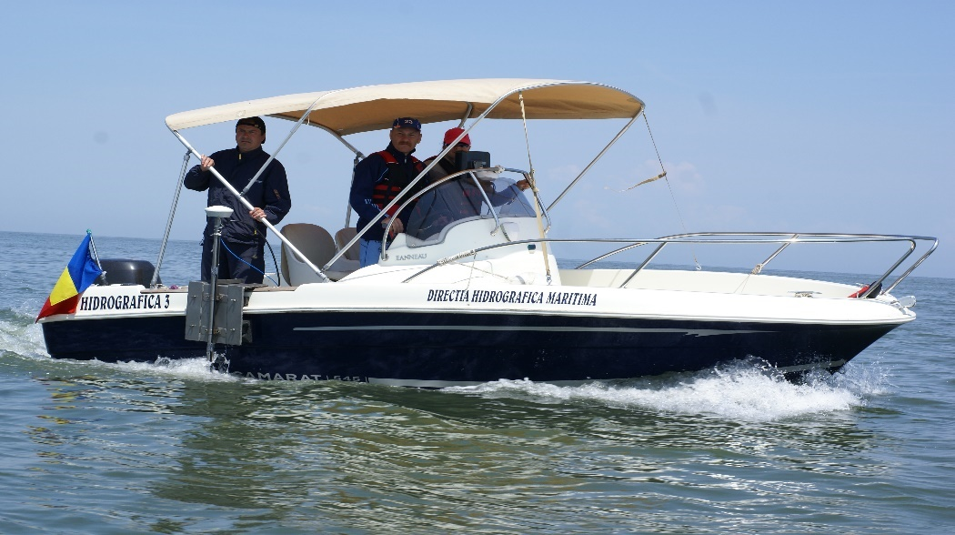
Equipment: EA 400 Single-beam
Magnetometer – Marine Magnetics

Survey Launch – OCEAN 1
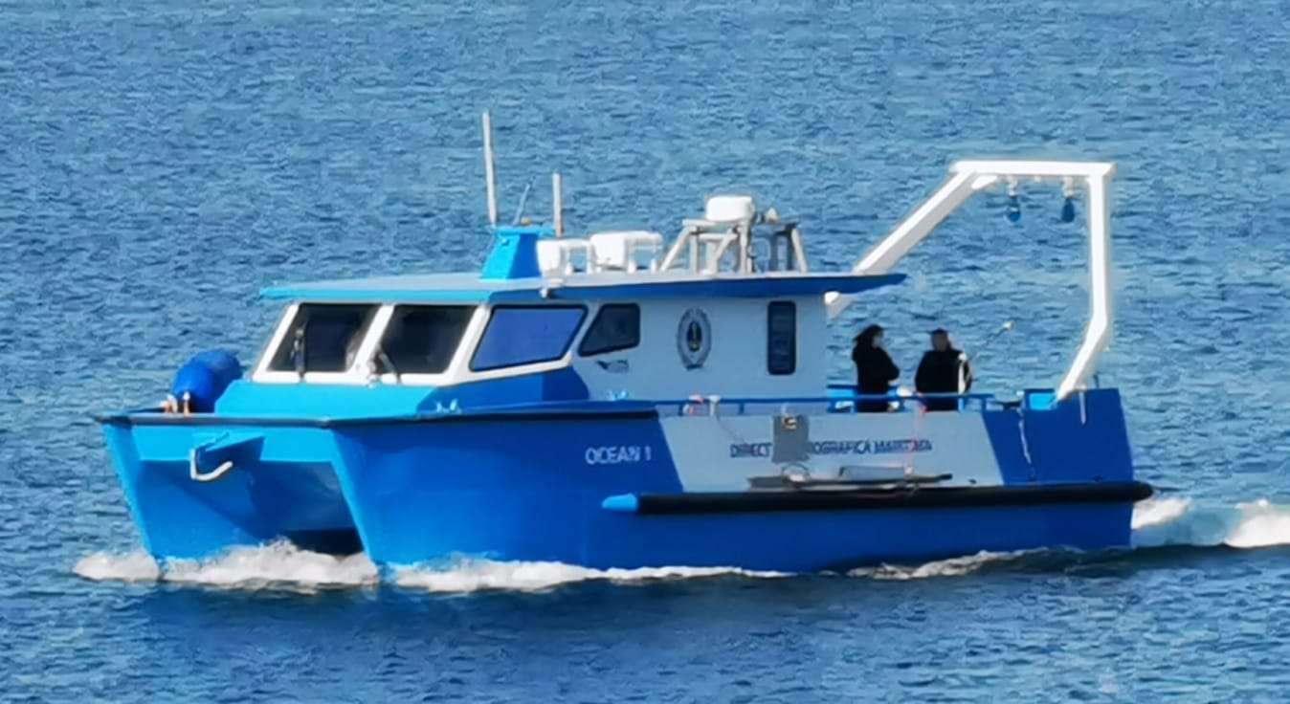
Equipment: T 20 R Multi-beam
Echotrack T 20 Single-beam
Santinel V ADCP
BATS USBL
Edgetech 4200 side scan sonar

Fixed stations:
We have at this stage four locations for tide measurements and RTK fixed stations spread on the Romanian coast line.

New technologies and /or equipment:
In 2021 the Romanian Hydrographic ship Cpt.Cdor ALEXANDRU CĂTUNEANU will have a modernization stage in order to update the onboard research equipment to latest technologies and expand the capabilities with the following:
- Deep sea multibeam system;
- ADCP;
- USBL;
- Sub bottom profiler;
- Inertial positioning system.

3. CHARTS

MDH produces official standard nautical charts (SNC) and electronic navigational charts (ENCs) covering the waters within the national responsibility area. For details see: https://www.dhmfn.ro/en/.
ENCs
From 1st April 2019 to 15th April 2021, MHD has increased the number of ENCs portfolio from 13 to 19 ENC cells based on existing paper charts (Figures 1-6). Since last report MHD has produced 40 updates, 13 new editions and 5 new ENC cells: RO501021, RO501022, RO600521, RO600522, RO600523, band 5 and band 6, covering Port of Constanța.
MHD intends to produce and send for distribution this year, 3 new ENC cells band 3.

Usage band | Navigation purpose | No of cells released | No of cells planned for production(this year)
1 | Overview | N/A | N/A
2 | General | 1 | N/A
3 | Coastal | To be produced | 3
4 | Approach | 6 | N/A
5 | Harbour | 5 | N/A
6 | Berthing | 7 | N/A
Total |  | 19 | 3

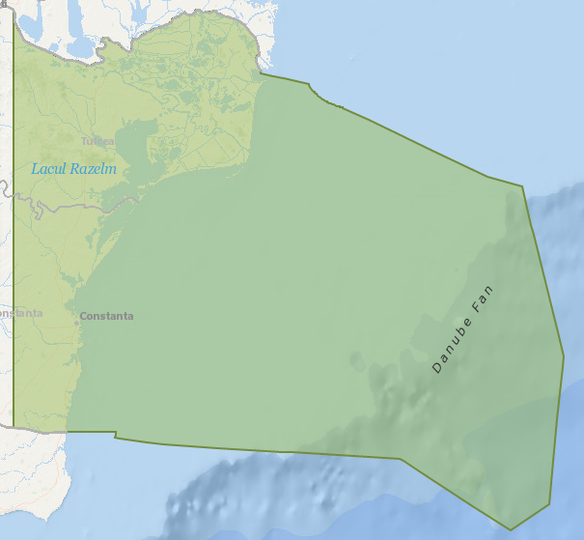
Figure 1. General band, scale 1:350000, covering Romanian Coast

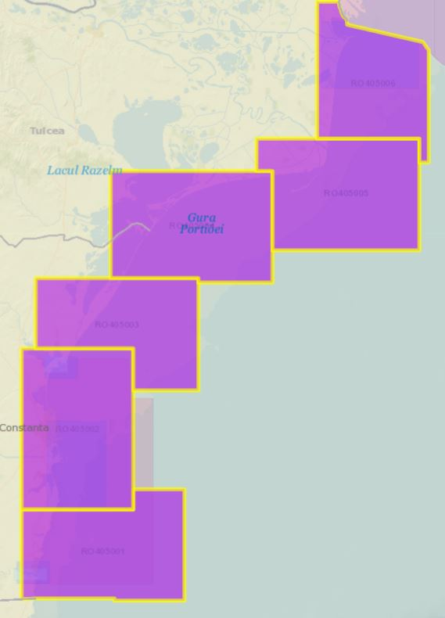
Figure 2. Approach band, scale 1:45000, covering Romanian Coast

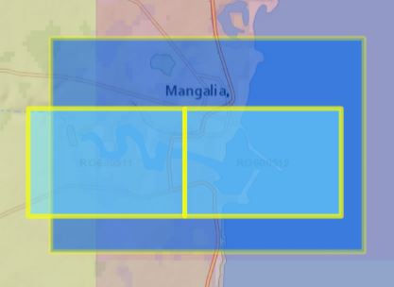
Figure 3. Harbour and berthing bands - Port of Mangalia

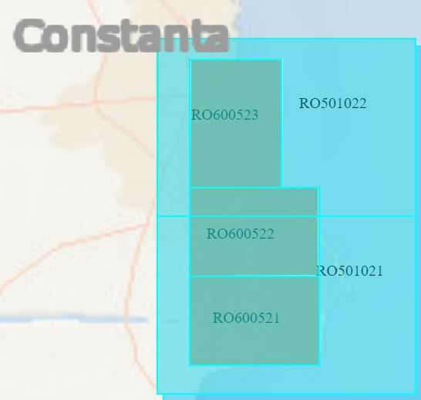
Figure 4. Harbour and berthing bands - Port of Constanța

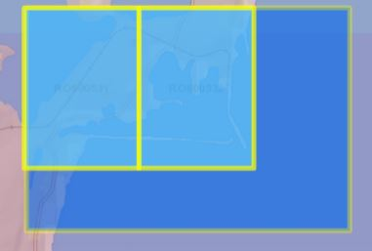
Figure 5. Harbour and berthing bands - Port of Constanța – Zone Midia

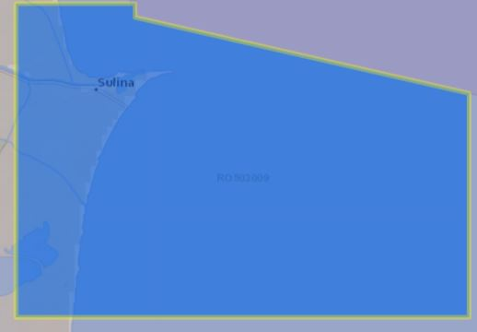
Figure 6. Harbour band - Port of Sulina

ENC distribution method
MHD distributes its ENCs through IC-ENC RENC.

RNCs
Romania does not produce RNCs.

INT Paper Charts
Romania has in its portfolio 6 INT numbers which cover the entire Romanian coast of the Black Sea and the Romanian ports.
The current status of INT charts produced by MHD is:

INT No. | SCALE | MAIN TITLE | STATUS | Edition Year
3820 | 1:300000 | From Kaliakra to Danube Delta | Produced | 2014
3902 | 1:10000 | Port of Mangalia | Produced | 2020
3904 | 1:10000 | Port of Constanta – Midia zone | Produced | 2021
3905 | 1:30000 | Port of Constanta and approaches | Produced | 2021
3907 | 1:50000 | From Gura Sf.Gheorghe to Gura Musura | In progress | Planned for 2021
3908 | 1:30000 | Port of Sulina and approaches | Produced | 2021

From 1st of July 2019 to 15th of April 2021, RO MHD produced 3 new INT charts and 1 new edition of INT charts (Figures 8-11).
Details on MHD INTs (title, chart limits, current status etc.) are accessible for all chart users in IHO Web Catalogue (Figure 7).

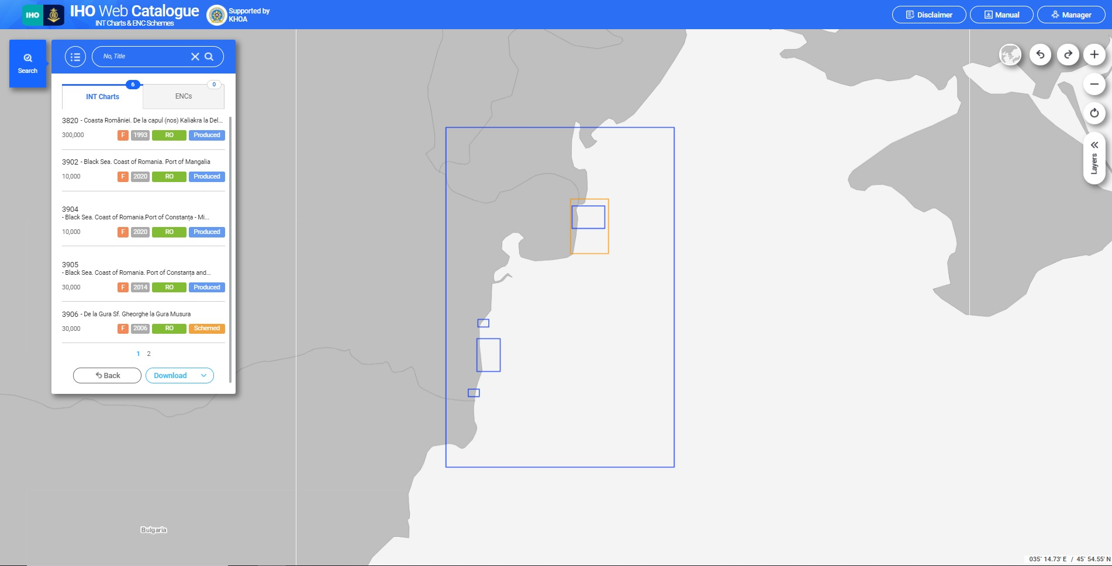
Figure 7. IHO Web Catalogue – Romanian INT charts

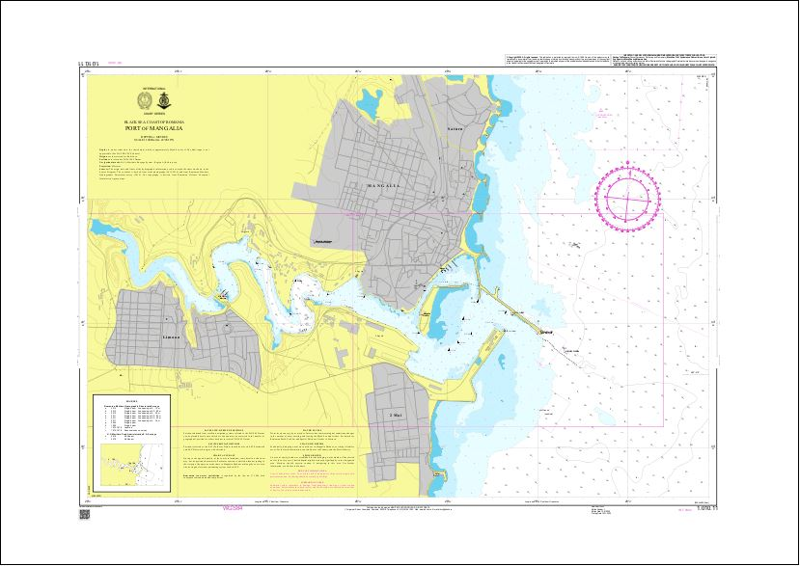
Figure 8. INT 3902 Port of Mangalia

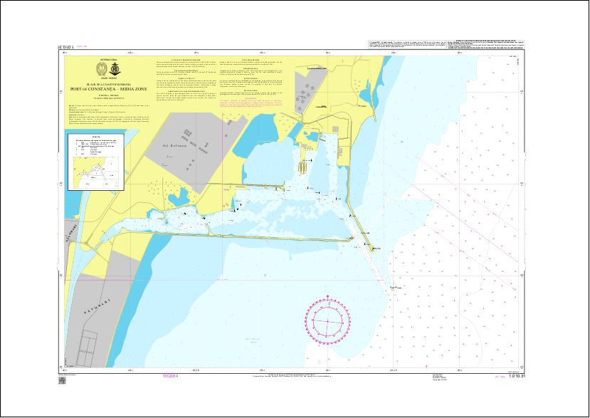
Figure 9. INT 3904 Port of Constanta – Midia Zone

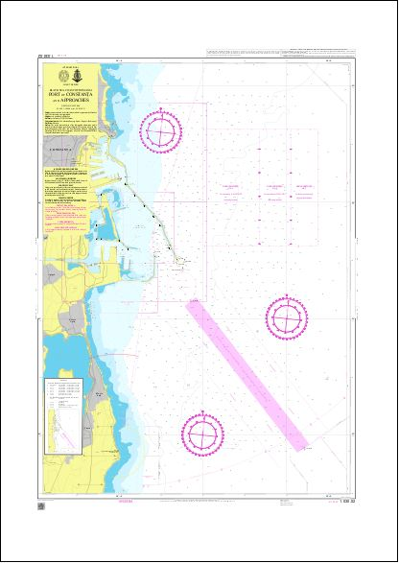
Figure 10. INT 3904 Port of Constanta and approaches

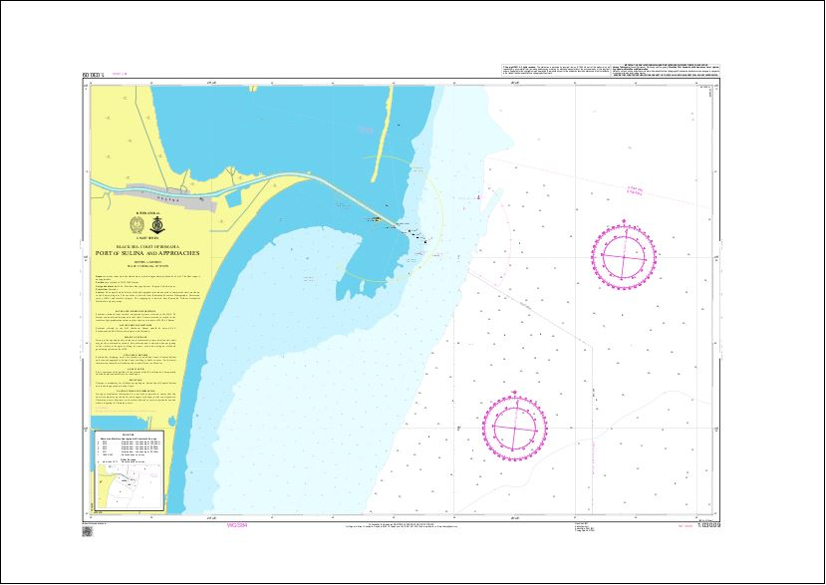
Figure 11. INT 3908 Port of Sulina and approaches

National Paper Charts

From 1st of July 2019 to 15th of April 2021, RO MHD produced 12 new editions of national paper charts.
The Romanian national folio of paper charts consists in: 18 paper charts edition 2007 (reprinted 2009), 1 paper chart edition 2014, 8 paper charts edition 2020 and 2 paper charts edition 2021.
The datum of all charts is WGS84.

SCALE | NO. OF CHARTS
MEDIUM-SCALE | 13
Landfall Charts | 4
1:750000 | 2
1:500000 | 2
Coastal Navigation Charts | 9
1:250000 | 1
1:150000 | 2
1:100000 | 3
1:75000 | 3

SCALE | NO. OF CHARTS
LARGE-SCALE | 16
Port Approach Charts | 6
1:50000 | 6
Harbour Charts | 2
1:10000 | 2
Berthing Charts | 8
1:5000 | 8

The charts issued by MHD cover all Romanian Exclusive Economic Zone and the Black Sea (Figure 12).

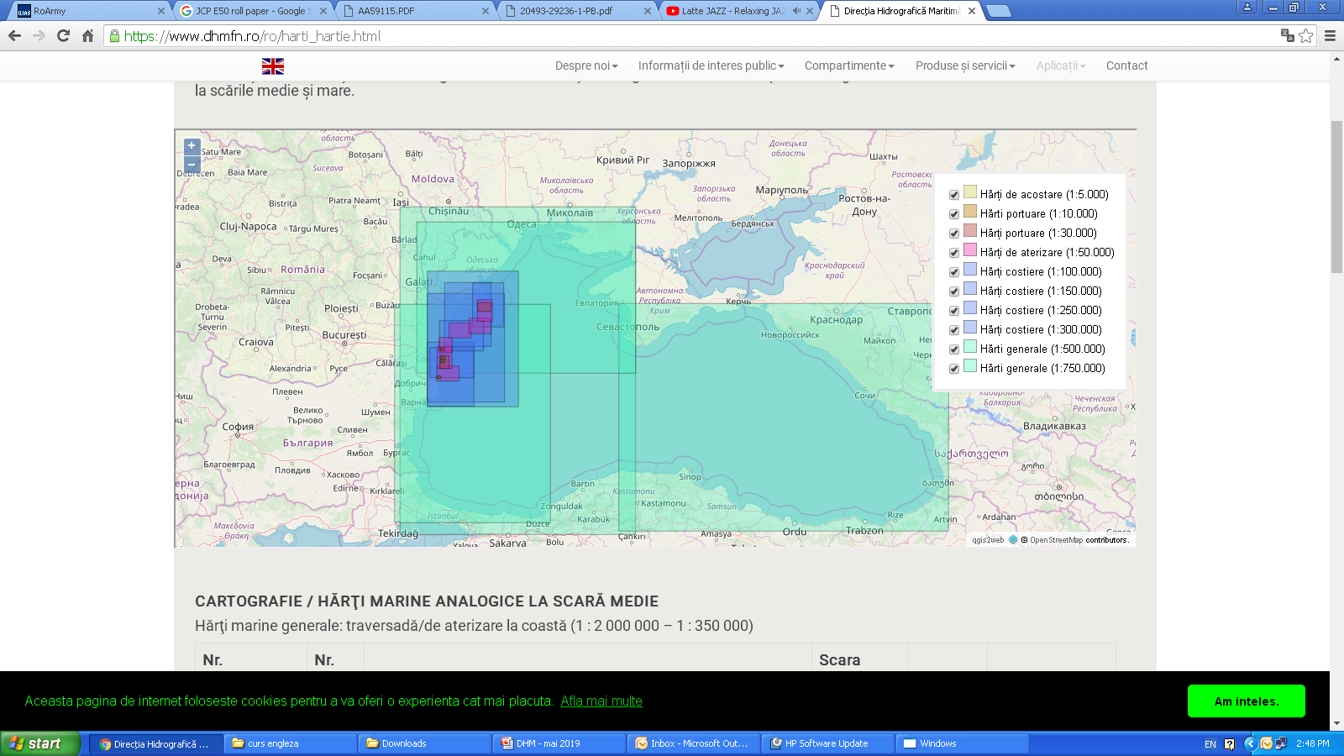
Figure 12. MHD Chart Folio coverage of Black Sea

An intensive work is carried on by the cartographic staff of MHD to create new editions for the national paper charts with editions older than 2020.
Starting from 2020 all paper charts editions have a QR code that allow the end user to check for updates. The service is available on RO MHD Internet webpage (www.dhmfn.ro) and became operational in April 2021.

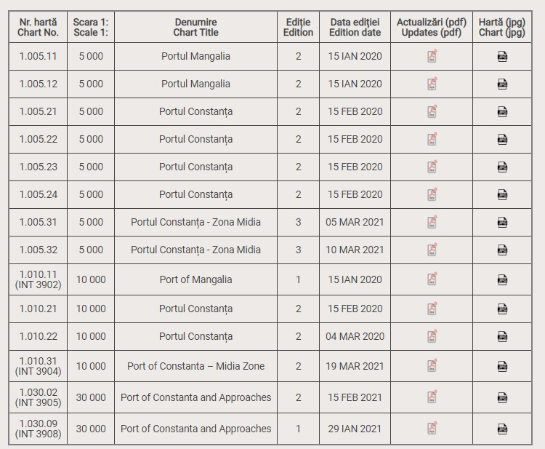
Figure 13. Paper charts update service

Special Naval Charts
A permanent task of MHD is to produce special naval charts for the Romanian Naval Forces. Therefore, we produce many types of thematic paper charts to fulfill RO NAVY needs and also additional military layers, according to NATO standards.

Cartographic Production
The production of paper charts with CARIS Paper Chart Composer is fully established. For ENCs CARIS S57 Composer is the production software.
Since 2017, MHD is using a large format plotter capable of printing high-quality paper charts (Figure 14).
MHD intends to introduce the Print on Demand (PoD) system, using the new A0 print system (Figure 15). This is capable of prints with high image durability and exposure to light over extended periods.

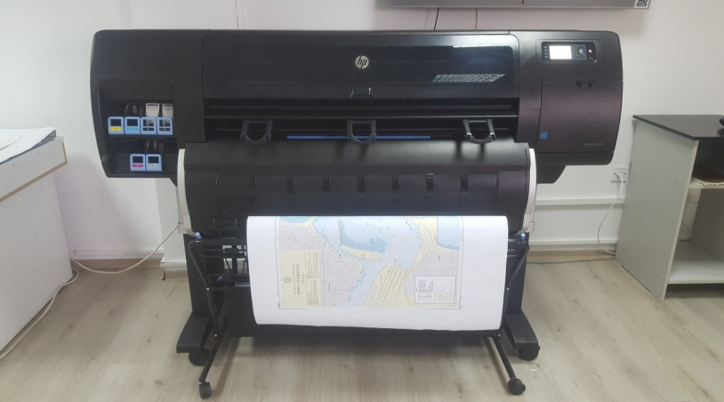 | 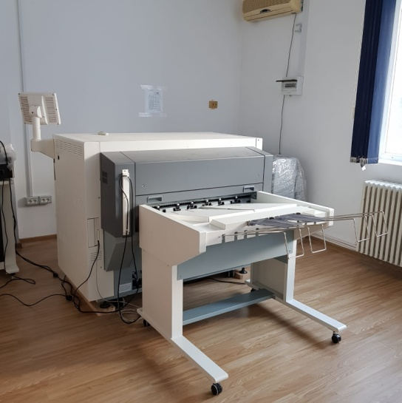
Figure 14. Plotter system | Figure 15. Digital printing system

Problems Encountered
1. Shortage in specialized human resources.
2. A few small overlaps on Ukraine/Romania ENCs are under consideration and deliberation.

4. NAUTICAL PUBLICATIONS

MHD Official Nautical Publications
Notification of the failure of lighthouses or buoys, notification of temporarily prohibited areas and all changes affecting charts in Marmara and Black Sea area are provided, monthly, to users of the marine environment through Notices to Mariners (Figure 16), in Romanian and English languages.
MHD publishes every year (Figure 17):  - Special Edition of Notices to Mariners  - Annex to Special Edition of Notices to Mariner  - Cumulative List of Notice to Mariners | 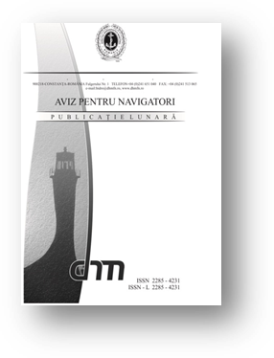 Figure 16. Notices to Mariners
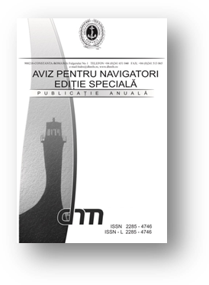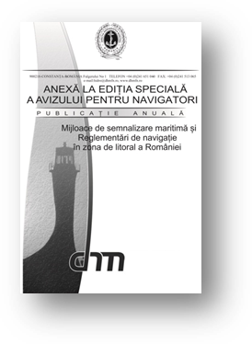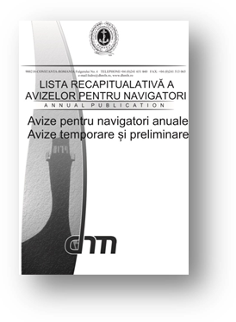
Figure 17. MHD annual nautical publications

MHD nautical publications portfolio includes the following documents:
- Black Sea Pilot
- List of Lights and Fog Signals
- Charts and Nautical Publications Catalogue
- Maritime Buoyage System
- Symbols and Abbreviations used on Romanian Paper Charts (according to INT1)
- Nautical Tables

All publications are printed in Romanian language and are available in hard copy format (Figure 18).
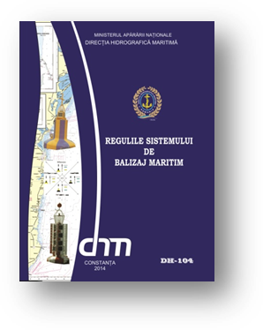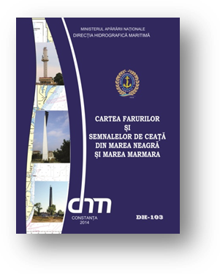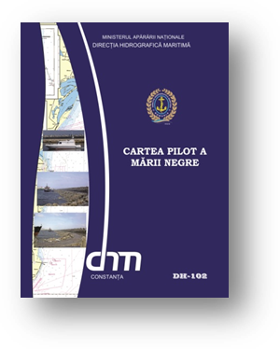
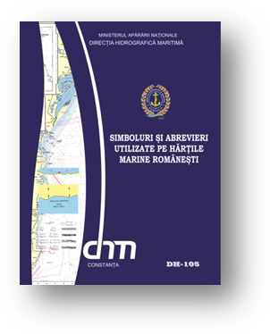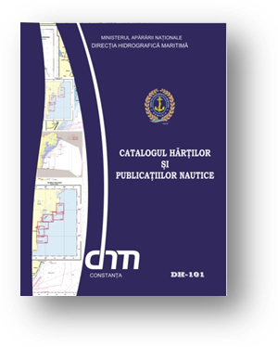
Figure 18. MHD official nautical publications

New Publication/ Edition of Nautical Publications
Since the 21st MBSHC Conference no publication has been issued.
In the second part of 2021 are to be printed:
- Symbols and Abbreviations used on Romanian Paper Charts (according to INT1), new edition;
- Instruction for How to Keep Romanian Nautical Charts and Publications Up-To-Date.

5. MARITIME SAFETY INFORMATION (MSI)

Existing infrastructure for transmission
Maritime Hydrographic Directorate is the national authority which promulgates navigational warnings and Constanta Radio is the National NAVTEX service provider.

NAVTEX
MSI Services are provided on 7/24 basis. The Romanian navigational warnings are transmitting in English language on 518 KHz through Varna Radio KHz. Other communication systems (VHF, MF and HF) are also available to promulgate MSI warnings in Romanian language if needed.

International NAVTEX service is performed through Varna Radio (on behalf of Romania – as agreed by IMO`s INTERNATIONAL NAVTEX COORDINATING PANNEL).
Coordinates – 43-04 N, 27-46 E;
NAVTEX coverage – 350 nautical miles;
MMSI - 002070810;
B1 character – [J];
Language – English;
Frequency – 518 kHz.

Graphic (UTC) | Weather Bulletins | Navigation and Storm Notices
01:30
05:30
09:30* | - *
13:30
17:30
21:30* | - *

* - Forecast on behalf of Romania, received from Constanta Radio
Number of Coastal and NAVAREA Warnings disseminated last year by MHD are listed below:

Year | NAVTEX Warnings | NAVAREA-III Warnings
2020 | 97 | 97
2021 | 14 | 14

MSI Equipment
MHD owns a NAVTEX receiver (NAV6/NAVTEX) from 2018, through which it can verify the promulgation of all the MSI messages, from area of responsibility (Figure 20).
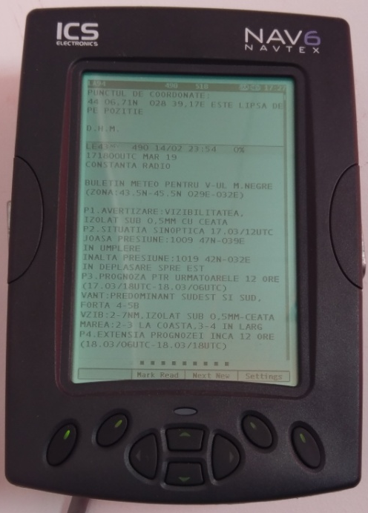
Figure 20. NAVTEX receiver

New infrastructure in accordance with GMDSS Master Plan
Ntr.

Problems encountered
Ntr.

6. CAPACITY BUILDING

Training received through capacity building program
One of our marine cartography specialists has been selected for the GEOMAC (Geospatial Marine Analysis and Cartography) training course in 2020. The training has been postponed for 2021 due to world pandemic situation.
It is the intention of the MHD to enroll other personnel in hydrographic and cartographic training in the next years.

Training received outside the capacity building program:
- One person attended CAT B hydrography training course at FOST(UK) in 2018

Training needed:
- S-100 product specification course and transition to S-100 products
- Cartographic Data Management course
- Nautical cartography and hydrography courses, cat A and cat B;
- Oceanography course;

We have only a few specialized personnel in hydrography and marine cartography. At this time, we have only 3 people that hold certification in hydrography and 2 people in marine cartography.
We have no persons specialized in oceanography.

7. OCEANOGRAPHIC ACTIVITIES
Tide gauge network: | 4 water level monitoring systems in Constanta, Midia,  Sulina and Mangalia
Equipment: | Pressure gauge Valeport tidemaster
Oceanographic measurements: | Oceanographic measurements were performed for: Midia, Mangalia, coastal route Constanta – Mangalia and the pouring mouth of Danube in Black Sea through Sulina and Sf. Gheorghe.
Problems encountered: | Lack of training courses for the oceanography personnel

8. OTHER ACTIVITIES

Meteorological data collection
The meteorological data collection is done by the Meteorological Department from the RO MHD. The data is stored into a database and it’s used for forecasts, mainly in support of Romanian Navy operations.

Geospatial studies
Erosion of the Romanian coast (in Romanian language).

Participation in IHO Events
MHD participated in the following IHO events since 20th MBSHC meeting:

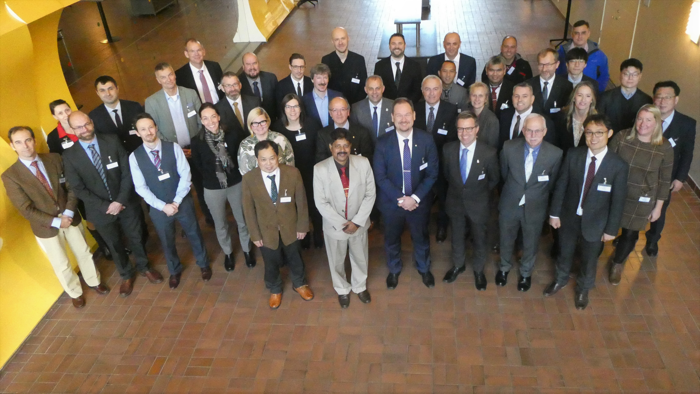
Figure 21 Nautical Cartography Working Group– 5th meeting (Stockholm, Sweden)
Participation in IC-ENC Events
Through the years passed from last MBSHC meeting, representatives of MHD attended IC-ENC meetings (Figure 21):
- Technical Conference 2019 (TC04) – Panama City, Panama
- Steering Committee 2019 (SC21) – Cape Town, South Africa
- Technical Conference 2020 (TC05) – Online
- Steering Committee 2020 (SC22) – Online

Figure 22. TC-04 IC-ENC.

Participation in Other Events
MHD personnel also participated in numerous NATO working groups such as: Geospatial Maritime WG, Naval Mine Warfare WG, Military Meteorology WG, Shipping WG, etc.
Starting up with 2019, MHD intends to participate at the following IHO Working Groups: ENCWG, NCWG, S-101PT, S-121PT and ABLOS Conference.

- CONCLUSIONS
The cooperation with Hydrographic Services and national research institutes regarding the hydrographic activity represent a key point in improving the quality of hydrographic products and services in the near future in Romania. Maritime Hydrographic Directorate will continue to strengthen the cooperation in the field of hydrography and cartography with similar organizations within and outside the Black Sea.
The cooperation in the field of hydrography, marine cartography and oceanography conducted to good results on the coverage of the responsibility areas, reducing the financial and human effort involved in such activities.

