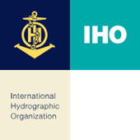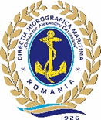

24th Mediterranean and Black Seas Hydrographic Commission (MBSHC)
01-05.07.2024, Constanta, Romania
PARTICIPANT REGISTRATION FORM

IMPORTANT Note: Please complete the information requested in this form, and forward it to the Romanian Maritime Hydrographic Directorate no later than the 15th of May 2024.

RMHD Contact Information:

Email: hidro@dhmfn.ro
Phone: +40241654040

Member State /
Organization

Personal details

Head or Member of delegation
Rank or Title
Name/ First name
Surname/ Last name:
Position / Job title / Role
Nationality
Address
E-mail
Phone
Passport NO
(and date of Issue)

Accommodation (for administrative purpose): Participants are expected to make their own accommodation arrangements if they choose different from our recommendation.
Arrival date: Departure date:
Hotel:

Social Events

Icebreaker: July 1st, 2024, Yes_____ No_____

Official dinner: July 3rd, 2024, Yes _____ No_____

Accompanying person at official dinner Yes_____ No_____

Special Dietary……………………………………………….

Comments or additional information:

Date:

