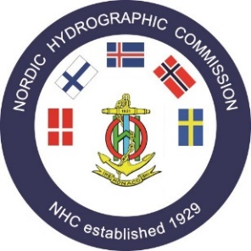

The 66th Nordic Hydrographic Commission Meeting

List of Actions

Number | Item | Action | Responsible | Timeframe | Remark Status
1 | NHC  66/  C3 | S-100 Implementation to be placed as standing item on the NHC agenda. | Chair | Ongoing
2 | NHC  66/  C4 | The incoming NHC Chair to communicate to the NCPEG that the ToR have been approved (without marketing as topic) and that the group is ready to start working and to select a Chair considering the nomination presented to NHC66. | Chair | April 2023
3 | NHC  66/  C5 | The incoming NHC Chair to communicate to the NSEG that the ToR have been approved, and that the group is ready to start working and to select a  Chair considering the nomination presented to NHC66. | Chair | April 2023
4 | NHC  66/  C5 | The incoming NHC Chair to communicate to the NSEG that they have been tasked to looking at automation of post-processing of survey data. | Chair | April 2023
5 | NHC  66/  D4 | The NHC Chair to contact NHC participants for input concerning the IRCC14 report | Chair | May 2023
6 | NHC  66/  D5 | The outgoing NHC Chair to inform the IHR editor-in-chief of the NHC representative to the IHR editorial board. | DK | April 2023 | Done
7 | NHC  66/  E4 | The outgoing NHC Chair to inform IENWG of the new NHC representative to the WG. | DK | March 2023 | Done
8 | NHC  66/  D6 | The outgoing NHC Chair to send out the revised Statutes for approval. NHC member states to report back. | All | April 2023 | Done
9 | NHC  66/  D6 | DK to bring the revised NHC Statutes to Assembly 3. The document will then be signed during Assembly by physical correspondence | DK | May 2023 | Done
10 | NHC  66/  E1 | DK to draft the NHC presentation to Assembly 3 and circulate the document among NHC member states | DK | April 2023 | Done
11 | NHC  66/  D2 | DK to report to NHC67 on the status of potentially signing a MoU with Seabed2030 | DK | NHC67
12 | NHC  66/  E1 | NHC67 to discuss on ‘how to address the sub-ECDIS market’ | All | NHC67

