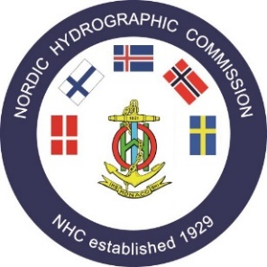

The 65th Nordic Hydrographic Commission Meeting

List of Actions

Number | Agenda item | Action | Responsible | Timeframe | Remark Status
1 | A.4 | DQWG Chair to make fresh call for CATZOC ‘best practice’ from NHC Member States. | DQWG Chair (NO) | End of May 2022
2 | B1.2 | DK to circulate statutes to NHC Member States and request:  - Comments and feedback on the revised objectives.  - Suggestions for necessary adjustments to the statutes.  - evaluate next steps following feedback | DK | End of June 2022 | To be discussed at NHC66
3 | C.2 | FI to share contact details related to the generation of HD Contours with all NHC Member States. | FI | End of april 2022
4 | C.3 | NHC Member States to appoint suitable representatives to determine the future tasks of both the NSEG and NCPEG and provide contact details to DK. ( JP) | All | End of June 2022 | DONE
5 | C.3 | DK to arrange meetings of the appropriate NHC Member States representatives in order to collaborate and define the scope, tasks, and way forward of both the NSEG and NCPEG. |  | End of 2022 | DONE
6 | C.3 | NSEG and NCPEG to appoint Chairs and arrange meetings. And agree on how best to share information | Chairs NSEG /NCPEG | NHC 66 | To be discussed at NHC66
7 | C.5 | NCPEG to compile best practice from all NHC Member States on procedures relating to the provision of T/P in ENC messages and make recommendations for standardisasiton of practice. |  | NHC 66 | POSTPONED
8 | Workshop | NHC Member States to rethink the structure of their National Reports to make them more effective and better suit their utility in HC discussions. | All | NHC 66 | DONE
9 | Workshop | Chair to circulate questionnaire relating to action 8 to gather views for discussion ahead of NHC 66. | DK | November 2022 | POSTPONED

