Annex 3 to NIOHC Letter No 04/2022

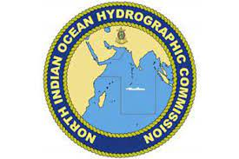

THE 21ST MEETING OF THE NIOHC
Bali, Indonesia
22nd - 25th August 2022

REGISTRATION FORM

Please submit the completed Registration Form to NIOHC-21 Secretariat by e-mail to infohid@pushidrosal.id not later than 22nd July 2022.

Member State
Organization

Head or Member of delegation

Head of Delegation |  | Member of delegation

Personal Details

Rank of Title
Name
Given/Personal Name
Position / Job Title / Role
Nationality
Mobile
E-mail

Date |  |  | Signature

