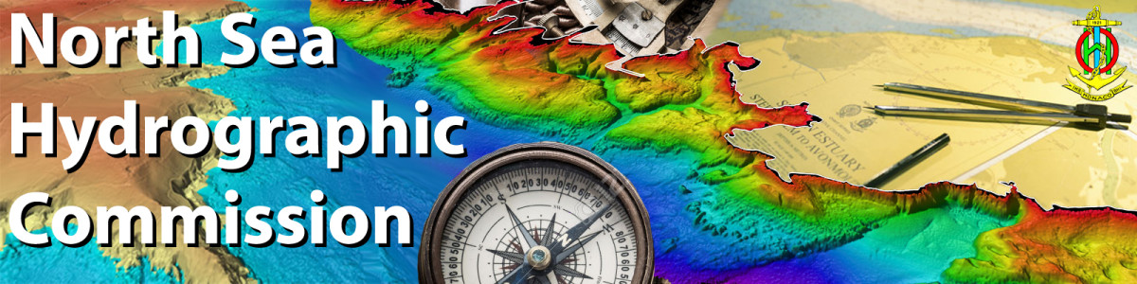
35th North Sea Hydrographic Commission meeting
Reykjavik, Iceland, 5 - 6 April 2022
Agenda and Timetable
Time | Monday 4 April
18:30-20:00 | Ice Breaker Event  Dress code: Smart casual | Onboard ICG Vessel Þór  Reykjavík harbour
DAY 1 of NSHC35 - Tuesday 5 April
Dress code: Business
08:30-09:00 | Registration – Hilton Nordica 1st floor
09:00-12:00 | First Session
 | - Opening formalities | Responsible
09:00-09:30 | A1. Opening remarks  Docs:  - NSHC35 A1 List of Participants  A2. Adoption of the Agenda  Docs:  - NSHC35 A2 Agenda and Timetable  A3. NSHC34 Minutes for approval  Docs:  - NSHC34 A3 NSHC34 Draft minutes V2  A4. NSHC34 List of Actions  Docs:  - NSHC34 A4 List of Actions | Chair  Chair  Chair  Chair
 | - IHO Work Programme 1 – Corporate affairs
09:30-09:50  09:50-10:10 | B1. IHO Report  Docs:  - NSHC35 B1 IHO Secretariat Report  - NSHC35 B1.1 IHO Sec Report - Presentation  B2. IHO Council Activities  Docs:  - NSHC35 B2 IHO Council Report | IHO SG  IHO SG  Germany
10:10-10:30 | Coffee break
10:30-10:50  10:50-11:30  11:30-12:00 | B3. What does the future have in store for us?  Docs:  - NSHC35 B3 What does the future have in store?  B3.1 Roundtable Discussion.  Where do MS wish to see IHO in few years’ time?  B4. IHO SP 2021-2026, NSHC MS Gap Analysis.  Docs:  - NSHC35-B4 IHO-SP NSHC MS Gap Analysis | IHO SG  All  Belgium
12:00-13:00 | Lunch
13:00-16:00 | Second Session
- IHO Work Programme 1
– Corporate affairs - cont.
13:00-13:40 | B4.1 S-100 plans - Roundtable discussion.  Where would NSHC MS like to be in a few years' time? | Belgium  All
- IHO Work Programme 2
– Hydrographic Services and Standards
13:40-14:20  14:20-14:40 | C1. HSSC - items relevant to NSHC (incl. S-100 Roadmap Implementation)  Docs:  - NSHC35 C1 HSSC report  Discussion – Q/A  C2. Future of the paper nautical chart - outcome  Docs:  - NSHC35 C2 Future of the Paper Nautical Chart  - NSHC35 C2.1 DGA production questionnaire | Sweden  All  Sweden  Denmark
14:40-15:00 | Coffee break
 | Regional and national developments
15:00-15:20  15:20-15:40  15:40-16:00 | C3. The INFOMAR seabed mapping programme - progress update.  Docs:  - NSHC35 C3 INFOMAR - progress update  - NSHC35 C3.1 Ireland INFOMAR - Presentation  C4. Marine base maps in Norway  Docs:  - NSHC35 C4 Marine base maps in Norway  C5. Danish Geodata Agency - strategy 2021-2030  Docs:  - NSHC35 C5 GDA strategy 2021-2030 | Ireland  Norway  Denmark
19:00 | Dinner hosted by Iceland  Dress code: Smart casual | Hilton Nordica

 | DAY 2 of NSHC35 - Wednesday 6 April
09:00-12:00 | Third Session
- IHO Work Programme 3
– Inter Regional Coordination and Support
09:00-09:20  09:20-09:30  09:30-10:10 | D1. IRCC - items relevant to NSHC  Docs:  - NSHC35 D1 Report IRCC  D2. IRCC13 actions and recommendations  Docs:  - NSHC35 D2 IRCC13 actions and recommendations  D3. Strategic Performance Indicators (SPI) allocated to IRCC  Docs:  - NSHC35 D3 SPIS allocated to IRCC. Presentation  D3.1 Roundtable discussion - How do we identify or provide values needed to measure the SPIs? | Germany  Chair  Netherlands  All
10:10-10:30 | Coffee break
10:30-11:00  11:00-11:20  11:20-11:40  11:40-12:00 | D4. NSHC sub-WGs  D4.1 NS-International Chart Committee (ICCWG)  Docs:  - NSHC35 D4.1 ICCWG Report  D4.2 Tidal Working group (TWG)  Docs:  - NSHC35 D4.2 TWG Report  D4.3 Resurvey Working group (RWG)  Docs:  - NSHC35 D4.3 RWG Report  - NSHC35 D4.3.1 Report RWG -Presentation  D5. D5 Report of the North Sea WEND WG  Docs:  - NSHC35 D5 WENDWG  - NSHC35 D5.1 WENDWG - Presentation  D6. BSNSMSDI WG  Docs:  - NSHC35 D6 BSNSMSDI WG  D7. Status CSB/GEBCO/Seabed 2030  Docs:  - NSHC35 D7 Status CSB/GEBCO/Seabed 2030 | UK  Iceland  UK  UK  Denmark  Norway
12:00-13:00 | Lunch
13:00-14:30 | Fourth session
13:00-13:30 | D8. Proposal for establishment of a Maritime Safety Information (MSI) Working Group  Docs:  - NSHC35 D8 Prop. for estab. of a MSI WG  - NSHC35 D8.1 NS-MSI WG – Presentation | UK
13:30-14:30 | - Any other business
 | - Election of new Chair
 | - Place and date of next conference
 | - Approval of NSHC35 list of actions
 | - Closing remarks

