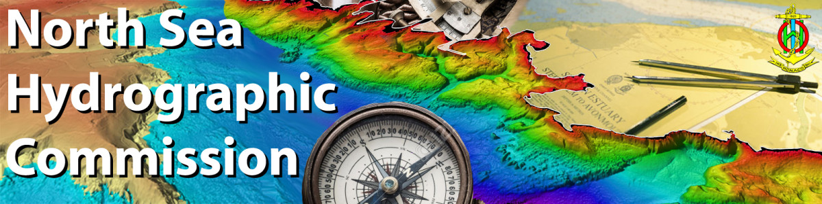
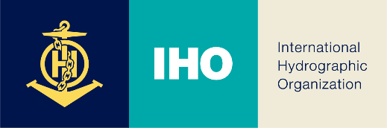
35th North Sea Hydrographic Commission meeting
5 - 6 April 2022 Reykjavik, Iceland

Participant Registration Form

Name and title
Gender / date of birth
Nationality
Organisation
Email
Mobile phone number
Special dietary
requirements
Hotel

Date: ________________________

Signature: _________________________________________________

You are requested to send this registration form before end of February to:
Email: arni.vesteinsson@lhg.is and sigridur.sverrisdottir@lhg.is

