18th Southern African and Islands Hydrographic Commission
Maputo, Mozambique
9th – 12th May 2022

Logistics Information

The 18th Southern African and Islands Hydrographic Commission (SAIHC) will be hosted by Instituto Nacional de Hidrografia e Navegacao (INAHINA) in Maputo, Mozambique, from 9-12 May 2022. INAHINA is pleased to welcome you to Maputo and provides the following logistical information to support you in planning your visit.

Venue
Maputo is the capital city of Mozambique, located in the far South of the country on the coast of the Indian Ocean. It is a bustling cosmopolitan port city boasting a vibrant, lively atmosphere, interesting architecture and delicious food.
The conference will be held at the Maputo AFECC Gloria Hotel, one of Mozambique’s largest luxury hotels, overlooking the Indian Ocean.
During the conference, lunch will be provided by the hotel. Please let the organisers know if you have any dietary requirements by contacting acianolipangue@inahina.gov.mz and laura.hewson@ukho.gov.uk as soon as possible.

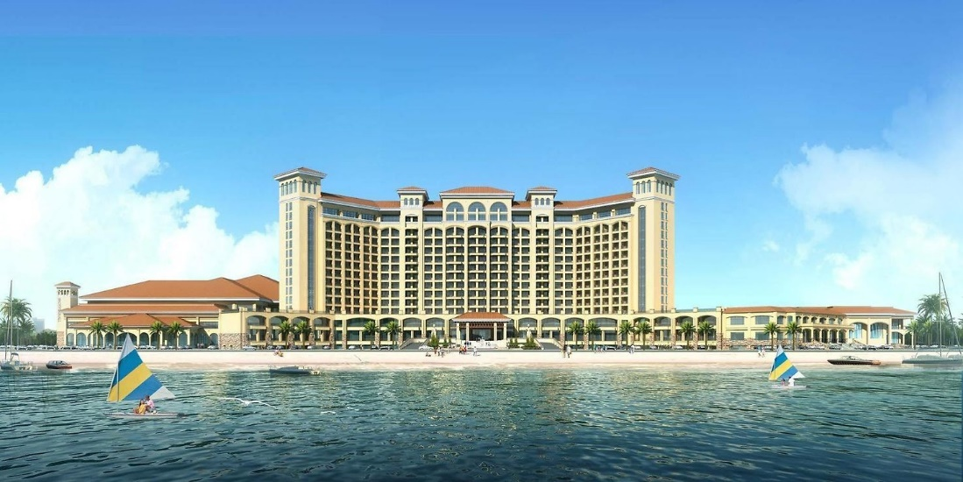
AFECC Gloria Hotel, Maputo

Accommodation
Delegates are encouraged to book rooms at the Maputo AFECC Gloria Hotel where the conference is being held. Hotel details are as below:

Maputo AFECC Gloria Hotel
Address: Av Da Marginal No. 4441, Maputo, Mozambique
Website: http://gloriahotel.co.mz/ or http://gloriahotel.co.mz/en
Sales: +25821266611
WhatsApp: +258 844527455

Our hosts at INAHINA have negotiated a discounted price for delegates. Please quote ‘SAIHC18’ when making your booking. This will entitle you to a deluxe king room, including breakfast, for $100 per night. Please make your reservations via Res.ggmpmb@gloriahotels.com, Francisco.manuel@gloriahotels.com or by calling the numbers provided above.
Rooms are equipped with a king-sized bed, free wi-fi, satellite tv, coffee and tea-making facilities and a sea view. The hotel also has gym access, swimming pool, spa and luggage storage.

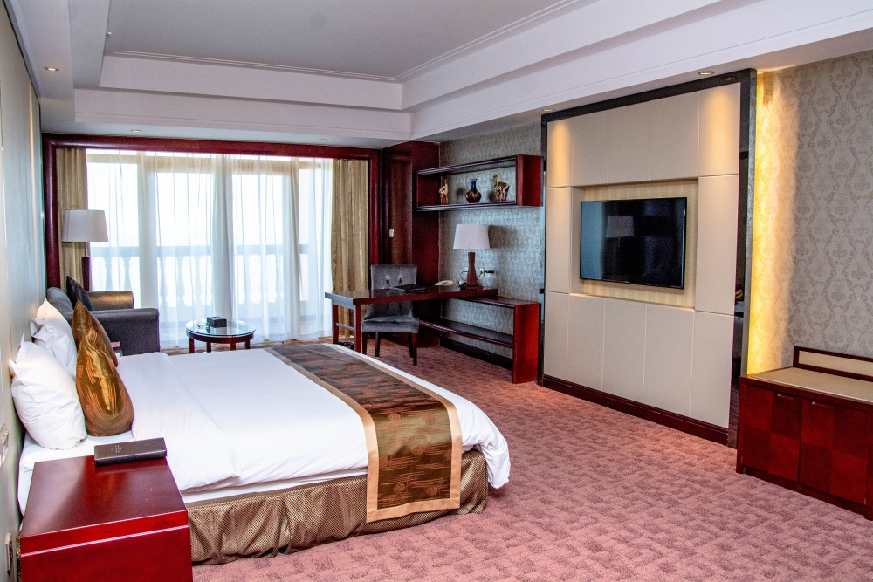
Deluxe King Rooms at the Gloria Hotel

Transport
Maputo AFECC Gloria Hotel is 6.8 km from Maputo International Airport and approximately 16 minutes transfer time to the hotel. Transport between Maputo International Airport and Maputo AFECC Gloria Hotel will be provided by INAHINA. Delegates are therefore kindly requested to send their flight details to acianolipangue@inahina.gov.mz and laura.hewson@ukho.gov.uk as soon as possible.
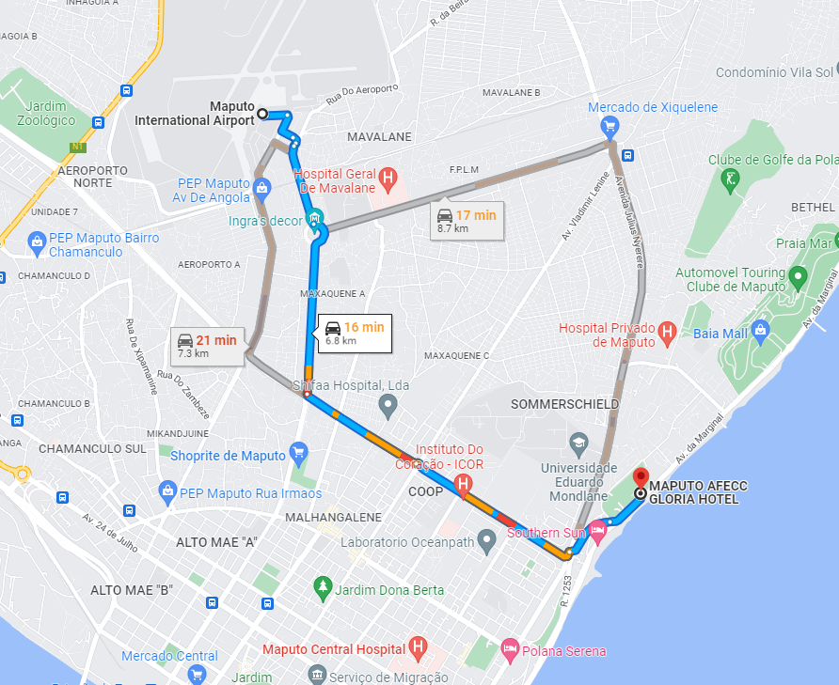

Visa Requirements
Depending on your nationality, you may require a visa to enter Mozambique. Please check the latest guidance with the local embassy or consulate based in your country.
Citizens of the following countries do not currently require a visa: Malawi, Mauritius, Republic of South Africa, Tanzania.
A list of face-to-face delegates has been provided to the Mozambican Migration Authorities. Anyone requiring a letter of invitation from INAHINA is requested to contact Mr Aciano A. Lipangue (acianolipangue@inahina.gov.mz) as soon as possible. INAHINA will try its best to accommodate late requests.

Vaccinations
Currently, all travellers must present a negative COVID-19 PCR test upon arrival into Mozambique. The test must have been issued in your departure country, within 72 hours prior to the time of arrival, even if you hold proof of vaccination against COVID-19.
All travellers arriving from or via countries with a risk of yellow fever must provide proof of vaccination upon entry. You may also require other vaccinations or medication, (such as anti-malaria tablets) so delegates are advised to seek medical advice in good time before your visit.

Other Information
Electricity. The standard voltage in Mozambique is 220v or 50Hz. There are three types of power outlet used in Mozambique: types F, C and M with the primary power outlets being type F.
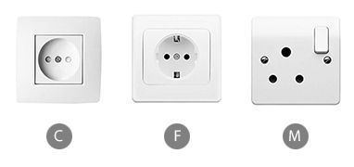
Plug Type C - You can identify this wall outlet by 2 round adjacent holes next to each other where the live and neutral plug socket pins slide into.
Plug Type F - This round wall outlet can be identified by two 4.8mm circular adjacent holes next to each other and metal grounding clips above and below.
Plug Type M - You can identify this wall outlet by three large round holes forming a triangular pattern for live, neutral and earth pins.

The Maputo AFECC Gloria Hotel can provide mobile phone and laptop chargers upon request.

Currency. The local currency is the Mozambican metical, which uses the abbreviation MZN or MT. As of 14th April 2022, 1 US Dollar = 63.84 MZN.

Weather. During the month of May, the temperature is expected to range between 22-29°C. It is the beginning of the dry season, so it is likely to be warm and mainly cloudy.

Points of Contact
For any queries or for additional information not supplied here, please see below contact details:

Mr Aciano A. Lipangue Mrs Laura Hewson
SAIHC18 Organizing Committee SAIHC Secretary
acianolipangue@inahina.gov.mz laura.hewson@ukho.gov.uk
+258 844028237 +447899877699

