South West Pacific Hydrographic Commission (SWPHC)

Disaster Response Framework
(Version 0.2 - 31/07/2023)

References: IHO Resolution 1/2005 as amended
IHO Resolution 2/1997 as amended
SWPHC Statutes

- Introduction
This plan aims to prepare the SWPHC to respond to events in accordance with the References above. This will be done in two steps:
- Readiness activities; and
- Response and recovery activities following an event.
These activities are described below.
Readiness activities
- Preparation activities by coastal States:
- Inform the SWPHC Chair of points of contact and the means of communication using the template provided in Annex B. Attention should be given to providing alternative means of communications in case there is no telephone and/or email access:
- Senior Point of Contact
- Working Point of Contact
- Communication means
- Prepare and maintain a checklist of the key infrastructure to assess whether they are intact or need urgent action. A template is provided in Annex C.
- Prepare and maintain a list of assets/resources that neighbouring coastal States may request (via diplomatic channels) in response to an event. A template is provided in Annex D.
- Prepare and maintain a national communication plan identifying stakeholders to be contacted to obtain and/or to pass information to. This should include NAVAREA and National MSI Coordinators. Consider using alternative means of communication such as radio communications or instant messaging apps if email is unavailable.
- Identify appropriate contacts in the Ministry of Foreign Affairs to facilitate requests for assistance via diplomatic channels.

- Preparation

- activities by the SWPHC Chair:
Prepare a communications plan based on the information provided in section 2. A template is provided in Annex E.

Response activities

- Response activities by a coastal State following an event:
- Immediately promulgate appropriate navigational warnings and maritime safety information (MSI) through NAVAREA and National MSI Coordinators.
- Prepare initial situational awareness report and send to the SWPHC Chair.
- Conduct an initial assessment of key infrastructure using the checklist prepared in section 2b.
- Assess the existence of hazards and the impact to shipping, and any changes to the seafloor that may hinder navigation, taking full account of the impact of drifting hazards which may also hinder survey activities.
- Prepare a priority survey and charting plan to ensure the safe passage of vessels providing support and supplies through shipping channels and ports, and the marking of new dangers where necessary.
- Inform the SWPHC Chair of the result of the assessment performed in section 4c, d and e above as soon as practicable.
- Communicate requests for support to the Ministry of Foreign Affairs to enable timely diplomatic clearance for other coastal States to deploy assets

- in support of the response.

- Provide ongoing updates to the SWPHC Chair including decision to stand-down response activities.

- Response activities by the SWPHC Chair:
- Establish communication with the affected coastal State to obtain an initial situational awareness report (4b) and disseminate to SWPHC and IHO Secretariat.
- Take any actions considered necessary in coordination with the affected coastal State.
- Prepare a situational awareness report, based on information received from coastal State (4f), and disseminate to the SWPHC and the IHO Secretariat.
- Communicate with the NAVAREA Coordinators to ensure awareness of the situation and that the necessary MSI is disseminated.
- Liaise with the IHO Secretariat.
- Communicate with the appropriate Regional and International Organizations as necessary to support the response for example:
- IMO (http://www.imo.org)
- IALA (http://www.iala-aism.org)
- SPC (http://www.spc.int)
- MapAction (http://www.mapaction.org)
Refer to the communications plan for a complete list of organizations.
- Consider ongoing updates using appropriate channels including an assessment of the full range of SWPHC support to assist in a response.
- Decide, based on the information obtained, whether an Extraordinary Meeting of the SWPHC is required, to evaluate the situation and respond as necessary to requests for support.
- Advise SWPHC and IHO Secretariat of decision to stand-down when notified by coastal State.
- Consider holding an Extraordinary Meeting of the SWPHC to provide a debrief as soon as practicable after the decision to stand-down response activities.

- Establishment of the SWPHC Disaster Response Framework
The SWPHC Disaster Response Framework will be prepared based on the information provided within the annexes and reviewed at each SWPHC annual meeting or by correspondence as necessary, based on the information provided by the coastal States. The Chair should ensure a permanent agenda item at SWPHC meetings to monitor the readiness of the Commission to respond to disasters and to conduct regular table-top exercises to evaluate the procedures.

- Online documents
Relevant documents will be made available online via the IHO SWPHC website as appropriate. This may include National Response Plans, experiences and related good practice.

Annex A - Response flow diagram
Annex B - Template for coastal State / organisation points of contact
Annex C - Template to assess the overall damage and operational condition of key infrastructure
Annex D - Template for SWPHC Members offering support in response to an event
Annex E - Template for a communications plan to be prepared by the SWPHC Chair

Annex A

Response flow diagram
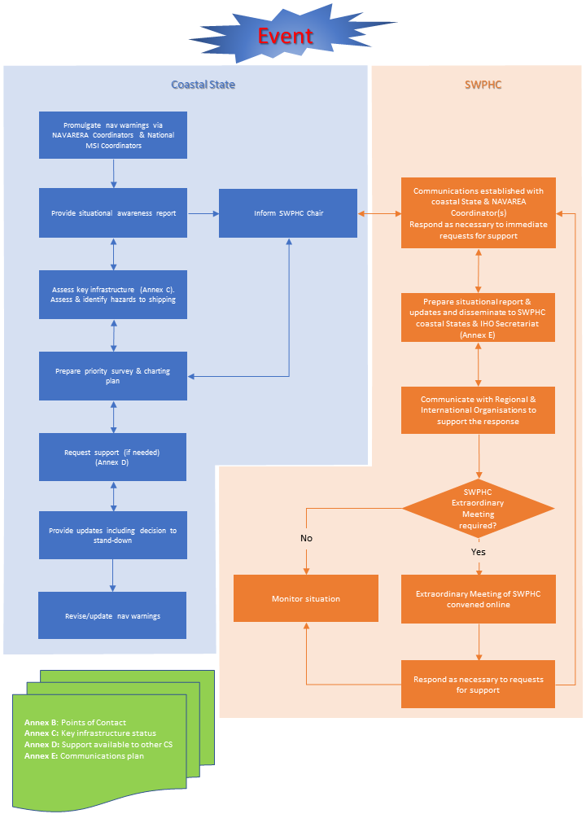

Annex B

Template for coastal State / organisation points of contact

Annex C

This template may be used to assess the overall damage and operational condition of port and harbour infrastructure and navigation channels, in particular water depth, obstructions, anchorages, aids to navigation and hazards after an event. A rapid assessment of the situation in the port area is important to ensure response activities can be carried out safely, such as hydrographic surveys of channels and berths to allow safe passage of support and supplies.

Port name
Location
Contact Name
Telephone | (country code) [number]
Email
Situation | Y/N | Description/Condition | Location
Disseminate key navigational information to the National MSI Coordinator
Is there debris?
e.g., wharves, jetties, berths
Are there obstructions?
e.g., wharves, jetties, berths
Is there HAZMAT?
Is there a change to the charted depths in channels/berths?
Are sea level gauges
operating?
Are AtoNs operating?
Are wharves/jetties/berths operational?
Is fuel available?
Is there a vessel
available for hydrographic survey?

Annex D

Template for SWPHC Members offering support in response to an event.
(Member States, Associate Members, Observers and Expert Contributors)

Country
Organisation
Contact name
Telephone | (country code) [number]
Email
Support | Description
Reconnaissance/assessment
flights
Assessment using satellite
imagery, including satellite derived bathymetry
Deployable survey teams
Production of interim-ENC
Preparation of situational
awareness maps
Other

Annex E

Template for a communications plan to be prepared by the SWPHC Chair

Communication objectives

- Establish communication with the coastal State affected to obtain an initial assessment
- Communicate with the NAVAREA Coordinators to ensure awareness of the situation
- Communicate with the SWPHC, appropriate Regional and International Organisations to support the response

Key messages

- Initial situational report:
  - [Coastal State] has been affected by [event] on [date, time], [any additional information]
  - Further information will be passed onto SWPHC as it becomes available
  - Next update at [date, time]

Communications messages

 | Initial report of event
Who needs to be contacted? | Coastal State affected  SWPHC Members  IHO Secretariat  NAVAREA Coordinators
What are the key things they should know? | Date, time, type of event, any further information
What channels will you use? | Email coastal States POC (Annex B)  Email NAVAREA Coordinators (https://iho.int/navigation-warnings-on-the-web).
When will the comms be sent out? | Schedule of communications

SWPHC Chair to consider ongoing updates using appropriate channels including an assessment of the full range of SWPHC support to assist in a response.

