South West Pacific Hydrographic Commission (SWPHC)

STATUTES
of the

SOUTH WEST PACIFIC HYDROGRAPHIC COMMISSION (SWPHC)
(revised at the 19th Meeting of SWPHC, VTC, 23-25 February 2022)

INTRODUCTION
- The South West Pacific Hydrographic Commission (hereinafter referred to as “The Commission”) is hereby established in conformity with IHO Resolution 2/1997 “ESTABLISHMENT OF REGIONAL HYDROGRAPHIC COMMISSIONS (RHC)” as amended). The Commission will provide, in pursuance of the resolutions and recommendations of the IHO, regional coordination of nautical information, hydrographic surveys, production of nautical charts and documents, technical cooperation, capacity building (CB) projects, and marine spatial data infrastructure (MSDI) projects related to the work of the IHO, and shall be governed according to these Statutes.
- The geographic area covered by the Commission (hereinafter referred to as “The Region”, shown in Annex A) shall be that defined by the IHO INT Charting Scheme Region L, together with the waters of those Pacific Island Countries and Territories that are members of the Pacific Community (SPC).

MEMBERSHIP
- Full Members of the Commission shall be IHO Member States within the Region, also being signatories to these Statutes.
- Full Members have the right to vote, each being entitled to one vote.
- Associate membership of the Commission is available to other IHO Member States, or other nations who are non-IHO members, and being signatories to these Statutes. Associate Members have the same rights and obligations as the Full Members of the Commission except for the right to vote or to be elected Chair or Vice-Chair.
- Commission Members are expected to be willing to contribute to the objectives of the IHO relating to hydrography, nautical charting, nautical information, navigational warnings, marine spatial data infrastructure, capacity building, and related fields in the Region. All Members are represented by their government agencies involved in the provision of hydrographic information.
- International Organisations, Non-Governmental Organisations, Industry, and Academia stakeholders active in the Region may be invited by the Commission to participate as an Observer or Expert Contributor.

OBJECTIVES
The Commission will align its activities with the objectives of the IHO as described in Article II of the Convention on the IHO, and Article 8 of the IHO General Regulations. Commission activities will align with and support the intent and objectives of the approved IHO Work Programme, and take into account the actions, recommendations, and outcomes of the IRCC.
The objectives of the Commission shall be:
- To promote technical co-operation and training, and to conduct joint research, where appropriate, in hydrographic surveying, nautical charting, nautical information, navigational warnings, marine spatial data infrastructure (MSDI) and related fields.
- To regularly assess the status of hydrographic surveying, nautical charting, nautical information, navigational warnings, hydrographic capacity and requirements within the Region and provide reports to the relevant IHO subordinate bodies, and inputs to relevant IHO publications.
- To contribute towards regional disaster preparedness and response (in support of the IHO Resolution 1/2005).
- To empower its Members to expand hydrographic activity in the Region, and to encourage them to seek technical advice and assistance from the IHO Secretariat to establish and strengthen their hydrographic capabilities and policies, including crowdsourced bathymetry (CSB) and satellite derived bathymetry (SDB).
- To facilitate the exchange of information related to surveys, research, scientific and technical developments, and to assist in the planning and organisation of hydrographic activities in the widest sense of the term, but without interference in national responsibilities.
- To identify, coordinate and assess INT Chart and ENC coverage for the Region.
- To ensure a coordinated and cohesive regional approach is considered for the implementation of the S-100 Universal Hydrographic Data Model by engaging with data owners, product and service providers, and other stakeholders as appropriate, in accordance with WEND Principles (S-57), WEND-100 Principles (S-1XX) and Guidelines on the WEND-100 Principles.
- To encourage implementation of the Global Maritime Distress and Safety System (GMDSS).
- To encourage the application of the UN shared guiding principles for geospatial information management in order to ensure interoperability and extended use of hydrographic data in combination with other marine-related data.
- To establish other committees and working groups, as appropriate, to pursue regional priorities that align with IHO’s global strategic objectives. These include efforts to establish regional charting schemes, elimination of ENC overlaps and gaps, and marine spatial data projects. All Members and Associate Members may contribute to the work of these committees and working groups. Observers may be invited to participate.
- To ensure that regional capacity building (CB) activities are aligned and coordinated in accordance with the IHO CB Strategy, and with CB procedures and practices developed by the Capacity Building Sub-Committee (CBSC).
- To appoint the Commission’s Representative(s) to the IHO Council, as outlined in the guidance provided in Annex B.
- To develop, implement and maintain a disaster response framework for the Region, and foster capacity building for disaster preparedness and response (IHO Resolution 1/2005 as amended).

CONFERENCES

- The Commission shall meet in plenary Conference within the Region, at least twice between two successive ordinary sessions of the IHO Assembly. The Commission may hold Conferences and informal discussions virtually, by agreement.
- The Chair shall extend an invitation to the IHO Secretariat to attend Commission Conferences.
- Members shall be represented by their government agencies involved in the provision of hydrographic information.
- The presence of two-thirds of the Full Members of the Commission shall constitute a quorum.
- At the end of each Conference those Full Members interested in hosting the following Conference shall make application to the Chair. Expressions of interest by Associate Members or Observers to host a Conference may also be considered. Where no other compelling circumstances exist, priority shall be given to a Full Member which has not yet hosted a Conference, or to the one which did so the longest time ago.
- The host country will assist with the arrangement of authorisations and visas, to facilitate attendance at the Conference.
- The Chair may convene an Extraordinary Conference of the Members of the Commission when their Representatives are assembled for a session of the IHO Assembly and extend invitations to other, suitably qualified, people to attend as Observers.
- In the case of urgent matters which cannot be treated by correspondence or delayed until the next Conference, the Chair, in agreement with the Full Members, may convene an Extraordinary Conference, either in-person or virtually, as circumstances dictate.

CHAIR AND VICE-CHAIR

- The Chair and Vice-Chair of the Commission shall be from Full Members of the Commission, elected on a rotational basis. Under normal circumstances, nominations shall be called for from Full Members for the positions of Chair and Vice-Chair at the Conference prior to each IHO Assembly. The Chair and Vice-Chair shall be elected for a three-year term by a simple majority of those Full Members present.
- The Chair and Vice-Chair shall take up their duties within four months following the Conference. The incoming Chair shall provide the Secretariat for the Commission for their term in office.
- The Conferences of the Commission are conducted by the Chair with the assistance of the Vice-Chair.
- If the Chair is unable to officiate at a Conference, they will be replaced by the Vice-Chair. If both are unable to officiate, they shall each be replaced by their designated Representative.

ACTIONS AND DECISIONS

- Voting shall be by a show of hands, except when electing the Commission’s Representative(s) on the IHO Council.
- The actions and decisions of Conferences should normally be confirmed by general agreement of those Full Members present. If opinion is divided, actions and decisions, except those relating to these Statutes, may be decided by a simple majority of those Full Members in attendance, either in-person or virtually.
- At the end of the Conference, the Chair shall read the text of the actions and decisions taken during the Conference. All decisions become operative immediately.
- The Chair shall, within one month of the close of the Conference, provide to each attending Full Member, Associate Member, and Observer a Draft Report containing the discussions, actions, and decisions of the Conference. The Full Members shall send the Chair their approval of, or any amendments to the Draft Report within one month of its receipt. Associate Members and Observers may comment on the Draft Report. Any objection shall be resolved by correspondence.
- The Final Report of the Conference shall be sent to the Commission’s Full Members, Associate Members, Observers and the IHO Secretariat.
- Subjects may, if necessary, be discussed between Conferences and decided by correspondence.

SECRETARIAT FUNCTIONS

- Proposals to be included in the Agenda of a Conference must be sent to the Chair with a copy to the Vice-Chair at least three months before the date fixed for the opening of the Conference.
- The Chair shall prepare the Provisional Agenda and List of Participants in consultation with the Vice-Chair and forward them to the participants at least one month before the opening of the Conference. The Agenda shall include reports of intersessional activities of the Commission and IHO bodies since the last Conference.
- The Chair shall report to the IHO Assembly on the activities and plans of the Commission, and the findings of the assessments made in accordance with Article 3b. The Chair shall also submit reports to the IRCC meetings.
- Between sessions of the IHO Assembly, reports of studies or other activities, which may be considered of general interest to all IHO Member States, shall be sent to the IHO Secretariat for general dissemination.
- The Chair and the host country shall be responsible for the organisation of the Conference (see Annex C: Guidance Notes on Hosting Meetings of the South West Pacific Hydrographic Commission).

EXPENSES
- Travel, hotel and per diem expenses of participants at Conferences shall be the responsibility of the participant’s nation or organisation.
- All expenses related to the provision of the venue and associated facilities for Conferences shall be the responsibility of the host country.

SELECTION OF COMMISSION REPRESENTATIVE(S) TO THE IHO COUNCIL
- The Secretary-General, in accordance with Article 16 (b) of the IHO General Regulations, will notify the Commission of the number of seats allocated to it on the IHO Council, and the names of the States eligible for selection to occupy the seat(s).
- The election of the State(s) to be the Commission’s Representative(s) on the IHO Council will be conducted according to the procedure agreed by the Commission, as outlined in the attached ‘Rules For The Designation of SWPHC Members To The IHO Council’ (Annex B).

REPRESENTATION OF THE COMMISSION
- The SWPHC may appoint, from among its Full Member or Associate Members, Representatives to IHO instances (with the exception of the IHO Council for which the appointment rules are detailed in Article 9), or international or regional committees. The appointment is then made during a Conference or by correspondence following approval by a majority of the Full Members.
- The Representatives of the Commission designated in accordance with paragraph 10.a) shall report to the Commission on any action or subject of interest.

COMMUNICATIONS
Members are required to ensure that their contact details in the IHO Yearbook (P-5) are correct. All official communications of the Commission will be dispatched to Members in accordance with the IHO Yearbook details.

LANGUAGE
The working language of the Commission shall be English.

THE STATUTES
- The IHO Secretariat shall be the custodian of these Statutes.
- Members of the Commission may propose amendments to these Statutes.
- Amendments to these Statutes require the approval of at least two-thirds of all Full Members of the Commission.
- If any amendment to these Statutes is agreed to by those Full Members attending a Conference, but the number of Full Members in favour is less than two-thirds of all Full Members of the Commission, the Chair shall submit the proposal(s) to all Full Members requesting their decision, with copies to Associate Members for their information.

ANNEX A

South West Pacific Hydrographic Commission (SWPHC) Region

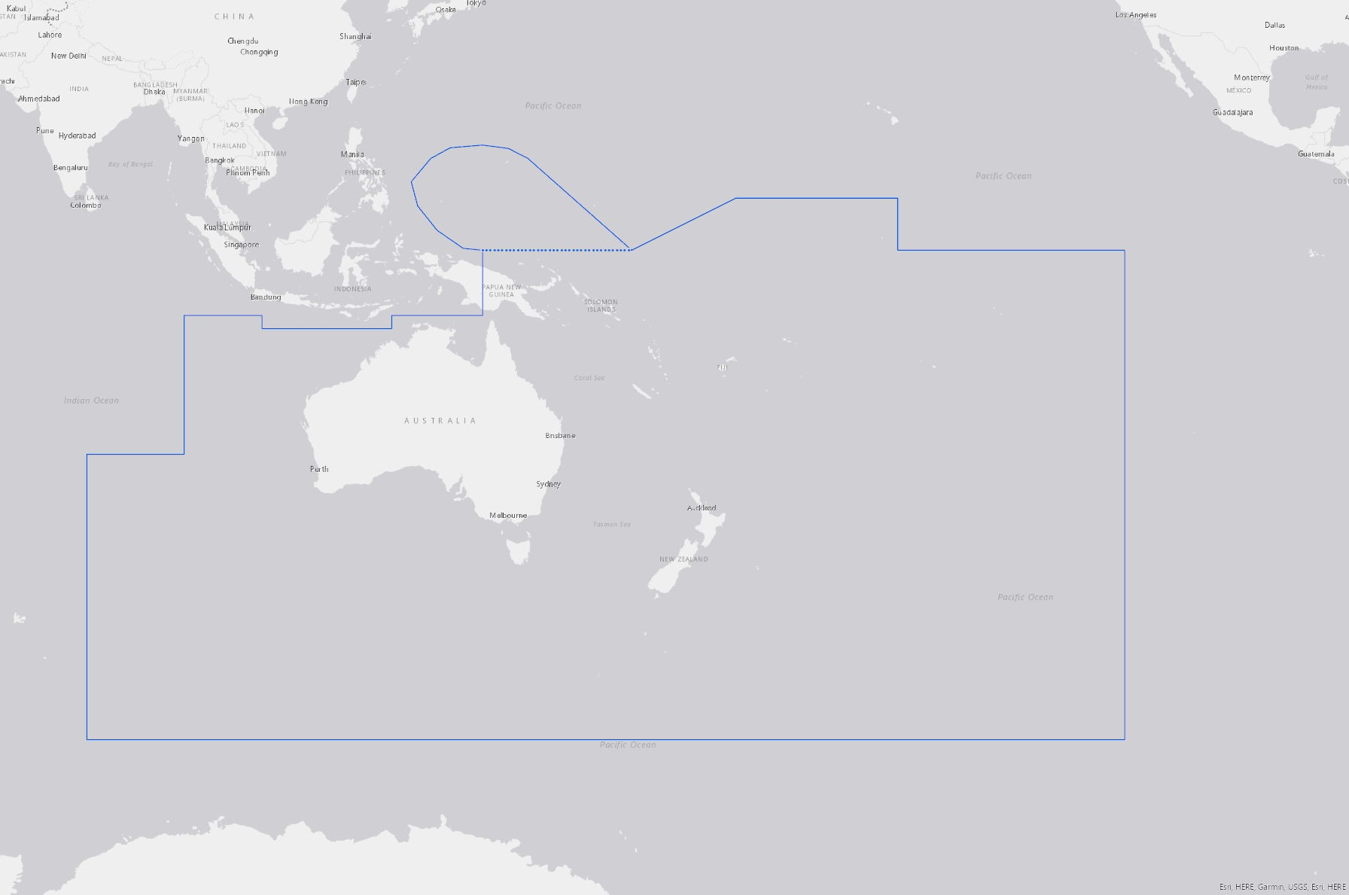
INDONESIA
NEW CALEDONIA
KIRIBATI
MARSHALL ISLANDS
PALAU
NAURU
TUVALU
TOKELAU
SAMOA
PAPUA NEW GUINEA
COOK ISLANDS
NIUE
TONGA
SOLOMON
ISLANDS
VANUATU
FIJI
AUSTRALIA
NEW ZEALAND

ANNEX B

RULES FOR THE DESIGNATION OF SOUTH WEST PACIFIC HYDROGRAPHIC COMMISSION (SWPHC) REPRESENTATIVES TO THE IHO COUNCIL

The IHO Member State(s) selected to occupy the Seat(s) on the IHO Council allocated to the SWPHC shall be determined in compliance with IHO General Regulations Articles 2 and 16.

Role and authority of the selected Member State(s) on the IHO Council
- The selected Member State(s) shall occupy their seat on the IHO Council throughout the inter-sessional period between Assemblies.
- In carrying out their role, representatives should take into account any relevant decisions, policies or directives established by the SWPHC and ensure that these are considered appropriately by the IHO Council.

Responsibilities of the SWPHC selected Member State(s) on the IHO Council
- The selected Member State(s) on the IHO Council should represent the interests of the South-West Pacific region as a primary consideration.
- Prior to nomination for selection for the IHO Council, Member State(s) must secure the appropriate approval from their Minister or the Head of the relevant government department.
- All expenses incurred by representatives relating to participation on the IHO Council must be met by their respective States in accordance with IHO General Regulations Article 3.
- The selected Member State(s) must be able to allocate appropriate resources to effectively execute their role. The ability to adequately resource representation for a three-year appointment must be a primary consideration for Member States when determining whether they should nominate for selection.

Selection Procedure (see also flowchart Appendix 1)
- Three months before an ordinary session of the Assembly, the IHO Secretary-General shall inform the Chair of the SWPHC of:
  - the number of IHO Council seats allocated to the SWPHC; and
  - the IHO Member States that are eligible for selection by the SWPHC (Eligible MS).
- The Chair of the SWPHC will invite Eligible MSs to indicate if they wish to be considered as Candidate MS for selection.
- If the number of Candidate MSs is equal to the number of seats allocated to the SWPHC by the Secretary-General, then the Candidate(s) will be automatically designated as the SWPHC representatives on the IHO Council.
- If the number of Candidate MSs is less than the number of seats on the Council assigned to the SWPHC, the Candidate(s), if any, will be automatically designated and will be supplemented by one or more Eligible MSs that have not represented the SWPHC on the Council for the longest time. If this proves inconclusive, the Chair will consult with other Eligible MSs to determine if they can serve as SWPHC’s representative on the Council.
- If the number of Candidate MSs is greater than the number of seats allocated, a vote will take place, either at a Conference of the SWPHC, or by correspondence to the Chair and Vice-Chair of SWPHC if no SWPHC Conference is scheduled in the three months prior to an Assembly.
- A valid voting process will be conducted in the following manner:
  - Each Full Member will submit one voting paper indicating which of the listed Candidates, not exceeding the number of seats allocated, they wish to represent SWPHC on the IHO Council. Voting will, as far as possible, be by secret ballot (see example of voting paper in Appendix 2 to Annex B).
  - At least half (50%) of all Full Members must cast a vote to achieve a quorum for a valid voting process. An incomplete or blank voting paper is a valid voting option and counts towards the quorum.
  - If the quorum is not achieved within the time allocated for returning votes, the voting window will be extended for two weeks, and the Chair invites the absent Full Members to cast their vote. The existing votes stand.
  - If, after the extended voting period has expired, the quorum has not been achieved, the votes cast will be counted by the Chair and the Vice-Chair of the SWPHC. In accordance with the number of seats allocated to SWPHC, the highest polling Candidate MS will be designated as the SWPHC Selected Member State(s) on the IHO Council.
- If the voting process conducted in accordance with Clause 12 results in a draw, the process will be as follows:
  - The Chair of the SWPHC (or the Vice-Chair in circumstances where the Chair is one of the Candidates) will designate the Candidate(s) as representative of the SWPHC.
  - The Chair (or Vice-Chair) of the SWPHC, when designating the Candidate(s) is to give favourable consideration to the following factors:
    - whether the candidate has previously been a Representative on the IHO Council, in any capacity,
    - if the candidate has previously been a Representative on the IHO Council, how much time has elapsed since they occupied this position, and
    - which candidate will provide the most effective representation for the interests of the SWPHC.

Designation of Representative(s) to the IHO Council
- The Member State(s) selected to represent the SWPHC on the Council would normally be represented by the head of a government agency involved in the provision of hydrographic information. Each Member State shall inform the Chair of the SWPHC and the IHO Secretary-General of the name and contact details of its official representative. An alternate may also be designated.
- SWPHC representative(s) must inform the SWPHC Chair of any changes in representation, whether permanent or temporary, as soon as practicable.
- SWPHC representative(s) on the IHO Council must inform the SWPHC Chair if there is any impediment, whether permanent or temporary, to the execution of their responsibilities at any time during their tenure.

Appendix 1 to Annex B to Statutes of the SWPHC

Appendix 2 to Annex B to Statutes of the SWPHC

SOUTH WEST PACIFIC HYDROGRAPHIC COMMISSION (SWPHC)
Selection of State(s) that will occupy seat(s) on the IHO Council allocated to the SWPHC
Example of Voting Paper

Part A

Number of Seats on Council allocated to the SWPHC: (Chair inserts number in here)
(This is the maximum number of boxes that may be marked below)

Part B

To vote for a candidate State put an ‘X’ in the adjacent box. The maximum number of boxes that may be marked is shown in Part A above.

Chair inserts candidate State A in here | Vote indicated with an ‘X’ here
Chair inserts candidate State B in here | Vote indicated with an ‘X’ here
Chair inserts candidate State C in here | Vote indicated with an ‘X’ here
Insert other candidate States if appropriate | Vote indicated with an ‘X’ here

Member State
Authorised by:
Position:
Signature:
Date:

ANNEX C

Guidance Notes on Hosting Meetings of the South West Pacific Hydrographic Commission

Based on text as agreed at the 12th South West Pacific Hydrographic Commission Meeting, 12-14 November 2013.
It is important that States offering to host a meeting of the South West Pacific Hydrographic Commission (SWPHC) appreciate the level of their responsibilities and obligations prior to commitment. The following guidance is a starting point for discussions and is not considered to be exhaustive.
States considering hosting a meeting should first consult the current Statutes of the SWPHC as this lays out the “rules” of the Commission.

Principal responsibilities of the host:
- Provide a written confirmation to the SWPHC Chair of its offer of host a meeting.
- Establish a reliable point of contact to enable communication between the host and the SWPHC Secretariat.
- Identify a suitable conference venue and hotel facilities.
- Negotiate with conference venue management:
  - Suitable dates (in consultation with Chair),
  - Meeting room layout and facilities (in consultation with Chair), coffee and lunch arrangements, and
  - Costs of conference room, facilities, refreshments.
- Negotiate with hotel:
  - Group discount rates and conditions, and
  - Options for social events.
- Provide logistics information to Secretariat for wider circulation
- All expenses related to the provision of the venue and associated facilities.
- Provide letters of invitation to facilitate visa applications, as required.
- Propose appropriate guests for opening ceremony.
- Provide appropriate assistance and support to the Chair and delegates during their time in country.

