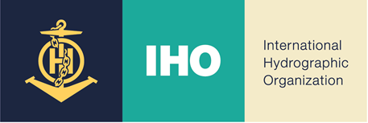

INTERNATIONAL HYDROGRAPHIC ORGANIZATION
UNITED STATES OF AMERICA
National Report

19th South-West Pacific Hydrographic Commission (SWPHC)

Virtual Teleconference

23 - 25 February 2022

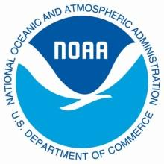 | Office of Coast Survey  National Oceanographic & Atmospheric Administration  http://www.nauticalcharts.noaa.gov
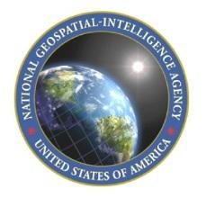 | Source Operations and Management Directorate  National Geospatial-Intelligence Agency  http://msi.nga.mil/NGAPortal/MSI.portal  https://www.nga.mil/Pages/Default.aspx
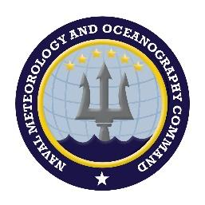 | Naval Meteorology and Oceanography Command  United States Navy  http://www.navmetoccom.navy.mil  https://www.facebook.com/NavalOceanography/

TABLE OF CONTENTS

INTERNATIONAL HYDROGRAPHIC ORGANIZATION 1
19th South-West Pacific Hydrographic Commission (SWPHC) 1
Virtual Teleconference 1
23 - 25 February 2022 1
1. HYDROGRAPHIC OFFICE/SERVICE 4
1.1 Government Agencies with hydrographic responsibilities in the SWPHC Region 4
1.2 United States Open Data Policy – Managing Information as an Asset 4
2. SURVEYS 5
2.1 Surveys in U.S. Waters 5
2.2 Surveys outside U.S. Waters 6
2.3 U.S Hydrographic Survey Platforms 6
3. NEW CHARTS AND UPDATES 7
3.1 Charting Plan 7
3.2 Electronic Navigational Chart (ENC) 8
3.3 Raster Navigational Charts (RNC) & Electronic Navigational Charts (ENC) Distribution 9
3.4 Raster Navigational Charts (RNC) and Paper Charts 10
3.5 International (INT) Charts 10
4. NEW PUBLICATIONS AND UPDATES 11
4.1 New Publications 11
4.2 Updated Publications 12
4.3 Means of Delivery 13
5. MARITIME SAFETY INFORMATION (MSI) 14
5.1 Existing infrastructure for transmission 14
5.2 Notice to Mariners 14
5.3 Navigation Warnings 14
6. C-55 15
7. CAPACITY BUILDING 15
7.1 Offer of and/or Demand for Capacity Building 15
7.2 Training offered 15
7.3 Status of National, Bilateral, Multilateral or Regional Projects with a Hydrographic Component. 17
8. OCEANOGRAPHIC ACTIVITIES 17
8.1 Crowdsourced Bathymetry 17
8.2 GEBCO/IBC’s activities, GEBCO Seabed 2030 activities 18
9. SPATIAL DATA INFRASTRUCTURE 18
9.1 Status of MSDI 18
9.2 Involvement in Regional or Global MSDI efforts 18
9.3 MSDI National Portal 19
10. INNOVATION 20
10.1 Use of New Technologies 20
11. OTHER ACTIVITIES 21
11.1 Preparations for Responses to Disasters 21
12. CONCLUSIONS 21

HYDROGRAPHIC OFFICE/SERVICE
This National Report provides specific information pertaining to individual products and services of primary interest to the South West Pacific Hydrographic Commission (SWPHC) Region. Three government agencies are responsible for the management of U.S. domestic and international hydrographic products, services, and maintenance.

1.1 Government Agencies with hydrographic responsibilities in the SWPHC Region
- National Oceanic and Atmospheric Administration’s (NOAA) conducts hydrographic surveys and produces nautical charts and related hydrographic information within the nation’s Economic Exclusion Zone (EEZ).

- National Geospatial-Intelligence Agency (NGA) provides nautical charts and related hydrographic information and is the mapping and charting authority for the U.S. Department of Defense (DOD) and commercial mariners in areas outside the U.S. where the U.S. is the designated charting authority.

- The U.S. Navy conducts oceanographic, bathymetric, and hydrographic surveys worldwide to satisfy DOD and national security requirements.

For more information on NOAA, NGA, and NAVY hydrographic activities, see IHO Publication 5.

1.2 United States Open Data Policy – Managing Information as an Asset
Access to data and services, usable to the public, can help fuel entrepreneurship, innovation, and scientific discovery – all of which improve lives and contribute significantly to job creation - is the foundation of the U.S. Open data policy. The open data policy has led to the public availability of most hydrographic data, products, and services produced by U.S. Hydrographic Offices (HO’s) for data downloads at no cost. Further information on U.S. Navy collected data is provided in Section 2.2, below.
Much of this open data information is available on the NOAA and NGA websites. Additionally, ENC data is available for use in GIS applications via the ENC direct to GIS website. The US DoD may make data available to support crisis events and various initiatives.

SURVEYS

2.1 Surveys in U.S. Waters
NOAA provides nautical charts and related hydrographic information for the safe and efficient navigation of maritime commerce as well as providing basic data for engineering, scientific, and other commercial and industrial activities within the nation’s 3.4 million square nautical mile EEZ (US EEZ) and along its 95,000 miles of shoreline.
NOAA is in the process of re-defining how hydrographic survey plans are generated and how survey priorities are identified in federal waters. NOAA hydrographic in-house field units or external contractors then conduct surveys to meet these priorities. Data acquired from these surveys meet the IHO Standard for Hydrographic Surveys (S-44) and the NOS Hydrographic Surveys Specifications and Deliverables, in compliance with the NOS data specification guide which is updated annually. The main component of the new hydrographic survey priorities method is the hydrographic health model. The hydrographic health model is based on the idea of navigational risk. Navigational risk is the product of the likelihood of an adverse event (e.g. traffic density, known hazards to navigation, reported ship groundings, etc.) and the consequence of that event occurring. Current information about the model and survey prioritization can be found at: https://nauticalcharts.noaa.gov/publications/national-hydrographic-survey-priorities.html.

Planned survey work for the NOAA Ship Rainier in Guam and the Commonwealth of the Northern Mariana Islands (CNMI) was delayed due to COVID-19 and is planned for FY22. The project includes collecting bathymetry and backscatter data from the nearshore to approximately 1500 meters depth for mapping, charting, and habitat characterization, performing dive operations to assess the condition of the coral reef ecosystems and fish populations, and collecting water quality data and other oceanographic observations for a comprehensive dataset to aid in managing the marine resources.

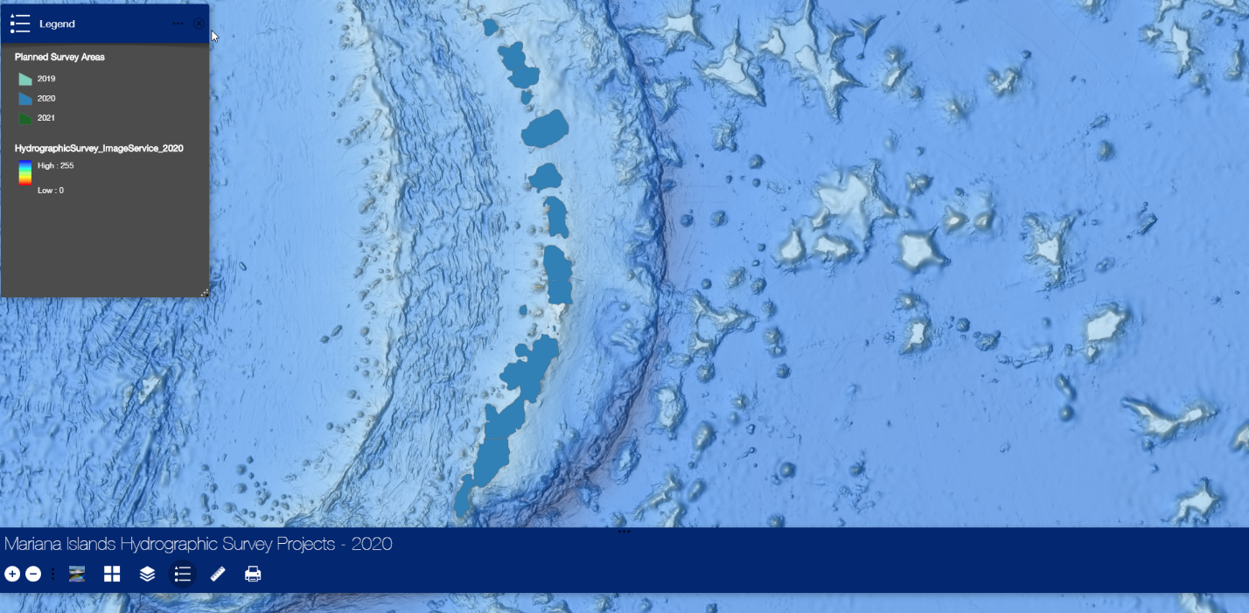
Figure 2.1: NOAA’s planned surveys on the Northern Marianas Islands in FY22..

2.2 Surveys outside U.S. Waters
The U.S. Navy conducts hydrographic surveys outside the United States in international waters and in territorial waters of partner nations, through diplomatic channels and international agreements. These survey operations enhance maritime commerce and security and support relationship and capacity building initiatives.
By U.S. Navy, Commander, Naval Meteorology and Oceanography Command (COMNAVMETOCCOM) Instruction 5510.1, “Disclosure of Information to Foreign Governments and International Organizations”, it is policy to treat all data collected through bi-lateral agreements as restricted from public release. Accordingly, the Hydrographic Service or Port Authority of the respective country is the appropriate point of contact for inquiries or requests for data regarding any of these surveys.

Since SWPHC17, the U.S. did not conduct any new survey work in the SWPHC regional waters. There are extensive holdings of bathymetric data available, collected for missions other than traditional hydrographic surveying. The review and application of this data will produce a substantial modernization of the data coverage on many US charts.

2.3 U.S Hydrographic Survey Platforms
National Oceanic and Atmospheric Administration (NOAA) NOAA survey platforms include six 28-foot survey boats, a research vessel, a LIDAR-capable aircraft, and private contractors and the following ships: NOAA Ship Fairweather, NOAA Ship Rainier, NOAA Ship Thomas Jefferson, and NOAA Ship Ferdinand R. Hassler.
Additional information on NOAA’s hydrographic vessels can be found online at: https://nauticalcharts.noaa.gov/about/survey-vessels.html
In addition, NOAA has a hydrographic services contract that is made up of seven individual contracts with a total ceiling of $250 million over the life of the five-year contract (FY 2019 - 2023).
U.S. Navy The Naval Oceanographic Office (NAVOCEANO), a subordinate command of COMNAVMETOCCOM, currently employs six Pathfinder Class 100-meter multi-purpose survey ships to conduct oceanographic, bathymetric, and hydrographic surveys in deep-ocean and coastal waters. Each ship carries two 10-meter hydrographic survey launches (HSLs).
NAVOCEANO also maintains the Airborne LIDAR Hydrography (ALH) capability with the Optech, Inc., “Coastal Zone Mapping and Imaging” LIDAR (CZMIL) system. A Basler BT-67, a refurbished DC-3, serves as the airborne system that carries the CZMIL system. NAVOCEANO’s subordinate command, Fleet Survey Team (FST), employs rapidly deployable survey assets equipped with: four portable multi-beam kits to support boat of opportunity (BOO) surveys; six Unmanned Surface Vessels (USV), including four Teledyne Z-Boat 180, and two Marine Robotics Sea Otters equipped with multi-beam sonar; two Iver3 580 Unmanned Underwater Vehicles equipped with Bathymetric Interferometric Side Scan Sonar; and four rapid littoral survey vehicles (RLSVs) (personal watercraft fitted with a single beam echo sound side-scan scan sonar). FST survey assets are highly portable and can be commercially shipped or hand-carried by our survey team as checked baggage on commercial airlines. FST also maintains a stand-by “Fly-Away Team” consisting of four personnel and survey gear to outfit boats of opportunity. This capability enhances standard Navy survey requirements and provides the capacity to maintain navigable approach corridors in support of humanitarian aid and disaster relief.

3. NEW CHARTS AND UPDATES

3.1 Charting Plan

On November 1, 2017, NOAA released the National Charting Plan, a strategy to improve NOAA nautical chart coverage, products, and distribution. Part of the plan involves “re-scheming” the current suite of ENCs- based on the original paper chart extents- to a gridded format with standardizes sizes and scales. The new layout will exceed 7,000 ENCs with new charts often providing larger scale and more detailed coverage. Since 2019, NOAA produced 770 new ENCs based on the gridded chart scheme. The timeline for completing regridding in the SWPHC region has not been determined, but the current status for the creation of all reschemed ENCs is available online at: https://distribution.charts.noaa.gov/ENC/rescheme/

NGA is in the process of creating a Worldwide ENC grid for use in building its future ENC portfolio. This ENC grid will provide for a standardization of ENC scales and coverage across the portfolio. The grid will be comprised of regions which will be labeled with a letter as the region identification. Each region will be further subdivided into smaller areas to support different scale ENC Cells. All chart information is available via the INToGIS system at: http://chart.iho.int:8080/iho/main.do

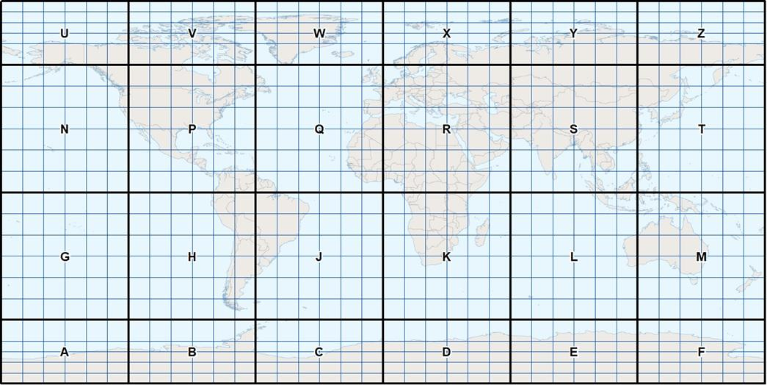
Figure 3.4: NGA ENC Grid

3.2 Electronic Navigational Chart (ENC)

The NOAA currently maintains ENCs in U.S. waters within the SWPHC region. NGA produces ENCs in areas where the U.S. functions as the Prime Charting Authority (PCA) outside U.S. domestic waters. These ENCs are maintained by NGA with new source information from the U.S., and our foreign partners as it becomes available. NGA is working to expand its ENC Portfolio within the SWPHC Region in areas where the U.S. acts as the PCA.

ENC Band | 1 | 2 | 3 | 4 | 5 | 6
Number of U.S. ENCs existing in SWPHC Region (NOAA) | 4 | 3 | 1 | 4 | 17 | 1
Number of U.S. ENCs existing in SWPHC Region (NGA) | 0 | 0 | 1 | 7 | 22 | 0

3.3 Raster Navigational Charts (RNC) & Electronic Navigational Charts (ENC) Distribution
In November 2019, NOAA released a Federal Register Notice (FRN) announcing the five-year program to end all raster and paper nautical chart production. Ultimately, production of all NOAA paper nautical charts, raster navigational charts (NOAA RNC®), and related products, will cease. In the interim, NOAA will apply critical updates to paper charts on a weekly basis and make them available for download as Print-on-Demand (POD) products or in paper form from NOAA-certified chart-printing agents. More details are available at: https://nauticalcharts.noaa.gov/charts/farewell-to-traditional-nautical-charts.html
NOAA is developing and improving a NOAA Custom Chart web-based application that will enable users to download and print raster chart backup files created from the most up-to-date ENC data. These chart backup files will look somewhat different from traditional paper nautical charts, but will provide a similar functionality. The NOAA Custom Chart is available at https://devgis.charttools.noaa.gov/pod/.
U.S. produced ENCs are available as free downloads from the internet. Mariners who wish to download NOAA and NGA ENCs directly and use the data to fuel ECDIS or ECS may do so. The ENCs are distributed directly from the following:

- NOAA website at: https://nauticalcharts.noaa.gov/
- NOAA’s Interactive Catalog at: https://www.charts.noaa.gov/InteractiveCatalog/nrnc.shtml
- International Center for ENC’s Distributors at: http://www.ic-enc.org/Distribution.html.
- PRIMAR Distributors at: https://www.primar.org/home

3.4 Raster Navigational Charts (RNC) and Paper Charts

Over the next five years, NOAA will end production and maintenance of NOAA traditional paper charts and RNC products. Six months before a chart is canceled, NOAA will update the chart with a note in the lower left corner stating the chart’s status as a “last edition” and the date on which it will be canceled. NOAA will also update the Lists of Latest Chart Editions on www.nauticalcharts.noaa.gov to indicate that the last edition of the chart has been published. When the chart is canceled, the chart number will be moved from its position in the list of active charts to a cumulative list of canceled charts at the bottom of the page. List of Latest Chart Editions can be found at: https://nauticalcharts.noaa.gov/charts/list-of-latest-editions.html

Other products and services based on the paper chart that will be canceled by January 2025 include: 1) Full-size nautical chart PDF images, 2) BookletCharts™, 3) RNC Tile Service, 4) Seamless Raster Navigational Chart Services, and 5) RNC Viewer.

NGA does not produce RNCs, but rather produces 350 paper charts for the SWPHC region. Most of these charts are not available via public sale but can be requested by bilateral partners via bilateral agreements. The only charts that NGA distributes to the public are those where NGA serves as the primary charting authority. These charts are in areas where the U.S. conducts the surveys, compiles and issues charts, and there is no fully functioning national authority or NGA has specific authority (e.g. Trust Territory of the Pacific).

U.S. RNCs are downloadable from a list at http://www.charts.noaa.gov/RNCs/RNCs.shtml

3.5 International (INT) Charts

The U.S produces INT charts within the SWPHC region, primarily over areas where they serve as the Prime Charting Authority (PCA) and builds its chart schema and DNC library limits from these INT schema, if practical.

Information for Certified Chart Agents for NGA public sale charts can be found at the following link:
https://nauticalcharts.noaa.gov/publications/print-agents.html#nga-paper-charts

There are a number of Agents that can print and distribute these charts to customers around the world. Many of these Agents provide listings of the NGA charts that they have available on their website. See the various vendor websites for more details.
The U.S. produces many DNCs in SWPHC waters. The DNC, produced by the National Geospatial-Intelligence Agency (NGA), is an unclassified, vector-based, digital database containing maritime significant features essential for safe marine navigation. The DNC uses the Vector Product Format, which is a NATO standard for digital military map and chart data.
Additional details can be located at http://msi.nga.mil/NGAPortal/DNC.portal.
DNC consists of libraries in a variety of scales for complete worldwide coverage. SWPHC data is included in DNC regions 4, 5, 6 and 12. See coverage below.

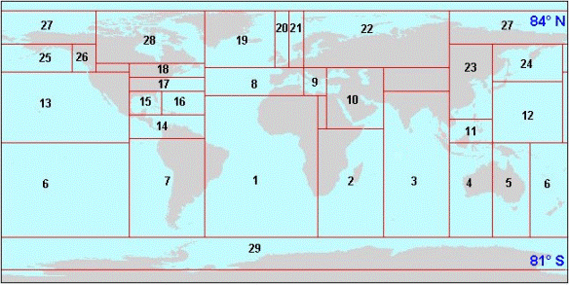

Figure 3.5: DNC Worldwide Coverage
DNC is maintained with new source information from the U.S. and foreign primary charting authorities. The DNC product is Limited Distribution and are not available for public sale or download except for those that are within U.S. territorial waters or in areas where source data restrictions allow them to be released. However, DNC data can be shared with host nations for coverage in their territorial waters through formal bilateral exchange agreements.
For requests regarding DNC data, please contact: maritime.international@nga.mil

NEW PUBLICATIONS AND UPDATES

4.1 New Publications

NGA is developing new web application(s) to view, analyze, download, and contribute port information for the World Port Index (WPI). The WPI will soon be available in csv, shapefile, json, and file geodatabase formats via the NGA Maritime Safety Information website. Contributors can submit new ports and edits to existing ports through an ArcGIS Online platform. An API will also allow dynamic information exchange for use in other platforms, such as the IHO ENC Catalog. This change allows users to view and work with WPI data in a dynamic new environment utilizing GIS information, and allows port data to be crowd-sourced from knowledgeable resources all over the world.

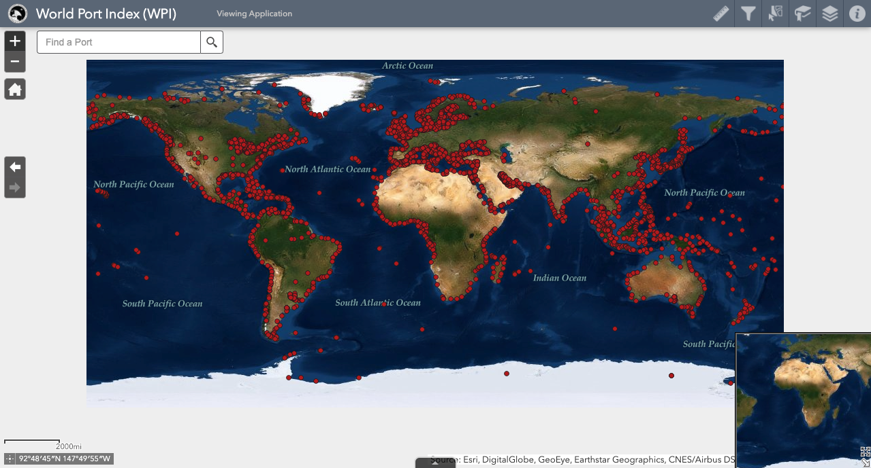
Figure 4.5: World Port Index (WPI) geodatabase.

The U.S. released two articles in the International Hydrographic review covering- “An Overview of the NOAA ENC Re-Scheming Plan” and “Hydrography from Fisheries Surveys”. The full text can be found at: https://iho.int/uploads/user/pubs/ihreview_P1/IHR_November2020.pdf

4.2 Updated Publications
- NGA has just updated the MSI interface to reorganize the information and improve the efficiency of the user. The information found on the MSI website includes Notice to Mariners, Publications, Navigational Warnings, Piracy, Drill Rigs, the Product Catalog, and several miscellaneous products and calculators. Users can also submit questions or subscribe to update services for some of following products as well. The interface can be found at: https://msi.nga.mil/
- The United States Coast Pilot consists of a series of nine regionally- focused nautical books that cover a variety of useful information important to navigators for coastal and intra-coastal waters and the U.S. Great Lakes. Coast Pilots 7 (2019) provides information for the U.S. west coast, Hawaii, and the Pacific, including Trust Territories of the Pacific Islands. U.S. Coast Pilots, updated on a weekly basis, can be downloaded at: https://nauticalcharts.noaa.gov/publications/coast-pilot/index.html
- NGA Sailing Directions consist of useful information important to navigators of coastal waters. Information for the SWPHC region is contained in following Publications:
Digital updates can be downloaded from NGA at: http://msi.nga.mil/.

Publication | Edition Date
Sailing Directions 120 – Pacific Ocean and Southeast Asia (Planning) | 2018 Edition
Sailing Directions 126 – Pacific Islands (Enroute) | 2017 Edition
Sailing Directions 127 – East Coast of Australia and New Zealand (Enroute) | 2017 Edition
Sailing Directions 171 – East Africa and South India Ocean (Enroute) | 2020 Edition
Sailing Directions 175 – North, West, and South Coasts of Australia (Enroute) | 2017 Edition

- World Port Index (WPI) - Pub150 is a publication maintained by NGA. It contains the location and physical characteristics as well as the facilities and services offered by major ports and terminals worldwide. The WPI is also available via the IHO Online catalogues and can be used as an API for other web services. Digital updates are available to the public and posted at the NGA Maritime Safety website, at: https://msi.nga.mil/Publications/WPI.
- The NGA List of Lights and their digital updates are available to the public and posted at the NGA Maritime Safety website, at: https://msi.nga.mil/Publications/NGALOL.

One volumes of List of Lights cover the SWPHC region:

Publication | Edition Date
List of Lights Pub. 111 (W. Coast N & S America (excluding USA), Australia, Tasmania, NZ, and Islands in the N/S Pacific Ocean | 2021 Edition,  2022 Edition available March 16, 2022

- The NGA Radio Aids and Fog Signals (Pub 117) and their digital updates are available to the public and posted on the NGA Maritime Safety website at: https://msi.nga.mil/Publications/RNA.

4.3 Means of Delivery
- All the publications are available digitally in PDF format from the NGA website at: https://msi.nga.mil/Publications.

- Users can enroll in a Publication Updates Subscription Service to receive e-mail notifications of nautical publication updates and new editions.

- Many of NGA’s products are available via the IHO Online catalogue.

- NGA publications can be ordered from commercial vendors found on the NGA website at: https://msi.nga.mil/Products.

MARITIME SAFETY INFORMATION (MSI)

5.1 Existing infrastructure for transmission
Maritime Safety Information (MSI) is navigational and meteorological warnings, meteorological forecasts and other urgent safety-related messages broadcast to ships NGA is the NAVAREA IV and XII Coordinator and promulgates warnings via Inmarsat’s SafetyNET II service. It is currently in the “on trial” phase for promulgating warnings via the Iridium Safetycast service. The USCG promulgates coastal warnings for the United States via NAVTEX. The USCG operates a NAVTEX station located in Guam, in NAVAREA XI. That station continues to broadcast on its back up frequency of 4209.5 kHz after its 518 kHz transmitter became not operational in July 2018. It remains unknown when the USCG will repair the 518 kHz antenna.

5.2 Notice to Mariners
The U.S. Notice to Mariners, provides timely information for the correction of all U.S. Government navigation charts and publications from a wide variety of sources, both foreign and domestic. Information published in Notice to Mariners provides for the correction of unclassified nautical charts, the unclassified NGA/DLA Catalog of Hydrographic Products, United States Coast Pilots, NGA List of Lights, U.S. Coast Guard (USCG) Light Lists, and other related nautical publications produced by NGA, NOAA, and the USCG.
The U.S. Coast Guard issues Local Notices to Mariners for NOAA charts, while NGA issues Notices to Mariners for the worldwide suite of NGA paper charts.
Local Notice to Mariners are updated weekly and available for download in several formats. For future chart cancellations, Local Notice to Mariners will announce “no new editions” and the cancellation date. It will subsequently announce the cancellation six months later. Mariners can download applicable Notices from the web at https://www.navcen.uscg.gov/?pageName=lnmMain
The U.S. Notice to Mariners are posted at the NGA Maritime Safety website at https://msi.nga.mil/NTM.

5.3 Navigation Warnings
The NAVAREA coordinator is the authority charged with coordinating, collating, and issuing navigational warnings for a designated NAVAREA within the IMO/IHO World-Wide Navigational Warning Service (WWNWS).
SWPHC Waters primarily lie within NAVAREA X (Australia is Regional Coordinator), NAVAREA XIV (New Zealand is Regional Coordinator), and NAVAREA XI (Japan is Regional Coordinator).

World Wide Navigational Warning Service (WWNWS)
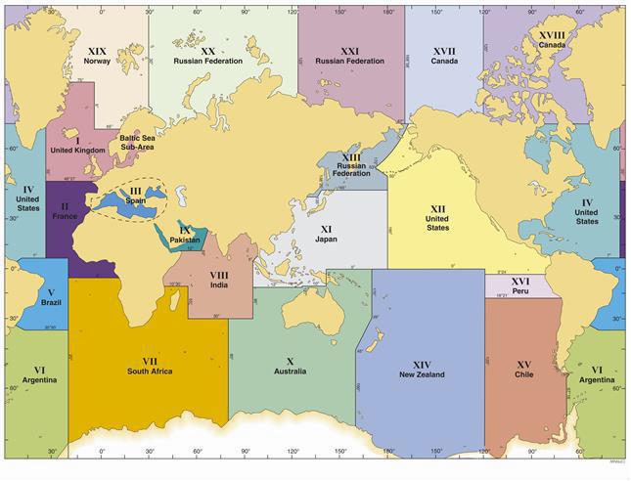
Figure 5.2: NAVAREAS for coordinating and promulgating navigational warnings under the WWNWS program.

C-55

The US updates its C-55 entry annually. C-55 can be found at: February 2021 IHO U.S. C-55. https://iho.int/uploads/user/pubs/cb/c-55/c55.pdf

CAPACITY BUILDING

Offer of and/or Demand for Capacity Building
The United States is an active participant in the IHO Capacity Building Sub-Committee (CBSC).
In 2022, NOAA will contribute to the IHO Empowering Women in Hydrography (EWH) project, a global effort led by the IHO and Canada that seeks to initiate, organize and track a series of activities and initiatives which will enable more women to participate equitably in the field of hydrography and to assume more leadership roles within the hydrographic community. NOAA will host three candidates for an 'at-sea experience' on NOAA hydrographic ships in 2022, and will host additional candidates each year over the lifespan of the EWH project. NOAA Ship Rainier, which will be surveying Guam and the Commonwealth of the Northern Marianas Islands (CNMI) in 2022 may host a candidate, schedule pending.

Training offered
    - Category-A Competence Training for Hydrography Training opportunities are available at various institutions in the United States. Two Category A certified hydrographic programs are available through:
  - The University of Southern Mississippi (USM) in partnership with U.S. Navy
  - The University of New Hampshire (UNH)
- Category-B Competence Training for Nautical Cartography The National Geospatial-Intelligence Agency (NGA) commenced training with an IHO/ICA/FIG IBSC approved portable S-8 Category B Nautical Cartography class in 2017. NGA teamed up with IIC Technologies to provide training to analysts with a comprehensive 20-week instructor led course and a six-week final project. All training has been conducted 100% virtually due to COVID -19 restrictions. A combination of lectures, hands-on compilation techniques, and homework assignments will prepare the students for the final project, the creation of a finished ENC product for NGA users. NGA plans to continue offering this training in the future.
The IBSC approved the NOAA program for Category B in Cartography in 2017. Since 2017, ~50 students graduated from the program, including one foreign national student from the Nigerian Navy.
- Category-B Competence Training for Hydrography U.S. Navy offers a six-month, IBSC approved Category B International Hydrographic Management and Engineering Program (IHMEP), commencing annually in February, via COMNAVMETOCCOM and the Information Warfare Training Group in Gulfport, Mississippi. This training is available to both uniformed and civilian government personnel. COMNAVMETOCCOM also offers mobile hydrographic training via NAVOCEANO. U.S. Navy’s Category A and B programs and mobile training all qualify for Security Cooperation assistance.
- Maritime Safety Information (MSI) Training – The US (NGA) directly supports the IHO Maritime Safety Information (MSI) training course as well as provides support to nations through on site and remote guidance and advice as they grow their hydrographic capacity. NGA is currently finalizing a virtual MSI training course which will be available to the IHO and our international partners in the months to come. The MSI course is an important first step for building that phase 1 Capacity Building capability within a country.

Status of National, Bilateral, Multilateral or Regional Projects with a Hydrographic Component.

- Palau Technical Visit - NGA Analysts representing the IHO participated in a Technical Visit to Palau during the week of 12-15 AUG 2019 to assess the Maritime situation in reference to the IHO Capacity Building process. The itinerary for the visit was arranged by the Acting Director of the Bureau of Marine Transportation, William "Hayes" Moses. The itinerary included visits with Palau Automated Land Resources Information Systems (PALARIS), the Coral Reef Research Foundation, Department of Law Enforcement and Conservation, Bureau of Tourism, Bureau of Marine Resources, Bureau of Marine Transportation and multiple other stakeholders during the Technical Visit. It was clear during the Technical Visit that Palau has made some advances in hydrographic capability during the last few years. This will help move them further in the direction of one day building a fully functional Hydrographic Office doing everything from MSI, to hydrographic surveys, to producing nautical charts.

- Marshall Islands Technical Visit - NGA Analysts representing the IHO participated in a Technical Visit to the Marshall Islands during the week of 19-23 AUG 2019 in order to assess the Maritime situation in reference to the IHO Capacity Building process. The itinerary for the visit was arranged by the Port Authority for RMI, Mr. Thomas Madison. The itinerary included visits with the Marshall Islands Marine Resources Authority, Coastal and Community Affairs, Office of Maritime Administrator, RMI Environmental Protection Authority, the US Embassy, USAID, the National Disaster Management Office, RMI Port Authority, and other stakeholders during the Technical Visit. It was clear during the Technical Visit that the Marshall Islands has made some advances in hydrographic capability during the last few years. This will help move them further in the direction of one day building a fully functional Hydrographic Office doing everything from MSI, to hydrographic surveys, to producing nautical charts.

OCEANOGRAPHIC ACTIVITIES

Crowdsourced Bathymetry
Crowdsourced bathymetric data can be used to identify areas where nautical charts are inadequate and proper hydrographic surveys are needed or can be applied to nautical charts when the source and uncertainties of the data are well understood. The key to successful CSB efforts are volunteer observers who operate vessels-of-opportunity in places where charts are poor or where the seafloor is changeable and hydrographic assets are not easily available.
The United States provides support for the IHO-initiated project to develop a global database for crowdsourced bathymetry hosted by the IHO Data Centre for Digital Bathymetry (IHO DCDB). The IHO DCDB, co-located with NOAA's National Centers for Environmental Information (NCEI), is building the infrastructure necessary to provide archiving, discovery, display and retrieval of global crowdsourced bathymetry data from mariners around the world. The online database can be found at https://maps.ngdc.noaa.gov/viewers/iho_dcdb/.
The vision is to tap into the enthusiasm for mapping the ocean floor by enabling trusted mariners to easily contribute data to fill the gaps in our current bathymetric coverage. NOAA and NGA are active participants in the IHO Crowd-Sourced Bathymetry Working Group (CSBWG), and together, with other CSBWG members, they have written a CSB Guidance Document for layman mariners who wish to collect and contribute CSB data to the IHO DCDB. This document will provide volunteer collectors with information about CSB, the installation and use of CSB data loggers, data quality issues, and instructions for submitting the data to the IHO data repository.

GEBCO/IBC’s activities, GEBCO Seabed 2030 activities
The United States participates on the IOC-IHO Guiding Committee for GEBCO and hosts the IHO Data Centre for Digital Bathymetry at NOAA’s National Centers for Environmental Information (NCEI) (formerly the National Geophysical Data Center, NGDC).
Seabed 2030 was officially launched at the United Nations Ocean Conference in 2017. Seabed 2030 (https://seabed2030.gebco.net/) aims to bring together all available bathymetric data to produce the definitive map of the world ocean floor, at the best possible resolution within practical limits, by 2030 and make it available to all. It builds on more than 100 years of GEBCO's history in global seafloor mapping. The project seeks to encourage both data collectors and data managers of governmental, academic and private interests to work together to improve the quality of publicly available data and grids of the ocean floor.
The Seabed 2030 project has great potential to create partnerships and cooperation between interested parties, significantly improving our understanding of the sea floor and empower sustainable ocean management in the coming century.

SPATIAL DATA INFRASTRUCTURE

Status of MSDI
The United States actively supports MSDI within the country as well as regionally, and internationally. The MSDI capability is important for supporting those non-traditional users of Maritime Safety data to allow them to complete their environmental research, port development, or disaster support projects. The US MSDI efforts help build a larger community of users for this marine data than the traditionally intended hydrographers and cartographers making Safety of Navigation products and data.

Involvement in Regional or Global MSDI efforts

- IHO - The International Hydrographic Organization Data Centre for Digital Bathymetry (IHO DCDB) was established in 1988 to steward worldwide bathymetric data on behalf of the IHO Member States. The Centre provides long term archive of and access to single and multibeam deep and shallow water ocean depths contributed by a range of mariners. The IHO DCDB welcomes bathymetric data and metadata, accepts descriptions and spatial footprints of data that is already online and of data that are not publicly available to provide easy search and discovery. Information can be obtained at https://www.ngdc.noaa.gov/iho/.

The U.S. holds active roles in supporting the work of several international MSDI-focused working groups:

- IHO MSDIWG
- UN-GGIM Marine Geospatial Information Working Group (MGIWG)
- Open Geospatial Consortium Marine Domain Working Group (Marine DWG)

- Marine Spatial Data Infrastructures – Concept Development Study (MSDI-CDS) – NGA, along with the Open Geospatial Consortium (OGC) on behalf of the IHO and international marine communities, supported and organized a project aimed to assess the current state of data/product management and exchange technologies used in the marine domain. Various workshops, meetings, and a survey conducted throughout the course of the CDS provided identification of gaps, and definition of core components of an SDI to be referenced by IHO MSDIWG and used to define reference use-cases and scenarios for use in future pilot activities. The knowledge gained from the CDS is captured in a technical report that provides the foundation for a future pilot that will in turn advance the state of Spatial Data Infrastructures (SDIs) that support marine data across the globe.

The final engineering report can be found on OGC’s website here: https://www.opengeospatial.org/docs/er

Direct link to download PDF here: https://portal.opengeospatial.org/files/?artifact_id=88037

The pilot, currently in the initiation phase, seeks to demonstrate a multi-country, federated MSDI under a land/ sea boundary use case to show how the value of MSDI can unlock data and information for use beyond traditional providers and consumers of hydrographic data, across borders, and across domains inclusive of improved connections between the terrestrial and marine foundational communities.

MSDI National Portal

    - National Marine Spatial Data Infrastructures (NMSDI) - The Federal Geospatial Data Committee (FGDC) is an organized structure of federal geospatial professionals that provide executive, managerial, and advisory direction and oversight for geospatial decisions and initiatives across the United States federal government. FGDC works collaboratively with federal, state, and local governments, non-Federal collaborates, communities, constituents, and professional bodies providing the enabling foundation of standards, data catalogs, partnerships, and tools that make up the National SDI (NSDI). For more information visit: https://www.fgdc.gov/.

Related to MSDI is the U.S., “MarineCadastre.gov.” This is an integrated marine information system that provides data, tools, and technical support for ocean planning. The team for MarineCadastre.gov continually works “to increase access to data through data and map services. The services are designed to deliver data without replication and directly from the 21 sources.” MarineCadastre.gov supports complementary efforts: Digital Coast, Data.gov, and Geoplatform.gov (a FGDC initiative). For more information see: https://marinecadastre.gov/.

INNOVATION

Use of New Technologies

- NGA Data Centric Production Transition – NGA is in the process of moving to a data centric production environment from the traditional product centric production environment. This development will create some efficiencies in the production process by removing some of the duplication found in the product centric model.

- NGA DNC to ENC Production Transition – In the next few years NGA will transition from producing the DNC product as the primary digital navigation product to ENC. This will bring NGA into line with the international community and allow for easier sharing of digital data with other hydrographic offices and provide a common operating picture when working together with other foreign partners.

- Global Maritime Traffic Density Service - Leveraging space-borne Automatic Identification Systems (AIS), NGA is developing a Global Maritime Traffic Density Service (GMTDS) to support hydrographic risk assessments at regional and global scales. The aim of the project is to make 1-kilometer monthly raster grids of historical maritime vessel traffic accessible via web-map services such as the IHO’s INT to GIS website.

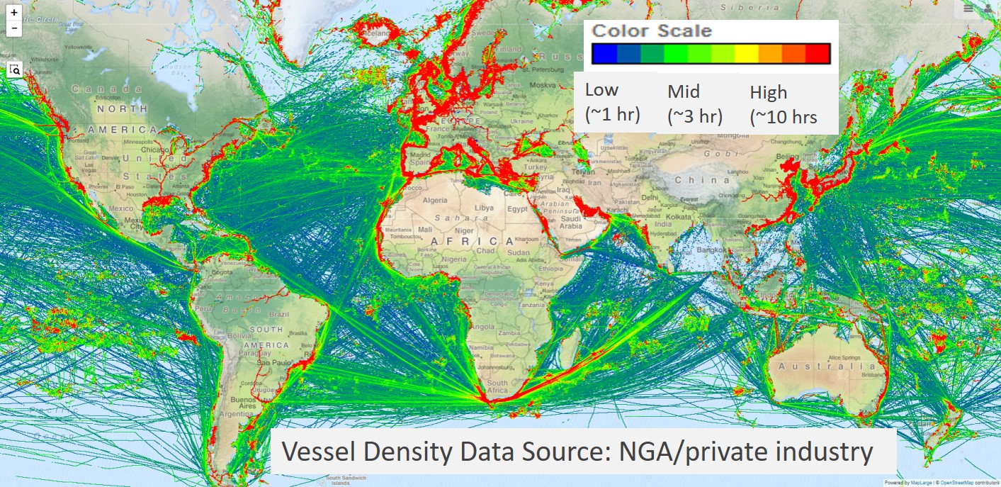
Figure 10.1 Maritime Traffic Density Map. Poin-in-poly “volume” aggregations of ~450M cleaned October 2020 AIS messages.

OTHER ACTIVITIES

Preparations for Responses to Disasters

- NGA Humanitarian Support Portal - NGA maintains a Humanitarian Assistance Disaster Response (HADR) website to support Hurricanes and various disasters around the World. It contains maps and documents to support the first responders in their relief efforts. This site includes everything from damage assessments, to data, to products that could support operations in the region in the aftermath of a disaster. This can be found at: https://nga.maps.arcgis.com/home/index.html

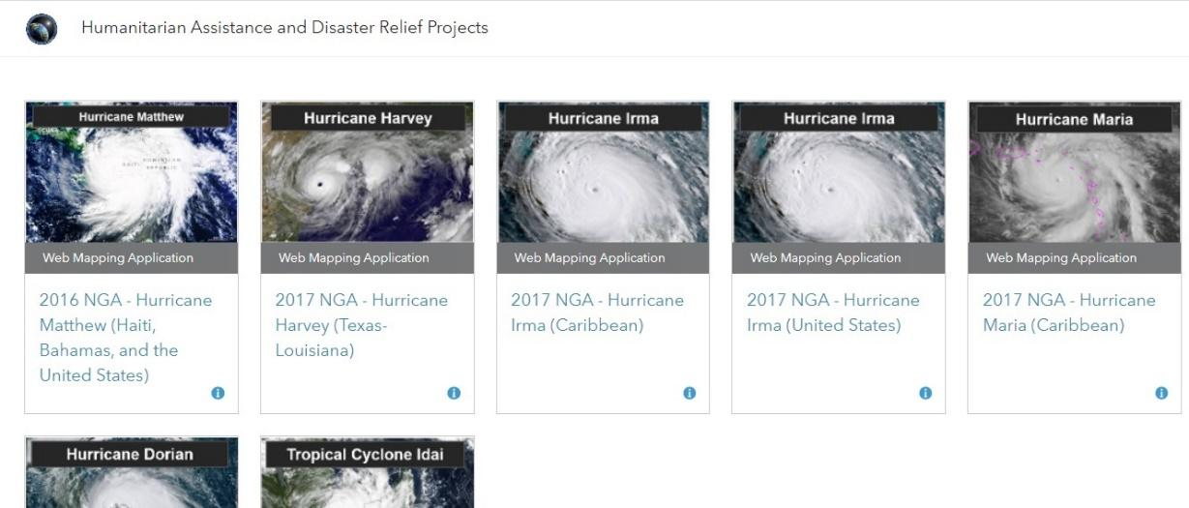

Figure 11.2: Hurricane Dorian Support Website

CONCLUSIONS

The multiple agencies, responsible for the management of U.S. domestic and international hydrographic products, services, and maintenance must continue to strive to work with one another to achieve proper balance of management of U.S. domestic and international hydrographic products, services, and maintenance. With the ever-increasing maritime commerce, this is especially important in the SWPHC Region.

Coastal State Status report on IHO Strategic Plan Indicators (SPIs)
United States of America- January 2022 Initial Baseline
INITIAL INFORMATIONAL DRAFT SUBMITTED TO SWPHC Meeting 2022

GOAL 1 | Target | Comment/status
Goal 1: Evolving the hydrographic support for safety and efficiency of maritime navigation, undergoing profound transformation
SPI 1.1.1 | Percentage of Member States having operationalized production and distribution of hydrographic data products and services based on IHO Universal Hydrographic Data Model (S-100), under an implementation framework of coordination and agreed timelines (2026: 100%) | ● US (NOAA) is working towards operationalization of S-111, S-104 and S-102 by 2026.  ● We are currently (2022) working on a transition/implementation plan for S-101  ● NOAA-OCS assumes that it will complete 5 S1xx products by 2026  ● S-111 surface currents are currently being distributed as prototype product  ● We (NOAA OCS) do not plan to distribute S-129 or S-122 (MPAs)  Important Assumptions:  We interpret “operational” to mean distributing via renc  The metric is yes/no whether a member state will distribute any (?) S-100 product by 2026  We understand the reference document the implementation framework is located: https://iho.int/en/s-100-implementation-strategy
SPI 1.4 | Percentage of navigationally significant areas (e.g. charted traffic separation schemes, anchorages, channels) for which the adequacy of the hydrographic knowledge is assessed through the use of appropriate quality indicators (2026: 100%) | US is 100% compliant at this point  NOAA does have a “hydrohealth model” that governs our assessment of navigationally significant areas  Definitional clarification:  When referring to waters/area, we are answering for the US EEZ only. The US EEZ=100% of the water body.  Is this specifically defined within IMO context? For example in the case of traffic separation schemes, is the IMO standard definition?
SPI 1.3.1 | Ability and capability of Member States to meet the requirements and delivery phases of the S-100 implementation plan (2026:  50%) | By 2026, the US is confident it will meet the targets in the S-100 roadmap  Does “ability and capability” mean the technical capacity itself (that is, policies, processes, existing infrastructure, and procedures), not necessarily the delivery of those?  Some clarification of what “phases” expressly refers would be helpful
GOAL 3 | Target | Comment/status
Goal 3: Participating actively in international initiatives related to the knowledge and the sustainable use of the ocean
SPI 3.1.1 | Percentage of Coastal States that are capable to provide marine safety information (MSI) according to the joint IMO/IHO/WMO manual on MSI (2026: 90%) | US: yes. (NGA)

Primarily the Office of Coast Survey
Primarily Source Operations and Management Directorate, Foundation Group, Maritime Safety Office (MSO).
Primarily, Commander, Naval Meteorology and Oceanography Command (COMNAVMETOCCOM) and the Hydrographer of the Navy
Open Data Policy-Managing Information as an Asset. (2013). Retrieved from https://www.whitehouse.gov/sites/whitehouse.gov/files/omb/memoranda/2013/m-13-13.pdf
NOAA & NGA websites: https://nauticalcharts.noaa.gov/index.html & https://msi.nga.mil/NGAPortal/MSI.portal?_nfpb=true&_st=&_pageLabel=msi_faq_page
NOAA ENC direct to GIS: https://nauticalcharts.noaa.gov/data/gis-data-and-services.html#enc-direct-to-gis
NGA Crisis Support website: https://nga.maps.arcgis.com/home/index.html
Current version is 2020, https://nauticalcharts.noaa.gov/publications/docs/standards-and-requirements/specs/hssd-2019.pdf
Current version is 20 20, https://nauticalcharts.noaa.gov/publications/docs/standards-and-requirements/specs/HSSD_2021.pdf
Source: March 2018 IHO U.S. C-55. https://iho.int/uploads/user/pubs/cb/c-55/c55.pdf
https://www.usm.edu/marine/hydrographic-science
https://marine.unh.edu/program/center-coastal-and-ocean-mappingjoint-hydrographic-center
Define “phases” and where the implementation plan on the IHO website is so we may consult it directly.

