## Paper for Consideration by WENDWG

## Way forward WEND-100 principles

|  |  |
| --- | --- |
| ***Submitted by:*** | NLHO (Netherlands) |
| ***Executive Summary:*** | The draft WEND-100 principles and the S-100 implementation Strategy have been endorsed at A2. This paper proposes a way forward with the aim to have a resolution on WEND-100 principles agreed at the start of the S-1XX implementation phase. For this the WENDWG needs to agree on the other S-1XX products that will be subject to the full extent of the principles beyond S-101. |
| ***Related Documents:*** | A2 Final Summary Reports_EN.pdf |
| ***Related Projects:*** |  |

**Introduction/Background**

This paper explores the way forward for the “Principles of the WEND for S-1XX ( WEND-100 )” after A2. Following relevant decisions were made during A2.

* The report of the IRCC was discussed. As a result: “The Assembly endorsed the draft WEND-100 Principles presented at IRCC12 and the proposed path forward in their subsequent development, as a consequence of the expanding range of hydrographic data products address in the IHO Implementation strategy (Decision A2/39)”. For information: the draft presented at A2 was designated as 1.0. This is the same as the drafting group WEND-100 version 3.1 dated 23 September.
* PRO 2.1, the S-100 Implementation Strategy, was discussed. As a result “the Assembly endorsed the S-100 Implementation Roadmap for the S-100 Implementation decade (decision A2/29)“. This Roadmap is an important driver for the traditional approach for application of the WEND-100 principles as identified in paragraph 2.2 and footnote 4 of the draft WEND-100.

How do these decisions affect the next iteration of the WEND-100 principles? To which other S-1XX products should the full extent of the WEND-100 principles also apply as part of an initial WEND-100 resolution?

**Analyses/Discussion**

Timing

Currently full applicability of the WEND-100 principles is defined for S-101. Other S-1XX products will follow incrementally. However, the Roadmap indicates that S-102, S-104, S-111 and S-129 will be ready for implementation and dissemination before S-101. See for details the diagram as presented at A2 below. Therefore the timeline of having an approved WEND-100 resolution is not driven by S-101 (the red line), but driven by these earlier S-1XX products, especially when used for safe navigation.

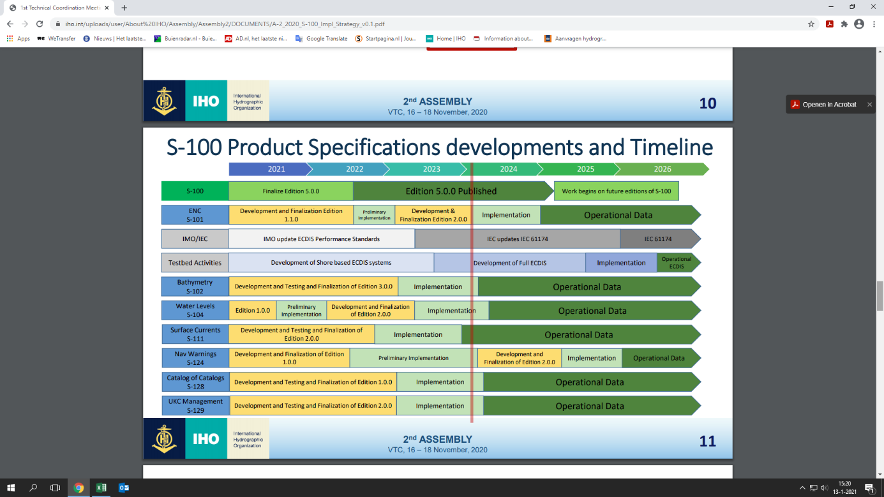

Preferably, there should be a resolution is in place at the start of the implementation phase of these earlier S-1XX products. In order to align with the current roadmap this must be completed at the beginning of 2023. Backward planning then requires an endorsed resolution at C6 in 2022 to be approved by Members States by CL (or back-up is A3). This in turn requires an endorsed resolution at IRCC14 in 2022. Assuming that the IRCC and Council will required two rounds to reach a decision, we need a mature draft of the WEND-100 resolution to be forwarded to IRCC13 in 2021.

This means that we are likely in a hurry and must spent our energy efficiently.

Scoping decisions

Before we start writing the next draft of WEND-100, we should therefore first make a few scoping decisions at WENDWG11 VTC01. This will give us direction.

Currently the full extent of the WEND-100 principles only applies to S-101. Para 2.2.d) states: “Incrementally the full extent or specific sets of the WEND-100 Principles will apply to other S-1XX products”. So, now we should determine to which other S-1XX products the full extent of the principles will also apply. The rest may follow later. This relates to decision A2/39 on the “proposed path forward”.

How can we arrive at such a determination? With a view safe navigation, I propose two criterions.

* Basic principle: in a particular area all maritime users (under SOLAS) should use the same authoritative source data for safe navigation. This is to ensure consistency and to avoid conflicting content of data products.
* End state: maritime users should use ‘packaged’ data from the same authoritative producer when available. This is to ensure harmonisation and consistency between the various S-1XX products, also for autonomous shipping.

During A2 the Chair of the HSSC presented the slide below which indicated a stepped approach. The HSSC Chair made a distinction between route monitoring and route planning. This also affects the applicability of WEND-100 principles. Such a route monitoring package reinforces the need to provide timely clarity for which other S-1XX product beyond S-101 the full extent of the WEND-100 principles should apply.

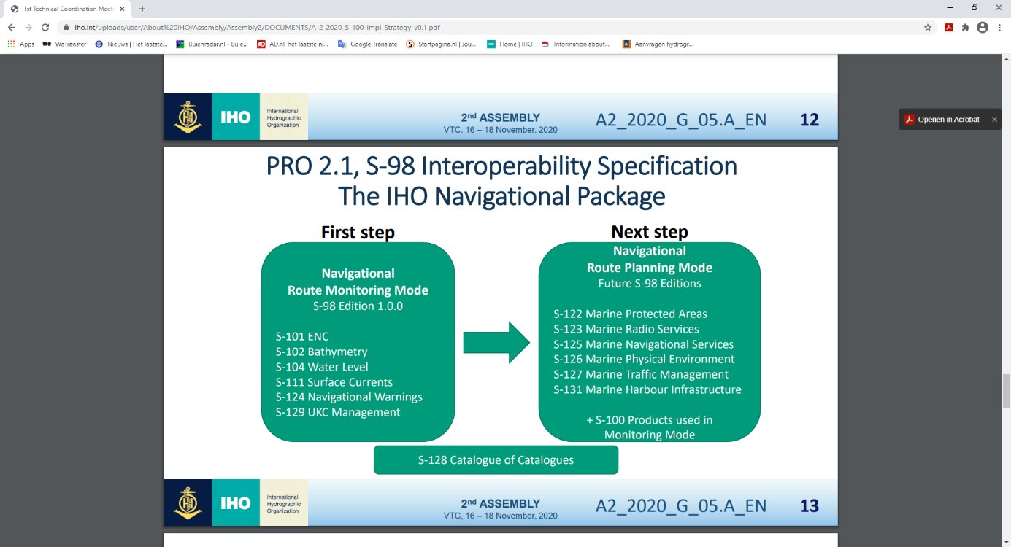

S-102: Bathymetric Surface

S-101 and S-102 both provide depth. This depth should be derived from the same authoritative bathymetric source-data using harmonized processing methods for instance on gridding, reference planes and depth filtering. There must not be an unknown or unintended discrepancy between S-101 and S-102, especially when S-101 and S-102 are used together in the same area.

Therefore both criterions apply and S-102 should follow the production and dissemination logic of S-101. In other words the full extent of the WEND-100 principles should apply.

S-111: Surface currents

S-101 and S-111 both contain current information (like S-57 and the paper chart). This current information should be based on the same modelling and measurements with consistent outcomes in S-101 and S-111; i.e. derived from the same source data. Again, there must not be an unknown or unintended discrepancy between S-101 and S-111, especially when S-101 and S-111 are used together in the same area.

Therefore both criterions apply and S-111 should follow the production and dissemination logic of S-101. In other words the full extent of the WEND-100 principles should apply.

Does this preclude Nation A from backfilling for Nation B, if Nation B does not yet have S-111 products available? No, but in the areas of national jurisdiction of Nation B this should be coordinated, for instance on data sources, and the S-111 products of Nation A should be withdrawn once Nation B produces and disseminate these themselves in alignment with section 4 of the draft WEND-100 Principles.

S-104: Water level

At first glance S-101 does not hold water level information. However, the current data in S-101 is linked to a reference tide such as High Water and Low Water. This HW and LW reference gives an implicit tide stamp. This time stamp should be based on the same modelling and measurements as those that determine times of the water levels in S-104; i.e. derived from the same source data. So, there must not be an unknown or unintended discrepancy between S-101 and S-104, especially when S-101 and S-104 (and S-111) are used together.

Therefore both criterions apply and S-104 should follow the production and dissemination logic of S-101. In other words the full extent of the WEND-100 principles should apply.

Does this preclude Nation A from backfilling for Nation B, if Nation B does not yet have S-104 products available? No, but in the areas of national jurisdiction of Nation B this should be coordinated, for instance on data sources, and the S-104 products of Nation A should be withdraw once Nation B produces and disseminate these themselves in alignment with section 4 of the draft WEND-100 Principles.

S-124: Navigational warnings

Navigation warnings are currently not part of S-101 or S-57. S-124 focusses on MSI, but NTM T/P are not included. Currently the dissemination of MSI follows the structures as developed within the WWNWS, Dissemination of S-124 is anticipated to follow this logic. Moreover, the implementation phase of S-124 is planned for the beginning 2025.

Therefore neither of the criterions applies at this time and S-124 does not need to be further specified in the WEND-100 resolution itself before the end of 2023.

S-128: Catalogue of Nautical products

This catalogue is in essence a derived product. It depicts the availability of other S-1XX (based) products. The authoritative nature of the underlying data is captured within the listed S-1XX products and not so much in the catalogue itself.

The catalogue will make it possible to visualize the available S-1XX products and services within a geographical area. This area does not necessarily coincide with national jurisdiction for S-1XX products or that of a PCA. It could well be an overview of the available product of a RENC in a certain sea basin. This logic precludes the concept of having a single authoritative source for a catalogue.

Therefore neither of the criterions applies directly and the full extent of the WEND-100 principles does not need to apply to S-128 products.

S-129: Under Keel Clearance Management

UKC management data sets are derived products with other environmental S-1XX data and ship data as input. This input data should be judged separately from S-129, for instance S-101, S-102, S-104 and S-111 as described above. The way authoritative data is incorporated in UKC management can be made specific to a vessel. Moreover, S-129 is relatively new and probably needs time to mature.

Therefore neither of the criterions applies directly and the full extent of the WEND-100 principles does not need to apply to S-129 products as part of the initial WEND-100 resolution.

**Conclusion**

The full extent of the WEND-100 principles should also apply to S-102, S-104 and S-111 products as part of the initial WEND-100 resolution.

To assist evaluation and decision-making on applicability, a matrix is provided listing the current WEND-100 principles against which the S-1XX products can be scored[1].

**Recommendation**

This paper focusses at the ‘packaged’ harmonisation and consistency of S-1XX products in a certain position/area. Another issue is harmonisation and consistency of S-1XX products between adjacent areas. For this separate issue production recommendations need to be developed in order to achieve consistency between various S1XX producers.

**Justifications and impacts**

The timely completion of a resolution on the WEND-100 principles underpins the Target 1.1 and SPI 1.1.2 of the IHO Strategic plan for 2021-2026

* Target 1.: “Deliver standards for hydrographic data and specifications of hydrographic products; support their regular production; and coordinate regional and global services for their provision.”
* SPI 1.1.2: “Number of hydrographic data products and services based on Universal Hydrographic Data Model that cater for the new requirements: autonomous shipping, reduction of emission.

**Action required of WENDWG**

The WENDWG is invited to:

1. Share their initial assessment for which S-1XX products the full extent of the WEND-100 principles should also apply before WEND11 VTC01 using the provided matrix.
2. Discus this paper.
3. Determine for which S-1XX products, besides S-101, the full extent of the WEND-100 principles will also apply.
4. Agree to write the next iteration of the “principles of the WEND for S-1XX” as a draft IHO resolution for submission to IRCC13 and C5.

1. Place an "X" in each cell where the WEND-100 principle applies for the S-1XX product when used for safe navigation and as part of the initial WEND-100 resolution. If the principle does not apply, please provide a rationale why not .