WWNWS WWNWS16/#/#-[NAVAREA]
Meeting 16 [Insert date of submission to IHO]
Agenda Item #.#

MSI Assessment for NAVAREA [Insert No]

Reporting period from 1st Jan 2023 to 31th December 2023

Submitted by [Insert country / organisation]
SUMMARY

Executive Summary: [Insert summary]

Action to be taken: [Insert paragraph number, e.g. 13]

Related documents: [Insert details if any, e.g. Excel spread sheet for inclusion of information into the IHO Country Information System (CIS) and Capacity Building (CB) database]

- General information:

  - Geographic Boundaries of the NAVAREA including boundaries for any coastal warning Areas and NAVTEX Stations
[Guidance: Provide a graphic and coordinates for the geographic boundaries of the NAVAREA and coastal warning areas for which your country is responsible]

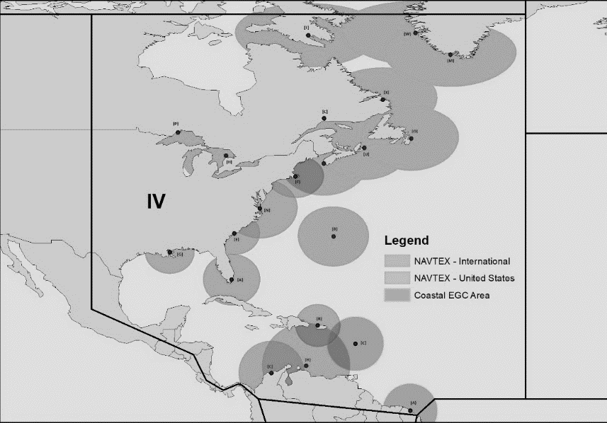
Example

  - Operational Points of Contact for National Co-ordinators within the NAVAREA [Guidance: Please note all changes from the WWNWS15 Self-Assessment in bold text]

COUNTRY | INSTITUTION | TELEPHONE | FACSIMILE | EMAIL

  - GMDSS Master Plan:
[Guidance: Please provide details of the status of the GMDSS master plan, including any updates or discrepancies within this reporting period for NAVTEX and Recognized Mobile Satellite Services (RMSS)]
- NAVAREA EGC broadcast and monitoring equipment or software:
Broadcast Equipment/Software  Examples | Broad cast schedule/Satellite  Examples | Manufacturer/Location (LES)/Implementation  Examples
LES | 1000 and 2200, AOR-E | Burum
SafetyNET II | 1000 and 2200 | Inmarsat
Iridium SafetyCast | 1000 and 2200 | Iridium
Iridium SafetyCast |  | Under Trial, expect to be operation in 6 months
Iridium SafetyCast |  | Require cost assistance to begin trials; IMO notified on 1 June 2022
Iridium SafetyCast |  | Require cost assistance to begin trials; IMO not yet notified
Monitoring Equipment/Software |  | Manufacturer/Software
TT-3027M |  | Thrane and Thrane / EasyMail 2.02
SafetyNET II |  | Inmarsat
Iridium SafetyCast |  | Iridium
Felcom 16 |  | Furuno

  - Details of EGC services:
[Provide details of EGC services, including EGC Mobile Satellites used for broadcasts (ex. AOR –E or SafetyNET II for Inmarsat), the GMDSS service provider and the schedule broadcasts per day, noting any changes.
Provide specifics on the Iridium SafetyCast system implementation status. If not fully operational, provide plans for progressing towards declaring full operational capability, including the requirement for cost assistance]
  - NAVTEX:
[Contact details for NAVTEX stations and service areas within NAVAREA.]
B₁  518  kHz | B₁  490 kHz | NAVTEX Station  Examples | Email  Examples | Telephone  Examples | Status  Examples
A | E | Corsen, France | corsen@mrccfr.eu | +33 2 988 93 131 | Operational
R | I | La Maddalena, Italy | navtex@mit.gov.it | +390 65922737  +390 59084793 | Operational
U | E | Mondolfo, Italy | navtex@mit.gov.it | +390 65922737  +390 59084793 | Not Operational
A | G | Antofogasta, Chile | cbaradio@directemar.cl | +56 55 2630072

  - Other methods of promulgation:
[Provide details of any other equipment of facilities used to promulgate MSI, noting any changes. Eg. HF NBDP]
- NAVAREA Metrics
  - Coastal Warnings issued by International NAVTEX or EGC coastal warning area: [Vital (NAVTEX) is defined as a messages for immediate broadcast, subject to avoiding interference to ongoing transmission. VITAL messages will normally be broadcast using NAVTEX number B3B4 = 00. Urgent (EGC) is defined as any message sent with an “urgency” priority, otherwise defined as any EGC message broadcast with a C1 code equal to “2”. Broadcast Data in megabytes is optional, but please provide data if you can]
 |  |  |  | 2023
Country | NAVTEX station name | B1 Character or Coastal Warning Area | Broadcast schedule times UTC (only for EGC) | Total number of warnings broadcast | Number of warnings broadcast with a vital priority (NAVTEX) or urgent priority (EGC) | Total number of warnings broadcast, including repetitions | Broadcast data in megabytes
Oman | Muscat | M | - | 50 | 0 | 834 | 77
New Zealand | Not required because this is an EGC Coastal Warning area | Z | 0900, 2100 | 70 | 3 | 370 | 57

  - NAVAREA Warnings broadcasts:
[Broadcast data in megabytes is optional, but please provide data if you can. Data for 2024 is optional.]

 | 2022 |  |  | 2023 |  |  | 2024
Provider | Total number of warnings issued | Total number of warnings broadcast, including repetitions | Broadcast data in megabytes | Total number of warnings broadcast | Total number of warnings broadcast, including repetitions | Broadcast data in megabytes | Total number of warnings broadcast | Total number of warnings broadcast, including repetitions | Broadcast data in megabytes
SafetyNet | 1071 | 3114 | 12 | 984 | 2997 | 15 | 1305 | 4998 | 14
SafetyCast | - | - | - | - | - | - | 1305 | 1305 | 7

  - Urgent EGC Warnings:
[Detail the number of NAVAREA or Coastal EGC Warnings promulgated with an urgent priority and detail the contents of the urgent warning. Urgent is defined as any message sent with an “urgency” priority, otherwise defined as any EGC message broadcast with a C1 code equal to “2”]
[Example: NAVAREA IV promulgated two urgent warnings concerning ice bergs outside the known limits of ice.]
  - VITAL Coastal Warnings:
[Detail the number of Coastal Warnings (NAVTEX messages) promulgated with a VITAL priority and detail the contents of the Vital warning. VITAL messages are for immediate broadcast, subject to avoiding interference to ongoing transmission. VITAL messages will normally be broadcast using NAVTEX number B3B4 = 00]

  - In-force warnings.
    - In-force bulletins issued:
[Do you issue “In Force warnings” Bulletins? How do mariners find the text of your “In Force” warnings that are more than 42 days old and which are no longer broadcast via EGC?]

2022 | 2023 | 2024
Total | Total | Total
    - Requests for In-force warnings:
[Specifics of requests for list of in-force navigations warnings. Data for 2024 is optional, but please provide data if you can.]
  - Arctic navigational warnings broadcast by HF NBDP. [Only for Arctic NAVAREAs: XVII, XVIII, XIX, XX and XXI. List total number of broadcasts by HF NBDP]
- Operational Issues:
[Provide information of any operational issues encountered within the NAVAREA]
- National Co-ordinator Communication:
  - IRCC Strategic Performance Indicator: [List all Coastal States within your NAVAREA for which you have not been able to establish and maintain regular communication; regular communication is defined as once per year. This information will be used to calculate the IRCC SPI 3.1.1 assigned to the WWNWS, which is the percentage of coastal states that are capable of providing MSI in accordance with the joint IMO/IHO/WMO Manual on MSI. For more information, please refer to IRCC Circular Letter 1/2021, dated 10 November 2021.]
[Example: NAVAREA IV did not receive any MSI in 2021 or 2022 from the following Coastal States and was unable to successfully communicate with them:
(Insert country name)
(Insert country name)
(Insert country name)]
  - Procedures. [Provide your operational procedures for maintaining communication with National Coordinators within the NAVAREA]
[Example: NAVAREA ## communicated with all National Coordinators twice, either via email or telephone, during the period for this report (1st Jan 2022 to 31th December 2022)]

- Contingency Planning:
[Provide information regarding contingency plans that have been established and future plans where appropriate. Also report on any annual exercises testing the plan that have been conducted, include outcomes, lessons learnt, problems, modifications and anticipated next exercise.]

- S-124 Navigational Warnings Development:
[Provide information regarding initial planning on S-124 Navigational Warning development to include participation in the S-124 Project Team Meetings and S-124 Project Team Sub-groups. Additionally, include information on any technical developments which will support S-124 creation and dissemination within your NAVAREA.]
- Capacity Building:
[Indication of coastal states within NAVAREA identified as being in need of MSI training and assistance, including prioritization. Offer of and/or demand for Capacity Building, Training received, offered, status of national, bilateral, multilateral or regional development projects with MSI component. Comment on when/if MSI training was provided to coastal states within NAVAREA and assessment of impact of training provided, including noticeable improvements of quality and quantity of MSI received by NAVAREA Coordinator for transmission.]
- Other Activities:
[Participation in other IHO or IMO Working Groups, Regional Hydrographic Commissions, regional conferences over past year]
- NAVAREA Website:
[(Website URL: http://NAVAREA_website.com
How often is the information on your web site updated?
Do you display the date and time of the last update on your web site?]
- NAVAREA Contact Information:
[Provide updated contact details or state no change. Complete SA Template Annex A Excel spread sheet for inclusion of information into the IHO Country Information System (CIS) and Capacity Building (CB) database; see uploaded example from NAVAREA IV-XII]
- Recommendations:
[If any]
- Actions requested:
[May simply be to note the information provided]
- Summary:
[Please provide a short summary of this paper which will be included in the final report of WWNWS16.]

Annex(es):

- Self Assessment Spreadsheet [Only for NAVAREAs with multiple coastal states]

