**IHO World-Wide Navigational Warnings Service – Sub Committee (WWNWS-SC)**

**MARITIME SAFETY INFORMATION TRAINING COURSE**

**SUMMARY REPORT**

**Date of report:** 13 May 2024

**Course:** Workshop on Maritime Safety Information (MSI) Development and Implementation.

**Date:** 7-9 May, 2024

**Venue:** Dedeman Istanbul Hotel 34340 İstanbul, Türkiye

**Instructors:** Mr. Timothy STACY (National Geospatial-Intelligence Agency, USA) and Mr. Christopher GILL (United Kingdom Hydrographic Office, GBR)

**Instructional and Administrative Support:** LT CDR Emre TÜKENMEZ (Turkish Navy - Office of Navigation, Hydrography, and Oceanography (TN-ONHO) and LT CDR Santiago RUBEN DIAZ PORTILLO (Spanish Hydrographic Office, ESP)

**Opening Address:** CAPT Hakan KUŞLAROĞLU (Director of TN-ONHO)

**Administrative Support:** LT CDR Emre TÜKENMEZ (TN-ONHO)

**Participants (15):** Türkiye (5), Bulgaria, Croatia, Georgia, Italy, Lebanon, Malta, Montenegro, Romania, Ukraine (**Annex A)**

**Introduction**

The International Hydrographic Organization (IHO) Capacity Building Sub-Committee (CBSC) in conjunction with the IHO's World-Wide Navigational Warning Service Sub-Committee (WWNWS-SC) conducted a Maritime Safety Information (MSI) Training Course to primarily benefit countries in the area of influence of the Mediterranean and Black Seas Hydrographic Commission (MBSHC).

This was the 28th learning opportunity facilitated by the WWNWS-SC as a capacity building first phase initiative since the program began in 2007. The first phase is the most urgent and easiest to implement and consists of organizing the collection and circulation of MSI necessary to provide real-time situational awareness of safety critical information. The course covered the supplementary requirements to maintain and update existing charts and publications to ensure the safe navigation of shipping as governed by the International Convention for the Safety of Life at Sea (SOLAS).

The WWNWS is a coordinated global service for the promulgation of warnings regarding hazards to navigation which might endanger international shipping. The syllabus included guidance on all the subject areas considered necessary to facilitate the transmission of NAVAREA and Coastal Warnings as described in IMO Res. A.706(17).

Spain, as the NAVAREA III Coordinator, is responsible for sea areas covered by the MBSHC. NAVAREA Coordinators control the broadcast of navigational warnings within its NAVAREA, making full and effective use of national broadcast facilities in keeping with the provisions of SOLAS. NAVAREA Coordinators have the responsibility to be informed of all events that could significantly affect the safety of navigation within their area.

**Objective**

The objective of the course was to ensure participants have the ability to produce MSI and disseminate that information as appropriate, often via the NAVAREA or NAVTEX coordinator. The secondary objective, and equally important, was to provide the knowledge to establish and fulfill the role of National Coordinator. To achieve this, the course provided practical instruction and guidance to participants who are involved with MSI and the drafting of Navigational Warnings or with the issuance of MSI for the high seas. The aim of the course was to ensure that all attendees would:

* Endeavour to be informed of all events that could significantly affect the safety of navigation within their coastal region.
* Assess all information for relevance to navigation in the coastal region.
* Draft navigational warnings in accordance with the Joint IMO/IHO/WMO Manual on MSI.
* Pass MSI for further promulgation to the NAVAREA Coordinator or other appropriate authority using the quickest means possible.

**Content**

The course content **(Annex B)** included all aspects of the WWNWS. The participants received instructional overviews, course documents, and digital media covering: The Global Maritime Distress and Safety System (GMDSS), Maritime Safety Information, and the World-Wide Navigational Warning Service. The instructors familiarized the students with the major guidance documents: IMO Res A.705(17), IMO Res A.706(17), the Joint IMO/IHO/WMO Manual on Maritime Safety Information, IHO Special Publication No.53 (S-53) and the IMO SafetyNET, SafetyCAST, and NAVTEX manuals. The course covered the role, responsibilities and requirements of National Coordinators, including the need to be informed of all events that could significantly affect the safety of navigation within its region. Training exercises emphasized the importance to immediately assess all information upon receipt and decide whether to inform the NAVAREA Coordinator. Additionally, for the first time an overview of the S-124 Navigational Warnings and its development was presented to course.

The course spanned a three-day period, which included a day of instruction and a day of practical exercises; the final day of the course consisted of the capstone exercise. On the second day of the course, the NAVAREA III representative LT CDR Santiago RUBEN DIAZ PORTILLO virtually provided a presentation on the NAVAREA III operation, its operational challenges, and future initiatives. Following the NAVAREA III presentation, students worked guided practical exercises. Participants worked in conjunction with the instructors to analyze MSI received, mirroring watch room operations in a controlled and structured environment. TN-ONHO graciously provided charts of Antalya, Türkiye and approaches, which the students used to evaluate the validity and applicability of MSI, and decide if the data warranted a NAVAREA or Coastal Warning. Additionally, students requested a briefing on the WWNWS-SC activities concerning development of S-124 Navigational Warnings. Due to the fact that both instructors are active within the S-124 Project Team, a presentation was quickly prepared concerning the activities of the project team including S-124 testing and Data Capture and Encoding Guide (DCEG) development. Students were encouraged to attending their Regional Hydrographic Commission Meeting and the WWNWS-SC to stay apprised of the latest S-124 developments. The final day had participants split into two-person teams. Each team played the role of NAVAREA Coordinator and worked independently in a rehearsed real-time operations room scenario with multiple categories of MSI to analyze. This allowed the instructors to see the progress each student made during this training effort and validate the course content and instruction as being both appropriate and effective. Following successfully completing the capstone exercise final remarks were given and certificates were distributed.

TN-ONHO, represented by LT CDR Emre TÜKENMEZ, provided outstanding support with respect to course coordination, instructional support, and accommodations in the weeks leading up to the course. Additionally, LT CDR TÜKENMEZ provided a quick presentation on TN-ONHO MSI operations including their four operational NAVTEX stations. CAPT Hakan KUŞLAROĞLU (Director TN-ONHO) provided the opening remarks. Without the support of TN-ONHO this course would not have been successful, and they have my sincere thanks.

**Instruction**

Mr. Timothy STACY (Deputy NAVAREA IV/XII Coordinator), acted as course leader supported by Mr. Christopher GILL (NAVAREA I Coordinator) who shared the presentation duties. Each instructor had varying degrees of experience, skill and knowledge with managing and staffing a NAVAREA operations room. This was Mr. Christopher GILLs second MSI capacity building course. He completed the MSI train the trainer session following the 15th meeting of the World-Wide Navigational Warning Service Sub-Committee in 2023 and has become a relied upon member of the WWNWS-SC to support MSI training courses globally.

The instructors encouraged a high level of interaction, which contributed to a relaxed classroom atmosphere and more individual participation. All the participants were actively encouraged to discuss their national MSI concerns and relay their own stories of note from within their regions.

Having so many participants with varying levels of GMDSS knowledge added depth to the proceedings. It provided the opportunity for the instructors to offer practical advice and guidance on best practices in conjunction with explaining the basic elements of establishing national procedures for the promulgation of MSI. The instructors encouraged each administration present to appoint a national point of contact for GMDSS issues and to communicate and revise their national strategy and plans with the IMO, IHO and respective NAVAREA Coordinators.

At the end of the course, all the participants received a flash drive containing copies of all the presentations and practical exercises. Their responsibility upon returning home was to share their knowledge and become the trainers for the personnel in their administrations who are responsible for gathering, analyzing, drafting, and promulgating navigational warnings for the coastal area of their country.

**Participants / Language**

The IHO Capacity Building Coordinator (CBC) made specific requests to the member states in their solicitation of participants to attend the course. The aim was to ensure that only those personnel charged with MSI responsibilities would attend the course and that it was not intended for policy or administrative personnel, and the IHO CBC successfully achieved that.

In alignment with the specific IMO requirements that NAVAREA and Coastal Warnings must be provided in English, the IHO CBC requested that attendees should have basic written and oral understanding of the English language. For this course, most participants had a working competency in the English language. Moreover, this course had an expertise in maritime safety information matters in their home countries which allowed the vast majority of students to quickly grasp the course materials and excel in practical exercises and the capstone exercise. Lastly, seven students serve as NAVTEX coordinators handling the promulgation of Coastal Warnings. These students were able to collaborate and share best practices in MSI promulgation. Additionally, it allowed the instruction team to discuss complex MSI exercises and provide a module on S-124 Navigational Warnings. The instruction team encouraged them to continue to liaise with the IHO WWNWS-SC to stay appraised on MSI developments in a quickly changing environment.

All participants arrived as scheduled. The ratio of 15 students from 10 countries provided excellent representation from the MBSHC.

**Facilities / Support**

Students and instructors stayed at the Dedeman Istanbul Hotel, İstanbul, Türkiye. The accommodations were outstanding in every category. The instruction took place in a comfortable well-equipped conference room at the hotel. Students had complimentary Wi-Fi both in the training room and in their hotel room. In addition to providing charted materials, TN-ONHO printed all supplementary information including name cards and placards and provided excellent support. The Dedeman Istanbul Hotel provided breakfast, lunch, and coffee/tea for the students and instructors. For future courses, the IHO should strive to make similar arrangements, which provided the most conducive learning environment, facilitated working relationships, and, more importantly, made it easy to form lasting friendships.

**Acknowledgements**

We would like to express our gratitude to IHO & TN-ONHO that led to make this workshop happen. Special thanks to the United States for funding the transportation and lodging its instructors. Also, we wish to say “thank you” to trainees that attended and added value to improve the safety of navigation in MBSHC region.

**Conclusion**

Once again it is very pleasing to report that this MSI training course maintained the high standards set by the previous models and that it fully met all the objectives. The analysis of the final practical exercises recorded the score of 95%, which means 95% of the answers rated at Good or Very Good. This score reflects changes, input from previous course surveys and instructor notes, to improve training and course material.

Having the local NAVAREA Coordinator present their operations, in this case NAVAREA III, is essential to the success of this course. The opportunity for the NAVAREA coordinator to develop a relationship with the National Coordinators and local experts in his or her region is an invaluable asset as the WWNWS-SC strives to achieve IRCC strategic performance indicator 3.1.1(90% of coastal states capable of providing maritime safety information).

At the closing of the course the instructors reminded the students of their responsibility to go back to their administrations and use their increased awareness and knowledge of the WWNWS to improve, and in some cases establish, the flow of MSI to their respective NAVAREA Coordinator and ultimately fulfill the role of National Coordinator within their country.

The course feedback **(Annex C)** confirms the overall success of this mission. In closing, the WWNWS is extremely pleased with the results of this training effort and looks forward to continuing its support as the course rotates to other IHO Regional Hydrographic Commissions.

**Next Planned Course**

*Currently there is no MSI training course scheduled by the CBSC. The WWNWS-SC is standing by to facilitate the 29th MSI training course when it is identified.*

Course photograph

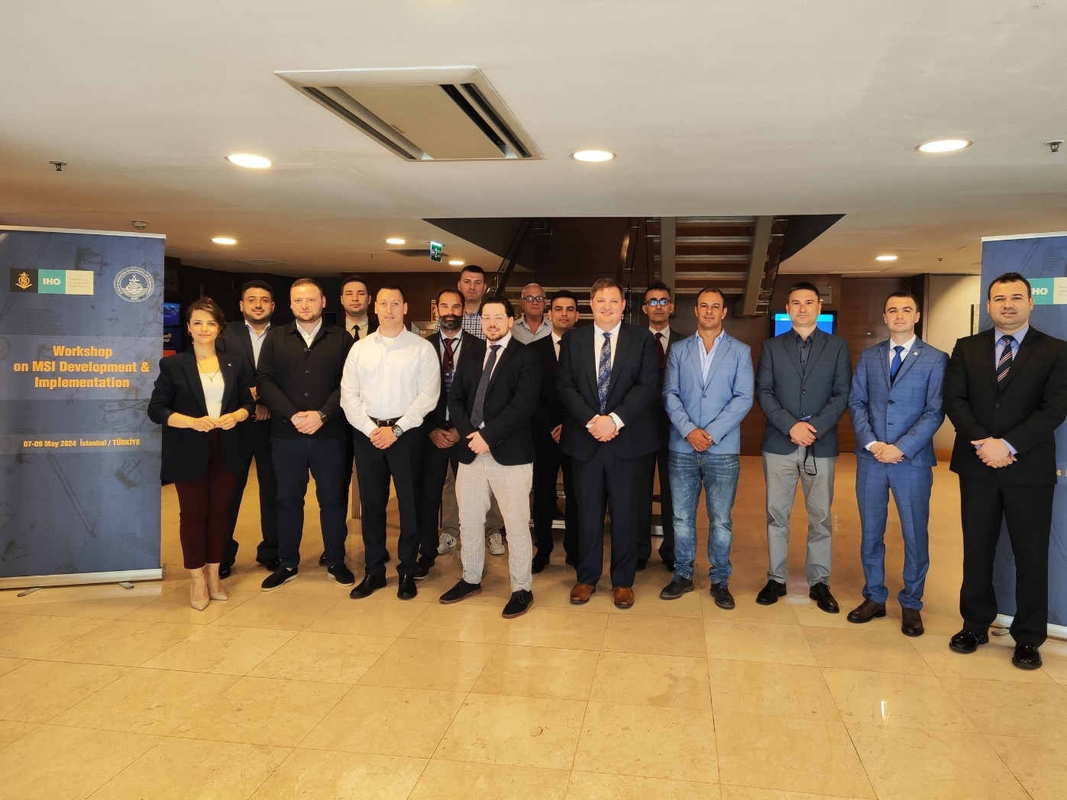

Students from Ukraine and Türkiye complete the capstone exercise

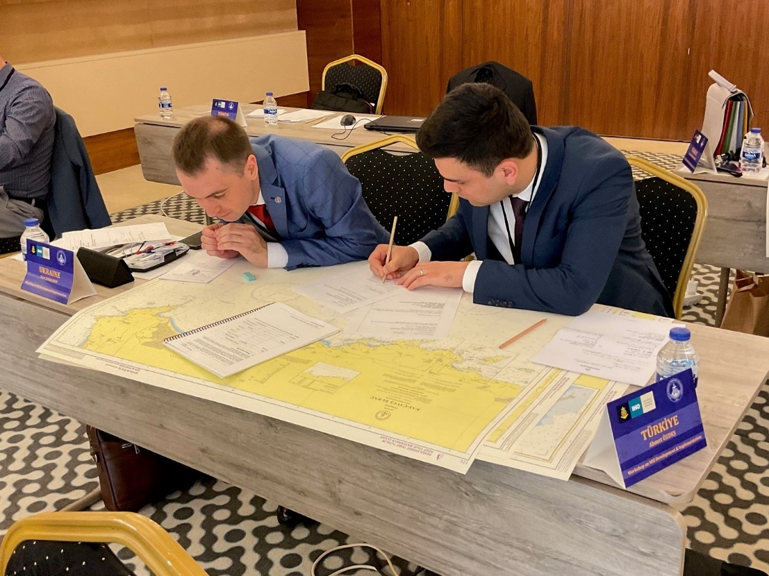

The Class receives a presentation from the NAVAREA III Coordinator

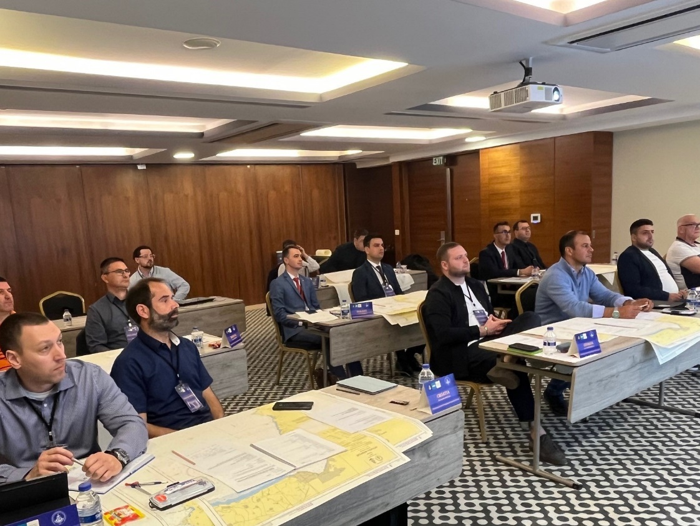

**ANNEX A**

**LIST OF PARTICIPANTS, MARITIME SAFETY INFORMATION (MSI) TRAINING COURSE, ISTANBUL, TÜRKİYE**

**Instructors:**

|  |  |  |  |  |  |  |  |
| --- | --- | --- | --- | --- | --- | --- | --- |
|  | **Surname** | **First Name** | **Country** | **Org.** | **Rank/ Title** | **E-mail:** | **Telephone** |
| 1 | STACY | Timothy | USA | NGA | Mr | Timothy.E.Stacy@nga.mil | +1 571 557 1667 |
| 2 | GILL | Christopher | GBR | UKHO | Mr | Christopher.Gill@ukho.gov.uk | +44 1823484119 |

**Participants:**

|  |  |  |  |  |  |
| --- | --- | --- | --- | --- | --- |
|  | **Surname** | **First Name** | **Country** | **Rank/ Title** | **E-mail:** |
| 1 | LYASKOVSKI | Nikolay | Bulgaria | Mr. | hs_varna@abv.bg  nrlyaskovski@gmail.com |
| 2 | DREZGA | Zvonimir | Croatia | Mr. | [zvonimir.drezga@hhi.hr](mailto:zvonimir.drezga@hhi.hr)  zdrezga@gmail.com |
| 3 | MIMINOSHVILI | Nika | Georgia | Mr. | [n.miminoshvili@hydrography.ge](mailto:n.miminoshvili@hydrography.ge)  nikamiminoshvili@yahoo.com |
| 4 | MONDINELLI | Paolo | Italy | Mr. | [paolo_mondinelli@marina.difesa.it](mailto:paolo_mondinelli@marina.difesa.it)  paolomondi@gmail.com |
| 5 | BOU SHAKRA | Ragheb | Lebanon | Mr. | [Surv.lnhs@army.gov.lb](mailto:Surv.lnhs@army.gov.lb)  lnhs.navy@army.gov.lb |
| 6 | ELLUL BONICI | Paul | Malta | Mr. | [paul.ellul-bonici@transport.gov.mt](mailto:paul.ellul-bonici@transport.gov.mt)  pebonici60@gmail.com |
| 7 | CALIC | Luka | Montenegro | Mr. | [luka.calic@meteo.co.me](mailto:luka.calic@meteo.co.me)  calicluka@gmail.com |
| 8 | CROITORU | Florin | Romania | Mr. | [florin.croitoru@dhmfn.ro](mailto:florin.croitoru@dhmfn.ro)  florincrtr@gmail.com |
| 9 | ZAKHAROV | Ivan | Ukraine | Mr. | [office@hydro.gov.ua](mailto:office@hydro.gov.ua)  zakharov.i@hydro.gov.ua |
| 11 | ÖZDEŞ | Ahmet | Türkiye | Lt.J.G. | ahmetozdessdu@gmail.com |
| 12 | GEREDE | Ahmet | Türkiye | Sgt.Major | gerede.a1216@dzkk.tsk.tr |
| 13 | TÜKENMEZ | Emre | Türkiye | Lt.Cdr. | etukenmez@shodb.gov.tr |
| 14 | ERİŞİR AKTÜRK | Aysemin | Türkiye | Lt.J.G. | aakturk@shodb.gov.tr |
| 15 | NART | Semih | Türkiye | Lt.J.G. | snart@ shodb.gov.tr |

**ANNEX B**

**SYLLABUS AND TIMETABLE**

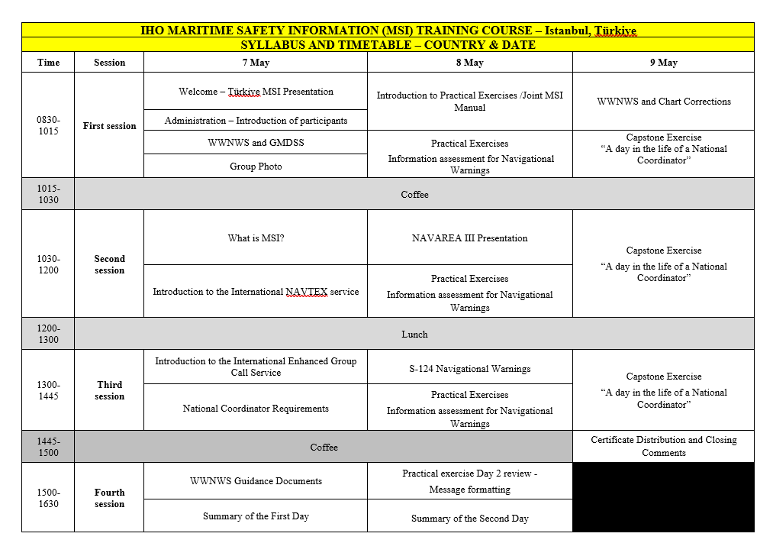**ANNEX C**

**MARITIME SAFETY INFORMATION (MSI) TRAINING COURSE – Istanbul, Türkiye - STUDENT SURVEY RESULTS**

|  |  |  |  |  |  |
| --- | --- | --- | --- | --- | --- |
| **Question** | **Strongly Agree** | **Agree** | **Disagree** | **Strongly Disagree** | **Total** |
| The Course was Organized. | 14 | 1 |  |  | 14 |
| The Course was the right length of time. | 12 | 2 |  |  | 14 |
| Presenters were understandable | 14 |  |  |  | 14 |
| Instructors were prepared | 14 |  |  |  | 14 |
| I understand what the WWNWS is | 14 |  |  |  | 14 |
| I better understand my MSI roles and responsibility | 13 | 1 |  |  | 14 |
| I would feel comfortable sending MSI | 12 | 2 |  |  | 14 |
| I feel the course was well worth my time | 14 |  |  |  | 14 |
| Guest Speaker was relevant | 12 | 2 |  |  | 14 |
| The Practical Exercises were helpful | 14 |  |  |  | 14 |

**Comments**

1. It was a very useful course for me. Thanks for your help.
2. Instructors are very helpful, kind. Course was very informative.
3. Thank you it was great.
4. Mr. Ed and Mr. Chris are helpful, well prepared and informed about all topics. They conveyed their knowledge and expertise on the subject very well. This kind of course is helpful for all involved with MSI. In this way, we also had the opportunity to meet our colleagues from different countries.
5. Mr. Chris and Mr. Ed are very helpful, kind, well prepared. They are very good about MSI. They taught the lessons in a fun way. The training is very useful for use. Thank you for kindness and friendliness.