**DQWG15 - 02.3.1A**

## Paper for Consideration by DQWG

## Quality of Bathymetric Data (QoBD) and ECDIS performance

|  |  |
| --- | --- |
| ***Submitted by:*** | Australia (AHO) |
| ***Executive Summary:*** | The AHO would like to propose the automated downgrading of **QoBD** by future S100 ECDIS in areas where **category of temporal variation** is ‘likely to change’ (2 or 3). In order to support this functionality, two new **QoBD** attributes are introduced. |
| ***Related Documents:*** | S-101 Ed. 1.0.0 PS and DCEG; S-101PT4_2019_04.09; TSM7_2019_7.6 |
| ***Related Projects:*** | S100TSWG, S101PT |

## Introduction / Background

When compared to its S-57 equivalent, object (**M_QUAL)**, the S101 feature **Quality of Bathymetric Data** **(QoBD)** includes a new attribute called **category of temporal variation** which main purpose is to inform mariners about the changeability of the bathymetry in an area. It’s expected that, based on this attribute value, the date the bathymetry was collected and the current date, mariners would be able to ‘mentally downgrade’ the level of reliability they allocate to the charted depths and contours.

Although the overall intention is good it seems that there are no plans or proposals to use this information to affect display or interact with ECDIS in-built safety functions. The AHO believes that, in areas where bathymetry is affected by a high rate of temporal variation, future S100 ECDIS should be able to automatically downgrade **QoBD** and therefore have a direct impact on display, route planning and route monitoring.

## Analysis/Discussion

At this point in time, category of **QoBD** is not an S-101 attribute but a ‘ranking’ to be calculated by S100 ECDIS using the DQWG ‘decision tree’ (S-101PT4_2019_04.09). The AHO understands that the DQWG has the intention to introduce the concept of category of **QoBD** in S101 Portrayal with the aim of driving ‘screen wide’ **QoBD** symbology (similar to S57 CATZOC).

The general idea would be that, based on the attribute values encoded in each **QoBD** feature, ECDIS will map them to a particular category of **QoBD** and consequently display each feature using some type of screen-wide symbology (still to be defined).This symbology would, at first sight, affect the level of confidence mariners allocate to the bathymetric content shown in a particular area.

Under this premise and with the objective of facilitating the implementation of smart ECDIS functions to automatically downgrade a category of **QoBD** in areas ‘likely to change’, the AHO is proposing two new **QoBD** attributes. These new attributes would be:

1. **temporal validity**: This attribute would be an integer (IN) value and the unit of measurement would be months. It would indicate how many months after **survey data range – survey end**, the HO expects the accuracy (vertical and/or horizontal) of the charted bathymetric data to deteriorate to a point where it falls outside the maximum accepted values for the charted category of **QoBD**.
2. **lowest QoBD category**: Possible values would be 2 (S-57 CATZOC A2) to 5 (S57 CATZOC D). This would be the lowest category a **QoBD** feature can be downgraded to. By default, unless this attribute is populated, category of **QoBD** should continue downgrading itself at multiples of **temporal validity.**

If an area is categorised as ‘likely to change’ (**category of temporal variation** = 2 or 3) the use of the attributes **survey end** and **temporal validity** must be encoded.

The AHO suggests that category of **QoBD** is downgraded by ECDIS at:

* one step intervals when **category of temporal variation** is 1 (likely to change but significant shoaling not expected),
* two step intervals when **category of temporal variation** is 2 (likely to change and significant shoaling expected).

**IMPORTANT**: Category of **QoBD** would be calculated by ECDIS using the DQWG ‘decision tree’. This means that for ECDIS to ‘downgrade’ a category of **QoBD**, it should first change the attributes affecting the decision process. By doing this, category of **QoBD** would be recalculated and consequently downgraded as required.

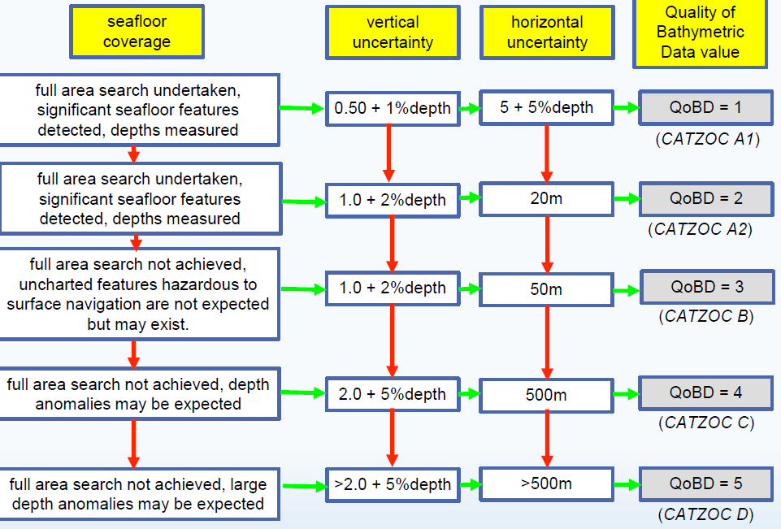

**Figure 1** – DQWG category of QoBD ‘decision tree’

ECDIS should not downgrade any of the following attributes: **category of temporal variation**, **temporal validity**, **data assessment** and **survey end.** ECDIS smart functions should only modify the attribute values for **features detected, vertical uncertainty** and **horizontal uncertainty.** This should be enough to trigger the downgrading of category of **QoBD**.

Based on the use of the new proposed attributes and performance expectations, ECDIS should be able to manage category of **QoBD** as per the logical sequence described in the following example:

**ENC setting**: S101 **QoBD** is encoded with: **category of temporal variation**= 2; **temporal validity**=7**; data assessmen**t=1; **least depth of detected features**=True; **significant features detected**= True; **full seafloor coverage achieved**= True; **horizontal position uncertainty** – **uncertainty fixed**= 2; **survey** **date end**= 20190101; **vertical uncertainty** – **uncertainty fixed**=0.3; **lowest QoBD category**= 4

**ECDIS expected performance:**

1. When ECDIS date is set to a value earlier than **survey end**, **QoBD** should display using the symbol corresponding to category of **QoBD**= 1
2. When ECDIS date is set to a date more than 7 months later than **survey date end** (> 20190801), **QoBD** display should change to the symbol selected to depict category of **QoBD**= 3. The attributes **features detected, vertical uncertainty** and **horizontal uncertainty** should now display the **QoBD=3** ‘worst case scenario’ values as per Figure 1 above.
3. When ECDIS date is set to a date more than 14 months (2 x **temporal validity**) later than **survey date end** (>20200301), **QoBD** data symbology should change to the one corresponding to category of **QoBD**= 4. Note that category of **QoBD** must not be changed to 5 due to the restriction imposed by the attribute **lowest QoBD category**. The attributes **features detected, vertical uncertainty** and **horizontal uncertainty** should now display the **QoBD=4** ‘worst case scenario’ values as per Figure 1 above.
4. If requested by the user, ECDIS should be able to forecast, display and trigger warnings at the route planning stage using the date and time of the waypoints along the route. Beyond display, the AHO would like to see future S100 ECDIS in-built safety functions to interact with category of **QoBD** in a way that triggers a warning when, either at planning or monitoring stages, a ship’s route is to enter an area where the category of **QoBD** is worse than a pre-set value.

Note: The ‘manual’ downgrading of QoBD attributes based on time, etc could be performed onshore by HO’s and released as ENC updates when required but it could become a logistic nightmare to keep track of the products to change, etc. This approach would certainly delay the availability of changes and won’t be able to assist mariners during route planning.

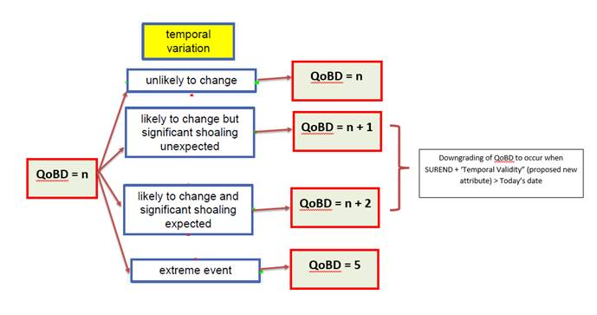

Proposed logic for ECDIS downgrading of charted QoBD features.

## Conclusions and recommendations

The AHO experience is that mariners usually overlook the use of attributes that do not directly affect display or ECDIS in-built safety functions. The only way to access this ‘hidden’ information is by performing ‘pick-reports’ across the chart which is neither intuitive nor practical.

Accordingly, the AHO wants to encourage and promote as much as possible, direct relationships between encoding practices and ECDIS display and/or performance.

The AHO plans to submit this paper for consideration of the S101PT, at the next available opportunity.

If supported by the DQWG and the S-101PT, the 2 new proposed attributes should be included in S-101 v 1.1 (Dec 2020) and encoding guidance included in the DCEG.

## Justification and Impacts

Automated functions related to the management and display of **QoBD** in S100 ECDIS will reduce mariners’ workload during route planning and monitoring facilitating their awareness and decision-making processes. All this should mitigate risk and have a positive impact on safety of navigation.

## Action Required of the DQWG

The DQWG is invited to:

1. Discuss and approve the proposed **QoBD** functionality in ECDIS. This includes the introduction of two new S-101 attributes and ECDIS performance requirements.
2. Coordinate with the S-100 TSWG the testing of the following ECDIS smart functions:
   * downgrading of category of **QoBD** by ECDIS
   * Use of category of **QoBD** as a new safety setting capable of triggering ECDIS warnings if breached.