DQWG15 05-01.B

Paper for Consideration by DQWG

Uncertainty of measurements and ECDIS performance

Submitted by: | Australia (AHO)
Executive Summary: | A proposal to explore the possibility of implementing the use of positional, horizontal and vertical accuracies by ECDIS’ in-built route checking safety functions.
Related Documents:
Related Projects: | S101PT; S-100 TSWG

Introduction / Background

Although supported by S-57, the encoding of positional, horizontal and vertical uncertainties was never considered when developing ECDIS’ in-built safety functionalities and therefore has not been of real use to mariners.
The AHO would like to investigate the implementation, in S-100 ECDIS, of automated functions that use measurements’ uncertainties on a range of attribute values to assist mariners with making informed decisions at the route planning and route monitoring stages. This new functionality should also work on the navigation systems of autonomous vessels.
Although the proposed new functionality looks useful on paper, the AHO would like the DQWG and the IHO to engage with mariners and seek their opinion before committing any resources to its development and testing. It is important to highlight that, in order for this functionality to be fully accepted and used by mariners, HOs will have to aggressively support its implementation by populating uncertainty values in key objects in the shortest timeframe possible. If the vast majority of the ENCs around the world are not encoded using uncertainty values, mariners will probably not include the use of this new functionality in their ECDIS standard procedures therefore this venture would not be worth the effort.

Analysis/Discussion
Currently in S-57 it is possible to encode:
- the best estimate of the accuracy of the positional error using the spatial attribute POSACC,
- the best estimate of the accuracy of the sounding data using the attribute SOUACC,
- the best estimate of the horizontal accuracy of horizontal clearance and distances using the attribute HORACC and
- the best estimate of the vertical accuracy of heights, vertical distances and vertical clearances (excluding sounding measurements) using the attribute VERACC.
According to S-57 Appendix B.1 Annex A UOC these attributes are available to the following Objects:
POSACC
The attribute POSACC may be applied to any spatial object, in order to qualify its location. This includes not only SOUNDG but also dangers to navigation such as WRECKS, UWTROC, OBSTRN, etc…
Positional Accuracy (POSACC) can then be used to indicate that a higher position accuracy has been achieved than specified for the overlapping M_QUAL object (CATZOC definition table). For example, a survey where full seafloor coverage was not achieved could not be classified higher that ZOC B; however, if the position accuracy was, for instance, ± 15 metres, the sub-attribute POSACC could be used to indicate this higher accuracy. If this attribute is left unpopulated it would indicate that all hydrographic features in the area would have a positional accuracy of ± 50m, the worst-case scenario for CATZOC B.
Sounding Accuracy (SOUACC) can be used in a similar manner to provide higher depth accuracy values than the one listed in the CATZOC definition table.

SOUACC
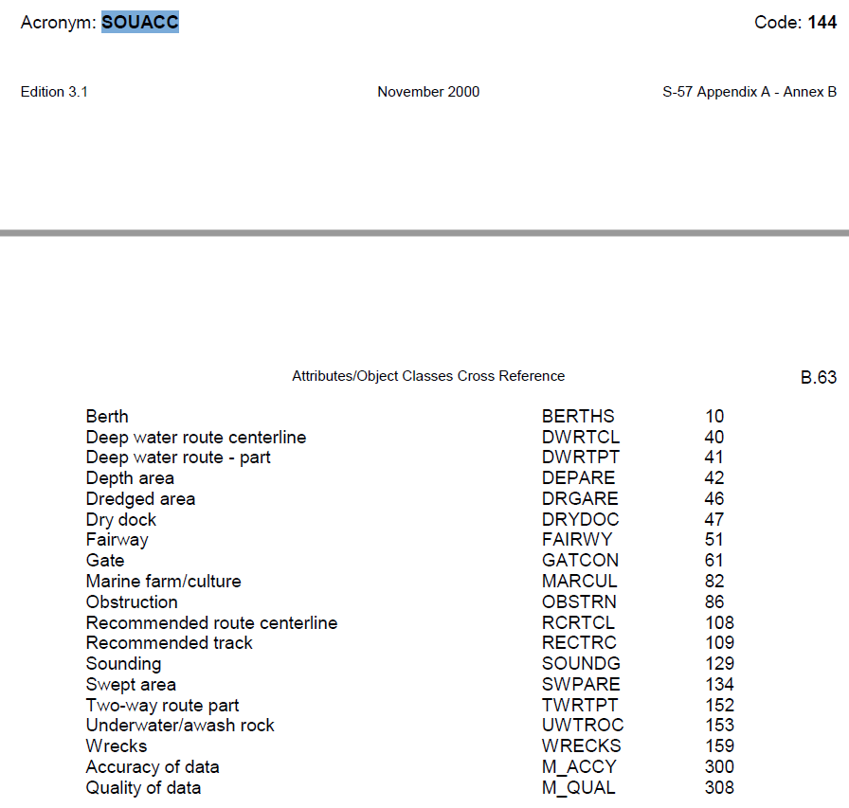
HORACC
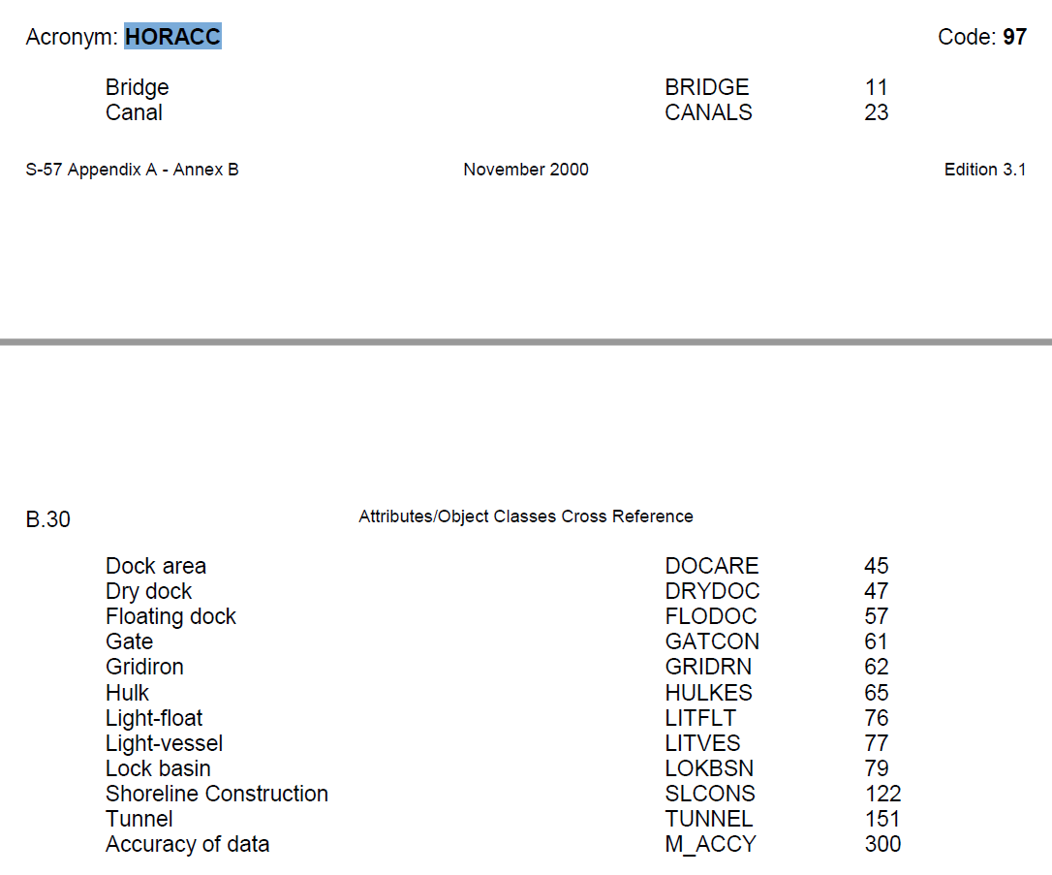

VERACC
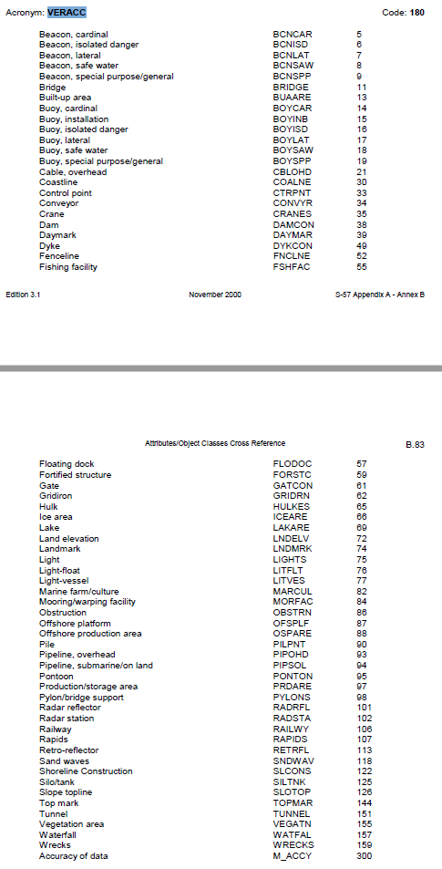
S-101
The feature catalogue for the future ENC products includes the following complex attributes to handle the uncertainty of measurements. Some of them have a direct relationship with the previously mentioned S-57 attributes (in red below):
- Horizontal distance uncertainty (S-57’s HORACC),
- Vertical uncertainty (S-57’s VERACC and SOUACC),
- Horizontal position uncertainty (S-57’s POSACC)
- Orientation uncertainty
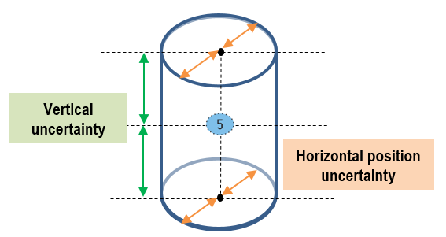
The new functionality proposed by the AHO aims to use measurements’ uncertainties to inform mariners, at their request, about any positional and dimensional offsets charted objects may have. This information could be used to reduce risk by increasing safety margins when possible.
ECDIS expected performance:
- At the mariners’ request, ECDIS should display ‘positional uncertainty circles’ around safety critical hydrographic features. As a minimum: SOUNDG, WRECKS, OBSTRN and UWTROC. This information should be managed in its own layer (overlay) and should be switched ON/OFF with the touch of a button. While displayed, an indication on the ECDIS screen must alert the user that this optional layer is active.
- At the mariners’ request, ECDIS route checking safety functions should generate Warnings when a ship’s safety framework is to cross:
  - the ‘positional uncertainty circle’ of a dangerous feature or
  - an otherwise non-dangerous feature whose vertical uncertainty makes it breach the safety margins stablished (e.g. safety contour is set to 7m and the ship is to cross an UWTROC with a charted least depth of 7.5m and a vertical uncertainty of ± 0.8m).
These warnings must be easily differentiated from the ones generated without considering any uncertainty values. This includes portrayal and reporting.
- Both functionalities listed above should be available during route planning and route monitoring.
Additionally, the AHO proposes the new S-100 ECDIS performance standard should also require the in-built safety functions to use a ship’s width and height when calculating safe passages under bridges, overhead cables, etc. Once again, the dimensions of a ship could be directly compared against charted clearances or use the extra safety buffer provided by the attributes ‘horizontal distance uncertainty’ and ‘vertical uncertainty’.

Conclusions and recommendations
The AHO’s experience is that mariners usually overlook the use of attributes that do not directly affect display or ECDIS in-built safety functions. The only way to access this ‘hidden’ information is by performing ‘pick-reports’ across the chart which is neither intuitive nor practical.
Accordingly, the AHO wants to strongly encourage and promote direct relationships between encoding practices and ECDIS display and/or performance.
In order for the proposed ECDIS performance enhancements to succeed, HOs should be strongly recommended to populate positional and vertical uncertainties on SOUNDG, WRECKS, OBSTRN and UWTROC in depths <= 50m and in areas of medium to low quality of bathymetric data (S-57 CATZOC B or worse).
It is also recommended that HOs populate the uncertainties of the horizontal and vertical clearances measured on bridges; overhead cables, pipelines and obstructions; canals; dry docks and lock basins.

Justification and Impacts
At the moment it is expected mariners will check the CATZOC of the areas they plan to transit and manually factor in the positional and depth uncertainties of the hydrographic data. To do this mariners would have to check (‘pick report’) every potentially risky feature along the route to find out if any of the uncertainty values have ben populated and, if not, refer to the worst-case scenario accuracy values listed in the CATZOC table.
This methodology is not only too tedious and time consuming but also inaccurate as the attributes designed to carry the uncertainty values for measurements are, in the vast majority of the cases, not used by the ENC producer agencies and, consequently, mariners end up using the ‘worst-case’ scenario for the CATZOC.
Automated functions related to the management and display of positional and dimensional uncertainties in ECDIS should reduce mariners’ workload during route planning and monitoring thus enhancing their awareness and facilitating the decision-making processes. All this should mitigate risk and have a positive impact on safety of navigation. This will become more and more relevant as the size of ships operating in ports increase and autonomous ships commence operations.
As mentioned earlier, although this new proposed functionality looks very practical on paper, in order to succeed it must be:
- fully embraced and accepted by the users (mariners) and
- fully supported by HOs due to the increased workload required to set it in motion. As a minimum, HOs should be strongly recommended to commence encoding uncertainties on new surveys and, in parallel, progressively research and update older charted features.

Action Required of the DQWG
The DQWG is invited to:
- Consider the proposed enhancements to ECDIS performance.
- Seek input from mariners.
- Support the submission of this paper to the upcoming S-101PT meeting in June 2020 (as is or with modifications approved at DQWG15)
- If supported, coordinate the implementation and testing of the proposed ECDIS performance enhancements with the S-100 TSWG.

