DQWG15_2020_02.3.2A_EN_Quality_Horizontal_Measurement
The AHO view is that S-101 encoding must be used to support marine navigation by encoding easy to interpret products (ENCs). Having developed S-101 using S-57 encoding as an starting point resulted in a number of attributes and attribute values, that were mainly designed to support the transference of hydrographic data (like a source database) between organisations, to be retained instead of being rationalised and adapted to serve a more practical role. S-101 should focus on ECDIS display and performance (alerts/alarms) and not in data transference.
Attributes and attribute values that do not have a direct impact on route planning or monitoring (of no practical use to the Mariner) should be avoided. What are the chances a mariner will find information by doing random pick reports all over the chart?? Do we expect them to do that??
With this in mind, having 11 different options to describe (this is a qualitative attribute) the quality of a measurement looks a bit crazy. What do we want mariners to know about the quality of a measurement? Why? How is he going to use it? If we have problems trying to understand and define the meaning of each value ….. imagine mariners!!! Lets make things simple for them.
The first logical option would be to encode more quantitative (horizontal position uncertainty, vertical uncertainty, horizontal distance uncertainty) than qualitative attributes (quality of horizontal measurement).
Instead of trying to describe quality is better to provide the uncertainties of each measurement and let them affect the safety parameters set by mariners in order to increase the safety margins and mitigate risk.
If a quantitative attribute value is not available, the qualitative attribute should be very simple. It should be as basic as ’trust’ or ‘use with care’ (the position or measurement indicated on the chart).
Two options should be enough:
- The measurement (position/distance) is good enough as to be trusted (e.g. if a tower is used to get a visual fix, the resulting position of the ship should be reliable).
- The measurement (position/distance) is not reliable and shouldn’t be used for any purpose other than reference. If the object is in the water and it may be a danger to navigation, mariners should consider using larger safety margins (greater than indicated by QualityOfBathymetric Data).
In summary, quality of horizontal measurement could have one attribute value only: ‘Unreliable’ (Low Accuracy). This will leave the default option (null) as an expression of ‘Reliable’ (Accurate). Visually in ECDIS, these low accuracy/unreliable objects have to look different; for example:
- Soundings: ’circle’ around the depth figure (SOUNDSC2/SOUNDGC2).
- Coastline or depth contour: Use of a dashed line (LOWACCnn).
- Other objects: ‘?’ with solid line connector (LOWACC01).

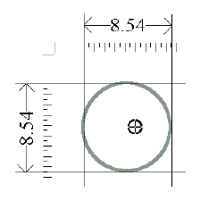 | 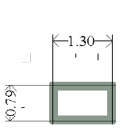 | 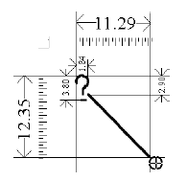
SOUNDSC2/SOUNDGC2 | LOWACCnn | LOWACC01

DQWG15_2020_04.4B_EN_Reporting Data Quality
The AHO comments below are for S-100 products to be used for navigation (front of bridge).
Currently in S-57, data quality (conformance with PS and UOC + data usability, etc) is checked by HOs and RENCs before a product is approved for distribution to mariners. The AHO believes mariners do not want (or need) to know about any of this. All relevant/useful quality information should be embedded in the product itself (features and attribute values). In ECDIS, the quality of the data would be visually presented to mariners or used by the in-built safety functions to generate alarms, etc.
No DQ report is required. Quality information should be included in the product.
Preference is Standalone Quality Report (e.g. IC-ENC P007.doc)
No comment. Up to the listed stakeholders to agree on this.

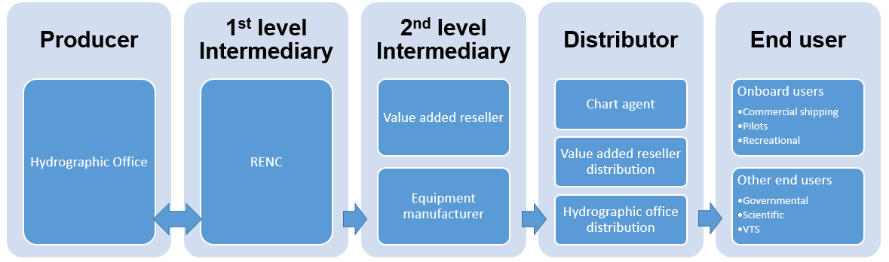

DQWG15_2020_05.1A_EN_Conditional visualization methodology of QoBD
Refer to AHO’s paper DQWG15_2020_05.1B_EN_Uncertainty of measurements and ECDIS performance.

The AHO prefers, over the creation of a new feature, encouraging HO’s to populate horizontal position uncertainty and vertical uncertainty on selected hydrographic features and amend ECDIS performance standard to make it possible for the ECDIS safety functions to use this information at mariners’ request.

DQWG15_2020_05.1C_EN_CATZOC and UKC compliance
“When the UKC required (the Safe Margin/Bottom Clearance) is greater (or equal) than the ZOC depth uncertainty, there is no need for additional measures. Accordingly, it is recorded in the passage plan and no additional measures are taken.”

Does Synergy Maritime Pty Ltd mean that, if a ship needs a UKC margin of 1m and it’s sailing in a ZOC A1 area where the ‘worst case scenario’ depth accuracy is (according to the ZOC Table) +/- 0.5m + 1% depth, it wouldn’t be a problem for the ship to sail through the area?? This logic wouldn’t work.

If, for example, the critical charted depth is 7.5m and the ship’s draft is 6.5m, at first glance it would mean that the UKC margin test passes but, as soon as the depth uncertainty is added to the mix, the potential least depth over the area could be as shallow as 7m and therefore the UKC test wouldn’t pass (the ship would require a charted least depth of 8m and not 7.5 !!
This means that Synergy Maritime Pty Ltd proposed statement is incorrect. Not taking additional safety measures when ‘ … the UKC required (the Safe Margin/Bottom Clearance) is greater (or equal) than the ZOC depth uncertainty …’ is certainly a problem and should be looked at and additional measures taken.

