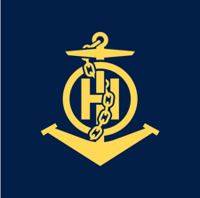
S-67
Published by the
International Hydrographic Organization
4b quai Antoine 1er
Principauté de Monaco
Tel: (377) 93.10.81.00
Fax: (377) 93.10.81.40
info@iho.int
www.iho.in
Mariners’ Guide to Accuracy of Depth Information in Electronic Navigational Charts (ENC)

Edition 1.0.0 – October 2020

© Copyright International Hydrographic Organization 2020
This work is copyright. Apart from any use permitted in accordance with the Berne Convention for the Protection of Literary and Artistic Works (1886), and except in the circumstances described below, no part may be translated, reproduced by any process, adapted, communicated or commercially exploited without prior written permission from the International Hydrographic Organization (IHO) Secretariat. Copyright in some of the material in this publication may be owned by another party and permission for the translation and/or reproduction of that material must be obtained from the owner.
This document or partial material from this document may be translated, reproduced or distributed for general information, on no more than a cost recovery basis. Copies may not be sold or distributed for profit or gain without prior written agreement of the IHO and any other copyright holders.
In the event that this document or partial material from this document is reproduced, translated or distributed under the terms described above, the following statements are to be included:
“Material from IHO publication [reference to extract: Title, Edition] is reproduced with the permission of the International Hydrographic Organization (IHO) Secretariat (Permission No ……./…) acting for the IHO, which does not accept responsibility for the correctness of the material as reproduced: in case of doubt, the IHO’s authentic text shall prevail. The incorporation of material sourced from the IHO shall not be construed as constituting an endorsement by IHO of this product.”
“This [document/publication] is a translation of IHO [document/publication] [name]. The IHO has not checked this translation and therefore takes no responsibility for its accuracy. In case of doubt the source version of [name] in [language] should be consulted.”
The IHO Logo or other identifiers shall not be used in any derived product without prior written permission from the IHO Secretariat.

Document Control
Changes to this Product Specification are coordinated by the IHO Data Quality Working Group (DQWG) which is a Working Group of the IHO Hydrographic Services and Standards Committee (HSSC). New editions will be made available via the IHO web site.
Edition Number | Date | Author | Purpose

Page intentionally left blank

TABLE OF CONTENTS

1 Introduction 2
1.1 Abbreviations 2
2 Accuracy of depth information in paper charts 3
3 Accuracy of depth information in Electronic Navigational Charts 4
3.1 Generalized information 4
Good quality area 5
Medium quality area 5
Poor quality area 5
3.2 Safety contour 5
3.3 Depth accuracy in relation to safety contours 6
3.4 Quality descriptions of individual objects dangerous to safe navigation 6
Obstructions 7
3.5 Survey reliability 8
4 Zones of Confidence symbols 10
5 Assessment of the quality of a survey into a Zone of Confidence by the HO 11
5.1 Assessment examples 12
5.2 Position accuracy of a survey 14
6 Impact of ZOC categories upon mariners 15
6.1 Effect of overzooming 16
7 Summary and recommendations 17
Annex A Zones of Confidence Categories 19
Annex B Dangerous effects of over-scale ECDIS display near ‘isolated dangers’ 21

Page intentionally left blank

Preface
IHO publication S-67 “Mariners Guide to Accuracy of Depth Information in an ENC” is a guide to navigators, and those planning ‘navigational operations’, on the degree of confidence they should have in the adequacy and accuracy of charted depths and their positions in an Electronic Navigational Chart.
This document is laid out, as far as possible, along the lines of the IHO publication “Regulations of the IHO for International (INT) Charts and Chart Specifications of the IHO – S-4”, “IHO Transfer Standard for Digital Hydrographic Data – S-57” and “Specifications for Chart Content and Display Aspects of ECDIS – S-52.”
The intended readers for this document are navigators on coastal or international voyages, organizations training navigators for coastal and/or international voyages.
This document is supplementary to already existing IHO Standards, to provide a more in-depth knowledge how a navigator should interpret the depth information presented to him/her by an Electronic Chart Display and Information System (ECDIS).

Introduction
The primary purpose of nautical charts is to provide the information required to enable the mariner to plan and execute safe navigation. The mariner has a need for appropriate, relevant, accurate and unambiguous information.
Most Hydrographic Offices have an obligation to provide nautical chart cover of their national waters to such an extent, and on such scales, as to permit safe navigation for all classes of vessel, from the smallest to the largest, throughout coastal waters, including major ports visited by the largest vessels, and minor arms of the sea of purely local interest. In this, the best-known sense, nautical charts are navigational tools.
National nautical chart series are usually the largest scale publications available showing the detailed configuration of the seabed offshore. In this respect, hydrographic offices have a de facto responsibility for their national waters similar to that of topographic mapping agencies for land areas. Such information about the shape of the seabed is required by a variety of national users other than navigators: construction engineers concerned with offshore developments, dredging contractors, oceanographers, defense departments, coastal zone managers and so on.
The combined effect of the two requirements has caused national chart series to cover national waters in great detail, reflected by medium scale charts to provide an overview, general picture, coastal image and large scale charts to provide information for an approach, harbor and berthing. Hydrographic Offices supply Electronic Charts in agreed scales, so-called Usage Bands. Their values are:
- Overview
- General
- Coastal
- Approach
- Harbor
- Berthing
The mariner requires charts to be consistent throughout the scales, at least for essential data content; this is called ‘vertical consistency’. At smaller scales, details must be generalized, with only a selection of the available source data (including soundings) being portrayed, so that the information which is selected is clearly present. Any sounding on the smallest scale chart will also be present on the largest scale.
A chart presents an image of the real world outside to the mariner. The depth information in a chart is compiled from various sources, each having their own adequacy and accuracy. How can the mariner distinguish, when using an ECDIS, what the adequacy and accuracy of the depth information is for the planned and executed voyage?

Abbreviations
CATZOC Category of Zone of Confidence in Data
ECDIS Electronic Chard Display and Information System
ENC Electronic Navigational Chart
HO Hydrographic Office
NM Nautical Mile
ZOC Zone of Confidence

Accuracy of depth information in paper charts
Paper charts provide information to guide navigators, and those planning ‘navigational operations’ (including the planning of new routes and official routeing measures), on the degree of confidence they should have in the adequacy and accuracy of charted depths and their positions. This is portrayed in a so-called Source Diagram. A Source Diagram provides details of sources – date and scale. It gives an indication of:
- The adequacy of the equipment used;
- The thoroughness of examinations of dangers at particular depths (based on the maximum draught of vessel afloat at that date); and
- The likelihood of changes in depths, particularly in areas of mobile or unstable seabed or coral growth.
The date of the edition of a published paper chart can be misleading (as the source data may be much older) but may have some value. Year dates only should normally be used.
The type of survey should be stated on conventional Source Diagrams (the terms being translated as necessary):
- ‘Survey’ implies a regular, controlled or systematic hydrographic survey of any date.
- ‘Sketch survey’ or ‘Reconnaissance survey’ implies that there is a significant risk of undetected dangers, even if the ‘survey’ is of recent date.
- ‘Passage soundings’ implies soundings acquired on an uncoordinated basis over a period of years.
- Qualifying comments, for example: ‘(leadline)’; ‘(no sonar)’; and ‘(multibeam)’, may be added after the type of survey where the date does not give sufficient indication of the survey methods.
- Where a charted survey is supplemented by occasional soundings from older or later sources, only the main survey should normally be listed.
Areas of continual and rapid change occur in many tidal rivers and estuaries, for example Hugli River (India) and Bahia Buenaventura (Colombia); over bars in the approaches to some ports, for example Esbjerg (Denmark) and Karachi (Pakistan); and over some off-lying banks, for example The Goodwin Sands (UK) and The Eastern Approaches to Nantucket Sound (USA).
In most areas which have not been wire-swept or fully insonified, there is a possibility that depths somewhat shoaler than those charted may exist. Navigators normally allow for that and other uncertainties by allowing safety margins. Inadequately surveyed areas may be defined as those where bathymetry is based on older leadlinesurveys or other surveys which are either open in nature (for example reconnaissance surveys), or are not hydrographic surveys (for example seismic surveys). These types of surveys are inadequate for identifying all shoals that may exist between lines of soundings, or may not be ‘shoal-biased’ in their selection of recorded depths.
The details and interpretations of published Source Diagrams often varied widely between nations. The variations in method, detail and interpretation render this type of quality information unsuitable for use in an electronic system such as ECDIS, as it prevents use of automated checking routines to look along a planned route to confirm suitability.
When making the transition from paper chart to the Electronic Navigational Chart, the International Hydrographic Organization developed and published Zones of Confidence areas in their “IHO Transfer Standard for Digital Hydrographic Data – S-57”.

Accuracy of depth information in Electronic Navigational Charts
Depth accuracy in Electronic Navigational Charts is described in two ways:
- Generalized information in Zones of Confidence (ZOC) diagrams
- Quality descriptions of individual objects dangerous to safe navigation
- Reliability of a survey

Generalized information
The quality of the hydrographic source data is assessed according to six categories (CATZOC): five quality categories for assessed data (A1, A2, B, C and D) and a sixth category (U) for data which has not been assessed. The assessment of hydrographic data quality and classification into zones is based on a combination of:
- Seafloor coverage;
- Depth accuracy; and
- Position accuracy.
The higher ZOC categories, A1 and A2, demand full seafloor ensonification or sweep and require very high accuracy standards which have only been achievable with the technology available since about 1980. Therefore many sea lanes which have hitherto been regarded as adequately surveyed may carry a ZOC B classification. Modern surveys of critical areas can be expected to carry ZOC A2 classification whilst ZOC A1 will cover only those areas surveyed under exceptionally stringent conditions for very special reasons.
Table 3-1 –ZOC Categories
ZOC | Position accuracy | Depth accuracy | Seafloor coverage
A1 | ± 5m + 5% depth | 0.50 m + 1% depth | Full area search undertaken. Significant seafloor features detected and depths measured.
A2 | ± 20m | 1.00 m + 2% depth | Full area search undertaken. Significant seafloor features detected and depths measured.
B | ± 50m | 1.00 m + 2% depth | Full area search not achieved; uncharted features hazardous surface navigation are not expected but may exist.
C | ± 500m | 2.00 + 5% depth | Full area search not achieved, depth anomalies may be expected.
D | Worse than ZOC C | Worse than ZOC C | Full area search not achieved, large depth anomalies may be expected.
U | Unassessed – The quality of the depth data has yet to be assessed.

The full version of this table can be found in Annex – A.
As a Quick Reference Guide, Table 3-1 above can be interpreted as follows:
- Good Quality Area (ZOC A1 and A2)
- Medium Quality Area (ZOC B)
- Poor Quality Area (ZOC C, D and U)

Good quality area
The depth of this area has been measured by a collection of regular, controlled or systematic hydrographic surveys. Significant seafloor features dangerous to the safety of navigation (rocks, coral reefs, wrecks, submerged obstructions) have been identified, accurately positioned and their least depth value has been accurately determined. The mariner is advised not to navigate closer than 20 meter to these features unless they are so deep that the mariner is confident to sail over them.

Medium quality area
There is a chance that significant seafloor features dangerous to the safety of navigation (rocks, coral reefs, wrecks, submerged obstructions) have not been identified, and do not appear in the chart. Those features that are present have a horizontal accuracy of ± 50 meter. The mariner is advised not to navigate closer than 50 meter to these features unless they are so deep that the mariner is confident to sail over them.

Poor quality area
The mariner should take appropriate caution when navigating through this area. Charted depths may in reality be significantly shallower. It is very likely that some significant seafloor features dangerous to the safety of navigation (rocks, coral reefs, wrecks, submerged obstructions) have not been identified, and do not appear in the chart. Those features that are present have a horizontal accuracy of ± 500 meter. The mariner is advised not to navigate closer than 500 meter to these features unless they are so deep that the mariner is confident to sail over them.
The figure below shows this where a charted shoal may be out of position in areas of CATZOC C, D or U. The difference between the charted and true position of the shoal is much greater than the difference between the GNSS measured ship’s position and the ship’s true position. The mariner is advised to take appropriate caution.
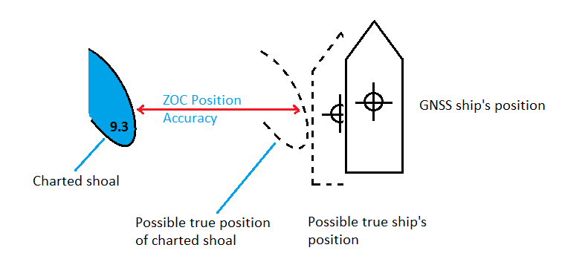

- A planned route should allow for both chart accuracy and ship’s positioning accuracy, as well as other factors.
Figure 3-1 –Horizontal positional accuracy for ZOCs C, D or U

Safety contour
In an ECDIS the default setting for a safety contour is the 30 meter depth contour. If the mariner is using the default settings of an ECDIS, depth areas deeper than 30 meters will be presented in white and areas shallower than 30 meters will be presented in blue. If the mariner enters a safety depth into ECDIS, the system will search for the nearest deeper depth contour and assign this as the safety contour to be used. White and blue colors will be adjusted accordingly.
In an ENC, the following contour lines are available:
0, 2m, 5m, 10m, 20m, 30m, 50m, 100m, 200m, 300m, 400m, 500m, 1000m, 2000m, 3000m, 4000m.
Optionally the ENC may contain the following depth contours:
3m, 8m, 15m, 25m, 40m, 75m, 600m, 700m, 800m, 900m.
For surface navigation the 0 to 100m range is of importance. For submarine navigation and deep water fishing the 0 to 800m is relevant.

Depth accuracy in relation to safety contours
CATZOC provides a general impression of the quality of the source data that is used to create depth areas bounded by depth contours. A depth area is an area where the charted depths are bounded by a minimum and (possibly) maximum value. A depth contour is default displayed as a solid line, a boundary between deeper and shallower water. The Hydrographic Office may have provided additional information that the contour line is approximate, it will then be displayed as a dashed line.
Several different depth areas may have the same CATZOC value. On the other hand, within one depth area more than one CATZOC value may be present. Zones of Confidence never overlap and have no gaps inbetween.
The mariner should take note of the accuracy of the depth areas the vessel is planning to transit and take appropriate caution:
Table 3-2 – Depth accuracy based on CATZOC value
 | CATZOC
depth | A1 | A2 | B | C | D | U
0 | 0.5m | 1.0m | 1.0m | 2.0m | >2.0m | unknown
10 | 0.6m | 1.2m | 1.2m | 2.5m | >2.5m | unknown
20 | 0.7m | 1.4m | 1.4m | 3.0m | >3.0m | unknown
30 | 0.8m | 1.6m | 1.6m | 3.5m | >3.5m | unknown
40 | 0.9m | 1.8m | 1.8m | 4.0m | >4.0m | unknown
50 | 1.0m | 2.0m | 2.0m | 4.5m | >4.5m | unknown
75 | 1.3m | 2.5m | 2.5m | 5.8m | >5.8m | unknown
100 | 1.5m | 3.0m | 3.0m | 7.0m | >7.0m | unknown

Quality descriptions of individual objects dangerous to safe navigation
In “IHO Transfer Standard for Digital Hydrographic Data – S-57”. the following (subsurface) items are considered to be hazardous to safe navigation:
- Obstructions
- Rocks
- Soundings
- Wrecks
These items may contain additional quality information only applicable to this item. The structure of the ENC allows Hydrographic Offices to add this information, however it is not mandatory for the Hydrographic Offices to do so.

Obstructions
The following items are considered to be an obstruction:
- Snags
- Stumps
- Wellheads
- Diffusers
- Cribs
- Fish havens
- Foul areas
- Foul ground
- Booms
- Ice booms
- Sites of cleared platforms
- Ground tackle
Individual obstructions, rocks, soundings, wrecks may have the following quality information:
Table 3-3 – Additional quality information for obstructions, rocks, soundings and wrecks
Object | Additional information | Options
Obstruction  Rock  Sounding  Wreck | Exposition of sounding | - within the range of depth of surrounding depth area
 |  | - shoaler than the range of depth of surrounding depth area
 |  | - deeper than the range of depth of surrounding depth area
 | Quality of sounding | - depth known
 |  | - depth unknown
 |  | - doubtful sounding
 |  | - unreliable sounding
 |  | - no bottom found at value shown
 |  | - least depth unknown
 |  | - least depth unknown, safe clearance at value shown
 |  | - value reported, not surveyed
 |  | - value reported, not confirmed
 |  | - maintained depth
 |  | - not regularly maintained
 | Sounding Accuracy | Value in meters
 | Technique of sounding measurement | - found by echosounder
 |  | - found by side-scan sonar
 |  | - found by multi-beam
 |  | - found by diver
 |  | - found by lead-line
 |  | - swept by wire drag
 |  | - found by laser
 |  | - swept by vertical acoustic system
 |  | - found by electromagnetic sensor
 |  | - photogrammetry
 |  | - satellite imagery
 |  | - found by leveling (not applicable)
 |  | - swept by side-scan sonar
 |  | - computer generated

For obstructions, note the difference between a foul area and a foul ground. A foul area is defined as an area of numerous uncharted dangers to navigation. If the Hydrographic Office creates a foul area in an ENC, it will show in an ECDIS “base display” as an obstruction to navigation, with all associated alarms to indicate that it is unsafe for vessels to enter or transit the area.
Foul ground is defined as an area over which it is safe to navigate but which should be avoided for anchoring, taking the ground or fishing.
The mariner can execute a “pick report” in the ECDIS to show the underlying information of an obstruction, rock sounding or wreck.
Note that the horizontal position accuracy for individual objects is not available in S-57. The value of the overlaying CATZOC applies to the horizontal accuracies of individual obstructions, rocks, soundings and wrecks.

Survey reliability
The Hydrographic Office may provide additional quality information on individual surveys. The information can be viewed by executing a pick report on the area. The components of the information are:
Table 3-4 – Components of survey reliability
Attribute | Allowable values | Definitions
Quality of Position | 1: surveyed | The position(s) was(were) determined by the operation of making measurements for determining the relative position of points on, above or beneath the earth’s surface. Survey implies a regular, controlled survey of any date. (Adapted from IHO Dictionary, S-32, 5195, & IHO Chart Specifications, M-4, 175.2)
 | 2: unsurveyed | Survey data is does not exist or is very poor. (Adapted from IHO Dictionary, S-32, 5732)
 | 3: inadequately surveyed | Position data is of a very poor quality. (Adapted from IHO Dictionary, S-32, 5732)
 | 4: approximate | A position that is considered to be less than third-order accuracy, but is generally considered to be within 30.5 meters of its correct geographic location. Also may apply to an object whose position does not remain fixed. (Adapted from IHO Dictionary, S-32, 213, 3967, & IHO Specifications, M-4, 424.1)
 | 5: position doubtful | An object whose position has been reported but which is considered to be doubtful.
 | 6: unreliable | An object’s position obtained from questionable or unreliable data.
 | 7: reported (not surveyed) | An object whose position has been reported and its position confirmed by some means other than a formal survey such as an independent report of the same object.
 | 8: reported (not confirmed) | An object whose position has been reported and its position has not been confirmed.
 | 9: estimated | The most probable position of an object determined from incomplete data or data of questionable accuracy. (Adapted from IHO Dictionary, S-32, 3960)
 | 10: precisely known | A position that is of a known value, such as the position of an anchor berth or other defined object.
 | 11: calculated | A position that is computed from data.
Quality of sounding measurement | 1: depth known | The depth from chart datum to the bottom is a known value.
 | 2: depth unknown | The depth from chart datum to the bottom is unknown.
 | 3: doubtful sounding | A depth that may be less than indicated. (Adapted from IHO Dictionary, S-32, 5th Edition, 4840)
 | 4: unreliable sounding | A depth that is considered to be an unreliable value.
 | 5: no bottom found at value shown | Upon investigation the bottom was not found at this depth. (Adapted from IHO Dictionary, S-32, 5th Edition, 4848)
 | 6: least depth known | The shoalest depth over a feature is of known value. (Adapted from IHO Dictionary, S-32, 5th Edition, 2705)
 | 7: least depth unknown, safe clearance at value shown | The least depth over a feature is unknown, but there is considered to be safe clearance at this depth.
 | 8: value reported (not surveyed) | Depth value obtained from a report, but not fully surveyed.
 | 9: value reported (not confirmed) | Depth value obtained from a report, which it has not been possible to confirm.
 | 10: maintained depth | The depth at which a channel is kept by human influence, usually by dredging. (IHO Dictionary, S-32, 5th Edition, 3057)
 | 11: not regularly maintained | Depths may be altered by human influence, but will not be routinely maintained.
Scale value one | numerical value  (25000 -> scale 1:25 000) | The largest scale for the range of survey scale as used in source diagram information.
Scale value two | Numerical value  (250000 -> scale 1:250 000) | The smallest scale for the range of survey scale as used in source diagram information.
Sounding distance - minimum | numerical value  (50 for 50 meters or feet) | The minimum spacing of the principal sounding lines of a survey.
Sounding distance - maximum | numerical value  (150 for 150 meters or feet) | The maximum spacing of the principal sounding lines of a survey.
Survey authority | name of the source survey authority | The authority which was responsible for the survey.
Survey end date | CCYYMMDD  CCYYMM  CCYY | The ‘survey date, end’ should be encoded using 4 digits for the calendar year (CCYY), 2 digits for the month (MM) (e.g. April = 04) and 2 digits for the day (DD). When no specific month and/or day is required/known, indication of the month and/or the day is omitted. This conforms to ISO 8601: 1988.
Survey start date | CCYYMMDD  CCYYMM  CCYY | The ‘survey date, start’ should be encoded using 4 digits for the calendar year (CCYY), 2 digits for the month (MM) (e.g. April = 04) and 2 digits for the day (DD). When no specific month and/or day is required/known, indication of the month and/or the day is omitted. This conforms to ISO 8601: 1988.
Survey type | 1: reconnaissance/sketch survey | A survey made to a lower degree of accuracy and detail than the chosen scale would normally indicate. (IHO Dictionary, S-32, 5th Edition, 5219)
 | 2: controlled survey | A thorough survey usually conducted with reference to guidelines.
 | 3: unsurveyed – no longer in use | Unsurveyed should now be encoded using the object unsurveyed area.
 | 4: examination survey | A survey principally aimed at the investigation of underwater obstructions and dangers.
 | 5: passage survey | A survey where soundings are acquired by vessels on passage
 | 6: remotely sensed | A survey where features have been positioned and delimited using remote sensing techniques.
INFORM | text | Textual information about the object.
ININFOM | text | Textual information in national language characters.

Zones of Confidence symbols
There are two different types of symbols for Zones of Confidence in an ENC:
- Downward triangle
- Horizontal bar
There are two validations of Zones of Confidence:
- Assessed
- Unassessed
Areas that have been assessed are symbolized by the number of stars inside the triangle or bar. Areas which have not been assessed are symbolized by the letter U inside the bar.
The number of stars inside the triangle or bar is an indication of the CATZOC value:
6 stars = A1
5 stars = A2
4 stars = B
3 stars = C
2 stars = D
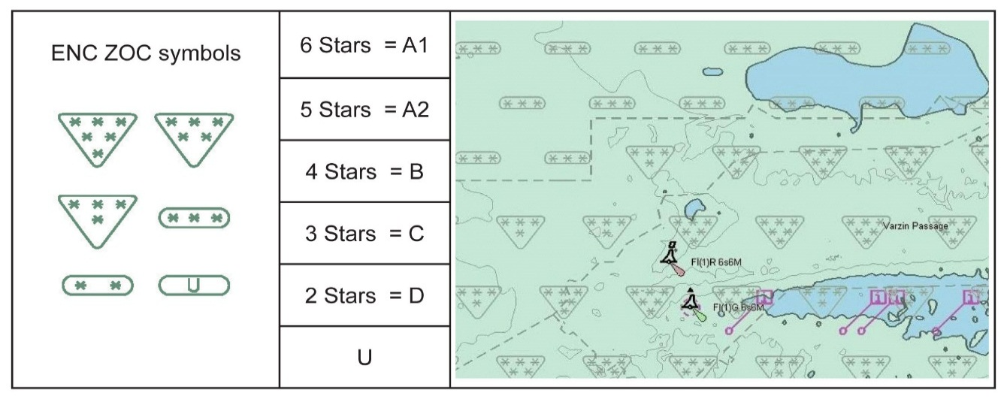
Zones Of Confidence symbols, categories and depiction on an ENC.

Figure 4-1 – Zones of Confidence symbols, categories and depiction on an ENC

The triangles are placed horizontally across the screen with a fixed separation of between two symbols. The bars are also placed horizontally across the screen with a fixed separation. The CATZOC value at the gravity point of each symbol is used the depict the value. This means that occasionally a CATZOC symbol may be pictured over two adjacent CATZOC areas with different values whereas only one value can be depicted. This type of symbology was developed in the 1990’s when computer monitors had less sophisticated capabilities than today’s technology.
To view the Zones of Confidence symbology, the mariner has to activate the “information on chart display layer” or a similar setting, depending on the type of ECDIS used.
This kind of symbology tends to clutter the screen. During execution of a voyage mariners will most likely de-activate this setting. However, when planning a new route of changing an existing route whilst enroute, mariners are recommended to active this and use the information before accepting the new route in the ECDIS system.
Quick Reference:
- 5 stars of more = good quality area.
- 4 stars = medium quality area.
- 3 stars of less = poor quality area.
- U = unassessed, take appropriate caution.

Assessment of the quality of a survey into a Zone of Confidence by the HO
Hydrographic Offices receive different kinds of data collected by different technologies. Some data may be more than 50 years old whereas other data is collected with the latest technology. Some data may be collected using a leadline from a ship, other data may be measured by satellite from space. All this data is compiled to provide an image of the seabed and objects above the seabed. Some data is collected by the Hydrographic Office, other data may come from port authorities, scientific research institutes and through private ship-owners. The Hydrographic Office has the task to evaluate the quality of the data received and decide if and how this data should be made available to update the ENC.
As a general guideline, the following choices are made by the Hydrographic Office:
- Data from ports are assigned CATZOC B; some port authorities provide CATZOC A1.
- Satellite data is assigned CATZOC C.
- Laser data by plane is assigned CATZOC B, sometimes A2.
- Private ship-owner data is assigned CATZOC D.
- Data before 1980 is assigned CATZOC B, C or D. In general, the older the data, the lower the value.
On a case-by-case basis, the Hydrographic Office may deviate from these general guidelines as they see fit, taking into account local knowledge of the area, intended shipping routes etc.

Assessment examples
Typical survey characteristics are the first considerations to make an assessment of seafloor coverage, depth accuracy and position accuracy. Finally, the systematic nature of the survey; does the survey comprise planned survey lines on a known geodetic datum that can be accurately transformed to WGS 84. How accurate are the transformation parameters when converting an old survey (before 1980) to the WGS84 datum used in the ENC? The Hydrographic Office should take this into consideration and downgrade the CATZOC areas accordingly.
In this example, a single beam survey conducted in 1963 is very complete. Developments (more survey lines) were made around the shoal areas and crosslines were conducted to see if any shoals existed between survey lines. Due to this completeness of this survey no uncharted features, hazardous to surface navigation are expected. The resulting charted depth data would be given CATZOC of B. The area could not be given a CATZOC of A1 or A2 because full seafloor coverage was not achieved. | 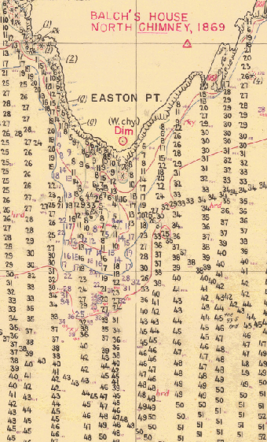
Figure 5-1 – Example: Systematic single beam survey from 1963

In this example, the older handwritten survey was completed in 1899. It was done by leadline measurements (recorded in fathoms)*. These measurements are actually quite accurate. However, they are only isolated measurements, with no guarantee of finding any hazard between one leadline depth and the next. This old survey only includes hazards seen by the surveyors at or above the sea surface. It was assessed as ZOC C – depth anomalies may be expected.  In contrast, depths taken from the modern metric survey shows a significant 2.1 meter shoal not found during the original survey. It proves that the 1899 survey, if it was the only survey in this area, could not be trusted, and that precautions should be taken.  (* 1 fathom equals 1.8 meters.) | 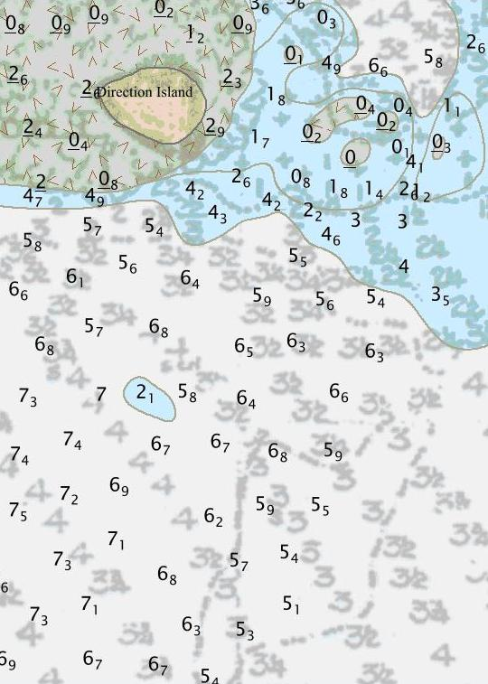
Figure 5-2 – Example: Leadline survey from 1899

Position accuracy of a survey
Positioning accuracy of a survey is typically determined by the positioning systems used during the hydrographic survey. The accuracy to position a ship anywhere on the globe has significantly improved over the last 100 years.
Since 1978 the US government has provided a space-based radio navigation system, operated by US Air Force. This service, Global Positioning System (GPS), is available to an unlimited number of users with a GPS receiver. The user can determine accurate time and location, in any weather, day or night, anywhere around the globe. Reception in Artic areas is less due to the fact that the satellites do not overpass these areas. Other countries have provided a similar service, GLONASS (Russian); Beidou (Chinese); and Galileo (EU). A user with a Global Navigation Satellite System (GNSS) receiver can now use all these services at the same time, thus improving the horizontal and vertical accuracy of its position.
The accuracy of a GPS receiver in the 1980s was approximately 30 meters. For hydrographic surveys, a land-based correction signal was supplied to correct for errors introduced by US Air Force for military purposes and for signal loss between satellites and receiver. The initial accuracy of 30 meters was initially brought down to 2 meters and eventually to 0.10 meters. The accuracy for a standard GNSS receiver is nowadays in the range of 5 meters. With the full service of Galileo soon, the accuracy of a standalone GNSS receiver will become 0.20 meters. This means that the position of the ship will become (far) more accurate than the surveys previously collected and charted.
From the late 1940s to the 1990s survey ships depended upon shore-based electronic positioning systems transmitting their signal over short or medium ranges, giving accuracy of around 20 to 100 meters. In coastal areas, this means that anything the ship found could be up to 100 meters from where it was thought to be. Much of this depended upon how accurately the transmitter ashore was positioned, as well as the accuracy of the transmitted ranges to generate the ‘fix’.
Prior to this, survey ships used sextants to measure angles between a system of prominent marks, or flag poles built on towers established ashore, with surveyors ‘angling’ for hours at a time. A second row of towers could be built in shallow water or on reefs to extend the network further offshore, but with a further reduction in accuracy. Depending upon how accurately the towers were placed, accuracy of 50 to 500 meters was possible for the survey ship. So again, when something was found, particularly offshore, the true position could quite easily be up to 500 meters from where it was surveyed to be.
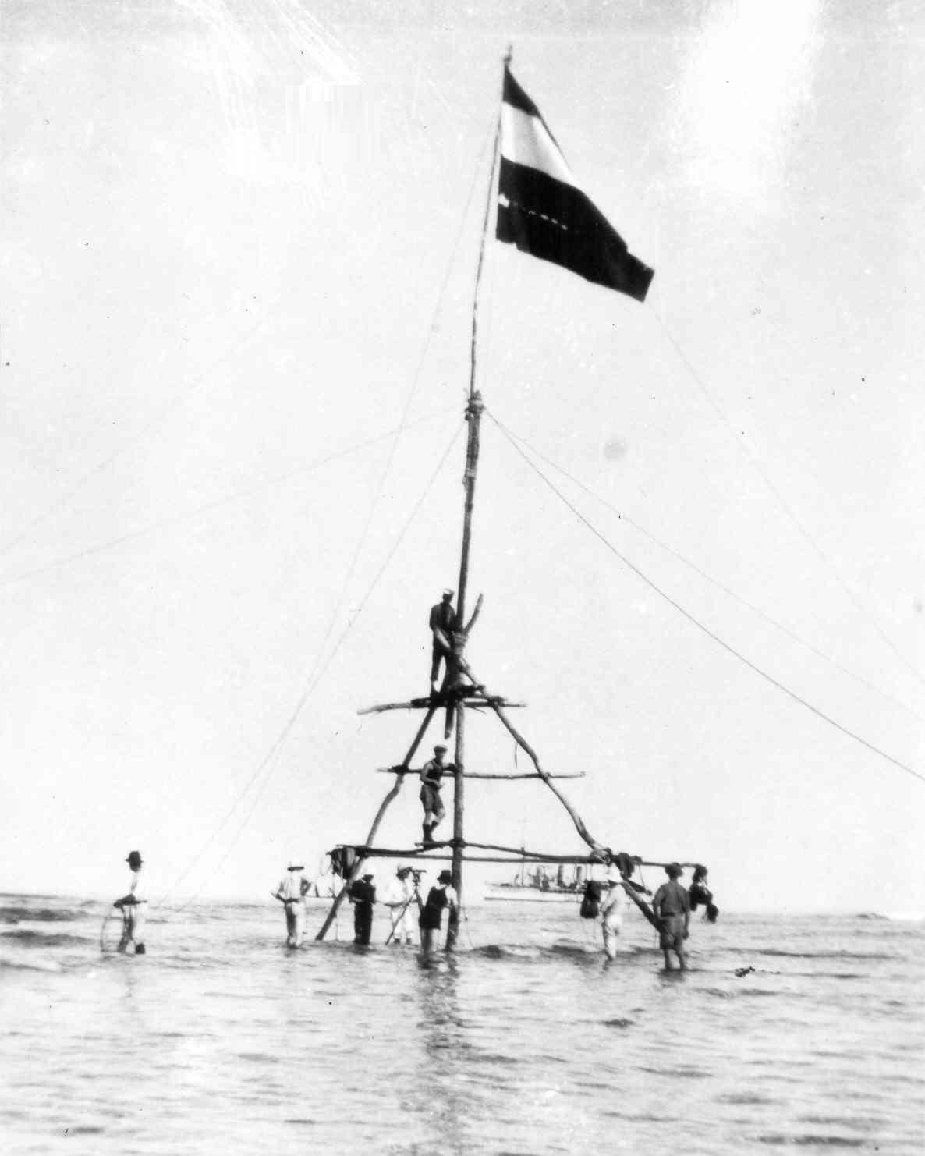
Up to early 1940s: Survey flag on an offshore reef to extend horizontal sextant control further offshore could achieve accuracy typically between 50 – 500 meters compared to GNSS. | Late 1940s to mid-1990s: Shore based electronic position fixing systems could achieve accuracy typically between 20 – 100 meters compared to GNSS.
Figure 5-3 – Position fixing – pre-1940s; late 1940s to 1990s
Further offshore, where information was collected by ships relying entirely upon celestial navigation, positions could be considerably less accurate, typically no better than 1 to 2NM, and frequently worse.
While modern satellite imagery can be used to correct the position of many isolated visible offshore features, such as islands, reefs or perhaps shoals breaking in rough weather, anything more than a few meters below the surface is likely to remain unseen, and therefore possibly well out of its true position.

Impact of ZOC categories upon mariners
Put in simple terms, mariners should be able to navigate with confidence in areas with ZOC A1 and A2 classifications. It is possible, but unlikely, that an uncharted danger affecting surface navigation exists in ZOC B areas. In ZOC C areas mariners should exercise caution since hazardous uncharted features may be expected, particularly in or near reef and rocky areas. A very high degree of caution is required for areas assessed as ZOC D, as these contain either very sparse data or may not have been surveyed at all. Finally, it is good practice to treat ZOC U areas with the same degree of caution as ZOC D areas.

To put this in perspective, the following table is an overall analysis of over 14 million square kilometers of coastal ENC from 32 nations:
Table 6-1 – Coverage by ZOC category - analysis
Category | % area of English Channel | % area of Singapore & Malacca Straits | % area of world’s coastal ENC (32 nations) | Confidence
A1 (6 stars) | 3.6% | 1.4% | 0.7% | Good
A2 (5 stars) | 9.4% | 0.2% | 1.0% | Good
B (4 stars) | 62.9% | 2.5% | 30.5% | Medium
C (3 stars) | 21.3% | 76.2% | 21.8% | Poor
D (2 stars) | 2.8% | 1.1% | 20.5% | Poor
Unassessed (U) | 0.0% | 18.5% | 25.4% | Poor

Effect of overzooming
ENC’s are compiled at a certain scale. IHO S-57 Appendix B.1 recommends that the compilation scales for ENC’s are based upon standard radar ranges:
Table 6-2 – Recommended standard ENC compilation scales
Selectable range | Standard scale (rounded)
200 NM | 1:3.000.000
96 NM | 1:1.500.000
48 NM | 1:700.000
24 NM | 1:350.000
12 NM | 1:180.000
6 NM | 1:90.000
3 NM | 1:45000
1.5 NM | 1:22.000
0.75 NM | 1:12.000
0.5 NM | 1:8000
0.25 NM | 1:4000

A large scale chart covers a small area with high level of details. The associated Zones of Confidence therefore also provide a high level of detail. When using a lower scale chart, at some point two adjacent Zones of Confidence will merge into one. At that point only the lesser value of the two Zones will be available for safety reasons. Shipping accidents have occurred when mariners did not have the largest scale chart in their ECDIS available, they overzoomed using a medium scale chart, and ran aground by passing to close to isolated underwater dangers.
Further details and examples are provided in Annex B of S-67.

Summary and recommendations
Accuracy of Depth Information in an ENC can be visualized by showing the Zones of Confidence areas. A Zone of Confidence area is a generalized picture of the quality of depth information for that area. The quality of the hydrographic source data is assessed according to six categories (CATZOC): Five quality categories for assessed data (A1, A2, B, C and D); and a sixth category (U) for data which has not been assessed. The assessment of hydrographic data quality and classification into zones by Hydrographic Offices is based on a combination of:
- Seafloor coverage;
- Depth accuracy; and
- Position accuracy.
As a Quick Reference Guide, this can be interpreted as follows:
- Good Quality Areas (ZOC A1 and A2), shown as 5 stars or more.
- Medium Quality Areas (ZOC B), shown as 4 stars.
- Poor Quality Areas (ZOC C, D and U), shown as 3 stars or less; or letter U.
Zones of Confidence can be visualized in an ECDIS by activating the information on chart display layer. (or some other setting, depending on the type of ECDIS). The following recommendations are made to the mariner:
- When planning a new voyage, Zones of Confidence should be visualized as an overall check of the quality of the area the vessel is going to transit.
- When changing the planned route whilst enroute, the Zones of Confidence should be visualized as an overall check of the quality of the area the vessel is going to transit.
- In ZOC A1 and A2, the vessel should stay clear from isolated dangers by 20 meters, unless the mariner is confident to sail over them.
- In ZOC B, the vessel should stay clear from isolated dangers by 50 meters, unless the mariner is confident to sail over them.
- In ZOC C, D and U, the vessel should stay clear from isolated dangers by 500 meters, unless the mariner is confident to sail over them.
- The mariner should take note of the accuracy of the depth areas the vessel is planning to transit and take appropriate caution, especially in situations where under keel clearance is critical.
- In ZOC D and U the mariner is advised to take caution as charted depths may in reality be significantly shallower. It is very likely that some significant seafloor features dangerous to the safety of navigation (rocks, coral reefs, wrecks, submerged obstructions) have not been identified, and do not appear in the chart.
- By using a Pick Report in ECDIS, the mariner can read additional quality information on isolated dangers to the safety of navigation and/or survey reliability, if these have been included in the ENC. Otherwise the mariner should assume that the isolated danger may in reality be out of position and/or be shallower as indicated by the Zone of Confidence.
- The mariner should make sure to have the full portfolio of ENC’s available at the appropriate chart scales of the areas the vessel is transiting through. ECDIS does allow the mariner to overzoom hence giving a false sense of security of the accuracy of isolated dangers if Zones of Confidence are not checked.
Put in simple terms, mariners should be able to navigate with confidence in areas with ZOC A1 and A2 classifications. It is also unlikely that an uncharted danger affecting surface navigation exists in ZOC B areas. In ZOC C areas mariners should exercise caution since hazardous uncharted features may be expected, particularly in or near reef and rocky areas, or areas of mobile seabed. A very high degree of caution is required for areas assessed as ZOC D, as these contain either very sparse data or may not have been surveyed at all. Finally, it is good practice for mariners to treat ZOC U areas with the same degree of caution as ZOC D areas.
Within ports, the Pilot or Harbor Master may advise that higher accuracy surveys have been conducted that allow for smaller under-keel clearances (subject to tides, weather, speed, and maneuvering margins). In the absence of this advice, smaller under-keel safety margins should not be assumed.
In coastal shipping areas the most common assessments likely to be encountered are:
- ZOC B – around 30% of the world’s coastal waters;
- ZOC C – around 20% of the world’s coastal waters;
- ZOC D – around 20% of the world’s coastal waters; and
- ZOC U – around 25% of the world’s coastal waters.
While these percentages may vary from place to place, the key point to note is that the standards of surveying in port are only very rarely encountered outside those ports. Ships are therefore at greater risk away from ports, even though depths may be deeper. In areas deeper than 100 meters, the risks will decrease, with increasing under keel clearance. Areas deeper than 200 meters are generally considered safe for surface navigation. An understanding of how much confidence can be placed in the depth information in an ENC is therefore most important.

Zones of Confidence Categories
Zones Of Confidence Categories
ZOC Category  (note 1) | Position  Accuracy  (note 2) | Depth Accuracy  (note 3) |  | Seafloor Coverage | Typical Survey Characteristics  (note 5)
A1 | ± 5 m + 5% depth | =0.50 + 1%d |  | Full area search undertaken. Significant seafloor features detected (note 4) and depths measured. | Controlled, systematic survey (note 6) high position and depth accuracy achieved using DGPS and a multi-beam, channel or mechanical sweep system.
 |  | Depth (m)  10  30  100  1000 | Accuracy (m)  ± 0.6  ± 0.8  ± 1.5  ± 10.5
A2 | ± 20 m | = 1.00 + 2%d |  | Full area search undertaken. Significant seafloor features detected (note 4) and depths measured. | Controlled, systematic survey (note 6) achieving position and depth accuracy less than ZOC A1 and using a modern survey echo-sounder (note 7) and a sonar or mechanical sweep system.
 |  | Depth (m)  10  30  100  1000 | Accuracy (m)  ± 1.2  ± 1.6  ± 3.0  ± 21.0
B | ± 50 m | = 1.00 + 2%d |  | Full area search not achieved; uncharted features, hazardous to surface navigation are not expected but may exist. | Controlled, systematic survey (note 6) achieving similar depth but lesser position accuracies than ZOCA2, using a modern survey echo-sounder (note 5), but no sonar or mechanical sweep system.
 |  | Depth (m)  10  30  100  1000 | Accuracy (m)  ± 1.2  ± 1.6  ± 3.0  ± 21.0
C | ± 500 m | = 2.00 + 5%d |  | Full area search not achieved, depth anomalies may be expected. | Low accuracy survey or data collected on an opportunity basis such as soundings on passage.
 |  | Depth (m)  10  30  100  1000 | Accuracy (m)  ± 2.5  ± 3.5  ± 7.0  ± 52.0
D | Worse than ZOC C | Worse than ZOC C |  | Full area search not achieved, large depth anomalies may be expected. | Poor quality data or data that cannot be quality assessed due to lack of information.
U | Unassessed - The quality of the bathymetric data has yet to be assessed
Column: 1 | 2 | 3 |  | 4 | 5
Source: IHO S-57 Ed3.1 Supp 3 (Jun 2014), pp 13-14

Remarks:
To decide on a ZOC Category, all conditions outlined in columns 2 to 4 of the table must be met.
Explanatory notes quoted in the table:
Note 1. The allocation of a ZOC indicates that particular data meets minimum criteria for position and depth accuracy and seafloor coverage defined in this Table. ZOC categories reflect a charting standard and not just a hydrographic survey standard. Depth and position accuracies specified for each ZOC category refer to the errors of the final depicted soundings and include not only survey errors but also other errors introduced in the chart production process.
Note 2. Position accuracy of depicted soundings at 95% CI (2.45 sigma) with respect to the given datum. It is the cumulative error and includes survey, transformation and digitizing errors etc. Position accuracy need not be rigorously computed for ZOCs B, C and D but may be estimated based on type of equipment, calibration regime, historical accuracy etc.
Note 3. Depth accuracy of depicted soundings = a + (b*d)/100 at 95% CI (2.00 sigma), where d = depth in meters at the critical depth. Depth accuracy need not be rigorously computed for ZOCs B, C and D but may be estimated based on type of equipment, calibration regime, historical accuracy etc.
Note 4. Significant seafloor features are defined as those rising above depicted depths by more than:
Depth Significant Feature
a. <40m: 2 m
b. >40m: 10% depth
A full seafloor search indicates that a systematic survey was conducted using detection systems, depth measurement systems, procedures, and trained personnel designed to detect and measure depths on significant seafloor features. Significant features are included on the chart as scale allows. It is impossible to guarantee that no significant feature could remain undetected, and significant features may have become present in the area since the time of the survey.
Note 5. Typical Survey Characteristics - These descriptions should be seen as indicative examples only.
Note 6. Controlled, systematic surveys (ZOC A1, A2 and B) - surveys comprising planned survey lines, on a geodetic datum that can be transformed to WGS 84.
Note 7. Modern survey echo-sounder - a high precision single beam depth measuring equipment, generally including all survey echo-sounders designed post 1970.

Dangerous effects of over-scale ECDIS display near ‘isolated dangers’

Use of over-scale display of an ENC may dangerous in certain circumstances. There is a mistaken belief that zooming in allows for greater accuracy – however, this is not the case. In reality, zooming in beyond the intended maximum display scale may be misleading and dangerous, particularly for ‘Isolated dangers of depth less than the safety depth’.
Every ENC is compiled at an intended maximum scale. At this scale the maximum level of detail is revealed, while zooming out will progressively reduce the level of detail. None of this affects the accuracy of the chart. Zooming in may reveal a new, larger scale ENC, but this too has limits, and a point will be reached where there is no point zooming in further.
At the intended maximum compilation scale, details which are too small to chart, but which still present a hazard to navigation, are typically replaced by a symbol larger than the charted size of the feature (such as a very small reef). Zooming in to over-scale destroys the relationship between the size of the (now larger) hazard and the size of the symbol.
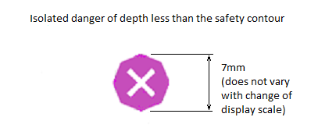

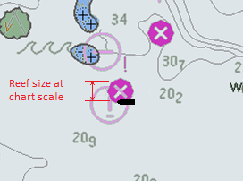 | 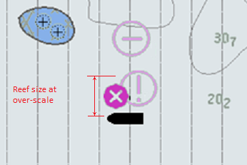
When the ENC is displayed correctly, the danger to a ship close to an isolated danger is clear. | However, when displayed at over-scale, a ship the same unsafe distance from the isolated danger incorrectly appears to be safe because the isolated danger symbol is still the same size.  This is not more accurate, and is definitely not safe.
Figure B-1 – Effect of over-zooming on relationship between point symbol and real-world feature
Remember, the positioning accuracy of the isolated danger may be worse than 500 meters. Routes should be planned to clear these dangers by at least as far as the ZOC category immediately around the danger dictates.

Page intentionally left blank

S-4 B-100.4
S-4 A-102.1
S-4 A-102.2
S-4 B-100.5
S-57 Appendix A, Chapter 2 – page 2.106
S-4 B-294.1
S-4 B-295.2
S-4 B-416
S-4 B-417
S-4 B-297.4
S-4 B-297.6
S-57 Appendix B.1 Annex A UOC Edition 4.1.0
S-57 Appendix A, Chapter 2 – Attributes
From Navigation Purpose 3 and 4 ENC in 2015, covering 14,218,244 SQ KM. The analysis did not include ports.

