PRIMAR response to DQWG Action (DQWG16/07):

Date for database extraction: 2021-11-05
Query: Extract M_QUAL CATZOC encoding, present based on ENC usage bands. Result:
- Table 1/Figure 1 presenting how many instances of a CATZOC category that has been encoded on a usage band, and the percentage according to the total of all CATZOC encodings available within each usage band.
- Table 2/Figure 2 presenting how many instances of a CATZOC category that has been encoded on a usage band, and the percentage within the CATZOC category.
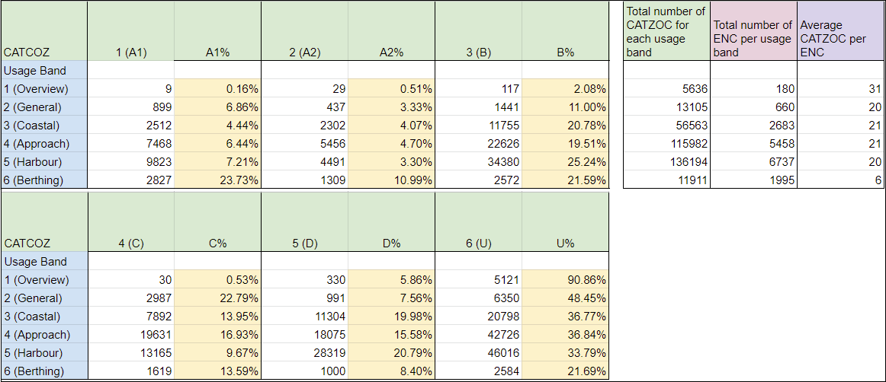
Table 1: Instances of CATZOC per usage band presented by number of instances. (%) indicates amount of CATZOC encodings against total of all CATZOC encodings available within the usage band (e.g., in usage band 1 CATZOC A1 make up 0.16% of all CATZOC encodings within usage band 1).

Table 1 comments:
- Example of use: For usage band 1 (Overview), 9(0.16%) instances of CATZOC=A1 and 330(5.86%) instances of CATZOC=D has been encoded.
  - Of total amount of CATZOC encodings in usage band 1, 0.16% are encoded with CATZOC=A1
  - Of total amount of CATZOC encodings in usage band 1, 5.86% are encoded with CATZOC=D
- CATZOC category=U is most common in usage band 1(Overview), with 90.86% of all instances encoded.
- Encoding of CATZOC category=U decreases from more than 90% in usage band 1(Overview) to just below 22% in usage band 6 (Berthing).
- A total of 339391 instances of CATZOC encodings are present.
- On average there are several CATZOC encodings within each ENC. (A deeper look into usage band 1 (Overview) reveals that a few numbers of ENCs heighten this number significantly, where the 3 top ENCs have respectively 997, 844 and 682 instances of CATZOC encoded).

The following charts present the distribution of CATZOC encodings per usage band according to table 1:
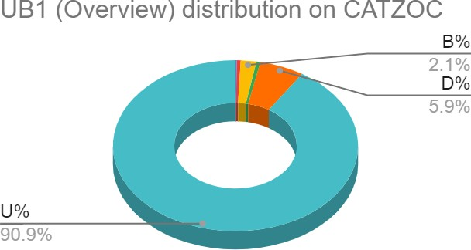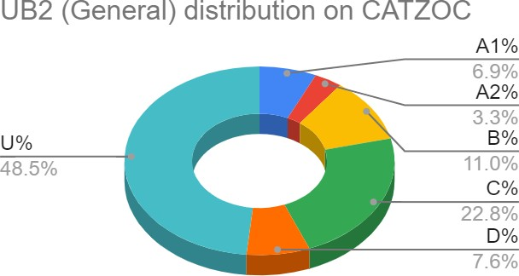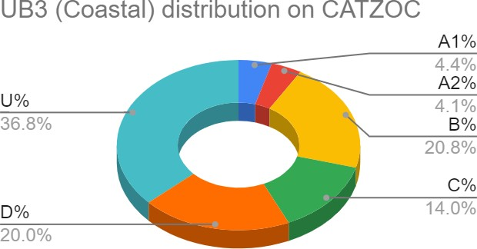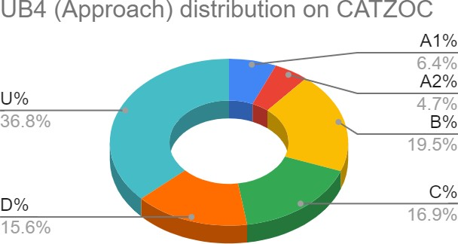

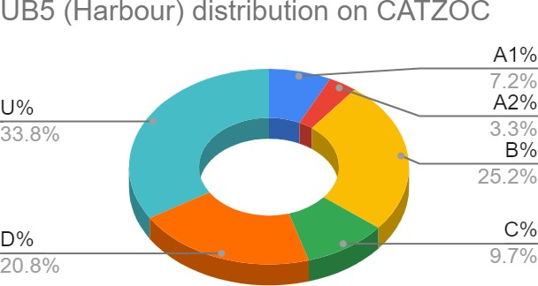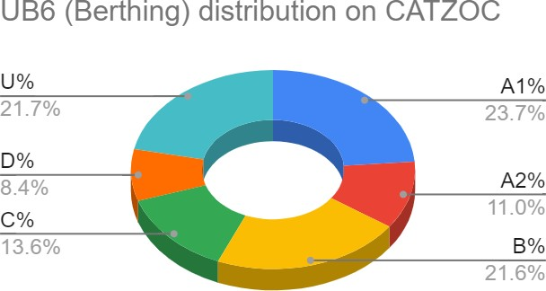Figure 1: Distribution of CATZOC encodings per usage band. Figure 1 comments:
- Example of use:
  - For usage band 3 (Coastal): 36.8% of the CATZOC encodings are CATZOC=U.
  - For usage band 3 (Coastal): 14% of the CATZOC encodings are CATZOC=C.
  - For usage band 6 (Berthing): 21.6% of the CATZOC encodings are CATZOC=B.

- Please note that percentages below 2 % are not represented in the figure (e.g., 0.51% of CATZOC=A2 on usage band 1 (Overview)).

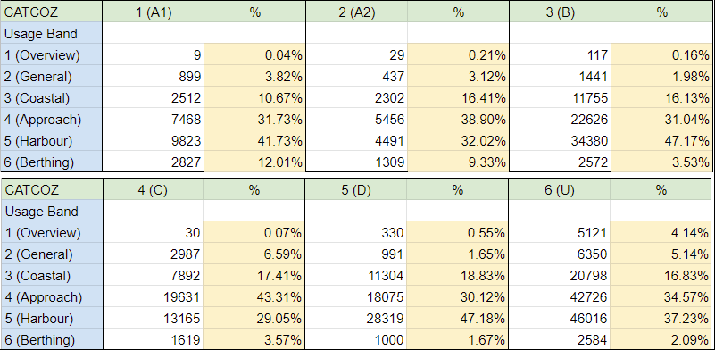
Table 2: Instances of CATZOC per usage band presented by number of instances. (%) indicates amount of CATZOC encodings within each CATZOC category (e.g., in CATZOC D usage band 5 make up 47.18% of all CATZOC encodings in the CATZOC D category).

Table 2 comments:
- Example of use:
  - For CATZOC=D, 991 (1.65%) instances of all CATZOC=D encodings are in usage band 2 (General).
  - For CATZOC=D, 28319 (47.18%) instances of all CATZOC=D encodings are in usage band 5 (Harbour).
- Of all CATZOC=A1 instances, most of them (41.73%) are encoded in usage band 5 (Harbour).
- Of all CATZOC=A2 instances, most of them (38.90%) are encoded in usage band 4 (Approach).
- Of all CATZOC=B instances, most of them (47.17%) are encoded in usage band 5 (Harbour).
- Of all CATZOC=C instances, most of them (43.31%) are encoded in usage band 4 (Approach).
- Of all CATZOC=D instances, most of them (47.18%) are encoded in usage band 5 (Harbour).
- Of all CATZOC=U instances, most of them (37.23%) are encoded in usage band 5 (Harbour).

The following charts present the distribution of usage bands within each CATZOC category:
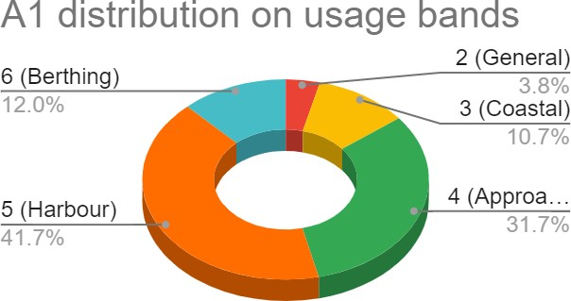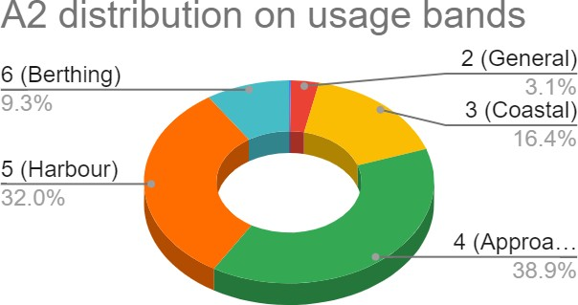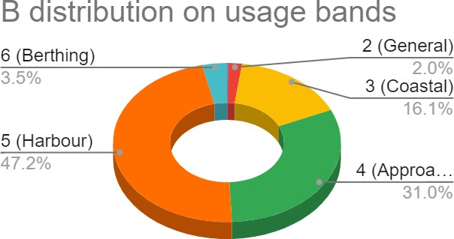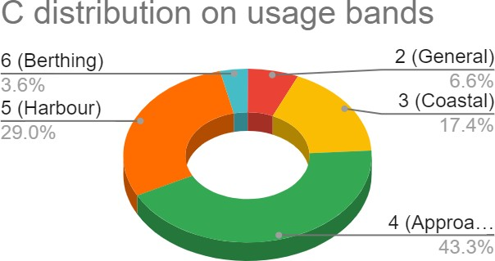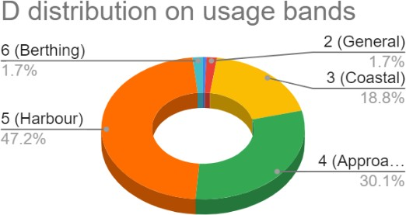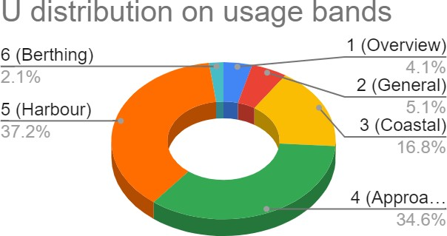

Figure 2: Distribution of usage bands per CATZOC encodings.

Figure 2 comments:
- Example of use: For CATZOC=A1 12% are encoded on usage band 6 (Berthing) and 31.7% are encoded on usage band 4 (Approach).
- Please note that percentages below 1 % are not represented in the figure (e.g., 0.21% of CATZOC=A2 on usage band 1 (Overview)).

