DQWG DQWG19/3/1
Meeting 19 25 Mar 2024
Agenda Item 3.1

Report on the Cross check of DQ chapters of S-100 based product specification
Submitted by review of S-100 Product Specification subWG
SUMMARY
Executive Summary: S-100 Product Specification subWG has carried out the Cross check of DQ chapters of published S-100 based PSs including S-124, S-130, S-131, S-201, S-240, S-401 and S-421. The results show that the implementation of S-97 Part C in these PSs is necessary to be harmonized and improved.
Action to be taken: See paragraph 5&6
Related documents: Action DQWG18/05

1. Introduction/Overview
S-1XX Product Specifications subWG carried out the Cross check of DQ chapters of 10 published S-100 PSs, i.e., S-101, S-102, S-104, S-111, S-121, S-122, S-123, S-127, S-128, and S-129 last year.
According to the action DQWG 18/05, S-100 Product Specification subWG, comprised of Chair, NL, SE, US and UNH, has implemented the Cross check of DQ chapters of 7 published S-100 PSs including S-124, S-130, S-131, S-201, S-240, S-401 and S-421.
2. Principles of the Cross check of DQ chapters
The Cross check of DQ chapters shall follow principles as below:
a) The Cross check shall be carried out in accordance with IHO publication S-97 Ed 1.1.0 - “IHO Guidelines for Creating S-100 Product Specifications”。
b) Only the DQ chapters of S-100 PSs shall be checked and the results presented in the form of a cross-check matrix.
c) DQ elements included in other parts of each S-100 PS shall be described in the form of Notes under the respective cross-check matrix.
3. Implementation process of the Cross check of DQ chapters
3.1 Identify the Required DQ Measures
The recommended data quality measures of each S-100 PS were identified by the subWG according to S-97 part C Table C-7-1 – Recommended data quality measures as shown in Table 1.
Table 1 - DQ requirements for S-100 PSs in S-97
Data Quality Measure | DQ measure / description | Applicable to spatial representation types | S-124 | S-130 | S-131 | S-201 | S-240 | S-401 | S-421
Completeness / Commission | numberOfExcessItems / This data quality measure indicates the number of items in the dataset, that should not have been present in the dataset. | All S-100 based PS | Y | Y | Y | Y | Y | Y | Y
Completeness / Commission | numberOfDuplicateFeatureInstances / This data quality measure indicates the total number of exact duplications of feature instances within the data. | All S-100 based PS | Y | Y | Y | Y | Y | Y | Y
Completeness / Omission | numberOfMissingItems / This data quality measure is an indicator that shows that a specific item is missing in the data. | All S-100 based PS | Y | Y | Y | Y | Y | Y | Y
Logical Consistency / Conceptual Consistency | numberOfInvalidSurfaceOverlaps / This data quality measure is a count of the total number of erroneous overlaps within the data. Which surfaces may overlap and which must not is application dependent. Not all overlapping surfaces are necessarily erroneous. | PS with geometric surfaces. | Y | Y | Y | Y | Y | Y | Y
Logical Consistency / Domain Consistency | numberOfNonconformantItems / This data quality measure is a count of all items in the dataset that are not in conformance with their value domain. | All S-100 based PS | Y | Y | Y | Y | Y | Y | Y
Logical Consistency / Format Consistency | physicalStructureConflictsNumber / This data quality measure is a count of all items in the dataset that are stored in conflict with the physical structure of the dataset. | All S-100 based PS | Y | Y | Y | Y | Y | Y | Y
Logical Consistency / Topological Consistency | rateOfFaultyPointCurveConnections / This data quality measure indicates the number of faulty link-node connections in relation to the number of supposed link-node connections. This data quality measure gives the erroneous point-curve connections in relation to the total number of point-curve connections. | PS with curves. | Y | Y | Y | Y | Y | Y | Y
Logical Consistency / Topological Consistency | numberOfMissingConnectionsUndershoots / This data quality measure is a count of items in the dataset within the parameter tolerance that are mismatched due to undershoots. | PS with curves | Y | Y | Y | Y | Y | Y | Y
Logical Consistency / Topological Consistency | numberOfMissingConnectionsOvershoots / This data quality measure is a count of items in the dataset within the parameter tolerance that are mismatched due to overshoots. | PS with curves. | Y | Y | Y | Y | Y | Y | Y
Logical Consistency / Topological Consistency | numberOfInvalidSlivers / This data quality measure is a count of all items in the dataset that are invalid sliver surfaces. A sliver is an unintended area that occurs when adjacent surfaces are not digitized properly. The borders of the adjacent surfaces may unintentionally gap or overlap to cause a topological error. | PS with geometric surfaces. | Y | Y | Y | Y | Y | Y | Y
Logical Consistency / Topological Consistency | numberOfInvalidSelfIntersects / This data quality measure is a count of all items in the dataset that illegally intersect with themselves. | PS with curves / geometric surfaces. | Y | Y | Y | Y | Y | Y | Y
Logical Consistency / Topological Consistency | numberOfInvalidSelfOverlap / This data quality measure is a count of all items in the dataset that illegally self-overlap. | PS with curves / geometric surfaces. | Y | Y | Y | Y | Y | Y | Y
Positional Accuracy / Absolute or External Accuracy | Root Mean Square Error / Standard deviation, where the true value is not estimated from the observations but known a priori. | PS with objects that have coordinative values associated. | Y | Y | Y | Y | Y | Y | Y
Positional Accuracy / Vertical Position Accuracy | linearMapAccuracy2Sigma / Half length of the interval defined by an upper and lower limit in which the true value lies with probability 95%. | PS with objects that have a vertical coordinative values associated. | Y | N | N | Y | Y | Y | N
Positional Accuracy / Horizontal Position Accuracy | linearMapAccuracy2Sigma / Half length of the interval defined by an upper and lower limit in which the true value lies with probability 95%. | PS with objects that have a horizontal coordinative values associated. | Y | Y | Y | Y | Y | Y | Y
Positional Accuracy / Gridded Data Position Accuracy | Root mean square error of planimetry / Radius of a circle around the given point, in which the true value lies with probability P. | PS with objects that have a gridded coordinative values associated. | N | N | N | N | N | N | N
Temporal Quality / Temporal Consistency | Correctness of ordered events or sequences, if reported. | PS with objects that have a time value associated. | Y | N | Y | Y | Y | Y | N
Thematic Accuracy / Thematic Classification Correctness | miscalculationRate / This data quality measure indicates the number of incorrectly classified features in relation to the number of features that are supposed to be there. [Adapted from ISO 19157]  This is a RATE which is a ratio, and is expressed as a REAL number representing the rational fraction corresponding to the numerator and denominator of the ratio.  For example, if there are 1 items that are classified incorrectly and there are 100 of the items in the dataset then the ratio is 1/100 and the reported rate = 0.01. | All S-100 based PS. | Y | Y | Y | Y | Y | Y | Y
Aggregation Measures / Aggregation Measures | DataProductSpecificationPassed / This data quality measure is a boolean indicating that all requirements in the referred data Product Specification are fulfilled. | PS that a require a complete pass of all elements of a dataset/dataset series/spatial object types | Y | N | Y | Y | Y | Y | Y
Aggregation Measures / Aggregation Measures | DataProductSpecificationFailRate / This data quality measure is a number indicating the number of data Product Specification requirements that are not fulfilled by the current product/dataset in relation to the total number of data Product Specification requirements. | PS that a require a complete pass of all elements of a dataset/dataset series/spatial object types | Y | N | Y | Y | Y | Y | Y
Y= required, N= not required.

3.2 Carry Out the Cross Check
An investigation of DQ chapters of S-124 Ed1.0.0, S-130 Ed1.0.0, S-131 Ed1.0.0, S-201 Ed1.1.0, S-240 Ed1.0.0, S-401 Ed1.0.0 and S-421 Ed1.0.0 was carried out to verify whether the recommended DQ measures (identified in Section 3.1) are included in the respective PSs. The results are presented in the below sub-sections, where Y is for the DQ measures present in the PS, N for those absent, and N/A for those not required per Table 1.
3.2.1 S-124
3.2.1.1 DQ chapters of S-124
The DQ chapter of S-124 is as follow:
3.2.1.2 Result of cross check
Data Quality Measure | S-124
1.Completeness | N
2.Conceptual consistency | N
3. Domain consistency | N
4. Format consistency | N
5. Topological consistency | N
6. Positional Accuracy | N
7. Thematic Accuracy | N
8. Temporal Quality | N
9. Aggregation | N
10. Introduction to DQ Paragraph | Y
Y=YES, N=NO
NOTES:
a）Regarding Measure 10 (“Introduction to DQ Paragraph”)，S-124 does include an introduction, however, this is not in accordance with S-97.
3.2.1.3 DQ elements included in other parts of S-124
No DQ element is included in other parts of S-124.

3.2.2 S-130
3.2.2.1 DQ chapters of S-130
The DQ chapter of S-130 is as follow:
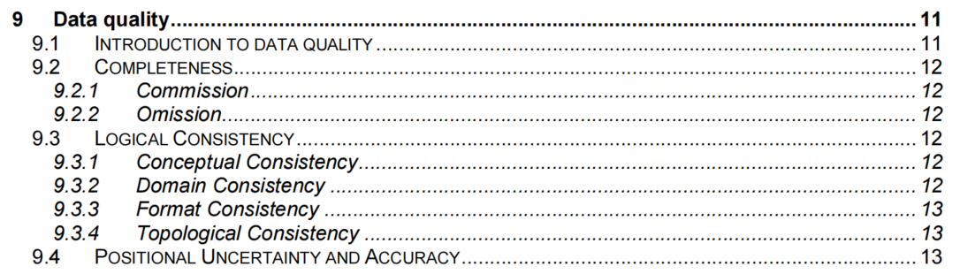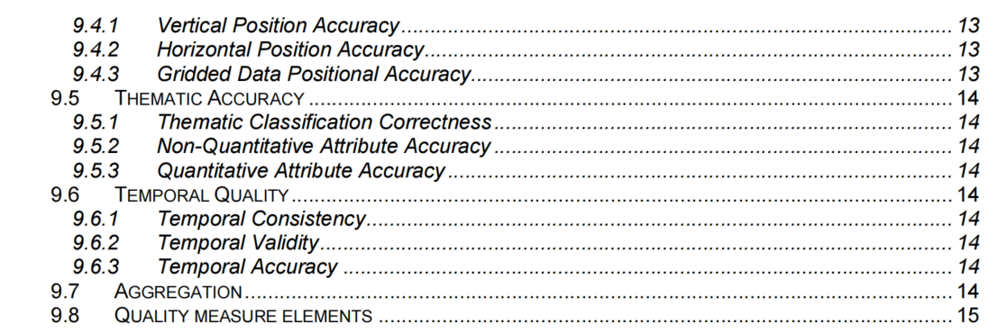
3.2.2.2 Result of Cross check
Data Quality Measure | S-130
1.Completeness | Y
2.Conceptual consistency | Y
3. Domain consistency | Y
4. Format consistency | Y
5. Topological consistency | Y
6. Positional Accuracy | Y
7. Thematic Accuracy | Y
8. Temporal Quality | N/A
9. Aggregation | N/A
10. Introduction to DQ Paragraph | Y
Y=YES, N=NO, N/A=not applicable
NOTES:
-.
3.2.2.3 DQ elements included in other parts of S-130
No DQ element is included in other parts of S-130.

3.2.3 S-131
3.2.3.1 DQ chapters of S-131
The DQ chapter of S-131 is as follow:
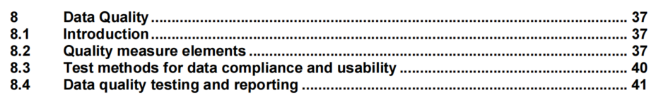
3.2.3.2 Result of cross check
Data Quality Measure | S-131
1.Completeness | Y
2.Conceptual consistency | Y
3. Domain consistency | Y
4. Format consistency | Y
5. Topological consistency | Y
6. Positional Accuracy | Y
7. Thematic Accuracy | Y
8. Temporal Quality | Y
9. Aggregation | Y
10. Introduction to DQ Paragraph | Y
Y=YES, N=NO
NOTES:
a） Regarding Measure 10 (“Introduction to DQ Paragraph”)，S-131 follows the template provided by S-97 but makes the, unnecessary, distinction of positional accuracy to depth and positional (horizontal).
b）Lacks a detailed text description of each quality element.
3.2.3.3 DQ elements included in other parts of S-131
No DQ element is included in other parts of S-131.
3.2.4 S-201
3.2.4.1 DQ chapters of S-201
The DQ chapter of S-201 is as follow:
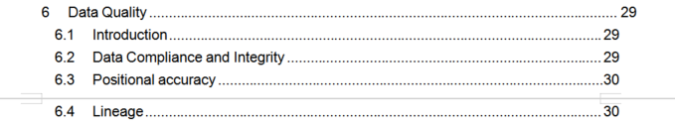
3.2.4.2 Result of cross check
Data Quality Measure | S-201
1.Completeness | N
2.Conceptual consistency | N
3. Domain consistency | N
4. Format consistency | N
5. Topological consistency | N
6. Positional Accuracy | Y
7. Thematic Accuracy | N
8. Temporal Quality | N
9. Aggregation | N
10. Introduction to DQ Paragraph | Y
Y=YES, N=NO
NOTES:
a）Regarding Measure 10 (“Introduction to DQ Paragraph”)，S-201 does include an introduction, however, this is not in accordance with S-97.
3.2.4.3 DQ elements included in other parts of S-201
No DQ element is included in other parts of S-201.

3.2.5 S-240
3.2.5.1 DQ chapters of S-240
The DQ chapter of S-240 is as follow:
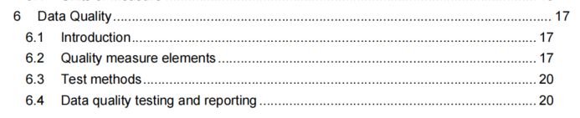
3.2.5.2 Result of cross check
Data Quality Measure | S-240
1.Completeness | Y
2.Conceptual consistency | Y
3. Domain consistency | Y
4. Format consistency | Y
5. Topological consistency | Y
6. Positional Accuracy | Y
7. Thematic Accuracy | Y
8. Temporal Quality | Y
9. Aggregation | Y
10. Introduction to DQ Paragraph | Y
Y=YES, N=NO
NOTES:
a）Lacks a detailed text description of each quality element.
3.2.5.3 DQ elements included in other parts of S-240
No DQ element is included in other parts of S-240.

3.2.6 S-401
3.2.6.1 DQ chapters of S-401
The DQ chapter of S-401 is as follow:
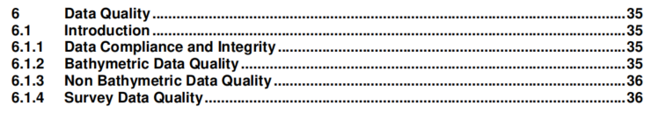

3.2.6.2 Result of cross check
Data Quality Measure | S-401
1.Completeness | N
2.Conceptual consistency | N
3. Domain consistency | N
4. Format consistency | N
5. Topological consistency | N
6. Positional Accuracy | N
7. Thematic Accuracy | N
8. Temporal Quality | N
9. Aggregation | N
10. Introduction to DQ Paragraph | Y
Y=YES, N=NO
NOTES:
-.
3.2.6.3 DQ elements included in other parts of S-401
No DQ element is included in other parts of S-401.

3.2.7 S-421
3.2.7.1 DQ chapters of S-421
There is no DQ chapter in S-421.
3.2.7.2 Result of cross check
Data Quality Measure | S-421
1.Completeness | N
2.Conceptual consistency | N
3. Domain consistency | N
4. Format consistency | N
5. Topological consistency | N
6. Positional Accuracy | N
7. Thematic Accuracy | N
8. Temporal Quality | N/A
9. Aggregation | N
10. Introduction to DQ Paragraph | N
Y=YES, N=NO, N/A=not applicable
NOTES:
-.
3.2.7.3 DQ elements included in other parts of S-421
No DQ element is included in other parts of S-421.

4. Cross-Check Matrix
Data Quality Measure | S-124 | S-130 | S-131 | S-201 | S-240 | S-401 | S-421
1.Completeness | N | Y | Y | N | Y | N | N
2.Conceptual consistency | N | Y | Y | N | Y | N | N
3. Domain consistency | N | Y | Y | N | Y | N | N
4. Format consistency | N | Y | Y | N | Y | N | N
5.Topological consistency | N | Y | Y | N | Y | N | N
6. Positional Accuracy | N | Y | Y | Y | Y | N | N
7. Thematic Accuracy | N | Y | Y | N | Y | N | N
8. Temporal Quality | N | N/A | Y | N | Y | N | N/A
9. Aggregation | N | N/A | Y | N | Y | N | N
10. Introduction to DQ Paragraph | Y | Y | Y | Y | Y | Y | N
Y=YES, N=NO, N/A=not applicable
NOTES:
- There is no DQ chapter in S-421.
b) Similar to the previously reviewed product specifications, DQ chapters of S-124, S-130, S-131, S-201, S-240 and S-401 are not in a harmonized way.
c) DQ chapters of S-124, S-131, S-201, S-240 and S-401 do not conform to the S-97.
d) S-124, S-201 and S-401 do not implement the table C-7-1 – Recommended data quality measures of S-97.
5. Recommendations
It is recommended to:
- Feedback comments and suggestions to developers of S-124, S-130, S-131, S-201, S-240, S-401 and S-421.
- Continue the review of new and amended Product Specifications.
- Invite other S-100 product specifications to join the review.
6. Action
The DQWG is requested to:
- Note the information provided;
- Approve the recommendations above.

