DQWG17 – nn.nn

Paper for Information to S-101PT, S-102PT, TWCWG, CSBWG

Guidelines and recommendations for HOs to allocate CATZOC values

Submitted by: | DQWG subWG
Executive Summary: | At DQWG16, a subWG was formed to develop general guidelines and best practices for HOs to populate appropriate CATZOC values in ENCs. This paper serves as the starting point for this development.
Related Documents: | DQWG Terms of Reference, Bulletin Report DQWG16, S-44 IHO Standards for Hydrographic Surveys (Edition 6.0.0 September 2020), INSPIRE D2.8.II.1 Data Specification on Elevation – Technical Guidelines, IHO Publication C-51 Manual on Technical Aspects on the UN Convention on the Law of the Sea (6th Edition), IHO publications S-4, S-57, S-67, S-101, S-102, B-12
Related Projects: | S-101PT, S-102PT, TWCWG, CSBWG

Introduction / Background
The DQWG should provide guidance on data quality aspects to hydrographic offices, in particular to ensure harmonized implementation (Terms of Reference art.3.b.iv). At DQWG16 (Feb2021, VTC) a dedicated subWG was created to draft guidelines and recommendations to Hydrographic Offices based on best practices to allocate CATZOC values (or S-101 Quality of Bathymetric Data values) from survey data qualified in application of the new Ed. 6.0 of S-44 – IHO Standards for Hydrographic Surveying.
The result of this subWG is to be presented at DQWG17 (8-11 Feb 2022).
This paper serves as a starting point for the work of the subWG. Due to the limited timeframe between DQWG16 and S-102PT VTC (08 March 2021), TWCWG5 (16-18 March 2021) and CSBWG10 (30 March – 01 April 2021), this paper will be presented to these WGs/PT as informative.

Analysis/Discussion
From survey to CATZOC, describes the process from the first ping (data capture) to data storage (S-57, S-101, S-102), validation and finally descriptive quality indicator (CATZOC, QoBD) to provide the end user with meta-information to make an assessment if this dataset will fulfill his/her requirements (fit for purpose). We will discuss each of these elements separately:
- Data capture, associated accuracy and evaluation according to S-44 Ed 6.0.0; (page 2)
- Data storage in S-57 format and S-101 format, depth contours, soundings, depth areas; (page 3)
- Data storage in S-102 format and associated uncertainty values; (page 7)
- Data quality measures and recommended target results (validation); (page 8)
- Assigning appropriate CATZOC (S-57) and Quality of Bathymetric data (S-101) values, (page 10)
- Added value of CSB data. (page 10)
The elevation of a terrain surface, whether land based or bathymetric in nature, is one of the most important descriptors of the Earth‘s morphology. The main purpose of a Digital Elevation Model is to provide an elevation property with reference to a specified origin (vertical reference or datum). This property may be height (when the value is measured opposite to the gravity field of the Earth) or depth (when the value is measured in the direction of the gravity field). Therefore, they share the basic modelling concepts. Integrated land-sea models may be provided using either a height or depth property referenced to a known vertical reference. When an elevation property describes the bare surface of the land or sea floor, the related model is called Digital Terrain Model (DTM). When an elevation property includes the heights of the objects present on the surface (e.g. vegetation, man-made objects) the related model is referred as Digital Surface Model (DSM).

Capturing the elevation of a terrain surface on land is nowadays mostly done from an airplane using a LIDAR sensor. Capturing the depth of the seabed is nowadays done from ship (multibeam, singlebeam), airplane (LIDAR) or satellite (SDB). When measuring from ship, a distinction can be made between 1) official and officially sponsored surveys, 2) unofficial surveys, 3) passage surveys; see also IHO publication S-4, B-611 Credibility of sources.
Official (and officially sponsored) surveys prepared specifically for nautical charting should be validated by competent surveyors. It must be ensured, as far as possible, that any errors and uncertainties arising from the method of surveying are understood and that the survey remains acceptable for use; see IHO publication S-44.
IHO publication S-44 has the following classification of safety of navigation surveys:
Order | Characteristics | Intended usage
2 | General depiction of the bottom is considered adequate. Evenly distributed bathymetric coverage of 5% | Areas deeper than 200m. Existence of features that are large enough to impact on surface navigation and yet still remain undetected is considered to be unlikely.
1b | General depiction of the bottom is considered adequate. Evenly distributed bathymetric coverage of 5% | Only recommended where underkeel clearance is considered not to be an issue. An example would be an area where the bottom characteristics are such that the likelihood of there being a feature on the bottom that will endanger the type of surface vessel expected to navigate the area is low.
1a | 100% feature search, bathymetric coverage less than or equal to 100% is appropriate as long as the least depths over all significant features are obtained and the bathymetry provides an adequate depiction of the nature of the bottom topography. | Coastal waters, harbours, berthing areas, fairways and channels.  Underkeel clearance becomes less critical as depth increases, so the size of the feature to be detected increases with depth in areas where the water depth is greater than 40 meters.
Special | 100% feature search and 100% bathymetric coverage. Size of the features to be detected is more demanding than order 1a. | Areas where underkeel clearance is critical. Examples are: berthing areas, harbours and critical areas of fairways and shipping channels.
Exclusive | 200% feature search and 200% bathymetric coverage. Size of the features to be detected is more demanding than special order. | Shallow water areas (harbours, berthing areas and critical areas of fairways and channels) where there is an exceptional and optimal use of the water column and where specific critical areas with minimum underkeel clearance and bottom characteristics are potentially hazardous to vessels.
Table 1: S-44 Classifications

Horizontal and vertical positioning and its associated uncertainty.
Positioning is a fundamental part for every survey operation. The hydrographer must consider the geodetic reference frame, horizontal and vertical reference systems, their connections to other systems in use (e.g. land survey datums), as well as the uncertainty inherent within associated measurements. In this standard, position and its uncertainty refer to the horizontal component of the sounding or feature, while the depth and its uncertainty refers to the vertical component of the same sounding or feature. Annex B provides background information on the realizations of geodetic reference frame, horizontal and vertical coordinate reference systems.

Horizontal Reference System:
If horizontal positions are referenced to a local datum, the name and epoch of the datum should be specified and the datum should be tied to a realisation of a global (e.g. ITRF2018, WGS84(G1762)) or a regional (e.g. ETRS89, NAD83) reference frame and their later iterations. Transformations between reference frames/epochs should be taken into account, especially for surveys with low uncertainty (very accurate GNSS positioning).

Vertical Reference System:
If the vertical component of the positions is referenced to a local vertical datum, the name and epoch of the datum should be specified. The vertical component of the positions (e.g. depths, drying heights) should be referenced to a vertical reference frame that is suitable for the data type and intended use. This vertical reference frame may be based on tidal observations (e.g. LAT, MWL, etc.), on a physical model (i.e. geoid) or a reference ellipsoid.

Chart and Land Survey Vertical Datum Connections:
In order for bathymetric data to be correctly and fully utilised, chart and land survey vertical datum connections or relationships must be clearly determined and described. The IHO Resolution on Datums and Benchmarks, Resolution 3/1919, as amended, resolves practices which, where applicable, should be followed in the determination of these vertical datum connections. This essential resolution 3/1919, as amended, is available in the IHO Publication M-3, Resolutions of the International Hydrographic Organization, which is downloadable from the IHO homepage www.iho.int. Examples of DTM/DSM on land and sea are provided in Annex C.

Data Storage
The DTM/DSM can be stored in a vector model (S-57, S-101) or grid model (S-102). The vector model consists of land elevation and bathymetry elements in the form of spot elevations and contour lines. Grid representation is based on a coverage geometry, indicating elevation values at the points of a rectified grid.

The storage of a DTM/DSM in S-57 is described in S-57 Appendix B.1: ENC Product Specification, Annex A: Use of the Object Catalogue for ENC, Edition 4.2.0 – April 2020.

Heights and elevations (on land)
If it is required to encode the altitude of natural features (for example hills, coastlines, slopes), with the exception of trees, it must be done using the attribute ELEVAT (figure 1 - a).
For artificial features (for example landmarks, buildings) or trees:
• If it is required to encode the altitude of the ground level at the base of the object, it must be done using ELEVAT (figure 1 - b).
• If it is required to encode the altitude of the highest point of the object, it must be done using the attribute HEIGHT (figure 1 - c).
• If it is required to encode the height of the object above ground level, it must be done using the attribute VERLEN (figure 1 - d).

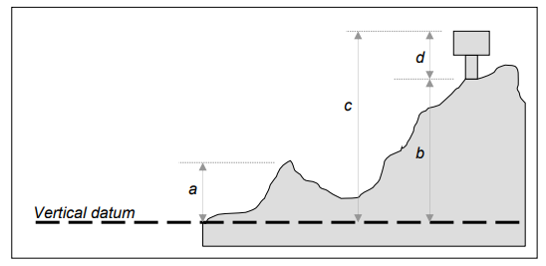
Figure 1 – heights and elevations (source IHO Publication S-57 UoC)

Depth contours
Geo object: Depth contour (DEPCNT)
Attributes: VALDCO – value of depth contour
VERDAT – INFORM NINFOM

Soundings
Geo Object: Sounding (SOUNDG)
Attributes: EXPSOU (exposition of sounding)
NOBJNM OBJNAM (object name)
QUASOU (quality of sounding measurement)
SOUACC (sounding accuracy) – see the use of the meta object M_QUAL
STATUS
TECSOU (technique of sounding measurement) – only for lower reliability soundings.
VERDAT (vertical datum)
INFORM
NINFOM
SORDAT (source date) – the production date of the source, e.g. the date of measurement

Depth Areas
Geo Object: Depth Area (DEPARE)
Attributes: DRVAL1 (depth range value 1) – shoalest
DRVAL2 (depth range value 2) – deepest
QUASOU (quality of sounding measurement)
SOUACC
VERDAT
INFORM
NINFOM

Geometry of depth areas
Where areas are not closed on the source, it may be necessary to close these areas using edges without associated line objects. This is mandatory at the boundary of a cell. As many depth areas as possible must be created using encoded depth contours.
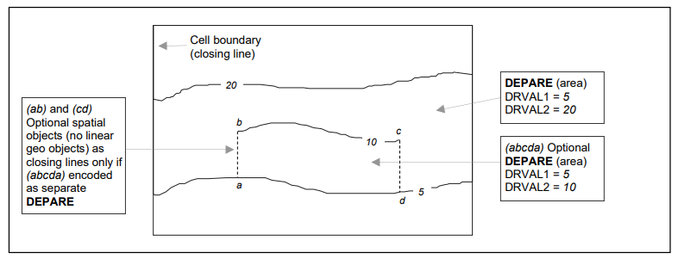
Figure 2: - Geometry of depth areas (source S-57 UoC)

Depth discontinuities between surveys
Depth discontinuities between adjoining or overlapping source bathymetric surveys may be caused by:
• Surveys in areas of continually changing depth (see clause 5.7) conducted with a significant time gap between the surveys; or
• Adjoining areas having significant differences in the quality of bathymetric data (see clause 2.2.3.1).
It may not be possible to safely resolve significant depth discontinuity by interpolating approximate depth contours, which may compromise the ability for the compiler to adequately encode complete, non-overlapping Group 1 coverage of the area of the ENC cell covered by data. Where it is required to indicate these significant depth discontinuities, it should be done by encoding a “very narrow” UNSARE object (see clause 5.8.1).
The “very narrow area” should be at least 0.3mm in width at ENC compilation scale (see clause 2.2.6).
Remarks:
• An indication of the purpose of the UNSARE may be done by population of the attribute INFORM, for example Discontinuity between surveys.
• In order to provide an indication to the mariner of the more reliable encoded bathymetry in an area of continually changing depth, the attribute CATZOC should be downgraded for the M_QUAL object (see clause 2.2.3.1) corresponding to the less reliable (or older) data.

The storage of a DTM/DSM in S-101 is described in the S-101 Annex A – Data Classification and Encoding Guide (DCEG) Edition 1.0.1 March 2021.

Depth contour
S-101 Geo Feature: Depth Contour (DEPCNT)
Primitives: Curve
S-101 Attribute: value of depth contour (VALDCO) – multiplicity 1,1
scale minimum (SCAMIN) – multiplicity 0,1

Sounding
S-101 Geo Feature: Sounding (SOUNDG)
Primitives: Pointset
S-101 Attribute: feature name – multiplicity 0,*
display name – multiplicity 0,*
language – multiplicity 0,*
name (OBJNAM, NOBJNM) – multiplicity 1,1
quality of vertical measurement (QUASOU) – multiplicity 0,*
reported date (SORDAT) – multiplicity 0,1
status (STATUS) - multiplicity 0,1 (only one value possible: existence doubtful)
technique of vertical measurement (TECSOU) – multiplicity 0,*
vertical uncertainty – multiplicity 0,1 (multiplicity is proposed to be 1,1 by S-101PT)
uncertainty fixed (SOUACC) – multiplicity 1,1
uncertainty variable – multiplicity 0,1
scale minimum (SCAMIN) – multiplicity 0,1

Depth Areas
S-101 Geo Feature: Depth Area (DEPARE)
Primitives: Surface
S-101 Attribute: depth range maximum value (DRVAL2) – multiplicity 1,1
depth range minimum value (DRVAL1) - multiplicity 1,1

Geometry of depth areas
Where surfaces are not closed on the source, it may be necessary to close these surfaces using edges without associated curve features. This is mandatory at the boundary of a dataset (see Figure 3 below).
In Figure 3 below, the annotation “min” equates to the attribute depth range minimum value and the annotation “max” equates to the attribute depth range maximum value.

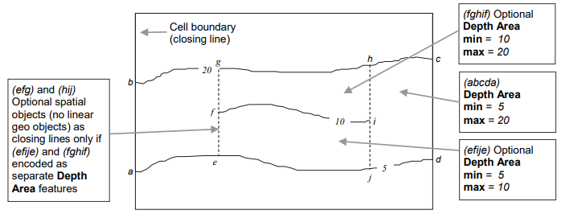
Figure 3: geometry of depth areas (source S-101 DCEG)

For short isolated sections of Depth Contour features such as (fi), it is up to the producing authority whether to encode the small areas (efije and fghif) as separate Depth Area features, or to encode only the curve (fi) as a floating Depth Contour feature within a single Depth Area (abcda) having attributes depth range minimum value = 5 and depth range maximum value = 20. NOTE: In Figure 3, if the optional Depth Area features are encoded, the depth area (abcda) will be split into two separate Depth Area features (abgea) and (jhcdj), both having depth range minimum value = 5 and depth range maximum value = 20.

The storage of a DTM/DSM in S-102 is described in the S-102 Bathymetric Surface Product Specification (Edition 2.0.0 October 2019). The S-102 Feature Catalogue layout is:

classification | unclassified
Simple Attribute
name | Depth
definition | the vertical distance from a given water level to the bottom
code | depth
alias | DEPTH
value Type | real
Simple Attribute
name | uncertainty
definition | The interval (about a given value) that will contain the true value of the measurement at a specific confidence level
code | uncertainty
remarks | Represents a +/- value defining the possible range of associated depth expressed a positive number
value Type | real
Feature Type
name | Bathymetry Coverage
definition | A set of value items required to define a dataset representing an depth calculation and its associated uncertainty.
code | BathymetryCoverage
multiplicity | 1..1 (always 1)
attribute ref | depth
multiplicity | 1..1 (always 1)
attribute ref | uncertainty
feature Use Type | geographic
permitted Primitives | coverage
Table 2: layout of the S-102 Feature Catalogue

Data quality elements and recommended target results

DQ element / sub-element | Definition | Evaluation scope | Application to spatial representation types
 |  |  | Vector | Grid
Completeness / Commission | excess data present in the dataset. | dataset / dataset series | X
Completeness / Omission | data absent from the dataset. | dataset / dataset series / spatial object type | X | X
Logical consistency / Conceptual consistency | adherence to rules of the conceptual schema | spatial object / spatial object type | X | X
Logical consistency /  Domain consistency | adherence of values to the value domains | spatial object / spatial object type | X
Logical consistency /  Format consistency | degree to which data is stored in accordance with the physical structure of the dataset, as described by the scope | dataset / dataset series | X | X
Logical consistency /  Topological consistency | correctness of the explicitly encoded topological characteristics of the dataset, as described by the scope | spatial object type / dataset series / dataset | X
Positional accuracy /  Absolute or external accuracy | closeness of reported coordinate values to values accepted as or being true | spatial object / spatial object type / dataset series / dataset | horizontal component
 |  |  | vertical component | vertical component
Positional accuracy /  Gridded data position accuracy | closeness of gridded data position values to values accepted as or being true | spatial object / spatial object type / dataset series / dataset |  | horizontal component
Table 3: Data quality elements for depth

Below some examples of DQ measures for depth contours regarding topological consistency:
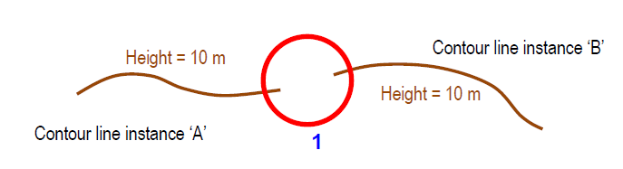
Figure 4: example of missing connections due to undershoots

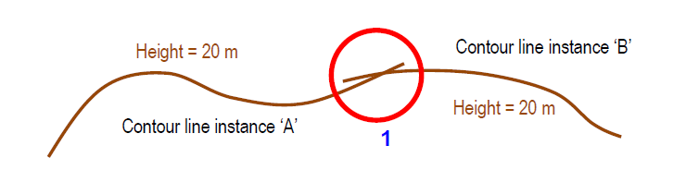

Figure 5: example of rate of missing connections due to overshoots

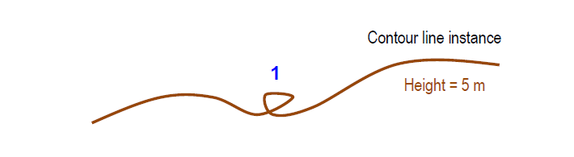

Figure 6: example of rate of invalid self-intersect errors

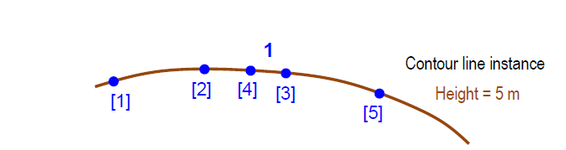
Figure 7: example of rate of invalid self-overlap errors (• vertices [digitized order] )

Recommended minimum data quality results for depth (to be discussed and agreed upon)
nr | Data quality element and sub-element | Measure name(s) | Target result(s) | Condition
1 | Completeness / Commission | Rate of excess items | 0 % | Data duplication can be checked and corrected automatically
2 | Completeness / Omission | Rate of missing items | 0%
3 | Logical consistency /  Conceptual consistency | Non-compliance rate with respect to the rules of the conceptual schema | 0%
4 | Logical consistency /  Domain consistency | Value domain non-conformance rate | 0% | Quality controls and data editing can be performed automatically
5 | Logical consistency /  Format consistency | Physical structure conflict rate | 0%
6 | Logical consistency /  Topological consistency | Rate of missing connections due to undershoots | 0%
 |  | Rate of missing connections due to overshoots | 0%
 |  | Rate of invalid self-intersect errors | 0%
 |  | Rate of invalid self-overlap errors | 0%
7 | Positional accuracy /  Absolute or external accuracy | Root mean square error of planimetry | Vector  Horizontal (m)  Max RMSE_{H} = E / 10000
 |  | Root mean square error | Vector  Vertical (m)  Max RMSE_{V} =V_{int} / 6  Note: V_{int} can be approximated by  E / 1000 | In low reliability areas the maximum error can be increased by 50%
Grid
Vertical (m)
Max RMSE_{v} = GSD / 3
8 | Positional accuracy /  Gridded data position accuracy | Root mean square error of planimetry | Grid  Horizontal (m)  Max RMSE_{H} = GSD / 6
Table 4: recommended minimum data quality results

NOTE The following notation is used:
E Denominator of the intended scale of mapping. (compilation scale)
V_{int} Normal contour line vertical interval.
GSD Ground sample distance

Consistency between spatial data sets:
There are three topic areas regarding consistency between spatial data sets, these are:
- Coherence between spatial objects of the same theme at different levels of detail.
- Coherence between different spatial objects within the same area.
- Coherence at state (maritime) boundaries.

Self-consistency of elevation data
Elevation data in the different spatial representation types should maintain integrity and positional consistency, at least when coming from the same data provider.

Consistency of elevation data with other themes
This requires a certain level of geometrical consistency so that all spatial objects being combined match within the limits of their respective accuracy. Data integrity demands that this data should be spatially consistent to ensure both a faithful representation of the real world and a professional appearance that will fill the user with confidence. This is perceived as achievable at least for data at the same level of detail (similar resolution).

Assigning appropriate CATZOC (S-57) and Quality of Bathymetric data (S-101) values
S-57 Annex A paragraph 2.2 Data quality description provides the existing guidance of how HOs should populate information about quality, reliability and accuracy of bathymetric data. The meta object M_QUAL for an assessment of the quality of bathymetric data is mandatory for areas containing depth data or bathymetry. More detailed information about CATZOC can be found in IHO Publication S-67.

The guidance of how to assign appropriate CATZOC values, based on the quality of the data capture process, described in the quality report according to S-44, the connection to the accuracy and quality of the depth contours, soundings and completeness of seabed coverage, taking into account the intended scale of mapping, is further to be discussed by the DQWG subWG.

Added value of CSB data
Data capture by official (hydrographic) surveys are done to capture the shape of the seabed and process this data into an official nautical chart. The captured data is validated against acquisition standards (S-44), then Product Specification (S-57) and User requirement (guaranteed use in certified ECDIS equipment by trained and certified user).
In order to assess the usefulness of CSB data to the nautical chart, metaquality is recommended to be used.

Metaquality elements are a set of quantitative and qualitative statements about a quality evaluation and its results. The knowledge about the quality and the suitability of the evaluation method, the measure applied and the given result may be of the same importance as the result itself.
Metaquality may be described using the following elements:
- confidence – trustworthiness of a data quality result.
- representativity – degree to which the sample used has produced a result which is representative of the data within the data quality scope
- homogeneity – expected or tested uniformity of the results obtained for a data quality evaluation

NOTE quantitative figures for confidence can be obtained by statistical parameters such as standard deviation or a confidence interval on a given confidence level.

Conclusions and recommendations
- Depth data can be represented by a vector model (S-57/S-101) and/or a grid model (S-102). The Producing Authority of an ENC, who also provides depth data in S-102 format, should ensure consistency between the two datasets (maintain integrity and positional consistency).
- In order to ensure consistency, as a minimum, the same vertical datum and realization of that vertical datum should be used when datasets are provided by the same Producing Authority.
- Coherence of depth data at different levels of detail should be maintained.
- There is a possible relationship between the ground sampling distance of the data captured, the intended scale of mapping and normal contour line vertical interval. This is further to be investigated to ensure that in a chart not too many contour lines are depicted giving a false sense of accuracy.
- Depth data has an associated uncertainty (mainly in a vertical sense). When combining different datasets, these uncertainties provide a degree of confidence to which data is the most representative to depict the shape of the seabed and additional man-made structures (wrecks).
- Using the associated uncertainties presented as meta-quality data, CSB may have additional value to existing nautical charts, most likely in areas where no gridded data exists and where soundings and depth contours have a high degree of uncertainty (remote areas).

Justification and Impacts
- S-101 and S-102 are under development. Combining datasets of these types of data requires appropriate data quality elements and appropriate meta-quality information (CATZOC) to the Mariner in order to asses a safe route planning and execution of voyage.
- Datasets provided by adjacent Producing Authorities may provide different depictions of the shape of the seabed and associated quality indicators. This paper provides some tools to make an assessment of the self-consistency of datasets produced by one Producing Authority and may explain the differences to datasets produced by the adjacent Producing Authority.
- This paper may help Producing Authorities to have more confidence in including CSB data into their nautical charts where they feel it is appropriate to do so.

Action Required of the DQWG subWG
The DQWG subWG is invited to:
- Note this paper;
- Start the work on draft guidelines and recommendations to Hydrographic Offices based on best practices to allocate CATZOC values (or S-101 Quality of Bathymetric Data values) from survey data qualified in application of the new Ed. 6.0 of S-44 – IHO Standards for Hydrographic Surveying.

ANNEX A: Terms and definitions:

CATZOC Category of Zone of Confidence
CD Chart Datum (also known as Sounding Datum)
Vertical coordinate reference system which is used to refer and portray depth measurements as property values. (INSPIRE D2.8.II.1)
Contour line Linear spatial object composed of a set of adjoining locations characterized by having the same elevation property value. It describes, together with other contour lines present in the area, the local morphology of the Earth's surface. (INSPIRE D2.8.II.1)
CRS Coordinate Reference System
CSBWG Crowdsourced Bathymetry Working Group
DCEG S-101 Data Classification and Encoding Guide
DEM Digital Elevation Model
Depth Elevation property measured along a plumb line in a direction coincident to Earth’s gravity field. (INSPIRE D2.8.II.1)
Depth area A water area whose depth is within a defined range of values
Depth contour A line connecting points of equal water depth (S-57)
DQWG Data Quality Working Group
DSM Digital Surface Model
DTM Digital Terrain Model
EGM2008 Earth Gravity Model 2008 (realization 2008)
ETRS89 European Terrestrial Reference System 89 (realization 1989)
Height Elevation property measured along a plumb line in a direction opposite to Earth’s gravity field. (INSPIRE D2.8.II.1)
ITRF International Terrestrial Reference Frame
ITRS International Terrestrial Reference System
MSL Mean Sea Level
NAD83 North American Datum 83 (realization 1983)
S-4 Regulations for International (INT) Charts and Chart Specifications of the IHO
S-44 IHO Standards for Hydrographic Surveys
S-101 ENC Product Specification
S-101PT S-101 Project Team
S-102 Bathymetric Surface Product Specification
S-102PT S-102 Project Team
S-57 IHO Transfer Standard for Digital Hydrographic Data
S-67 Mariner’s Guide to Accuracy of Depth Information in Electronic Navigational Charts
SDB Satellite Derived Bathymetry
TWCWG Tides, Water Levels and Current Working Group
Uncertainty Estimate characterising the range of values within which the true value of a measurement is expected to lie as defined within a particular confidence level. It is expressed as a positive value.
WGS 84 World Geodetic System 1984 (realization 1984)

ANNEX B: Realization of geodetic reference frame and horizontal and vertical coordinate reference systems.

IHO Publication C-51 Manual on Technical Aspects on the UN Convention on the Law of the Sea (6th Edition), Chapter 2 – Geodesy and positioning, provides an in-depth reading to the establishment of modern space geodesy, geodetic datums, vertical datums and satellite positioning. For this paper, a summary with images is presented below.
The locations of points in three-dimensional space are most conveniently described by Cartesian coordinates: X,Y and Z. Since the start of the Space Age, such coordinate systems are typically “geocentric”, with the Z-axis aligned with either the Earth’s conventionally defined or instantaneous rotation axis. Because the Earth’s geocentre, or centre of mass, is located at one focus of a satellite’s orbital ellipse, this point is the natural origin of a coordinate system defined by satellite-based geodetic methods. The International Celestial Reference System (ICRS) forms the basis for describing celestial coordinates, and the International Terrestrial Reference System (ITRS) is the foundation for the definition of terrestrial coordinates to the highest possible accuracy. The definitions of these systems include the orientation and origin of their axes, scale, physical constants and models used in their realisation, e.g., the size, shape and orientation of the “reference ellipsoid” that approximates the geoid and the Earth’s gravity field model. The coordinate transformation between the ICRS and ITRS is described by a sequence of rotations that account for precession, nutation, Greenwich apparent sidereal time, and polar motion, which collectively account for variations in the orientation of the Earth’s rotation axis and its rotational speed.
While a reference system is a mathematical abstraction, its practical realisation through geodetic observations is known as a “reference frame”. The conventional realisation of the ITRS is the International Terrestrial Reference Frame (ITRF), which is a set of coordinates and linear velocities (the latter due mainly to crustal deformation and tectonic plate motion) of well-defined fundamental ground stations.
The solid surface of the Earth (including the sea floor) consists of a number of large tectonic plates (and many smaller ones whose boundaries are less well defined) that slide across the Lithosphere, in the process colliding with other plates. The speed of the plates may be as high as a decimetre or more per year, though typically tectonic plate motion is of the order of a few centimetres per year relative to a fixed coordinate framework. That framework is realised by the fixed axes of the ITRF.

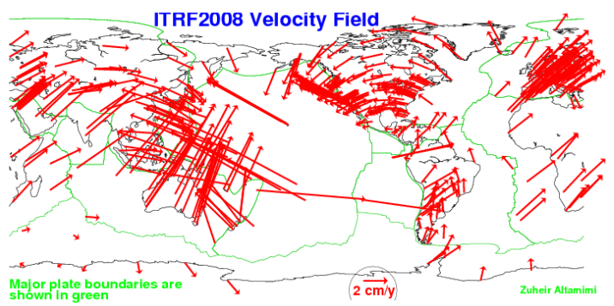
Figure 8: Global model of the Earth’s tectonic plates with estimated velocities (ITRF2008, 2012)

The geoid:
The word geoid is used to designate that special equipotential or geopotential surface which coincides with, but is not exactly equivalent to, the mean sea level (MSL) surface of the oceans in an average sense. It is that surface to which the oceans would conform over the entire Earth, if free to adjust to the combined effect of the Earth's mass attraction and the centrifugal force of the Earth's rotation, the forces of which are collectively referred to as the Earth’s gravity field. Although the above definition refers to sea level, conceptually the geoid extends under the continents and differs from a best fitting ellipsoid by vertical distances that are up to one hundred metres or so.
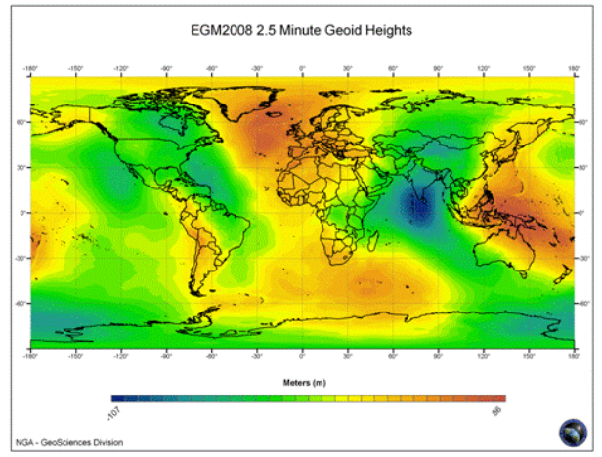
Figure 9: Earth Gravity Model EGM2008 geoid heights, derived from a combination of surface gravity data principally on land, satellite altimetry over ocean areas and an analysis of the observed orbit perturbations of many near-Earth satellites (EGM2008, 2012)
The reference ellipsoid:
The geoid is a very irregularly shaped surface (Figure 9) and therefore for geodetic and mapping purposes it has been necessary to use a simplified geometric shape – the ellipsoid which closely approximates the shape of the geoid for all calculations. The IAG recommends the use of the “GRS80” reference ellipsoid. However, the slightly different WGS84 ellipsoid is also commonly used. A reference ellipsoid with its centre at the geocentre best fits, in a geometric sense, the geoid globally – resulting in the maximum separation of these two surfaces being of the order of 100 metres (Figure 10). The geoid height is mathematically defined as so many metres above (+N) or below (-N) a given ellipsoid (Figure 11)
H = H + N
Where:
H – geodetic height (height above the ellipsoid)
H = height above MSL
N – geoidal height
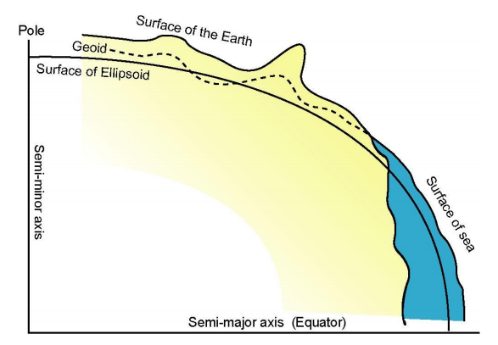
Figure 10: A meridian section of the Earth showing the various physical and mathematical surfaces used in geodesy.

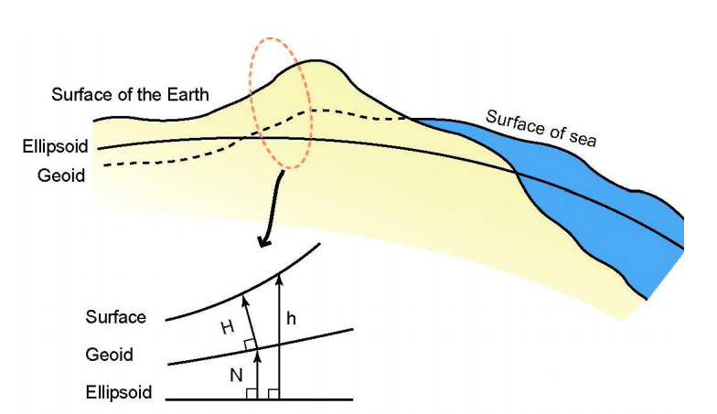
Figure 11:Geodetic height (h), orthometric height (H), geoid height (N) and their interrelations

Transformation between geodetic datums:
The parameters of the transformation between two geodetic datums are determined empirically from the coordinates of a set of identical points on both datums. These positions are always distorted due to the inevitable presence of both systematic and random errors, and hence the determination of transformation parameters must be done carefully. It is recommended that the transformation parameters relevant to a State’s datum be obtained from the appropriate national mapping or charting agency. There are also published 14-parameter transformation models that incorporate time-rate-of-change of the standard 7 similarity transformation parameters. With such a model, it is possible to both accommodate epoch year differences between datums, as well as origin, orientation and scale effects.
Vertical datums:
For land height systems, the geoid and MSL are assumed to coincide at the fundamental benchmark(s) or tide gauge(s) that define(s) a State’s geodetic height datum to which heights on land maps are referred (see Figure 12). A high water level, determined by some procedure that samples the high tide, may define the so-called hydrographic shoreline, where land mapping transitions to marine charting. In some countries a high water level marks the limit of land property that can be registered in a cadastre (register of rights of property owners).
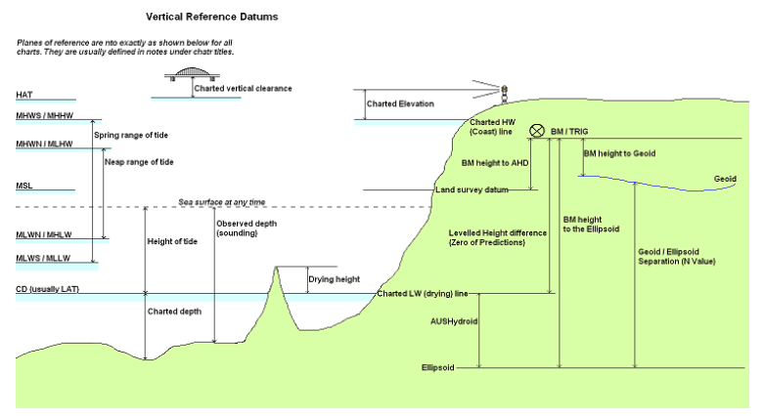
Figure 12: Vertical datums for mapping and charting (courtesy Australian Hydrographic Office)

Chart Datum:
To provide the mariner with a margin of safety in terms of depth measurements, all charted depths are referred to chart datum, which is equated to the datum of tidal predictions and defined by the IHO as a plane so low that the tide will not frequently fall below it (see Figure 12). Thus, unlike heights on land maps, which are normally referred to MSL as a proxy surface for the geoid, depths on charts are referred to a low water level. For the determination of chart datum, it is necessary to observe heights of points above the low water. Thus, the height of low water below MSL must be determined. This is done by analysing the records of tide gauges from the vicinity of the area of interest, which may require a specific expertise that is generally available within a State’s hydrographic survey authority or harbour port authorities.
Owing to the many varied tidal characteristics existing throughout the world, a precise, scientific definition for chart datum, which could be used universally, has not been agreed upon. Over the past 200 years, different countries have adopted different methods for computing chart datum, depending usually on the type of prevailing tide. In accordance with an IHO Resolution of 1926, chart datum should:
- Be so low that the water will but seldom fall below it.
- Not be so low as to cause the charted depths to be unrealistically deep.
- Very only gradually from area to area and from chart to chart to adjoining chart, to avoid significant discontinuities.
In very basic terms, a chart datum can be defined as the mean of specific low waters over an extended period of time. The time period should ideally be 19 years or more, in order to include all the significant astronomical variations described above. Opinions vary, however, in terms of which low waters should be used to arrive at this mean value, and as a result different definitions are in use. For example, some countries define chart datum as the mean of all the lower low waters (MLLW) over a specified 19 year period. Others use a chart datum called lower low water large tides (LLWLT), which is defined as the average of the lowest low waters, one from each of 19 years of prediction. Yet others use the lowest low water spring tide (LLWST), which is the average of the lowest low water observations of spring tides, over a specified period. The most conservative use the lowest astronomical tide (LAT), which is the lowest level that can be predicted to occur under average meteorological conditions and under a combination of astronomical conditions (see Figure 12).

ANNEX C: Examples

The data models incorporated are aimed at describing the three-dimensional shape of the Earth‘s surface in terms of Elevation properties, either height or depth. Both properties are constrained to the physical vertical dimension, measured along the plumb line from a well defined surface, such as a geoid or a specific water level. The orientation of the positive axis is opposite to the Earth's gravity field in the case of the height property (upwards) and coincident to the Earth's gravity field in the case of the depth property (downwards). Hence, heights are positive above the surface taken as origin whereas depths are positive below it, as show in the next figures.

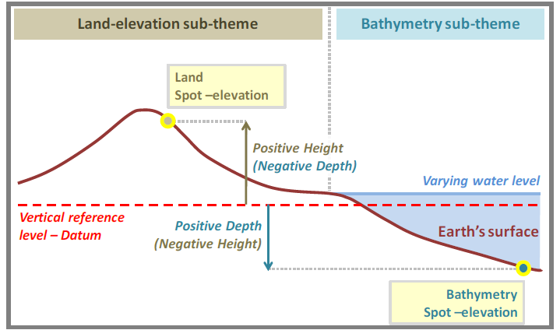
Figure 13 Measuring of elevation properties

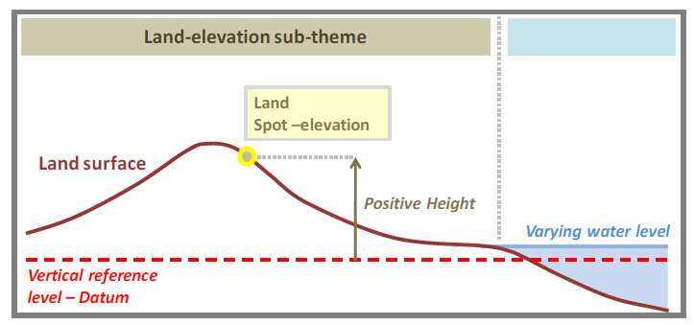
Figure 14 Description of land elevation

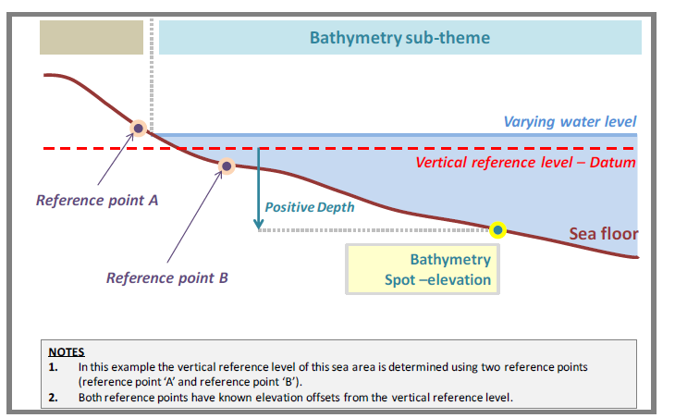
Figure 15 Description of the sea floor

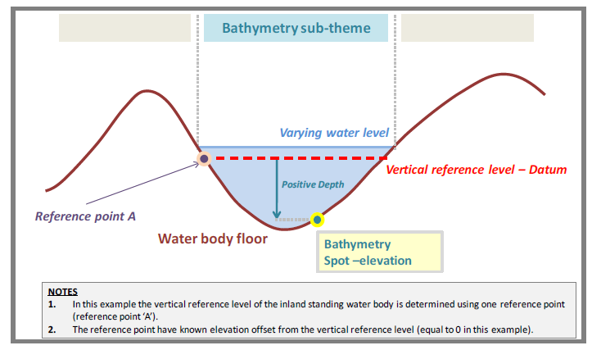
Figure 16 Description of the floor of an inland standing water body

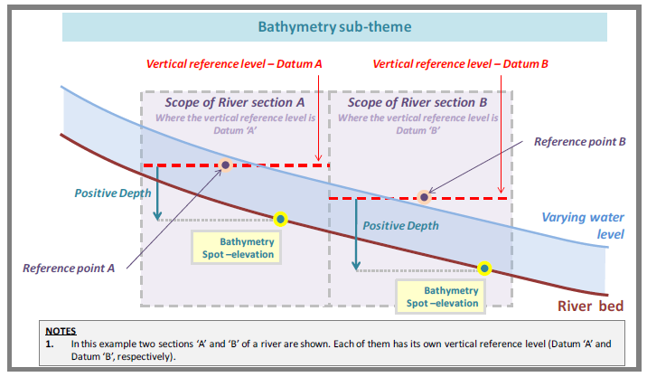
Figure 17 Description of the bed of a navigable river

INSPIRE D2.8.II.1 Data Specification on Elevation – Technical Guidelines
Satellite Derived Bathymetry
IHO Publication S-4 Regulations for International (INT) Charts and Chart Specifications of the IHO (Nov 2018) , item B-611.1
IHO Publication S-44 Ed.6.0.0 Chapter 1
IHO Publication S-44 Ed.6.0.0 Chapter 2
IHO Publication S-44 Ed.6.0.0. par 2.1
IHO Publication S-44 Ed.6.0.0 par. 2.3
IHO Publication S-44 Ed.6.0.0 par 2.4
IHO Publication S-57, UoC par 5.8.4
INSPIRE D2.8.II.1_v3.0 par 7.3
ISO-19157 par. 7.5
IHO publication C-51, page 2-19

